**Name: Prashasti Gupta**

**Roll Number: R171218077**

**SAP ID: 500068493**

**Exp:06 -- Create Pipeline using Jenkinsfile**

Start the Jenkins service using the **java -jar jenkins.war** command in the command prompt and then go to the Jenkins dashboard at **localhost:8080**

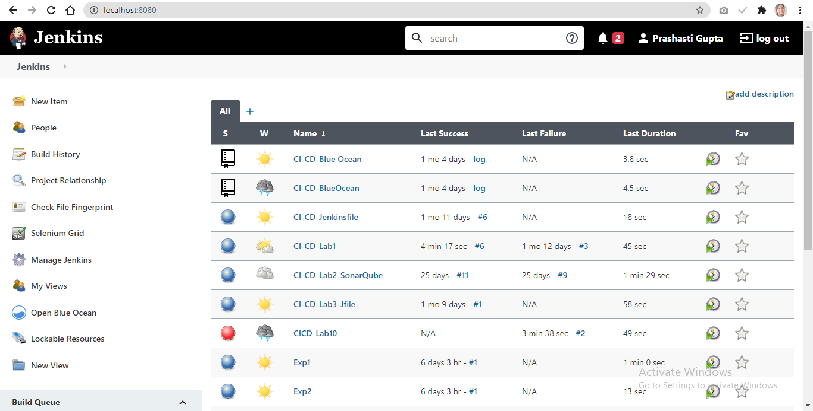

Click on the **New Item** option. Select the Pipeline option and give a name to the project.

Click **Ok**.

You will be directed to a page similar to this.

Click on the **Pipeline** tab. From the **Definition** dropdown, select **“Pipeline Script from SCM”.**

Then, choose **Git.** Add the URL of the github repository in the specified placeholder.

The github repository has to contain a file named “Jenkinsfile” that tells the Jenkins server what tasks to do.

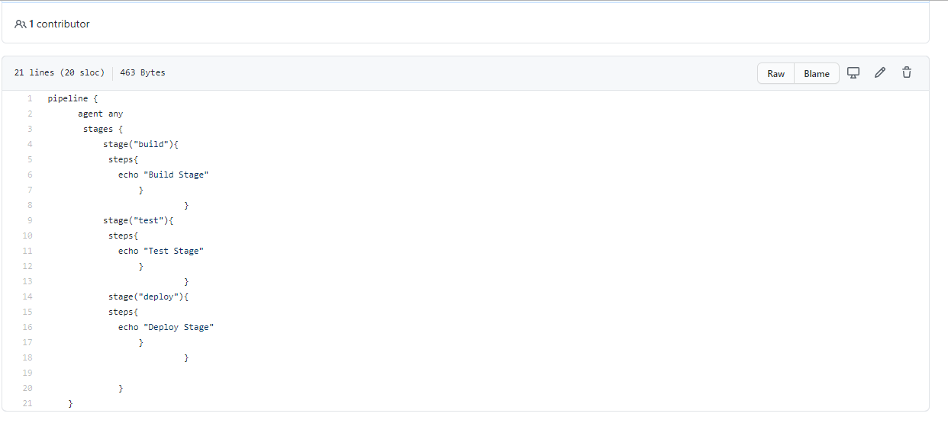

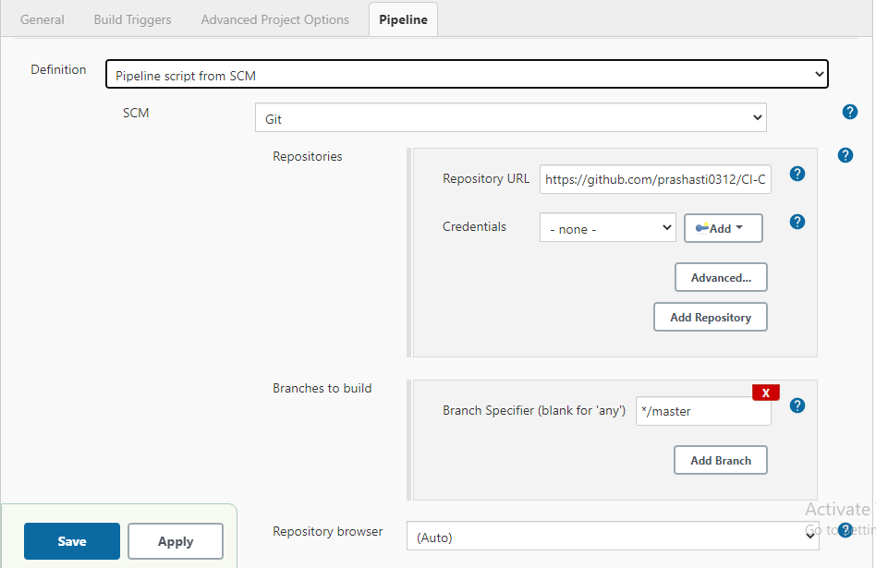

In the Script Path field, write **“Jenkinsfile”.**

Click **Save and apply**.

Click on **Build Now** option to build the project.

Select the console output option to check how the build is running.

