**Name: Prashasti Gupta**

**Roll Number: R171218077**

**SAP ID: 500068493**

**Exp:07 -- Create Pipeline using Blue Oceans Plugin**

Start the Jenkins service using the java -jar jenkins.war command in the command prompt

Go to the Jenkins dashboard at **localhost:8080**

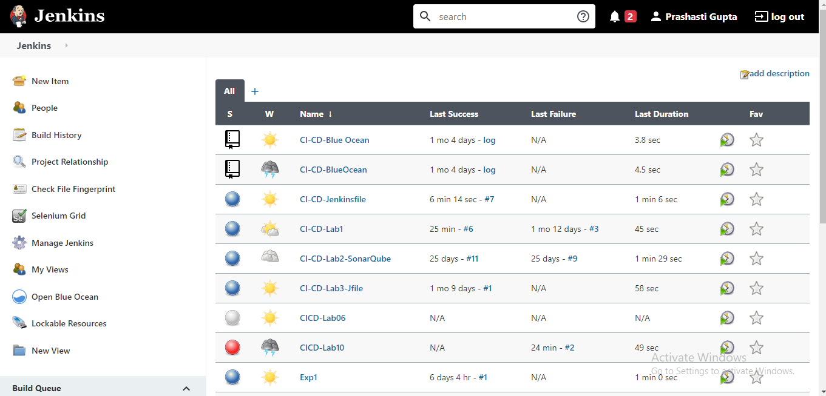

Go to **Manage Jenkins** and then to **Manage Plugins.** Find “Blue Ocean” plugin and install it.

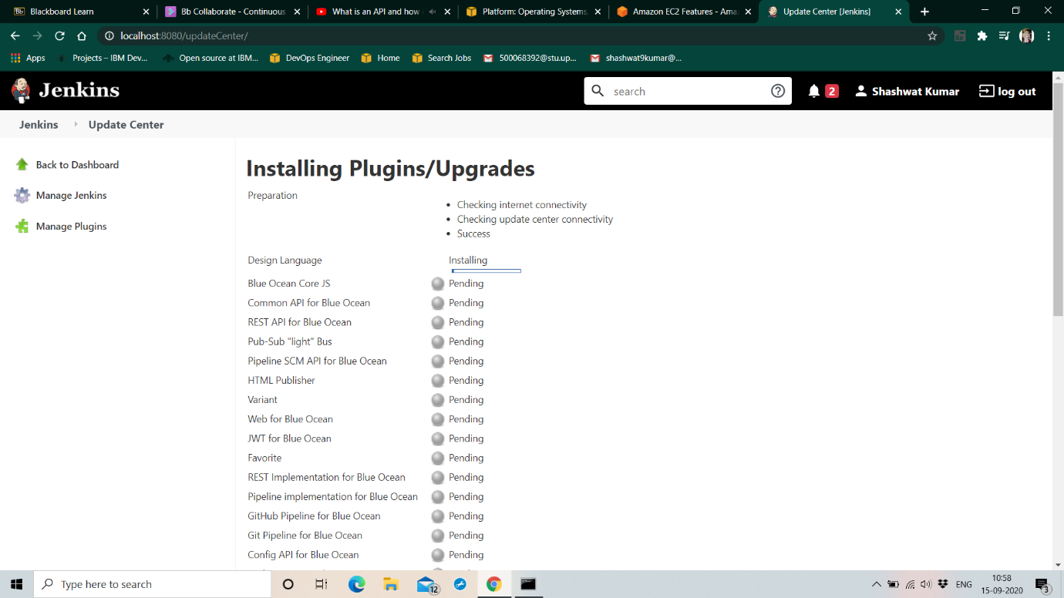

Now you’ll be able to see the Blue Oceans option on the main dashboard.

Go to the **Blue Ocean Pipeline**.

Select **Git** as the SCM manager for the project.

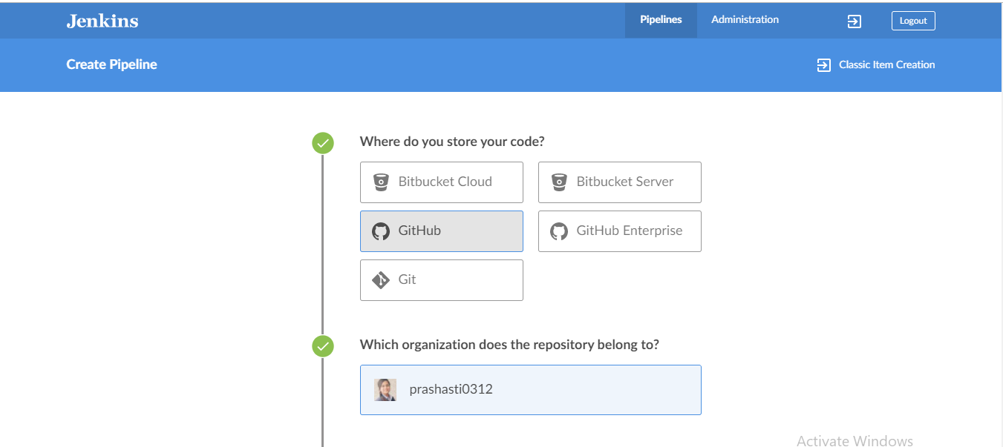

Go to the maven project for which you want to build the pipeline. Provide the same repository URL in the required placeholder. Provide the username and password for your github account.

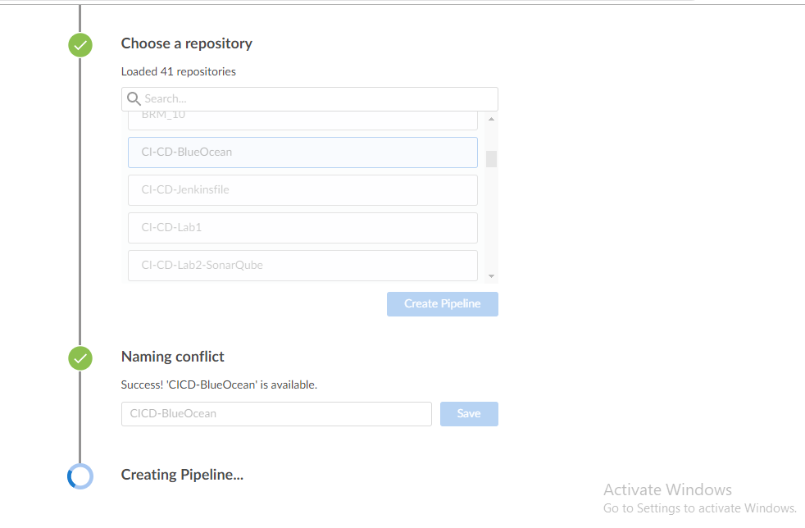

You will find a pipeline created very similar to the pipeline shown here. Click on the run button just next to it to initiate the build process.

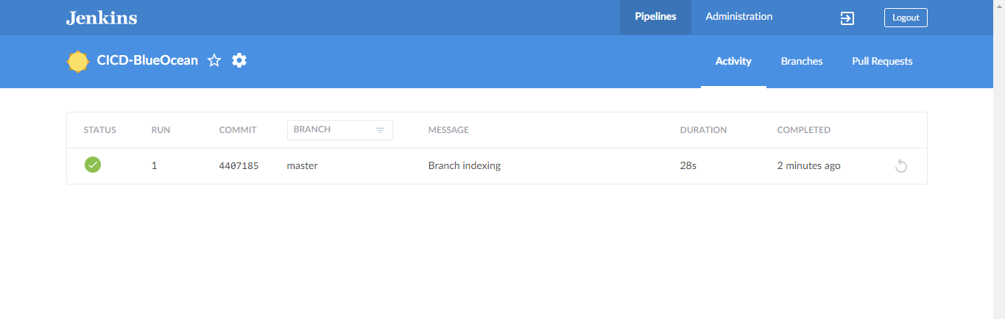

Once the Build process completes successfully, it would turn green

If any errors happens during the build process, the pipeline turns red.

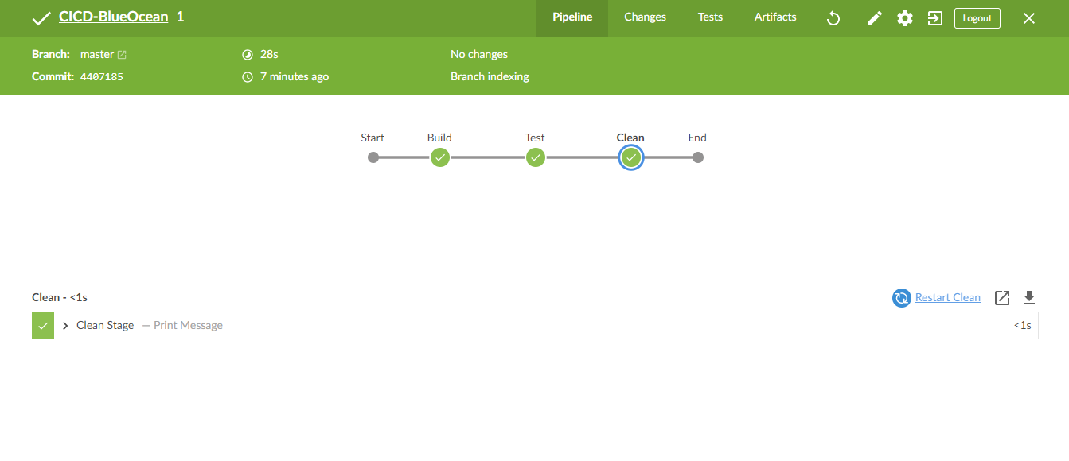

The commands executed can also be seen in the terminal provided in the bottom half of the window.

