**EXPERIMENT-11**

**NAME- RAJAT PANWAR**

**ROLL NO- R171218080**

**SAP ID- 500069414**

**Submitted to:-**

**MR. HITESH KUMAR SHARMA**

**1]. Vagrant init**

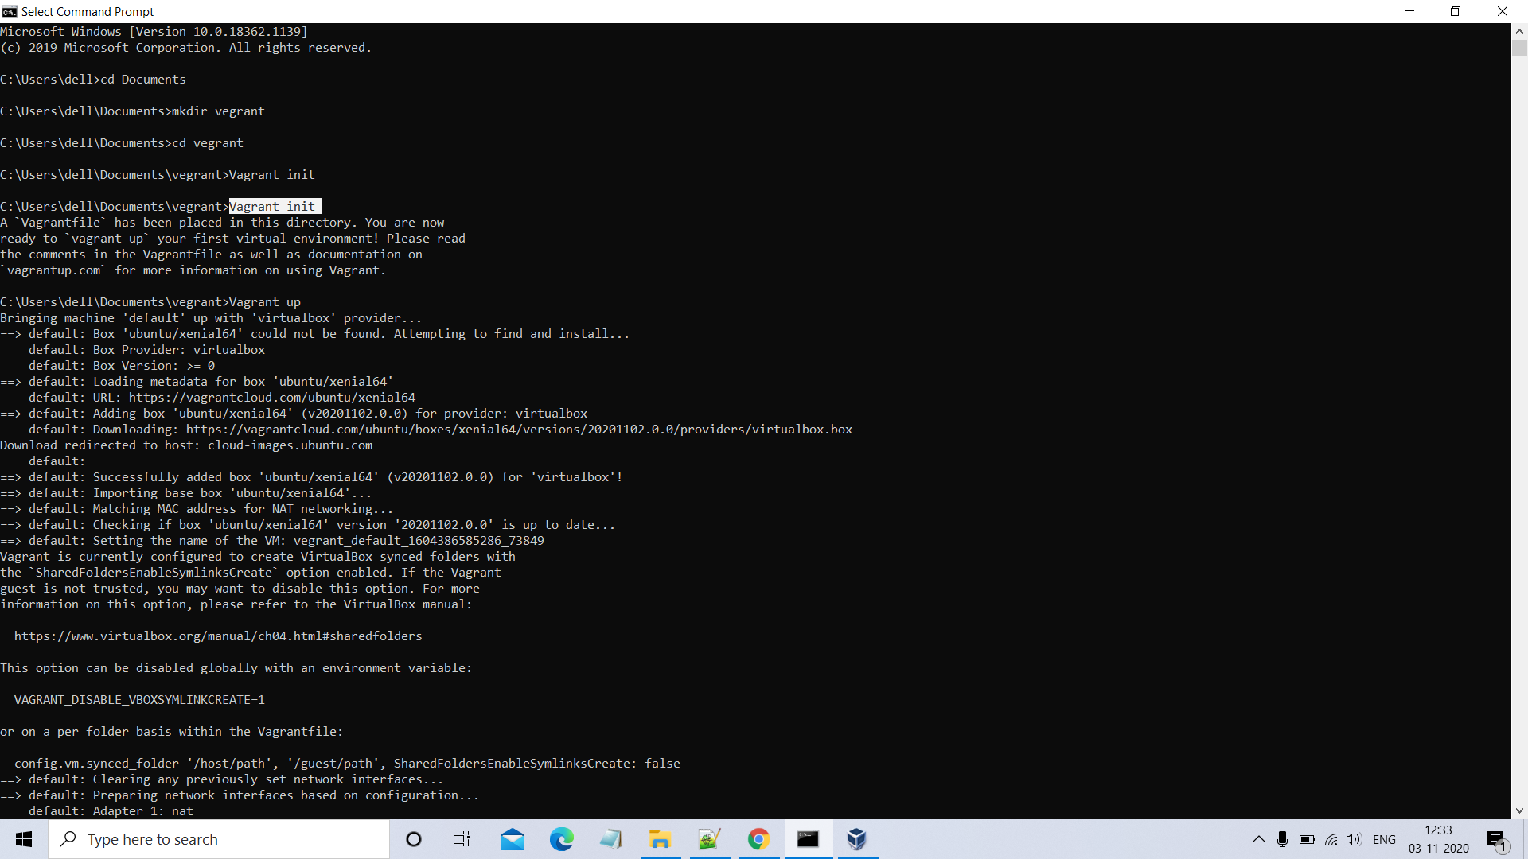

**Edit vagrantfile**

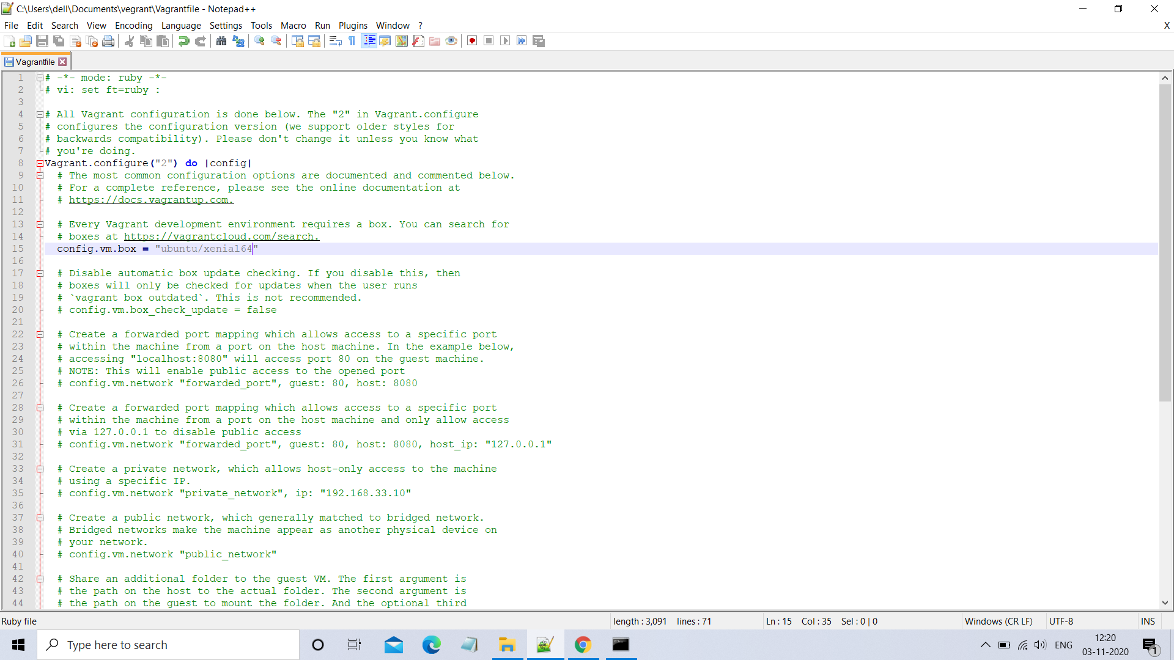

**2]. Vagrant up**

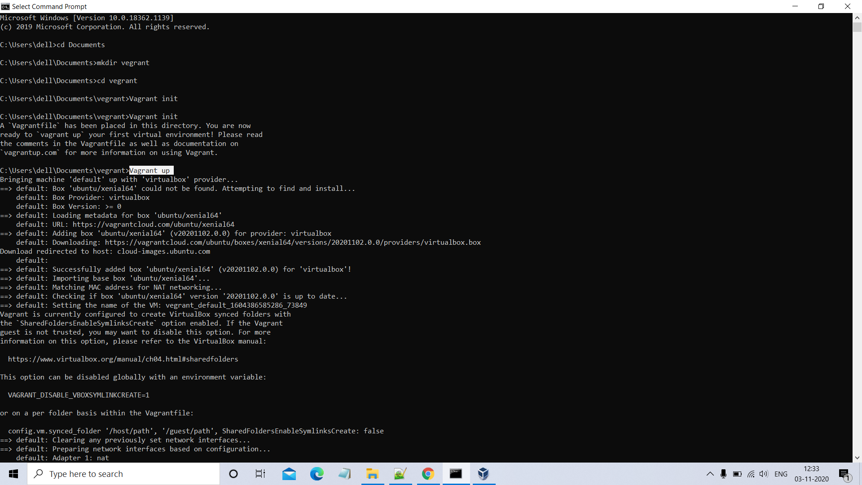

**3]. vagrant ssh**

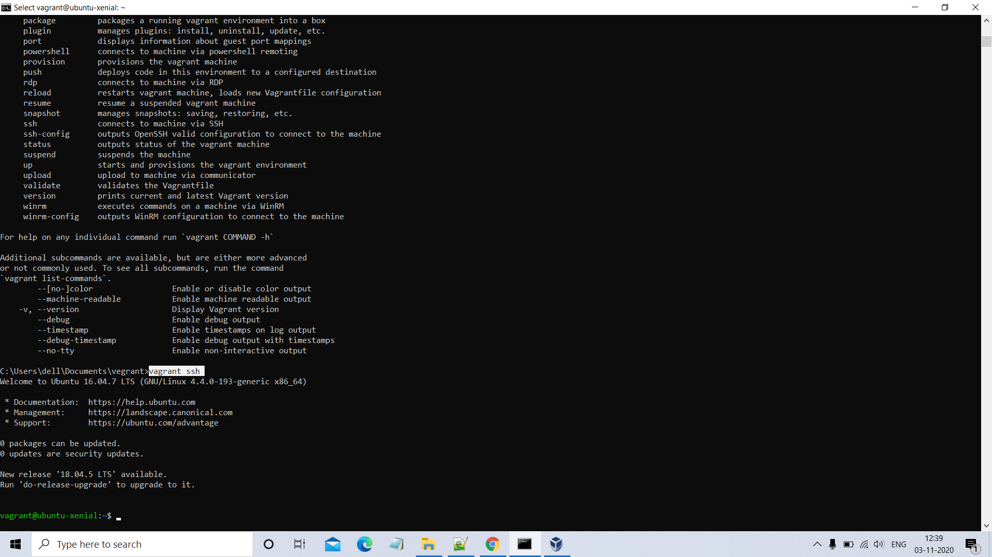

**FOLDER :-**

