**Name: Shashwat Kumar**

**Roll Number: R171218093**

**SAP ID: 500068392**

**Lab: 10**

**Nexus Integration with Jenkins**

**Solution:**

Head over to: sonatype.com/nexus/repository-oss/download to download nexus server

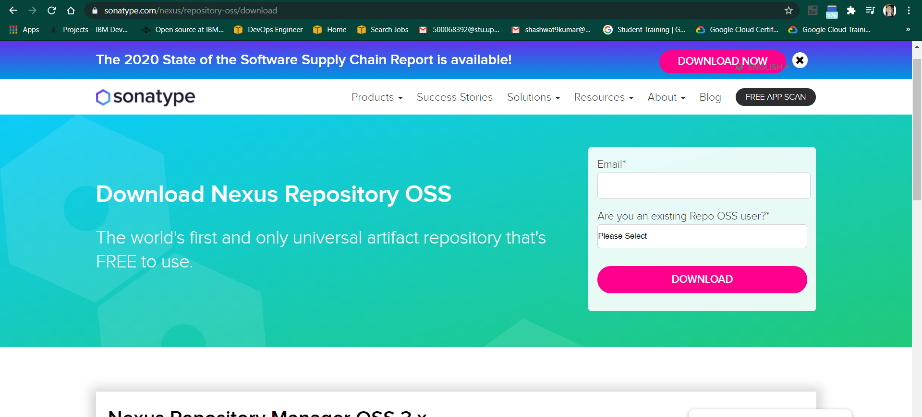

Go to the location where nexus is installed.

Open the bin folder to find nexus.exe file

Open command prompt in the same folder and run the following command :

Nexus.exe /run

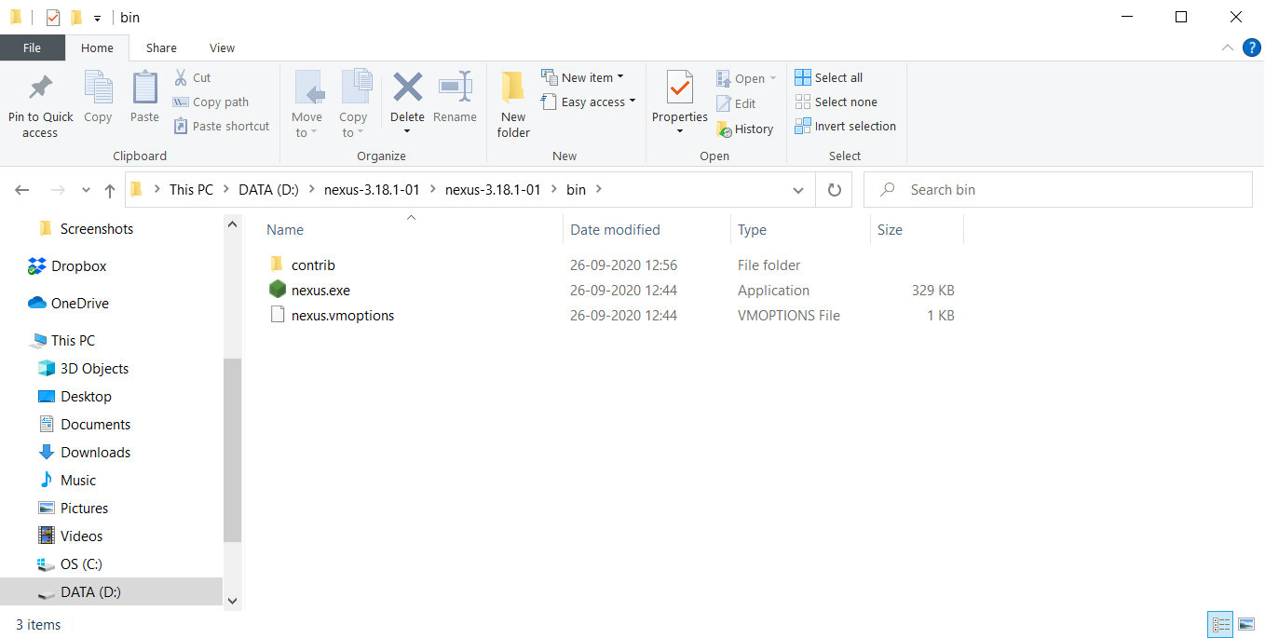

Once the command runs head to localhost:8081, the port where Nexus server runs

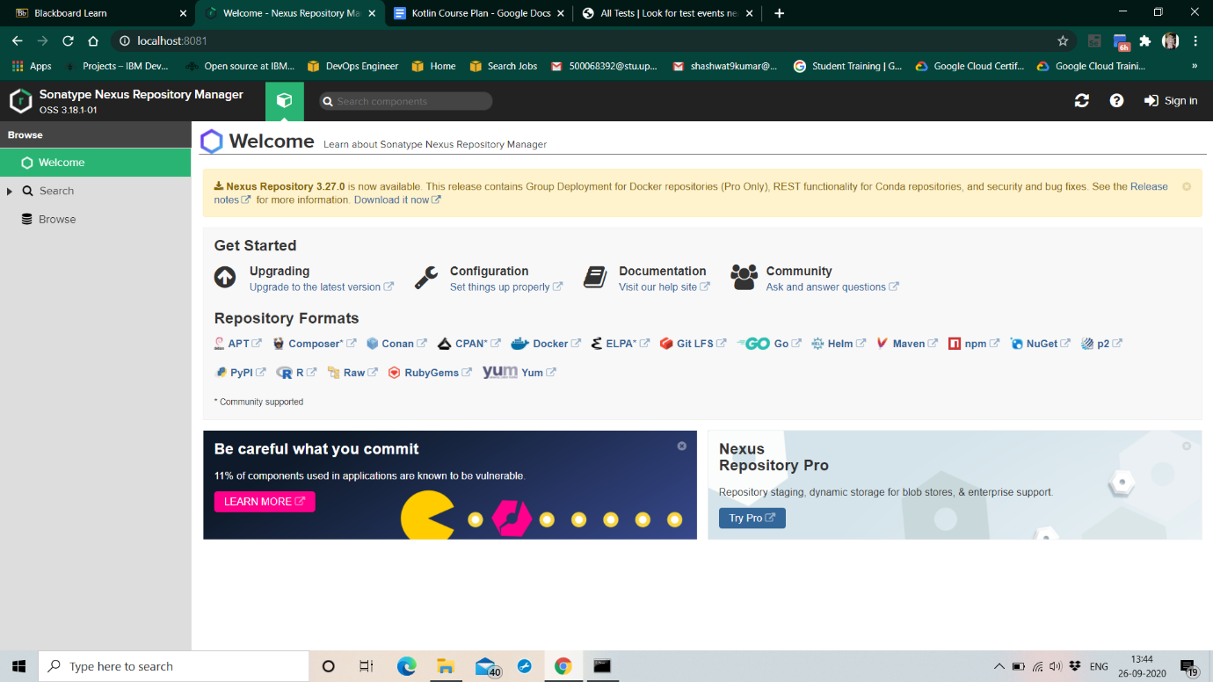

For the first time, nexus requests the admin password already given with the installation.

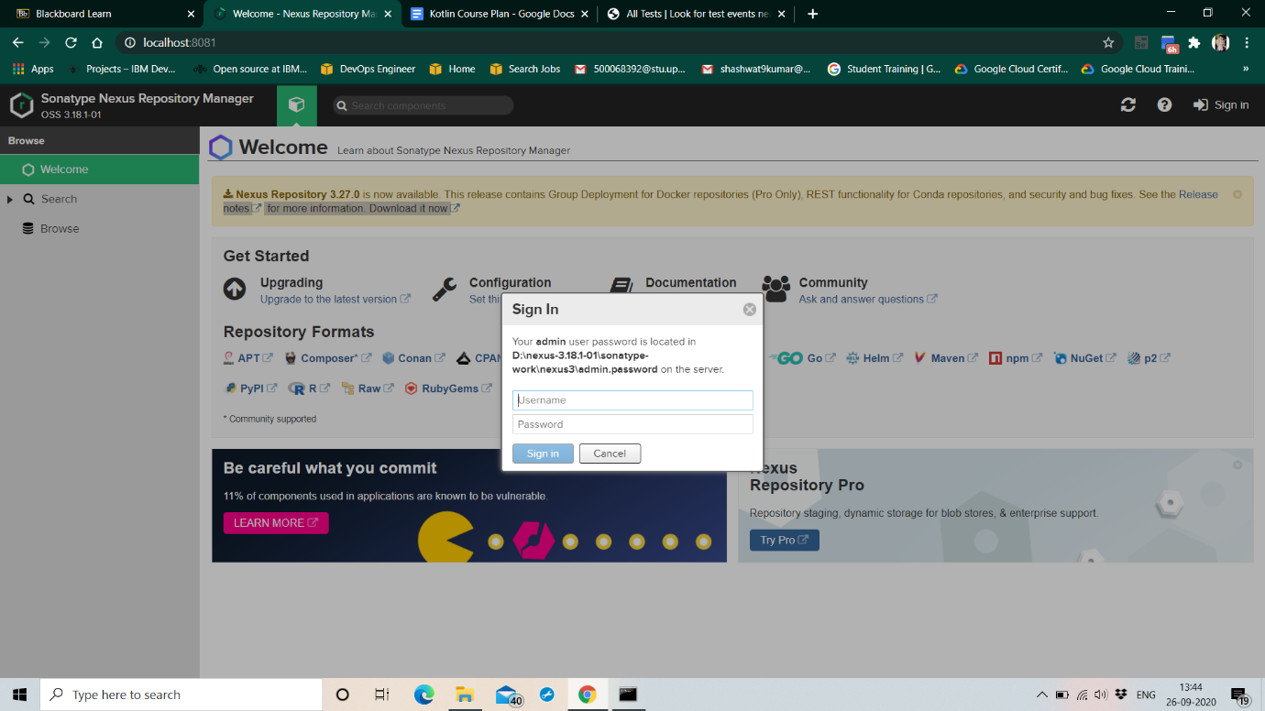

Find the default admin password at the sonatype-works/nexus3/ folder with the name admin.password

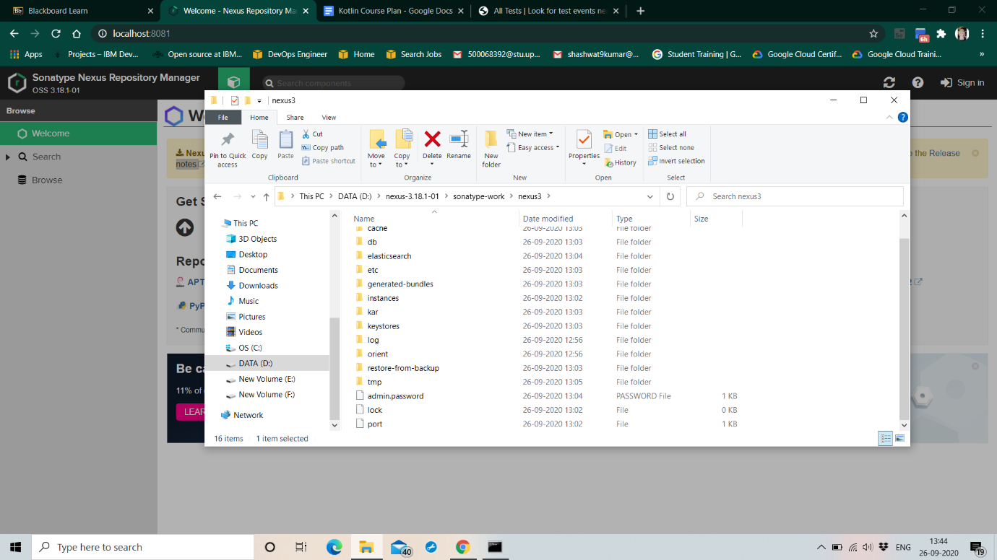

Complete the set-up, to create a new admin username and password and login

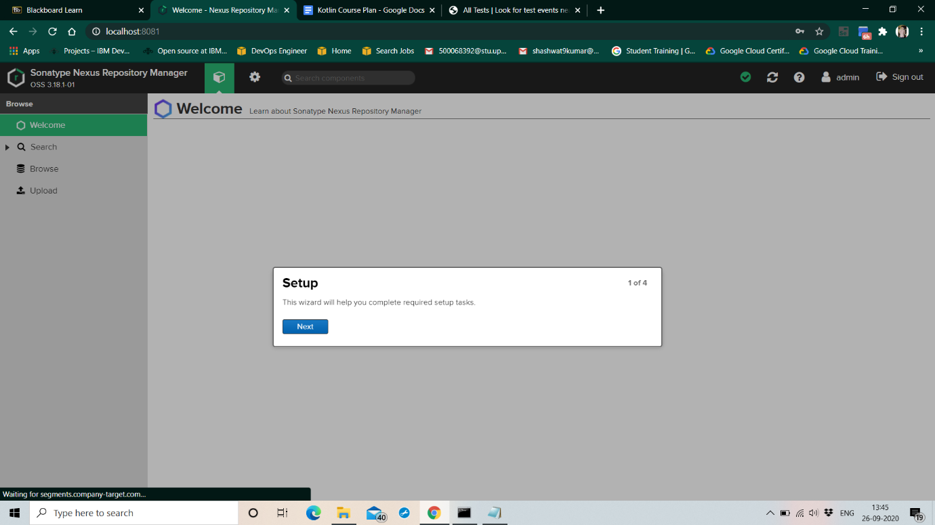

On login, Nexus server dashboard should look similar to this

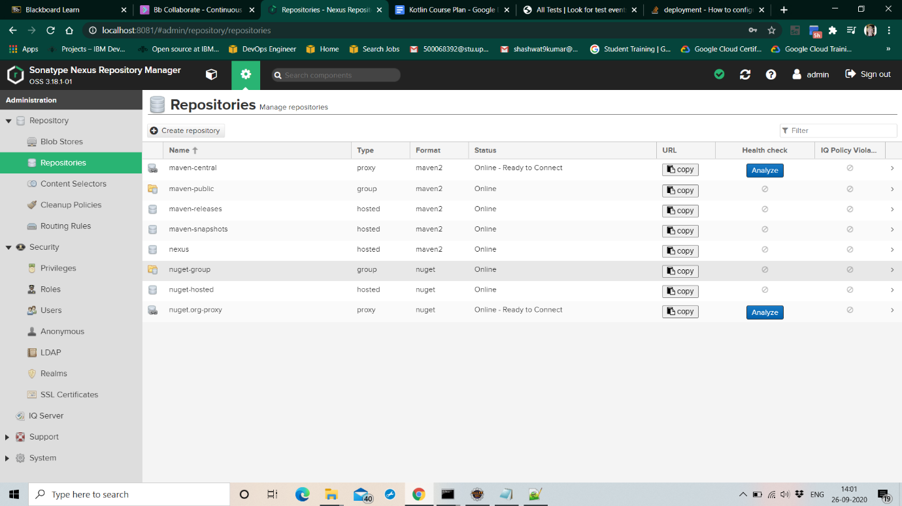

Create a new repository in Nexus (here called “nexus”) and copy its URL

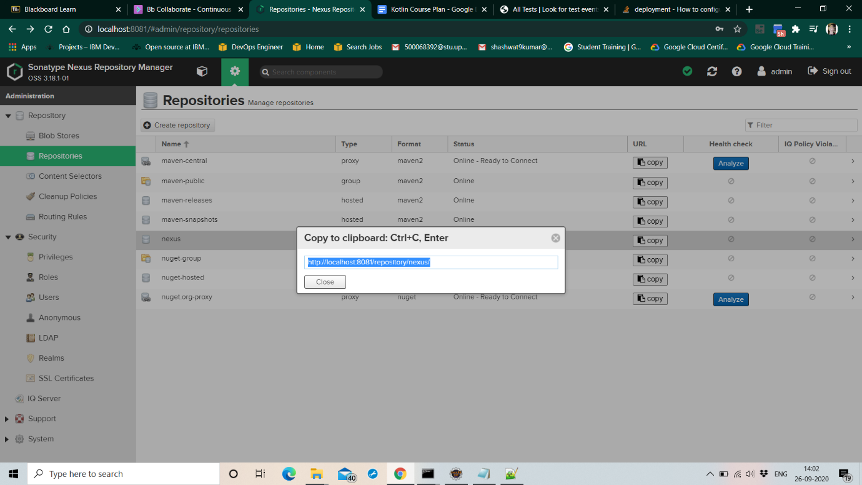

Open the pom.xml of the Maven project to be published to Nexus

Add the snapshot Repository tag into the pom.xml and give the URL of Nexus repository copied

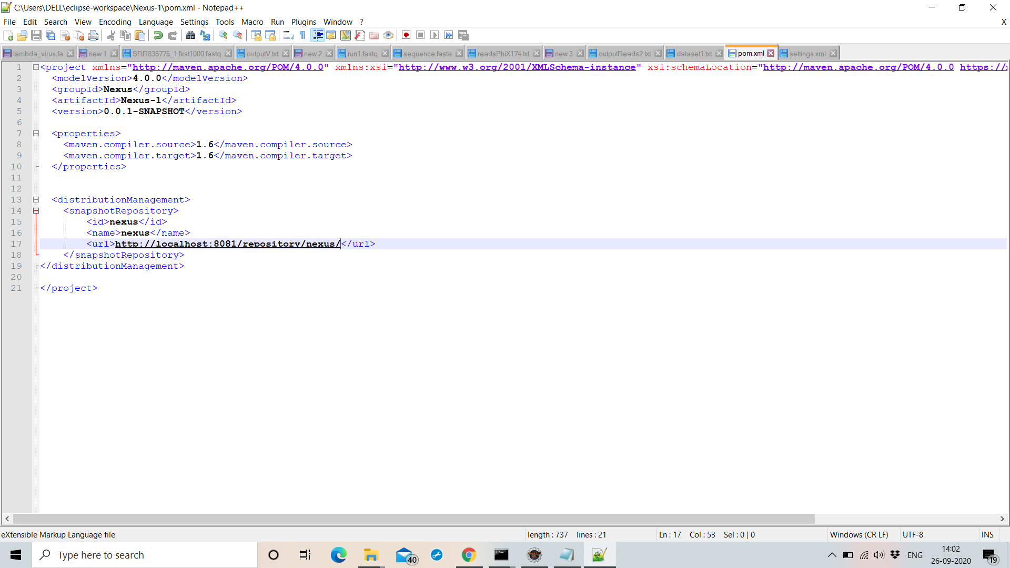

Go to Jenkins dashboard and then go to global configuration settings. Add the URL of Nexus server there

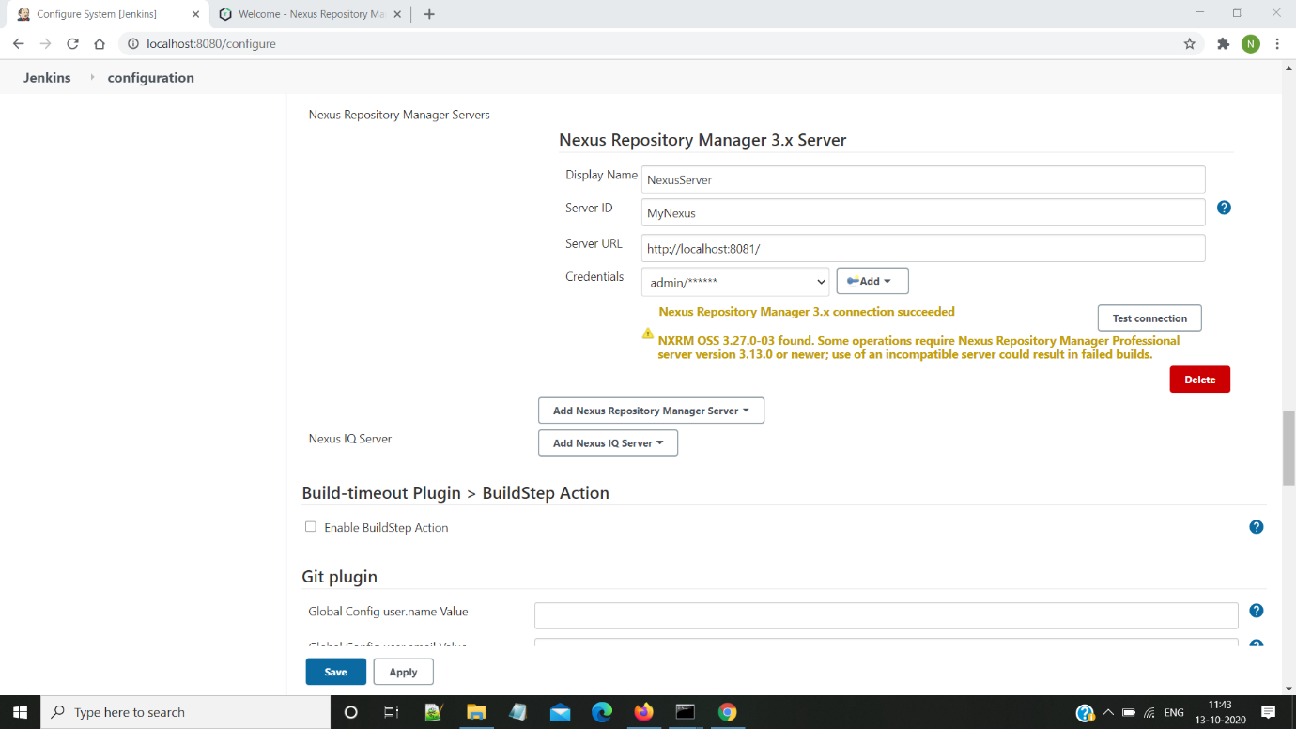

In the Source Code Management Section select Git

Give the repository location in the specified placeholder

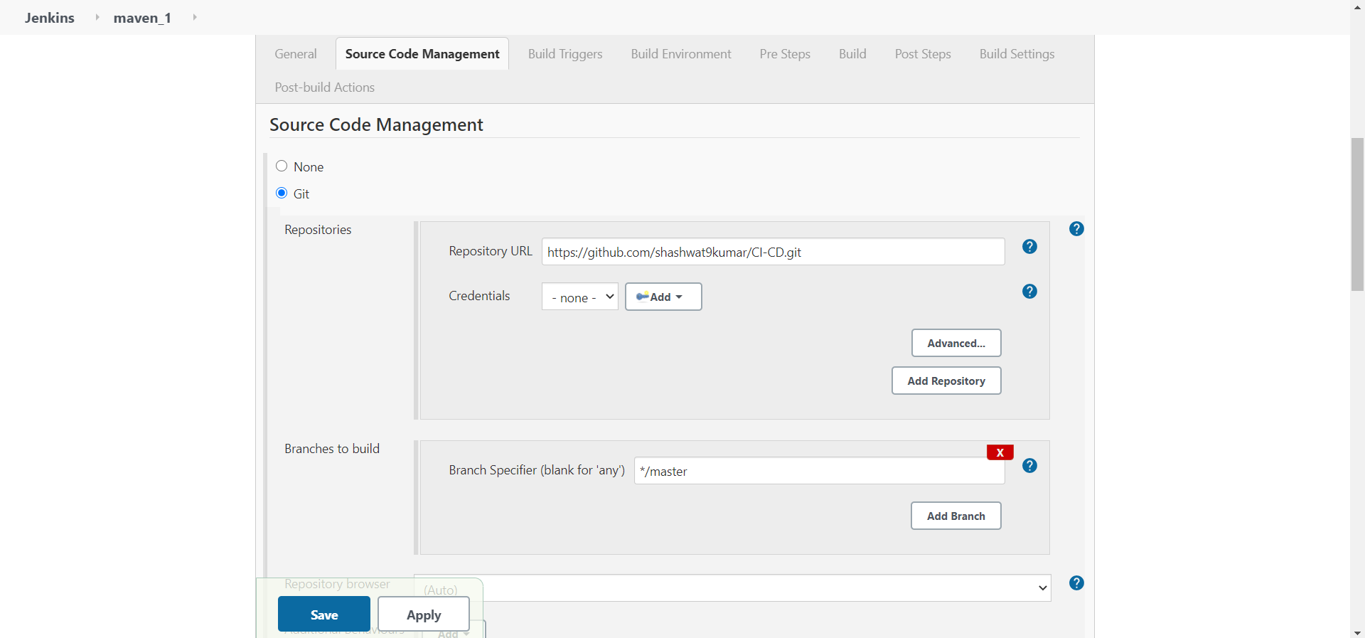

The github repository must contain a Jenkinsfile that contains “mvn deploy” stage. This would help us deploy the artifact on Nexus server.

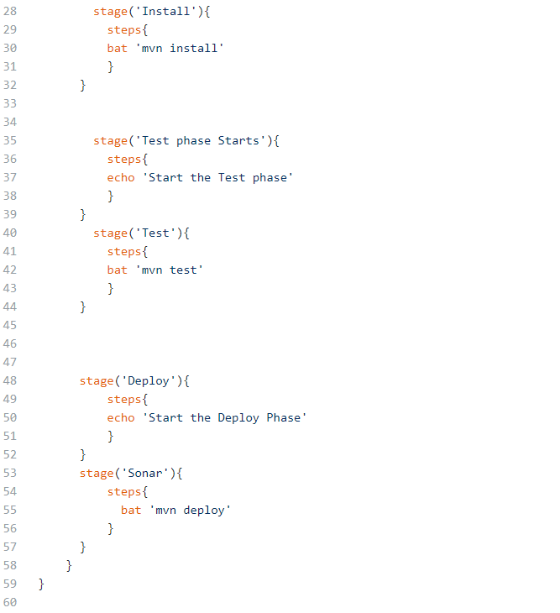

Click on Build Now option to build the project.

Select the console output option to check how the build is running

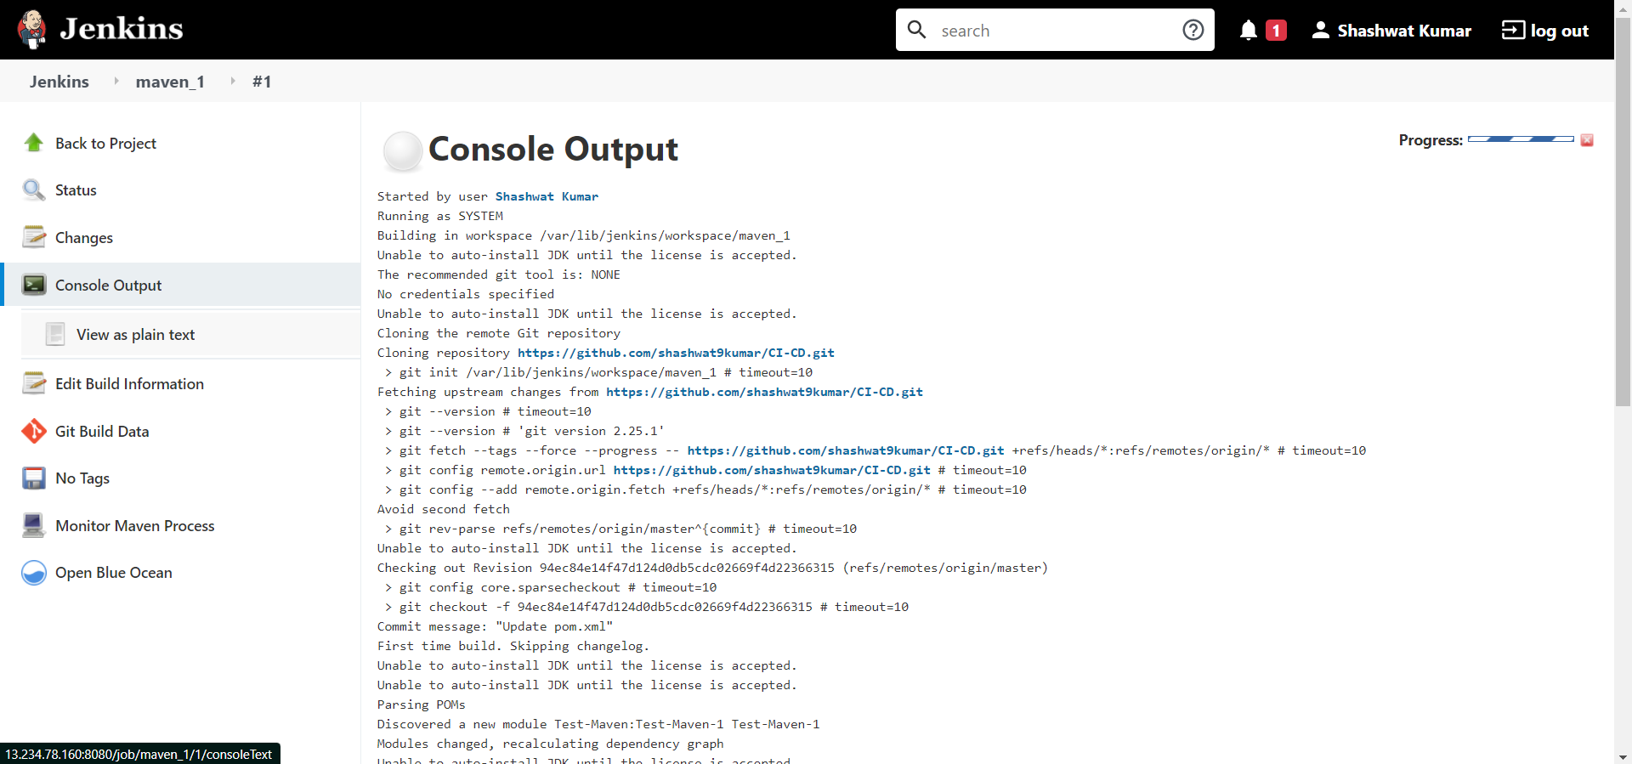

If the build runs successfully it would return “BUILD SUCCESS”. It would return failure in case of any errors in the project

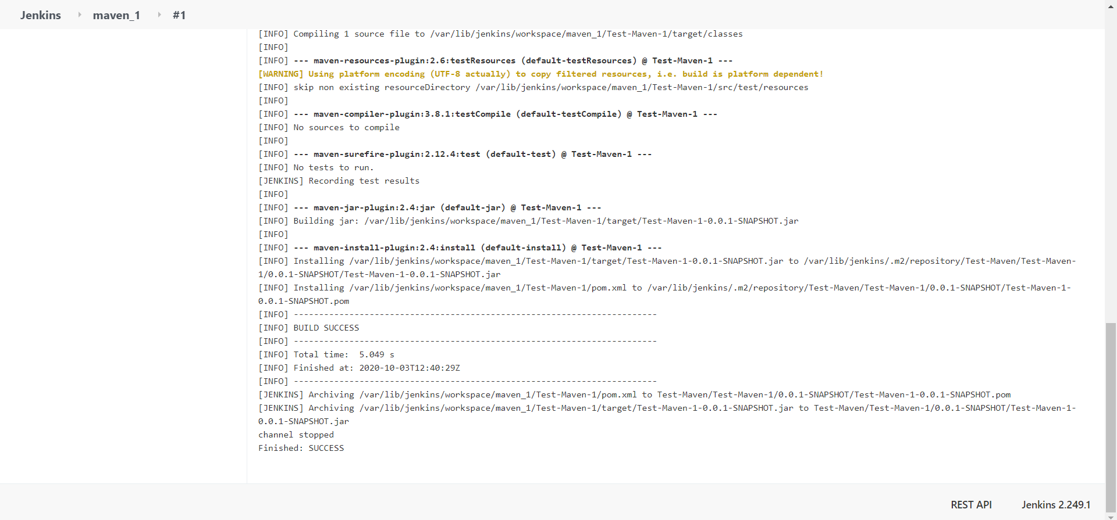

Browse the Nexus repository now to see the deployed jar

