**Name: Shashwat Kumar**

**Roll Number: R171218093**

**SAP ID: 500068392**

**Lab: 11**

**Downloading and Running Ubuntu-Xenial on Vagrant**

**Solution:**

Start Ubuntu.

Run the following command:

sudo apt install virtualbox

## this will install virtual box on the system.

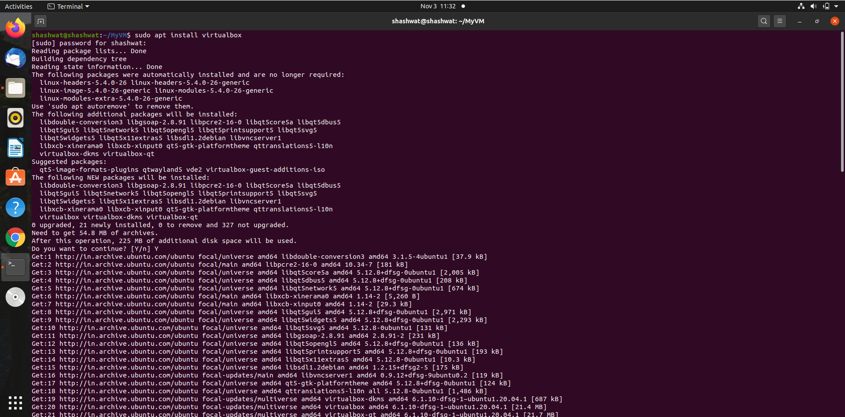

Now, we will install vagrant

sudo apt install vagrant

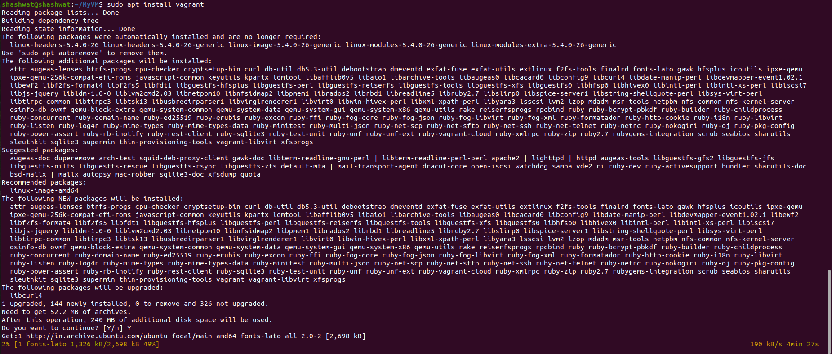

Check the installed version of vagrant

vagrant --version

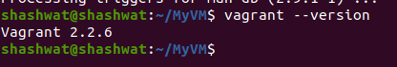

Switch to a newly created directory for vargrant machine:

sudo mkdir ~/vagrant-ubuntu

cd ~/vagrant-ubuntu

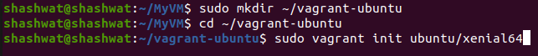

Install a new vagrant image:

sudo vagrant init ubuntu/xenial64

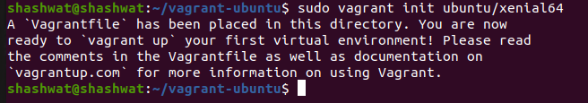

Change the owner of the vagrant file and up the system:

sudo chown -R <username> <vagrant directory>

vagrant up

