**Name: Shashwat Kumar**

**Roll Number: R171218093**

**SAP ID: 500068392**

**Lab: 12**

**Running Docker on Windows Machine using WSL**

**Solution:**

On Windows 10(Home) {with WSL v2 enabled}, download Docker.

Install Docker

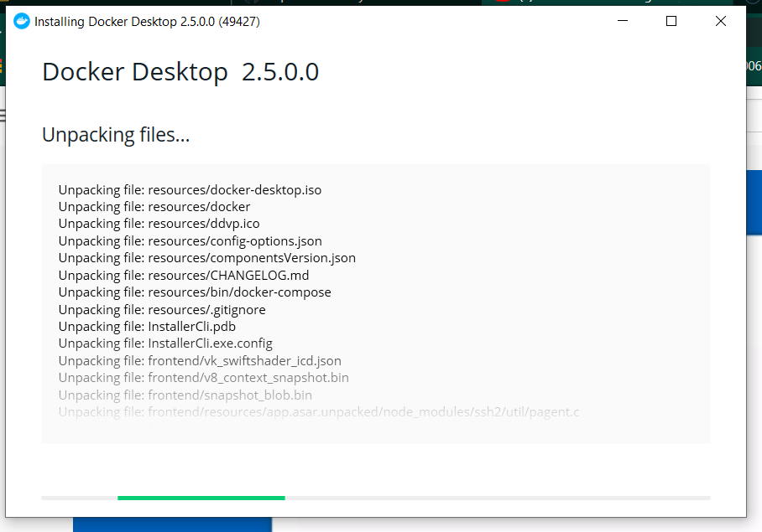

After the completion of installation, log into Windows again.

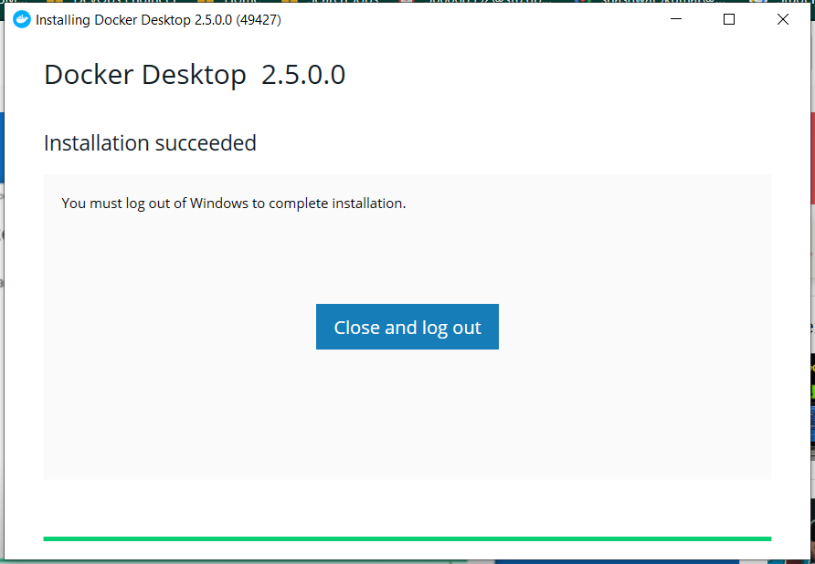

Start Windows Power-shell.

Run the following commands to see if WSL is enabled and running version 2:

wsl -l -v

If the configurations are correct, set the default ubuntu installation to version 2 for WSL

Run the following command:

wsl –set-version <Default WSL> 2

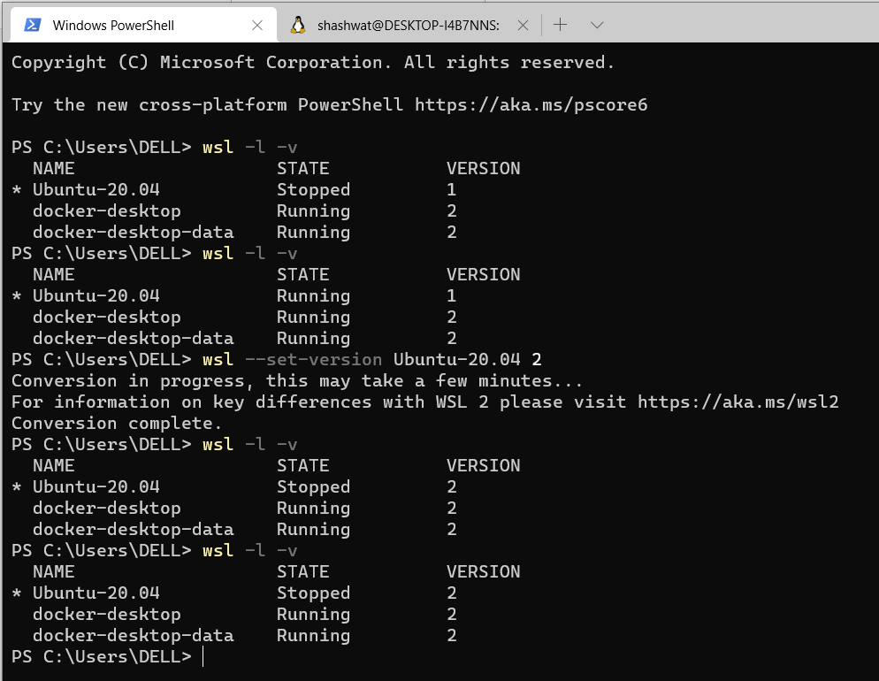

Open the Ubuntu kernel terminal.

Run:

docker run -d -p 80:80 docker/getting-started

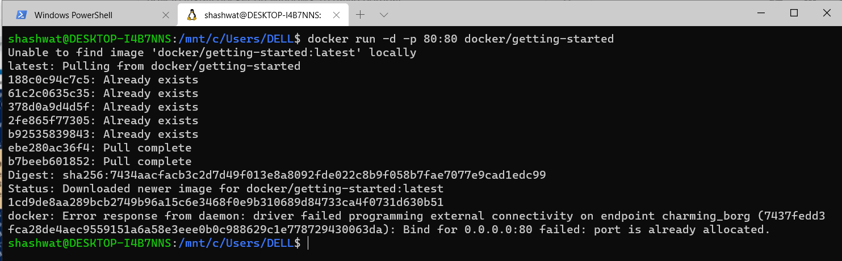

To test Docker run:

docker run hello-world

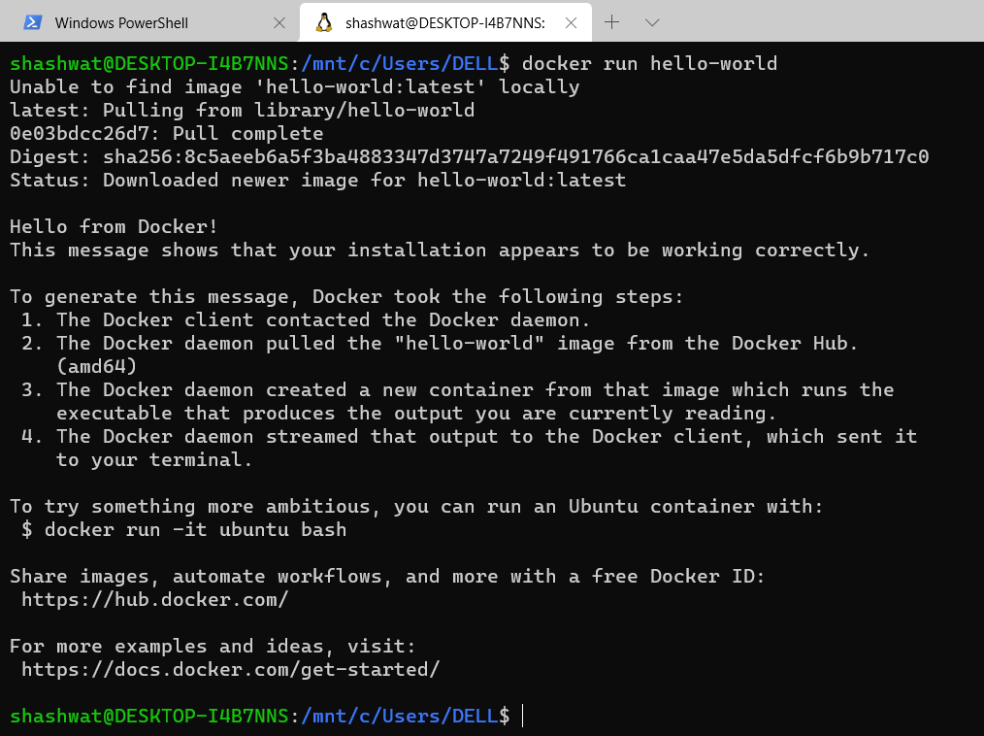

To Run ubuntu on Docker, use the following command:

docker run -it ubuntu bash

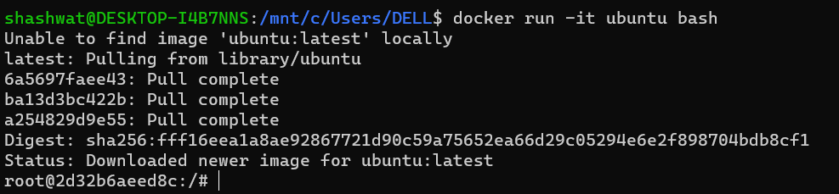

After installation of ubuntu, you can see the ubuntu directory using the following command:

ls -a

