**EXPERIMENT-1**

* **JENKINS SETUP**

**STEP-1**

Go to Link [**https://www.jenkins.io/download/**](https://www.jenkins.io/download/)

**STEP-2**

Click on Generic Java Package (.war):- This will download a (.war) file

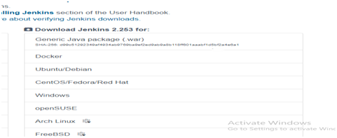

**STEP-3**

Now run command on cmd: — java –jar jenkins.war

· Requirement:- JDK ( VERSION 8 TO 11 anyone )

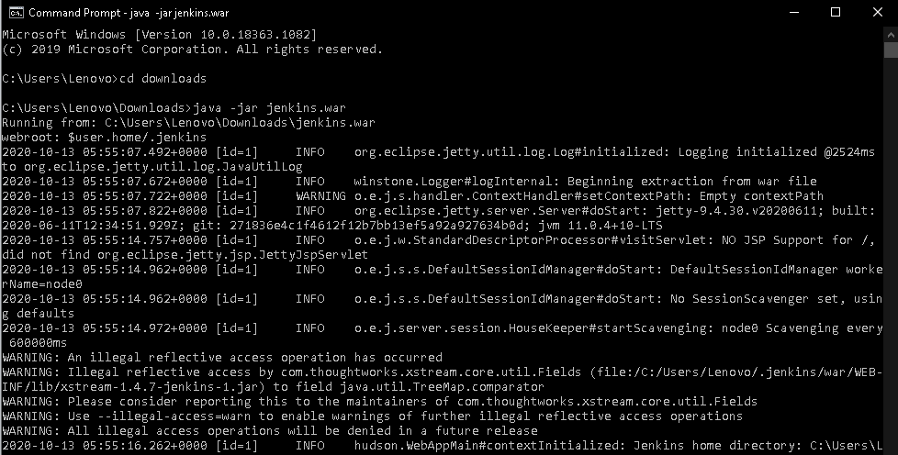

**STEP-4**

type: — **localhost:8080**

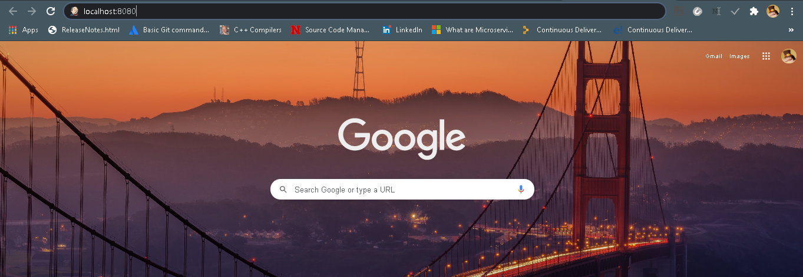

Step -5

Dashboard of Jenkins

