**EXPERIMENT-2**

**Setting up JENKINS environment using MAVEN AND GITHUB**

**Step: 1**

**Creating Github Repository**

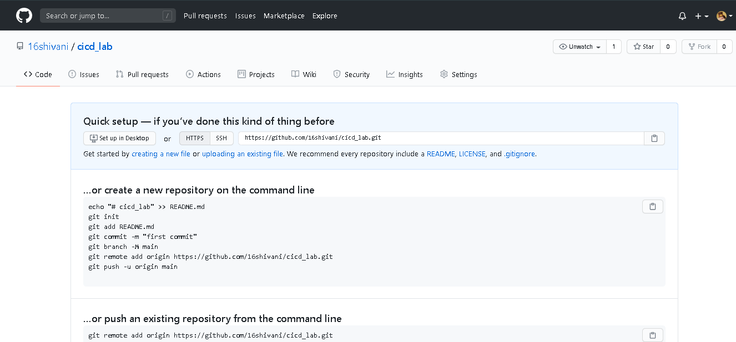

**Step: 2**

**Push the changes of maven project to git through git perspective**

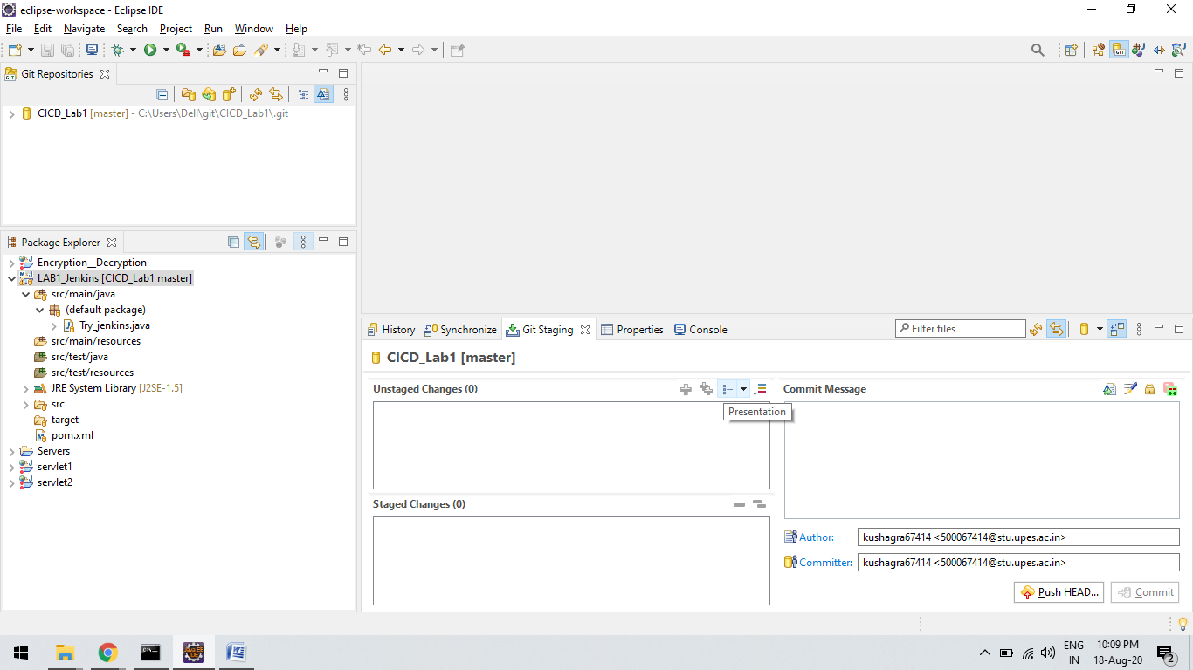

**Step 3 :**

Create a job in jenkins and configure it

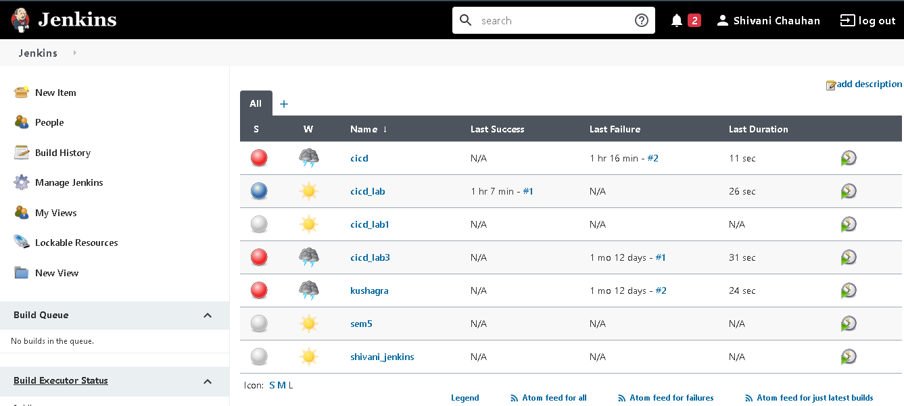

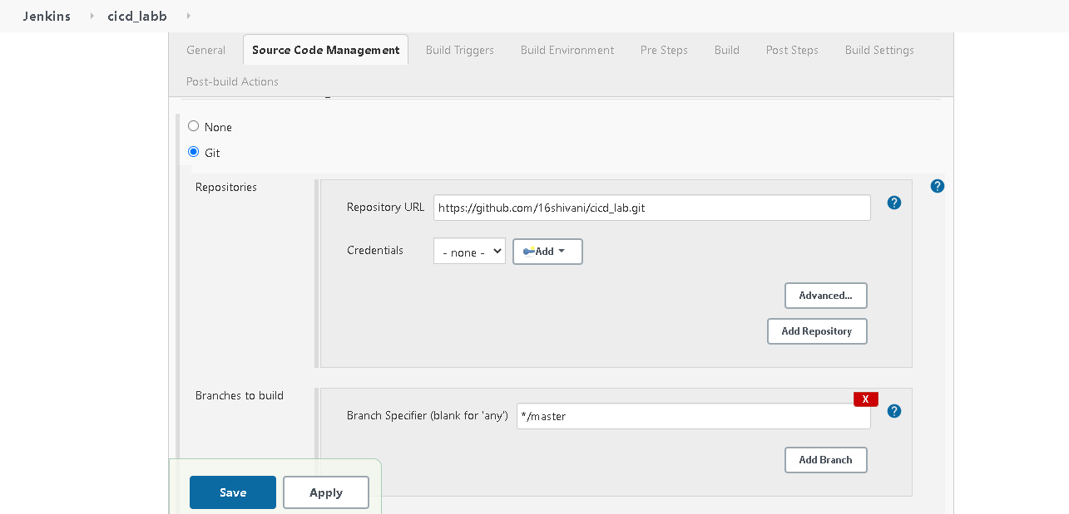

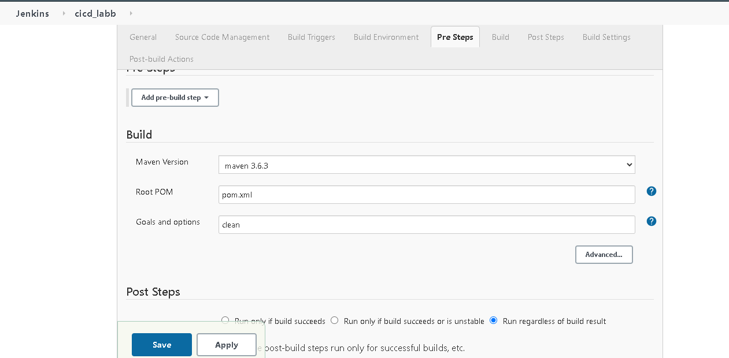

***Step-4 :***

**Click on Build now and check the Build Success**

