**Expeiment-3**

**Using Static Code analysis Tool “SONARQUBE”**

STEP-1

Make a project on eclipse which will be used for analysis

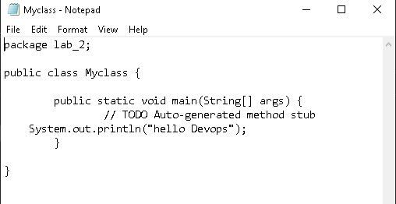

STEP-2

Go to SonarScanner configuration folder and edit sonar-scanner.properties

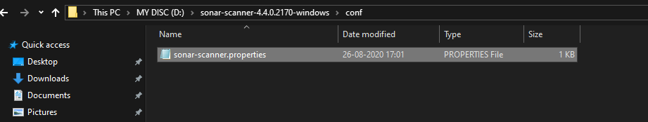

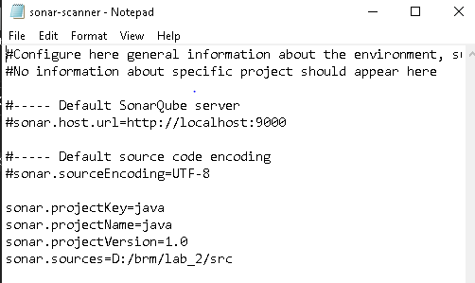

STEP-3

Now Open your COMMAND PROMPT and go to your project location and run command

“sonar-scanner.bat”

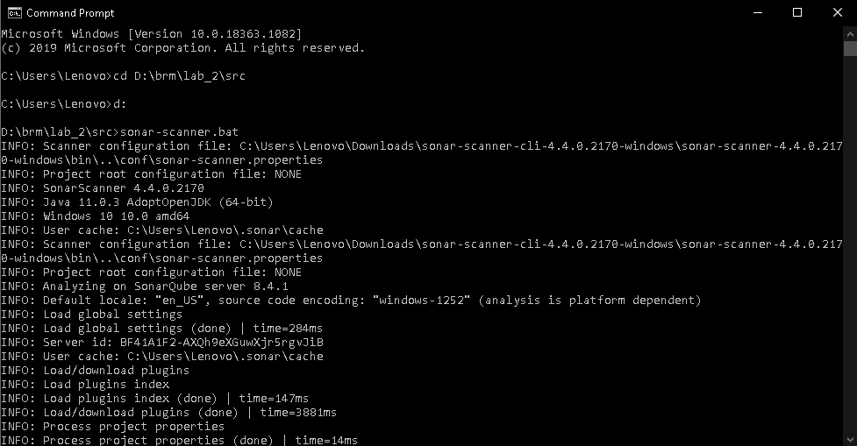

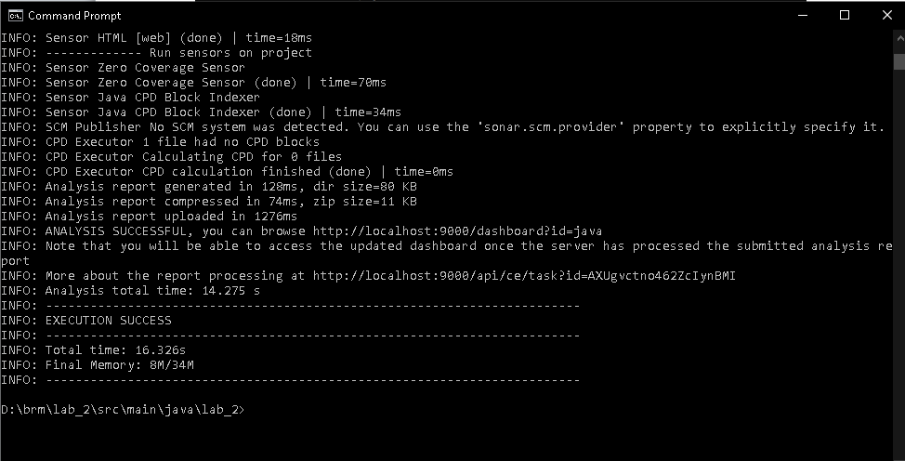

STEP-4

Check you “localhost” on chrome

