**Experiment-9**

**Jenkins integration with SonarQube**

Click on the new item option

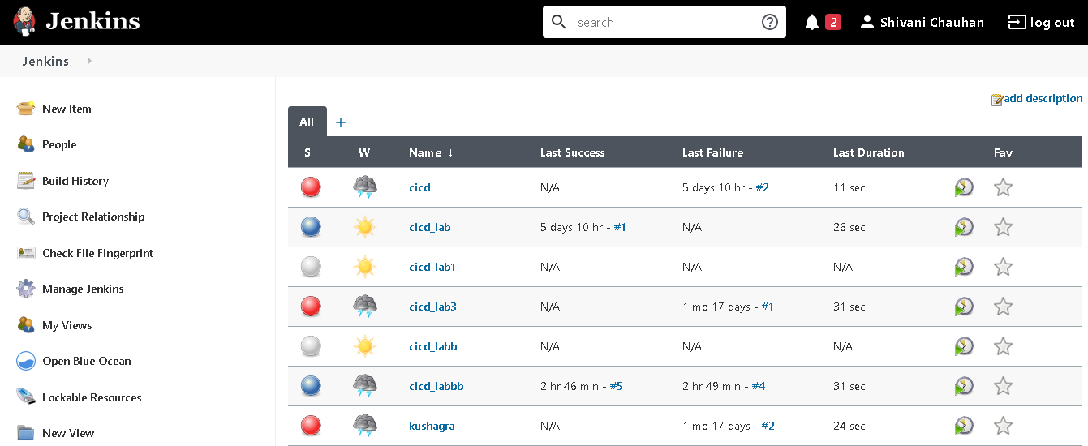

Create a maven project.

Do the configuration and provide the location of the github repository consisting Jenkinsfile for the maven command invocation.

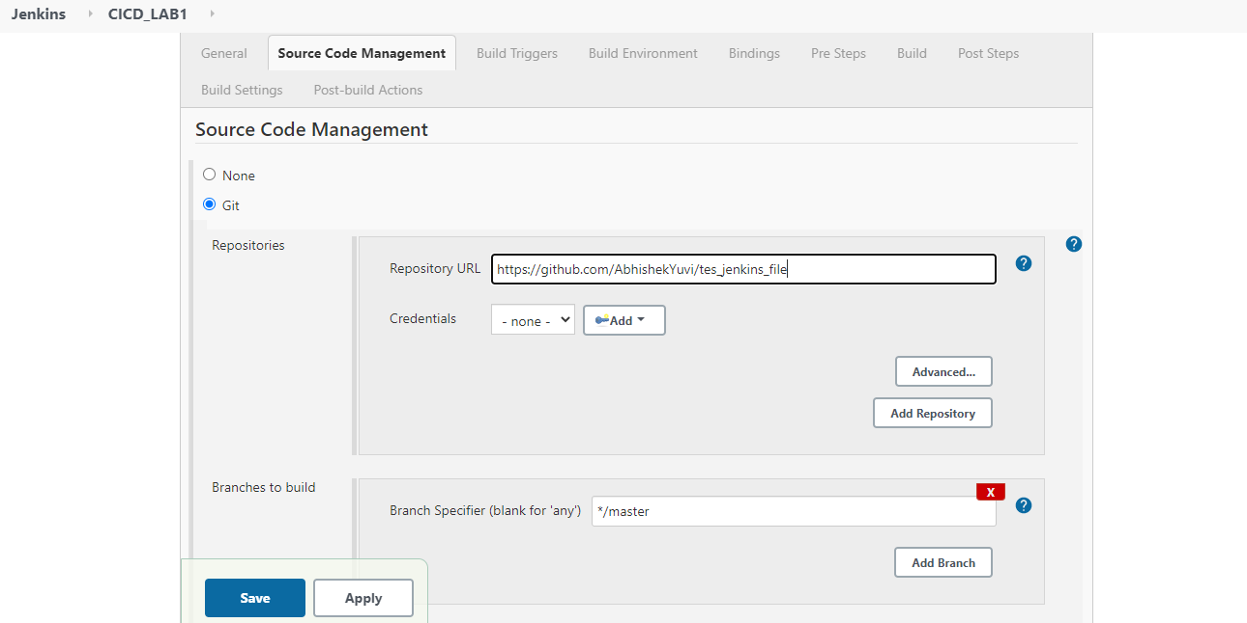

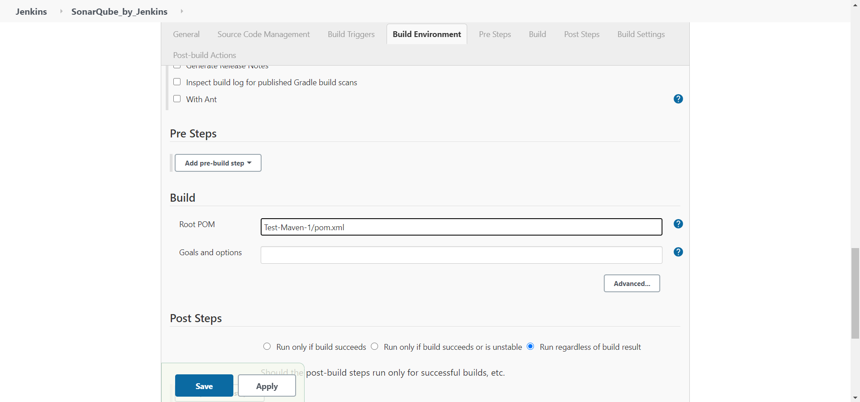

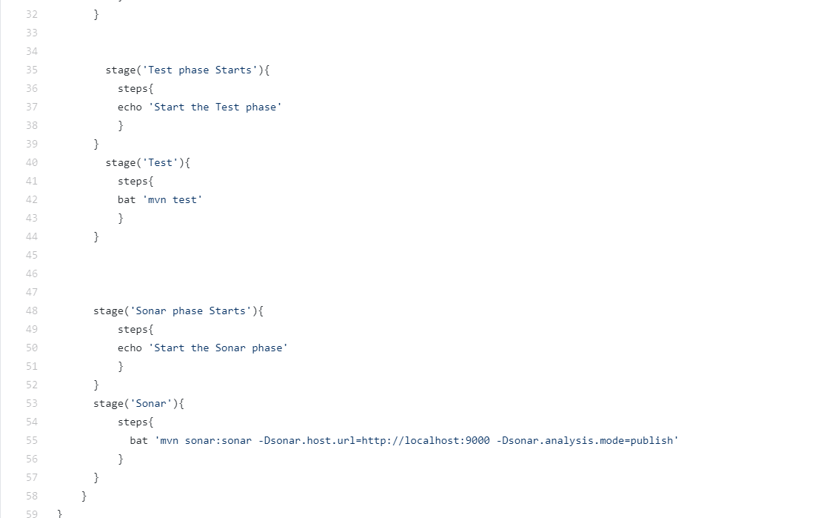

Build the project and check for the console output. 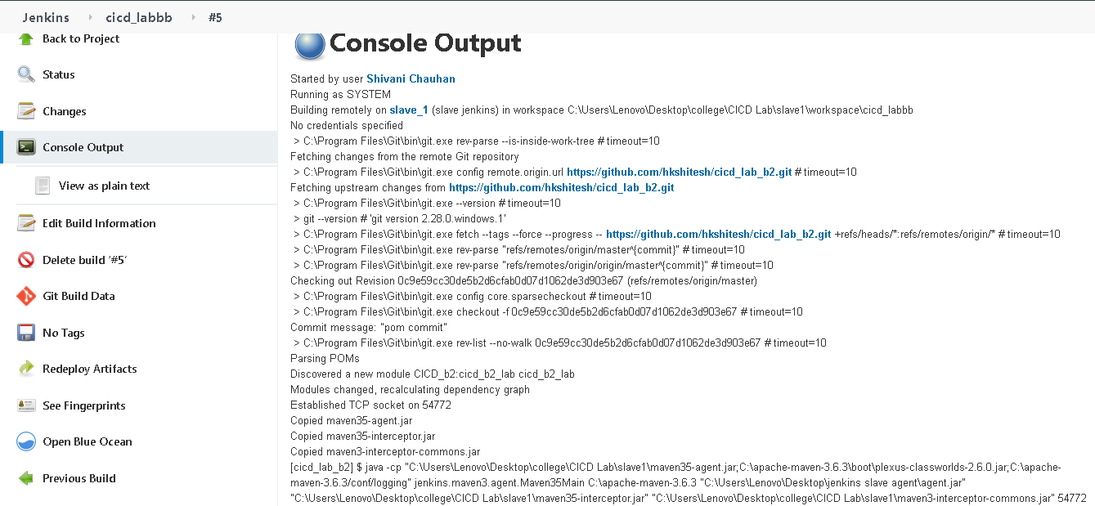

* BUILD SUCCESS

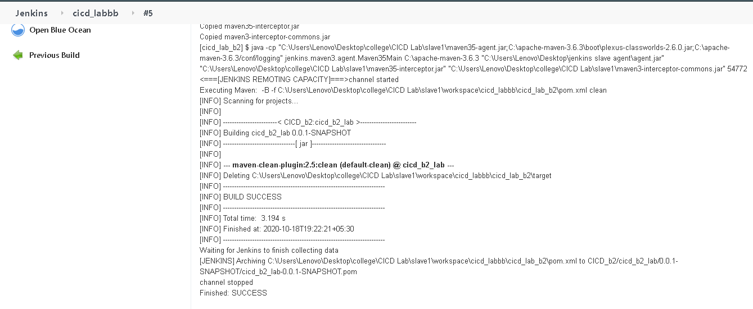

* **SONARQUBE DASHBOARD**

