**CICD LAB EXPERIMENT -7**

**Updating artefact on nexus server using CMD**

1. Starting Nexus server

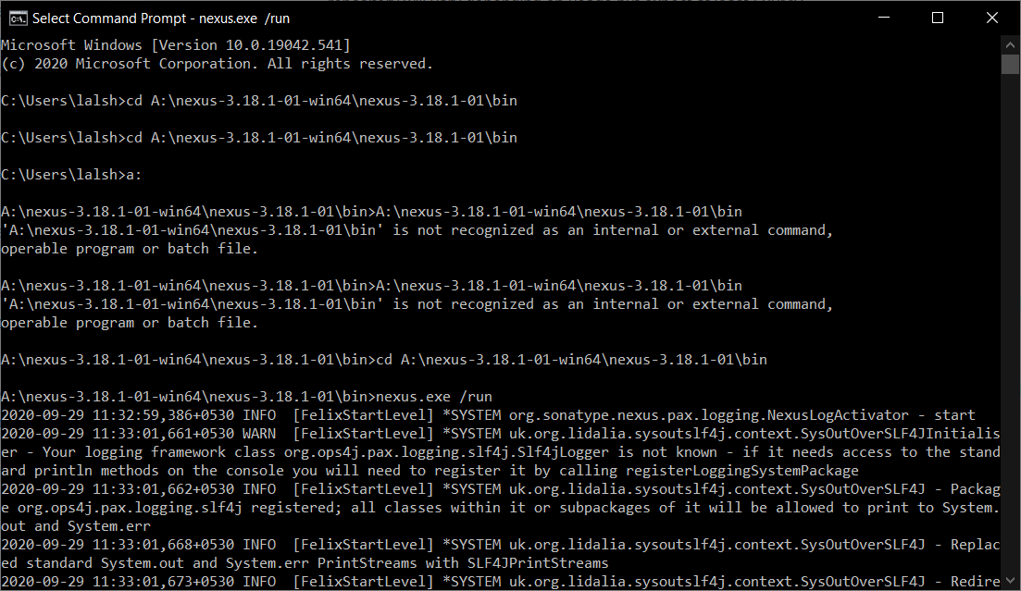

1. Creating Nexus repository

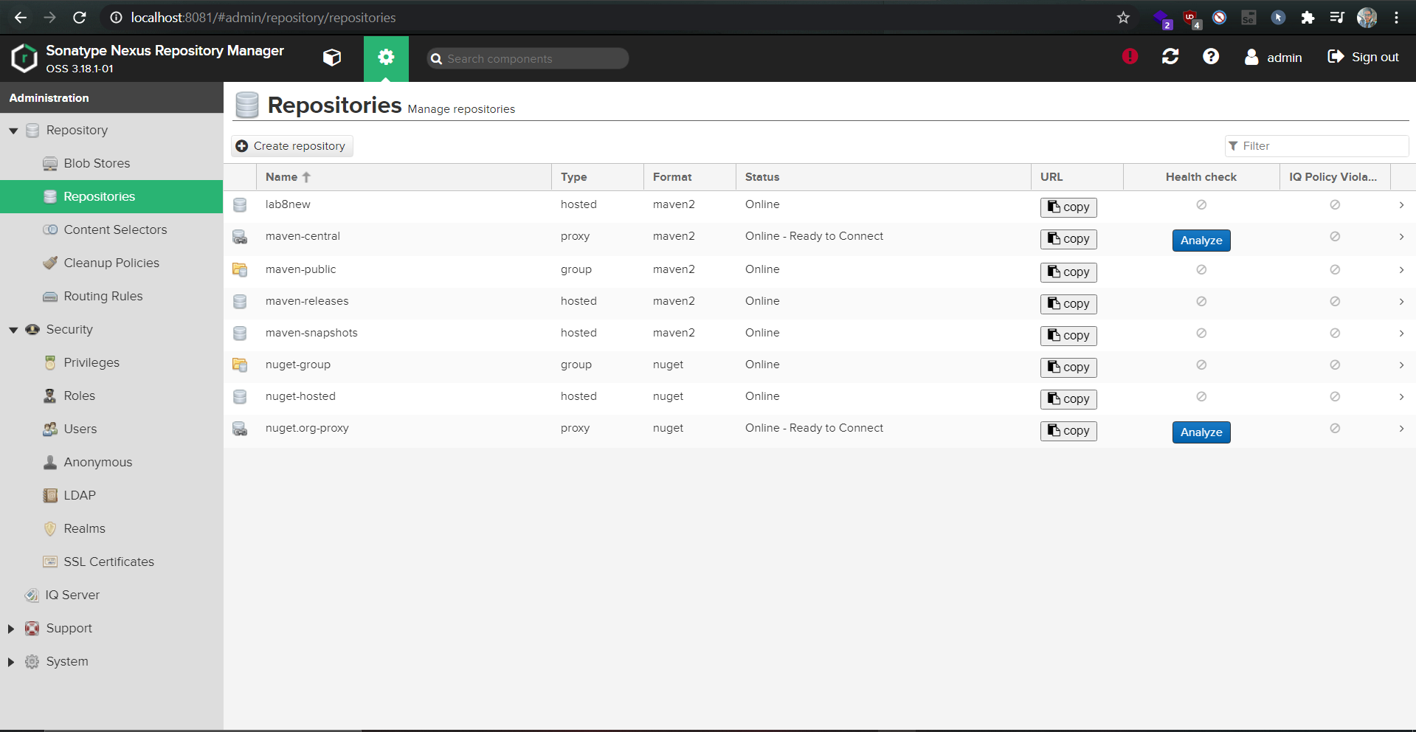

1. Creating Maven project

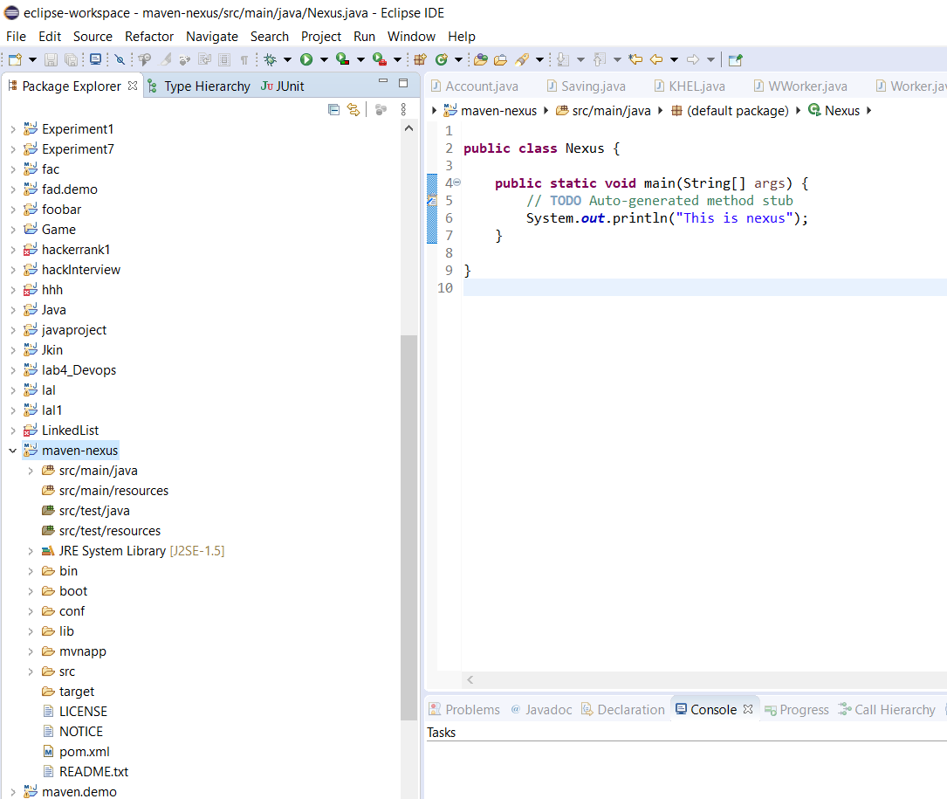

1. Adding server in confi of Apache Maven

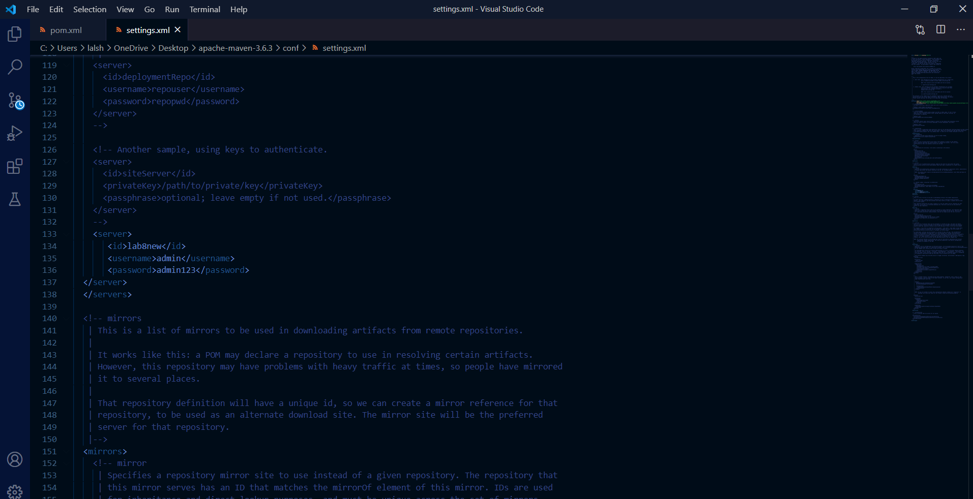

1. Adding distribution management in pom

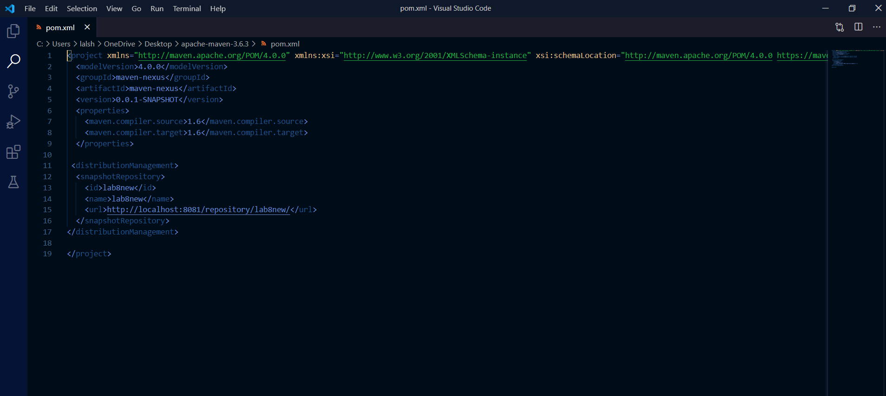

1. Running mvn deploy

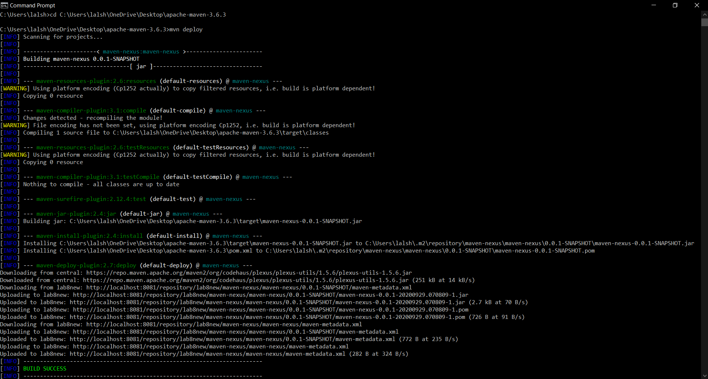

1. Maven project deployed in nexus server

