**LAB EXPERIMENT-6**

**BLUE OCEAN PLUGIN**

1. Starting Jenkins

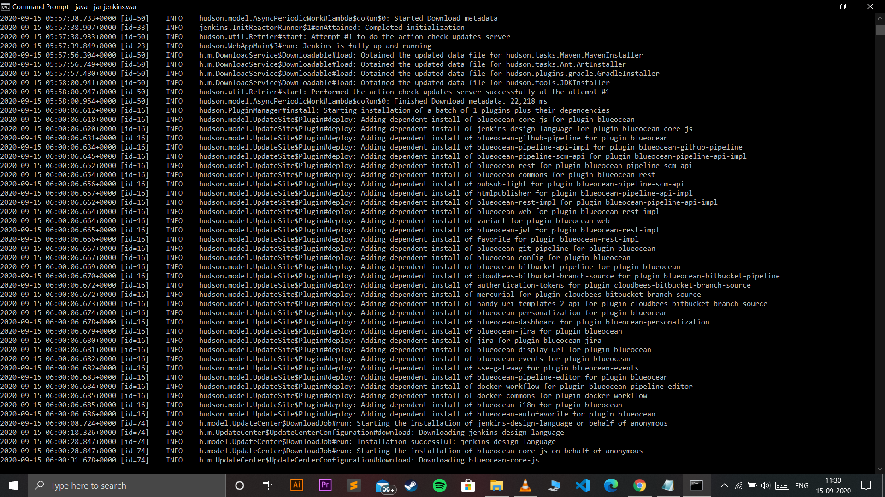

1. Installing Blue Ocean plugin

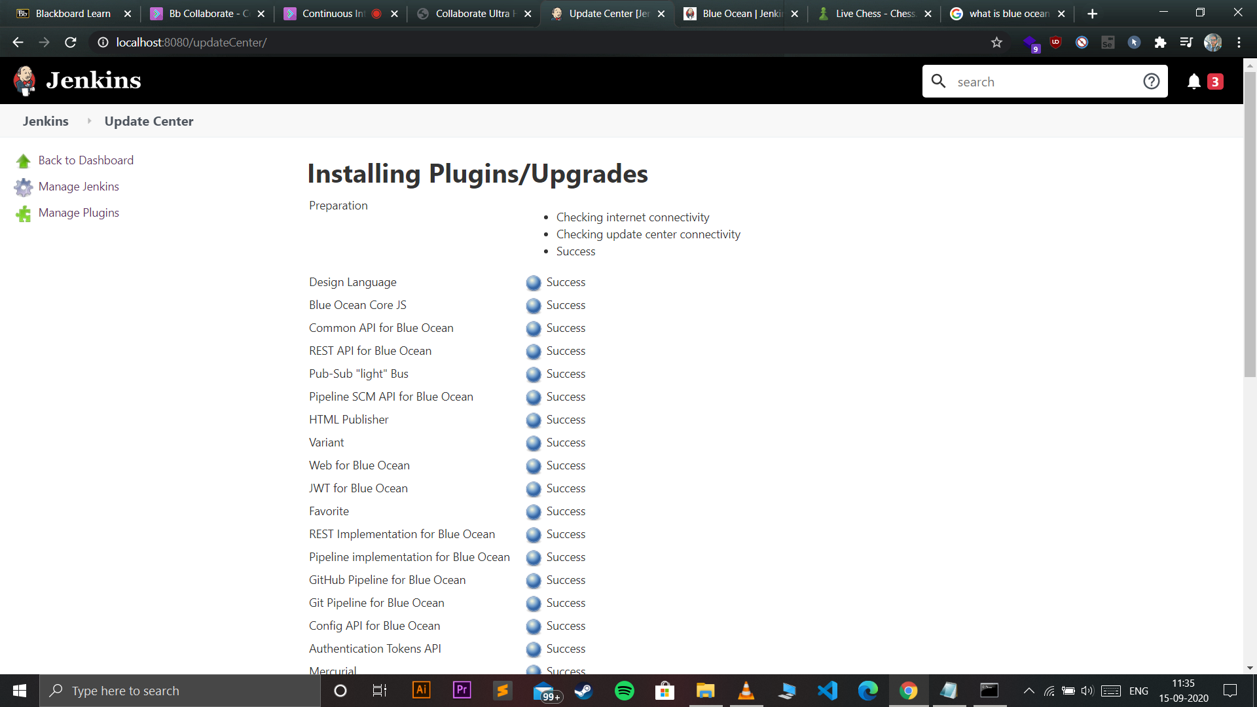

1. Blue Ocean dashboard

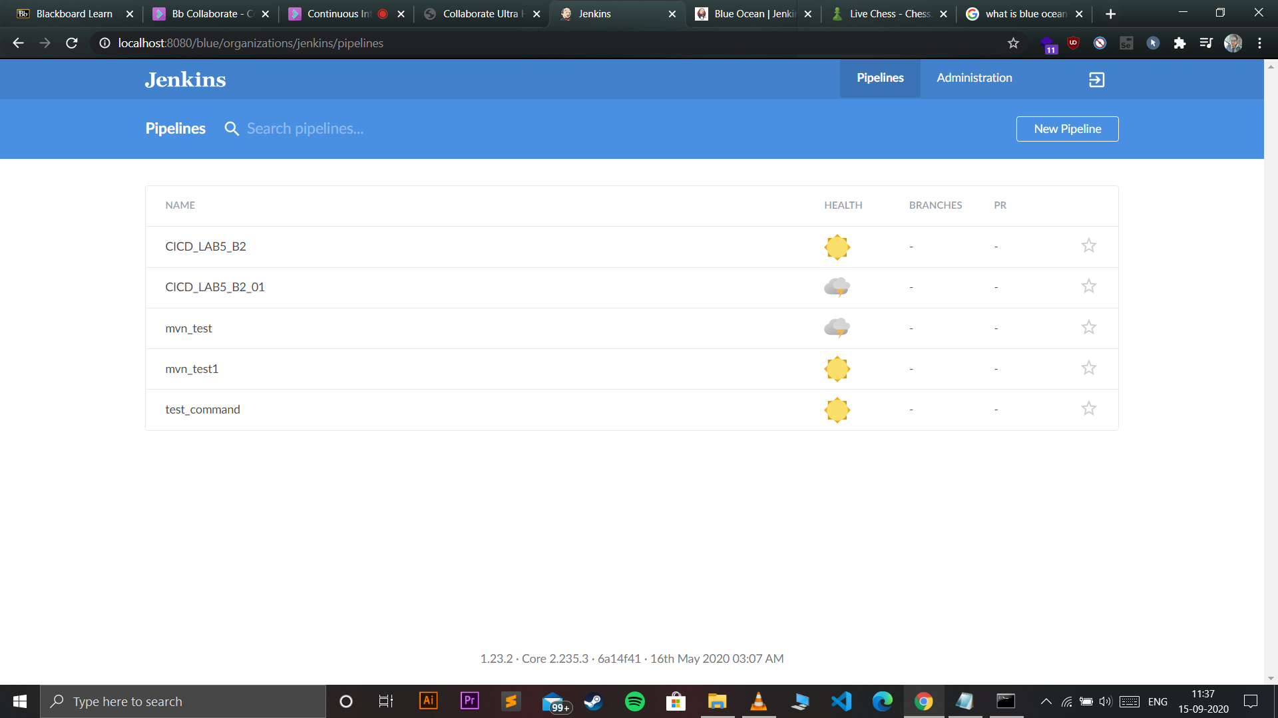

1. Pipeline being executed

