**SUBMITTED BY:**

Shrikant Lal

500069167

R171218099

**SUBMITTED TO:**

HITESH KUMAR SHARMA SIR

**Lab Experiment 1**

* Install Jenkins 2.259

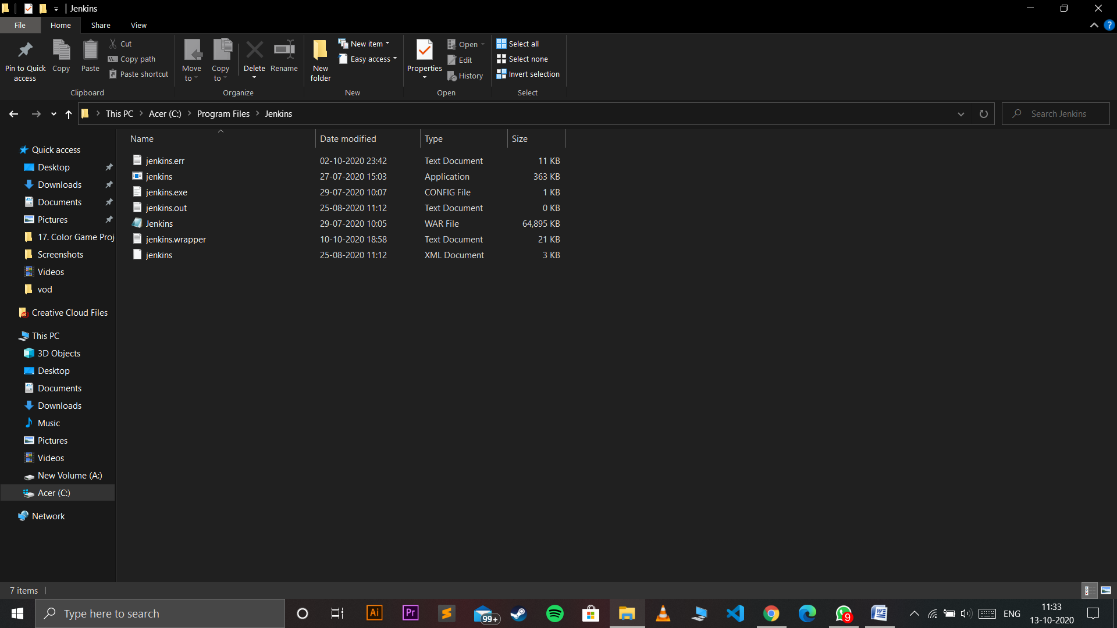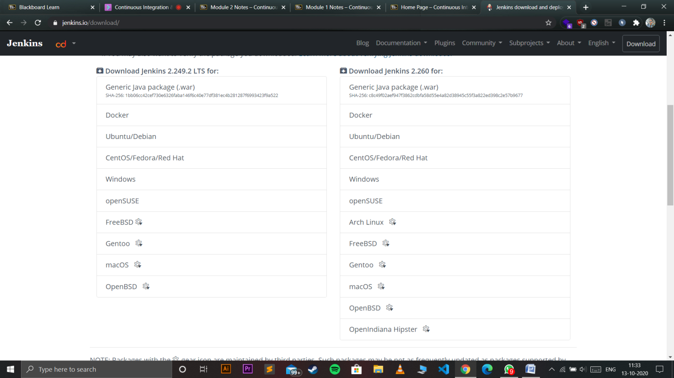

* Run Jenkins

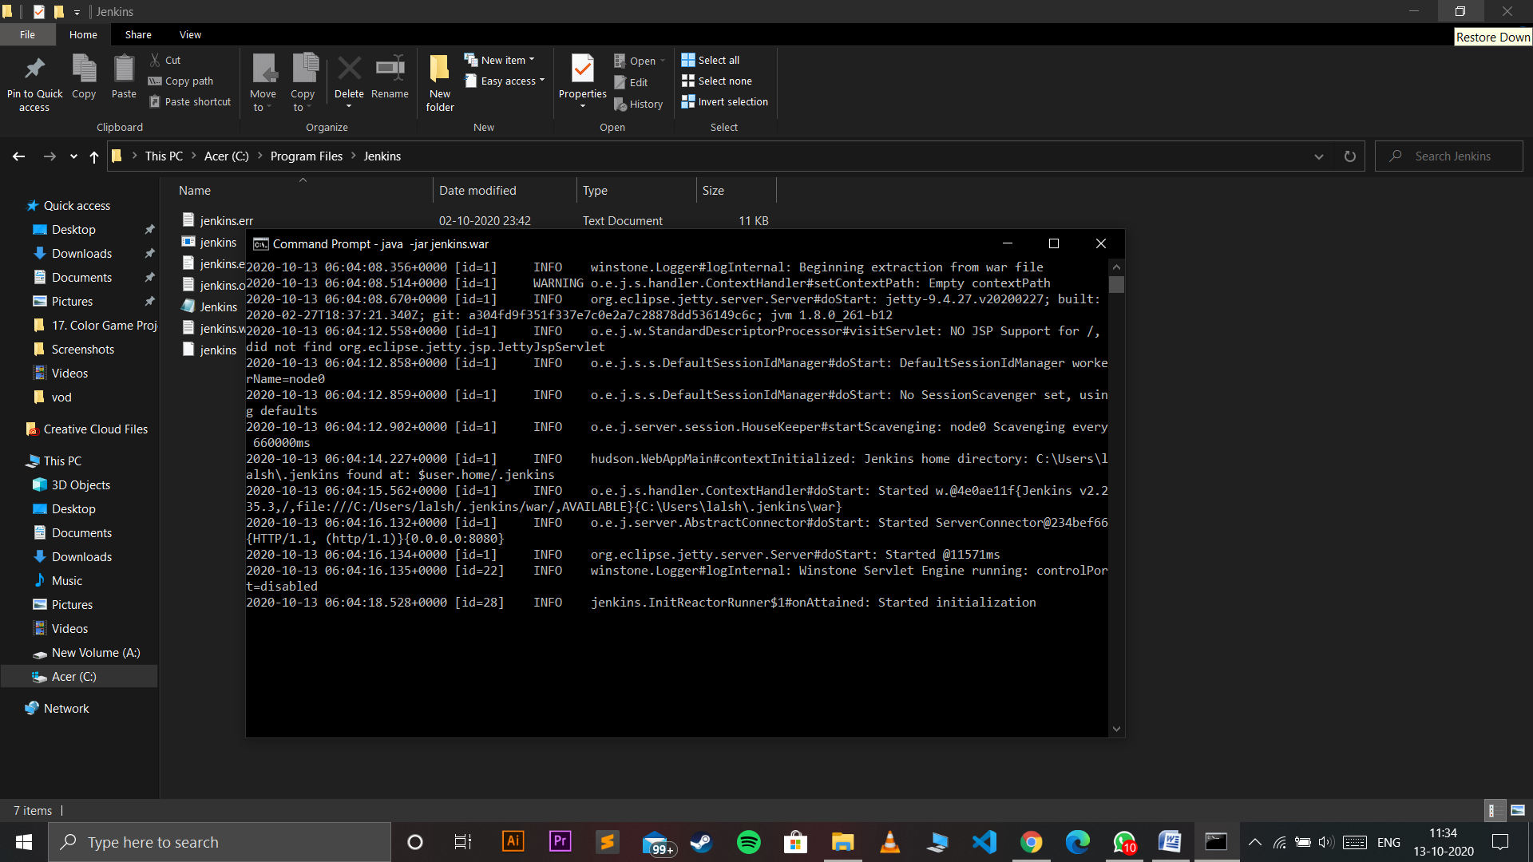

Go to new Item and create any project

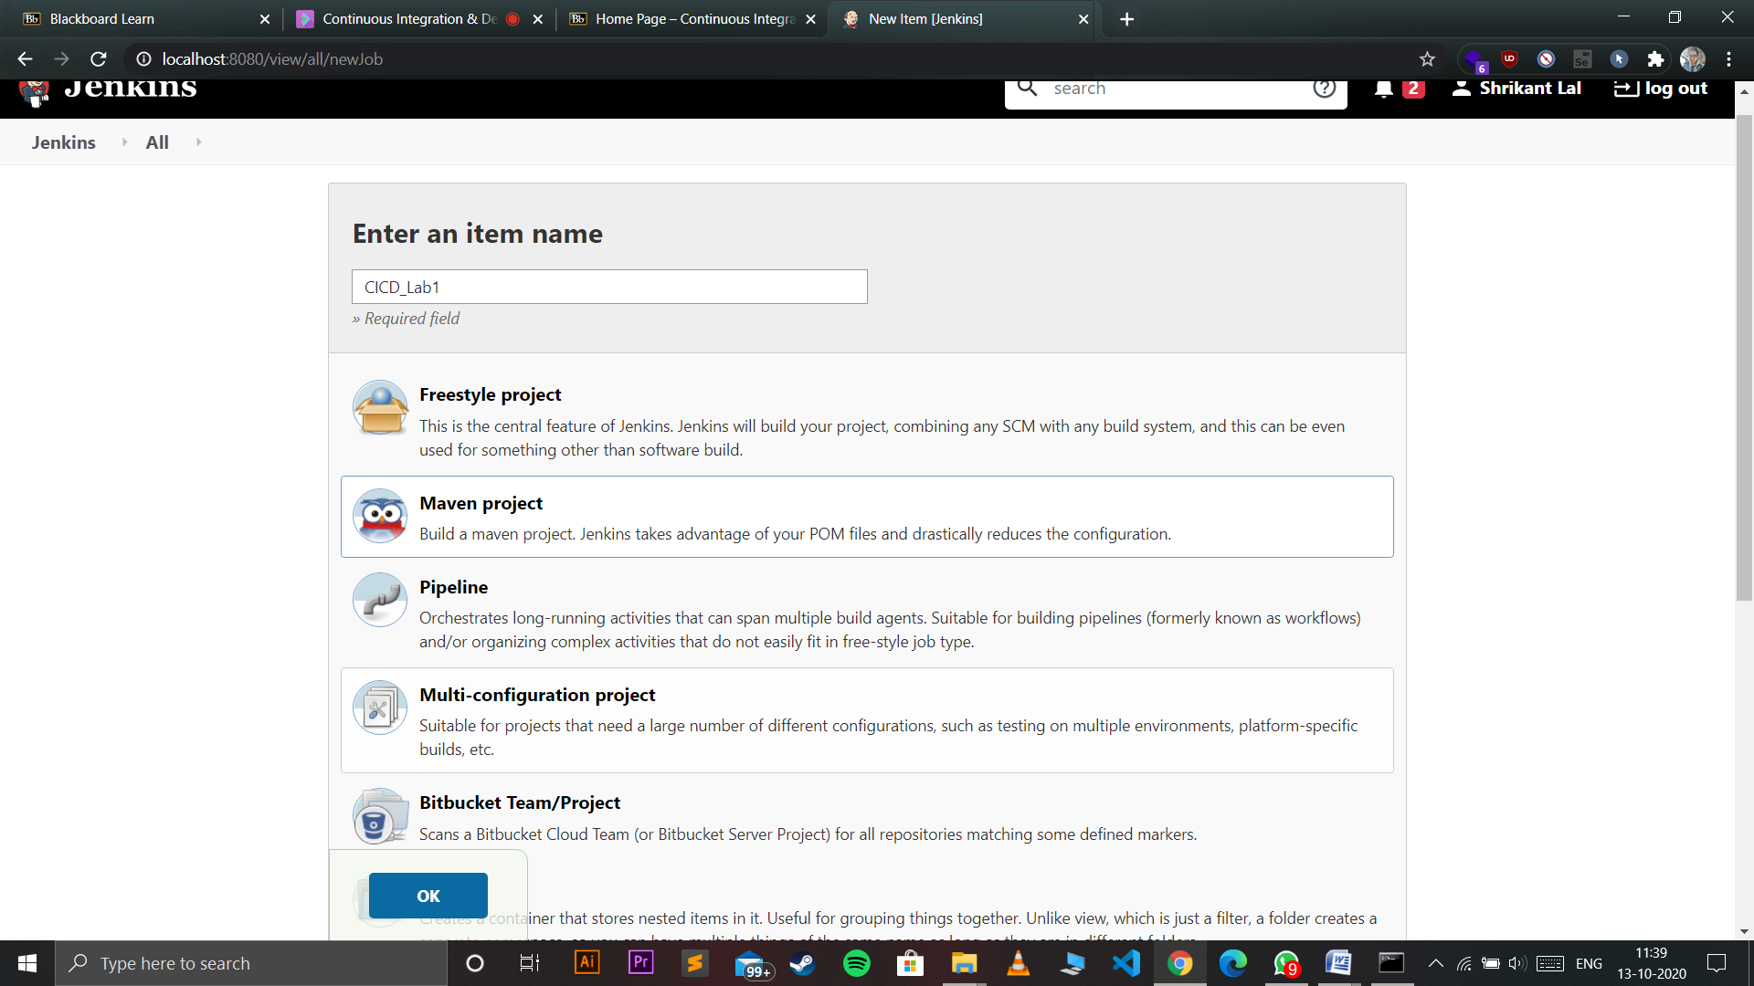

* Enter Git url

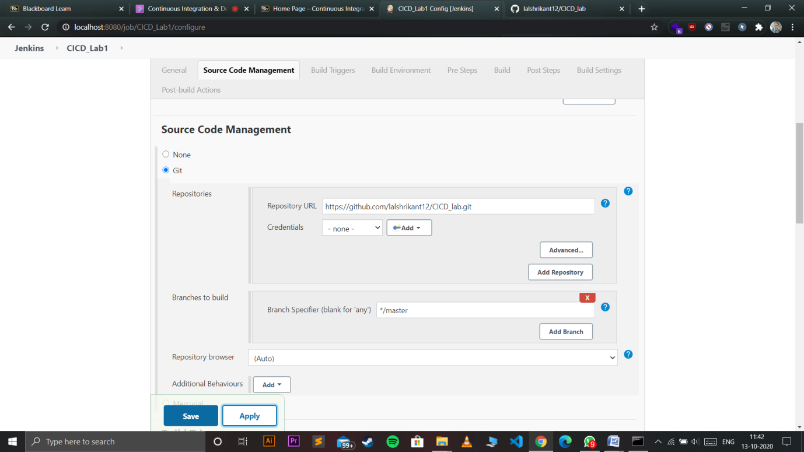

* Mention goal if you are building maven project

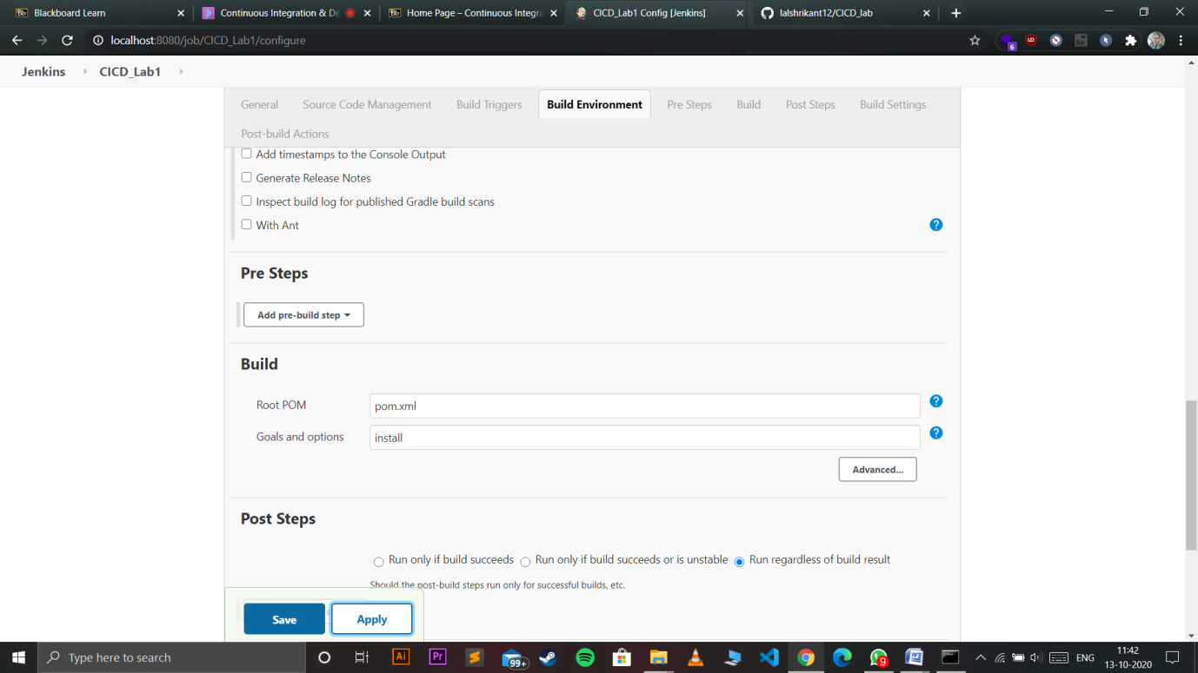



* Finally build your project

