**Lab Experiment-2**

Jenkins integration with Github

* Select plugings required for git

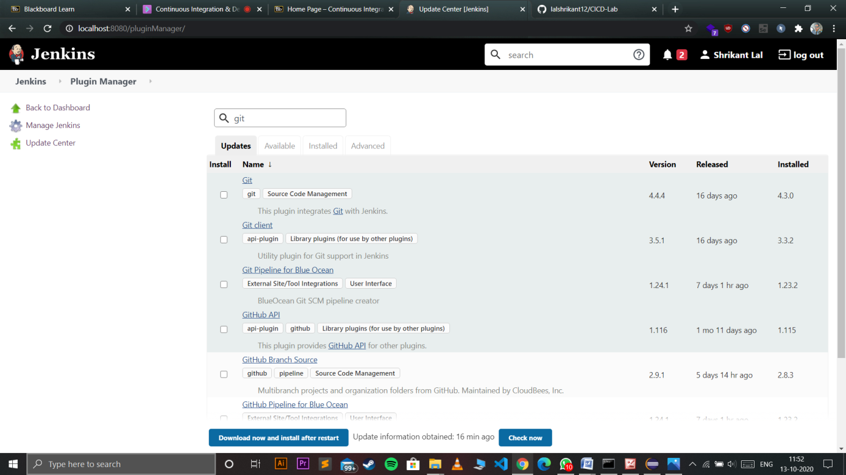

Lab Experiment-2

Jenkins integration with Github

* Select plugings required for git



* Go to new item and create a maven project enter the git url and maven goal you want to execute

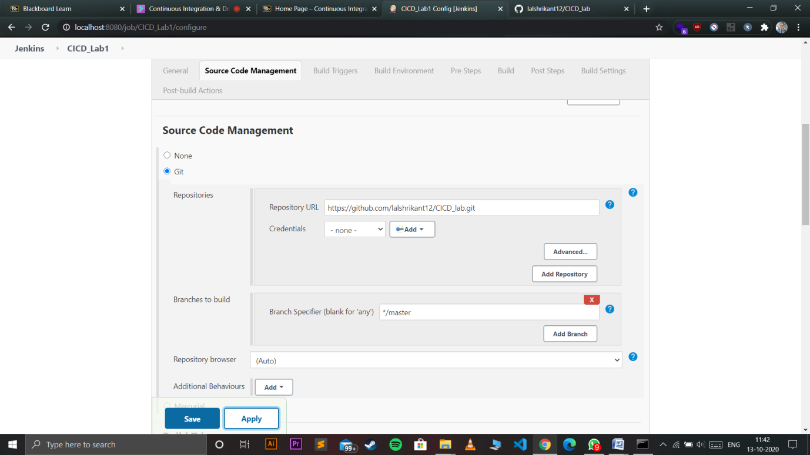

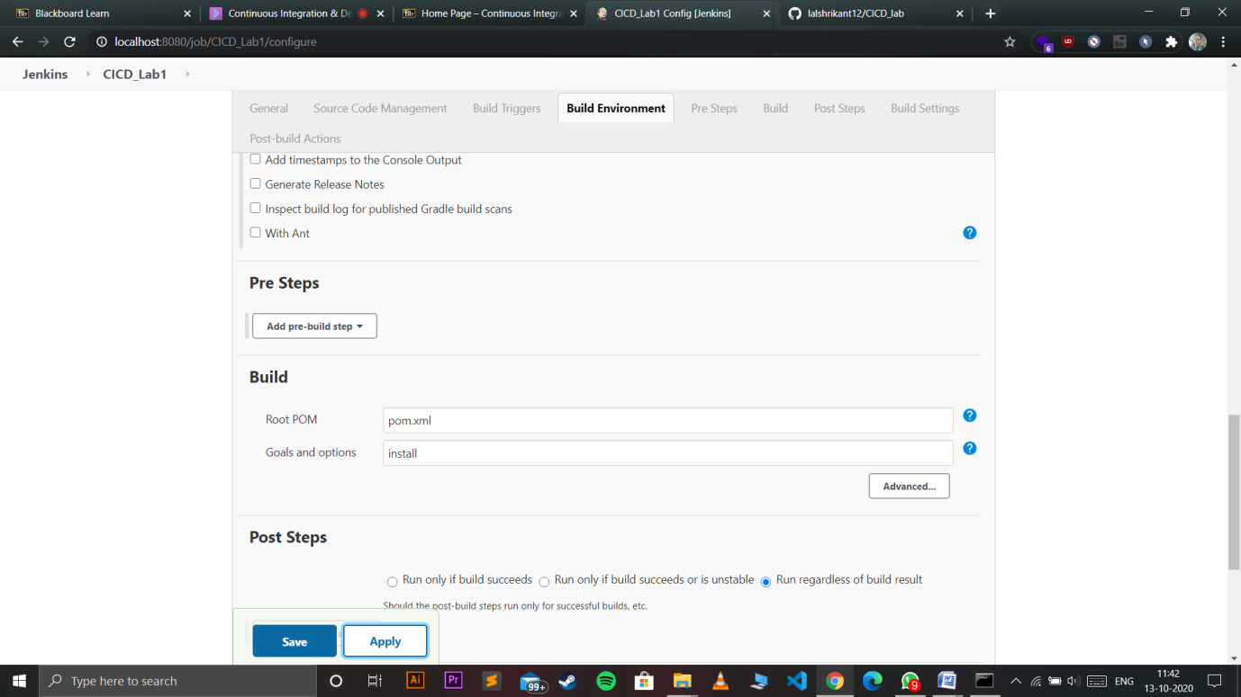

* Push your maven project to git by using gitbash or maven

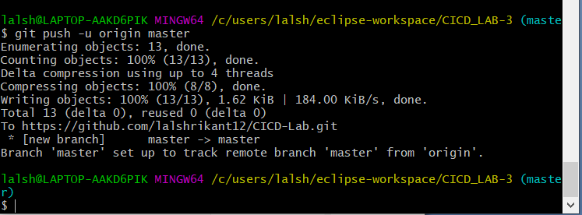

* Finally build the project

