

**UNIVERSITY OF PETROLEUM & ENERGY STUDIES**

**Dehradun**

**CONTINOUS INTEGRATION**

**AND**

**CONTINOUS DELIVERY**

**Experiment**

**Name: Siddhant Mishra**

**Course: B. TECH CSE DevOps (2018-22)**

**Roll no.: R171218101**

**Sapid: 500069136**

**Experiment-1**

**Installation of Jenkins**

**Step-1:** Go to the link for downloading the Jenkins .war file.

**<https://www.jenkins.io/download/>**

We require .war for this experiment.

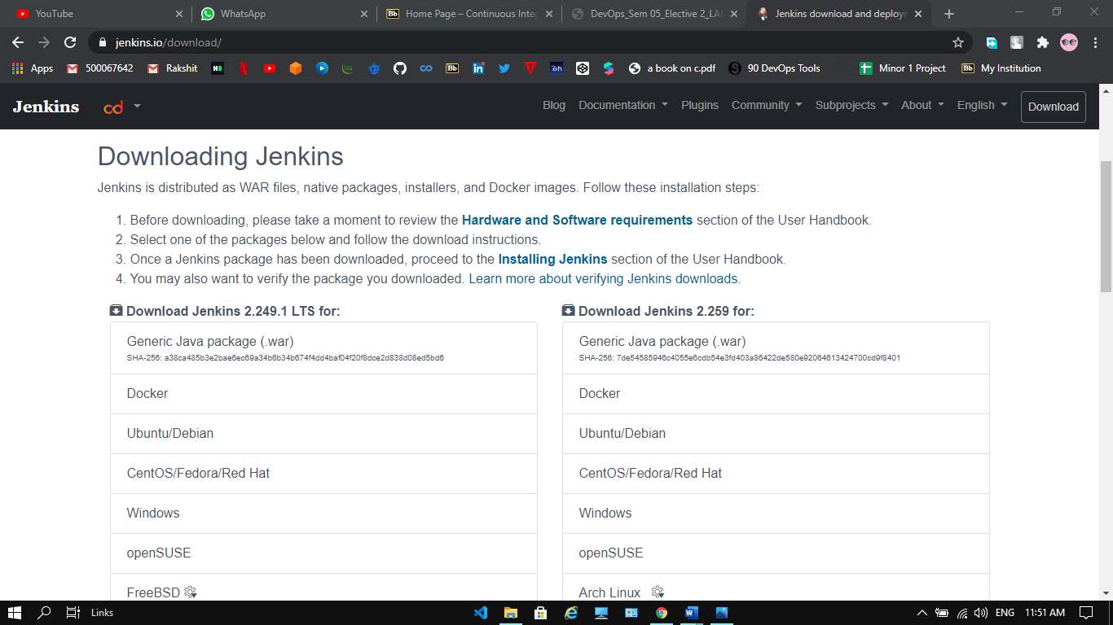

**Step-2:** After downloading the file transfer that file to a specify folder and name the folder Jenkins. After completing this process open command line for the specific folder.

To start run the Jenkins use “**java -jar Jenkins.war”**

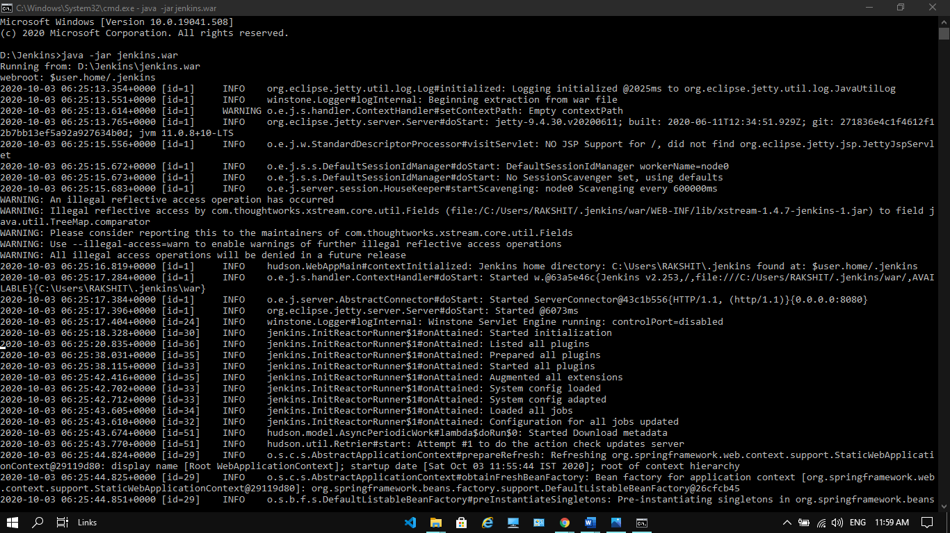



**Step-3:** Go to Browser. Type “**localhost:8080”** and press enter.

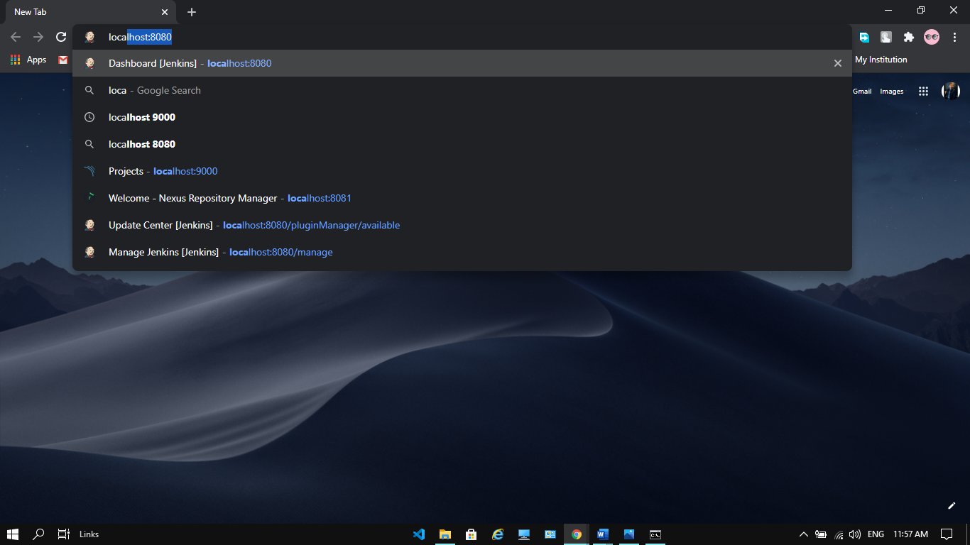

**Step-4:** This Window will appear.

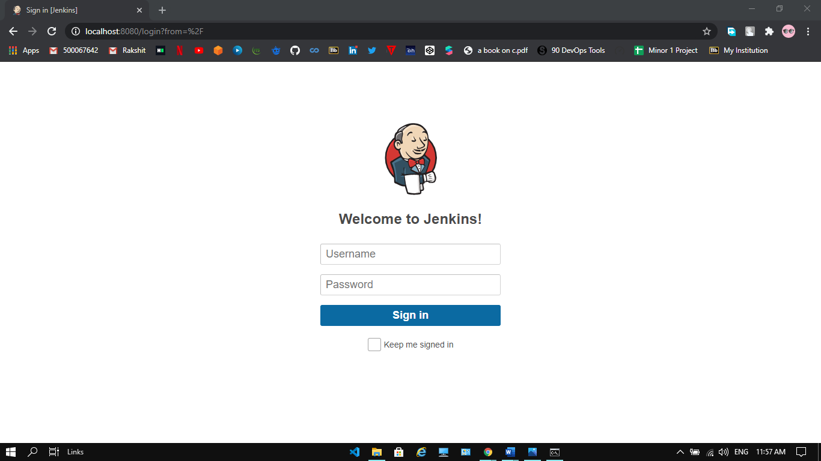

**Step-5:** Enter the username and password, at the time of first login the username and password would be **admin.** After signup enter all the details as required and you can further change username and password.

**Step-6:** Your welcome window will appear with your username.

