**Installation of Jenkins and Execution of a simple job in Jenkins**

Go to the download website for Jenkins: <https://www.jenkins.io/download/>

Open the command prompt.

Traverse to the directory containing the jenkins.war file

Type the command : java -jar jenkins.war

Open the web browser.

Go to localhost:8080

(Jenkins runs on port 8080 by default) 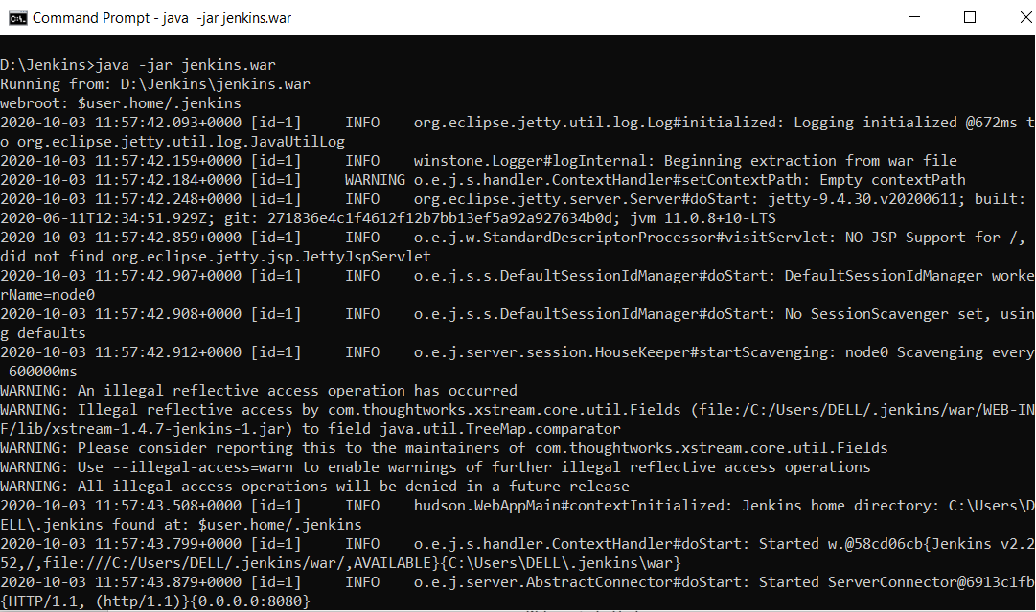

Jenkins run on JAVA therefore we need to configure our host java with Jenkins to use it.

Additionally, we can also configure Maven to use it for our future JOBS.

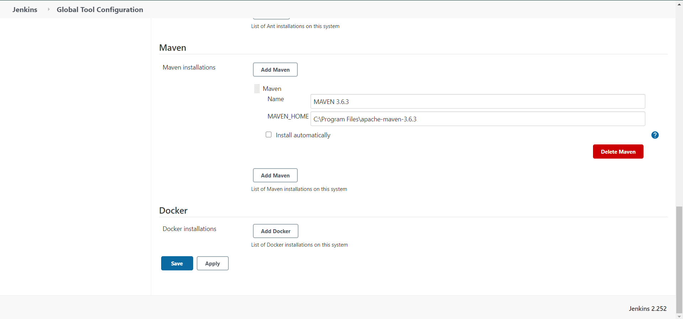

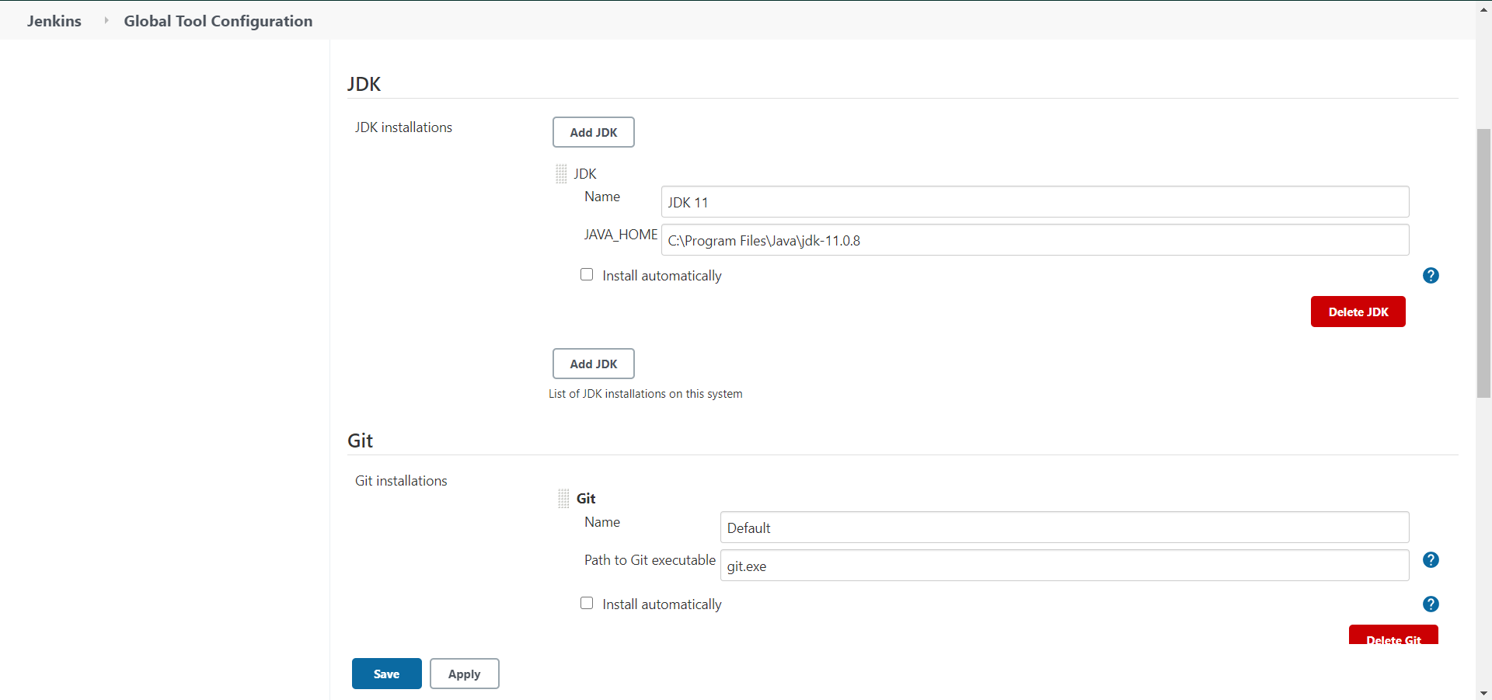

Now, we can make a new Maven project and execute Jobs.

