**Jenkins integration with Github**

* Go to the Jenkins dashboard at localhost:8080
* Click on the new item option
* Select the freestyle project option
* Give a name to the project
* Click on the source code management to add github repo.
* Give path of the repo in the blank and apply.
* 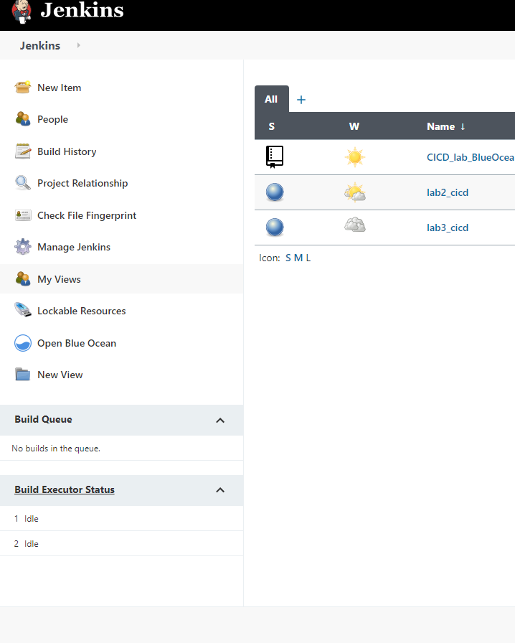 save and apply.

