Download Community edition of SonarQube.

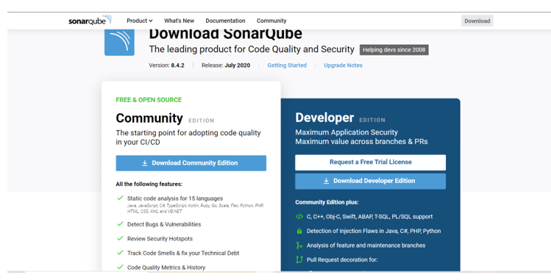

Go to downloaded folder

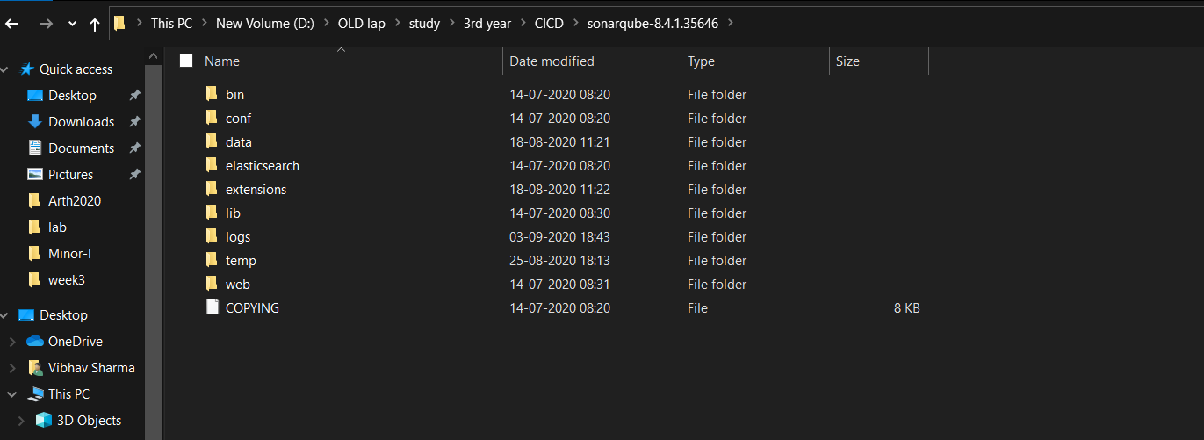

Run file ‘StartSoanr.bat’

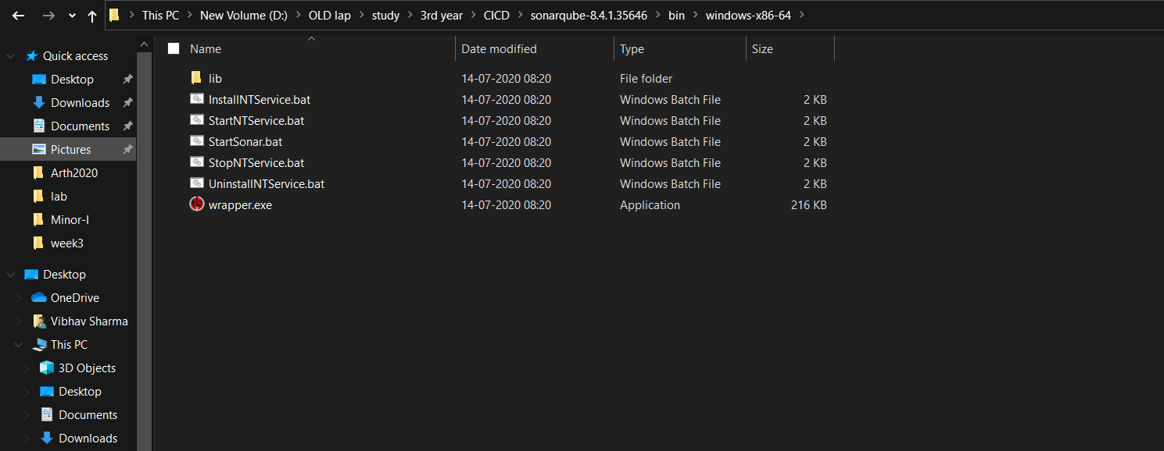

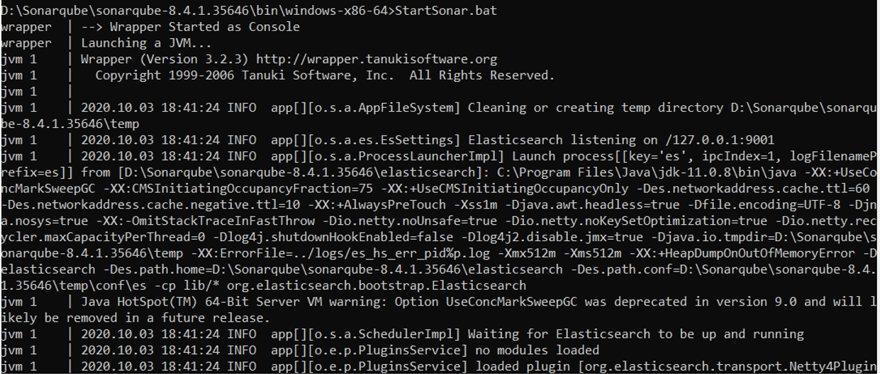

GO to localhost:9000 to access portal

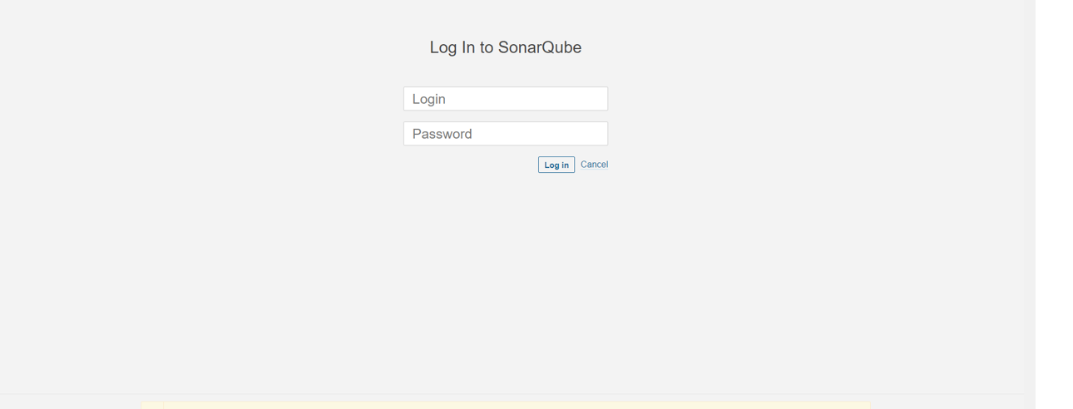

Run this command in maven project folder

‘mvn clean install sonar:sonar -Dsonar.host.url=http://localhost:9000 -Dsonar.analysis.mode=publish’

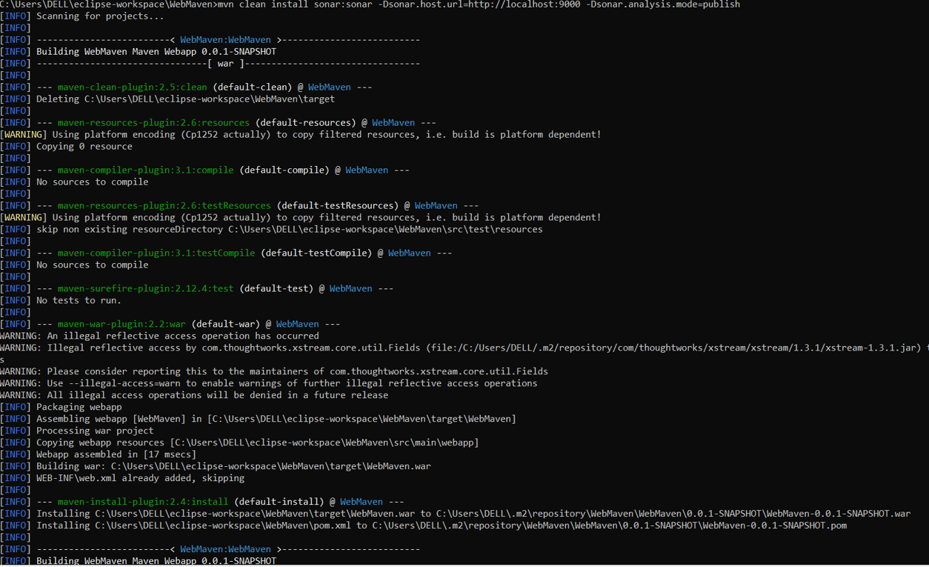

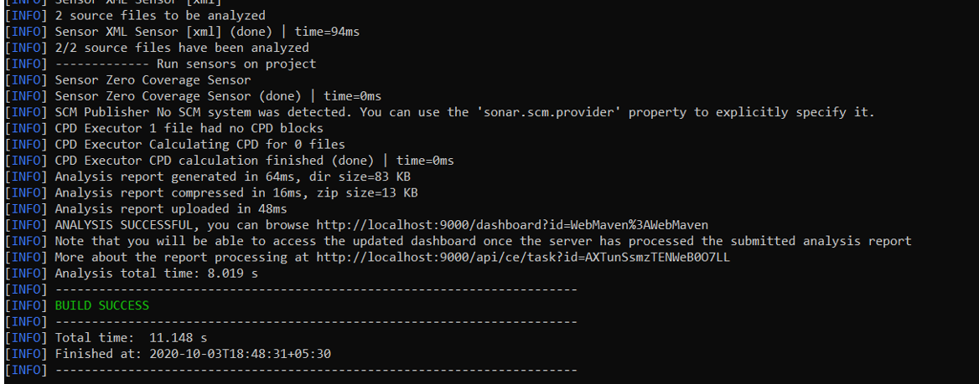

Check web portal for more info

