**Experiment-2**

**Jenkins Integration with GitHub**

**Step-1:** Open Command line and type the command to run the Jenkins.

**“java -jar Jenkins.war”**

Type localhost:8080 in the browser to run the Jenkins and login.

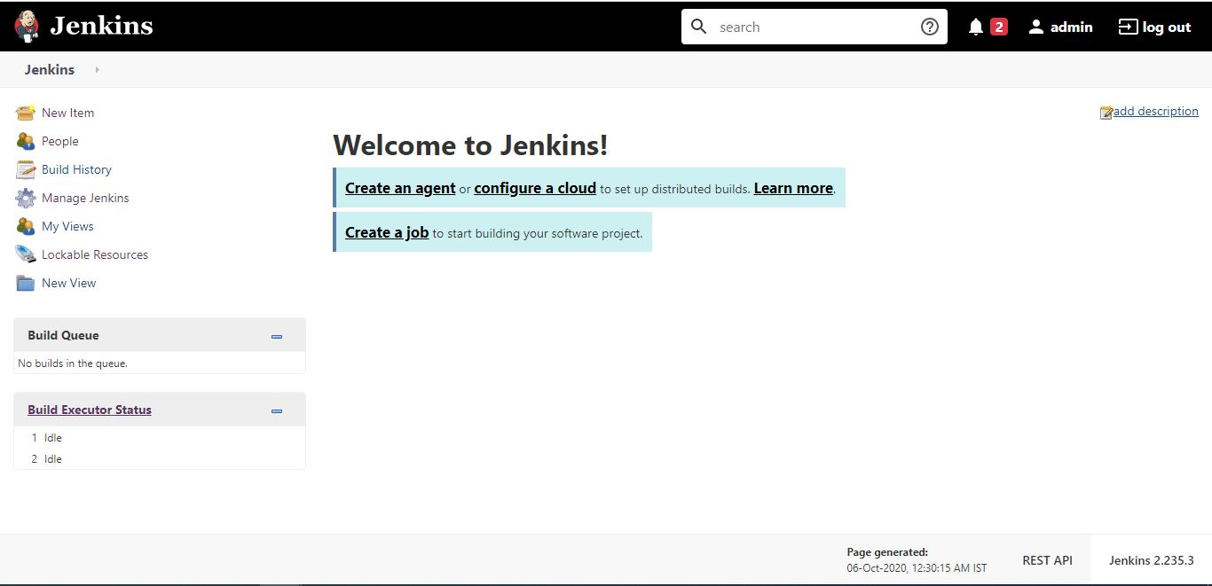

**Step-2:** Click on the new item to create a new freestyle project and specify the name and click ok.

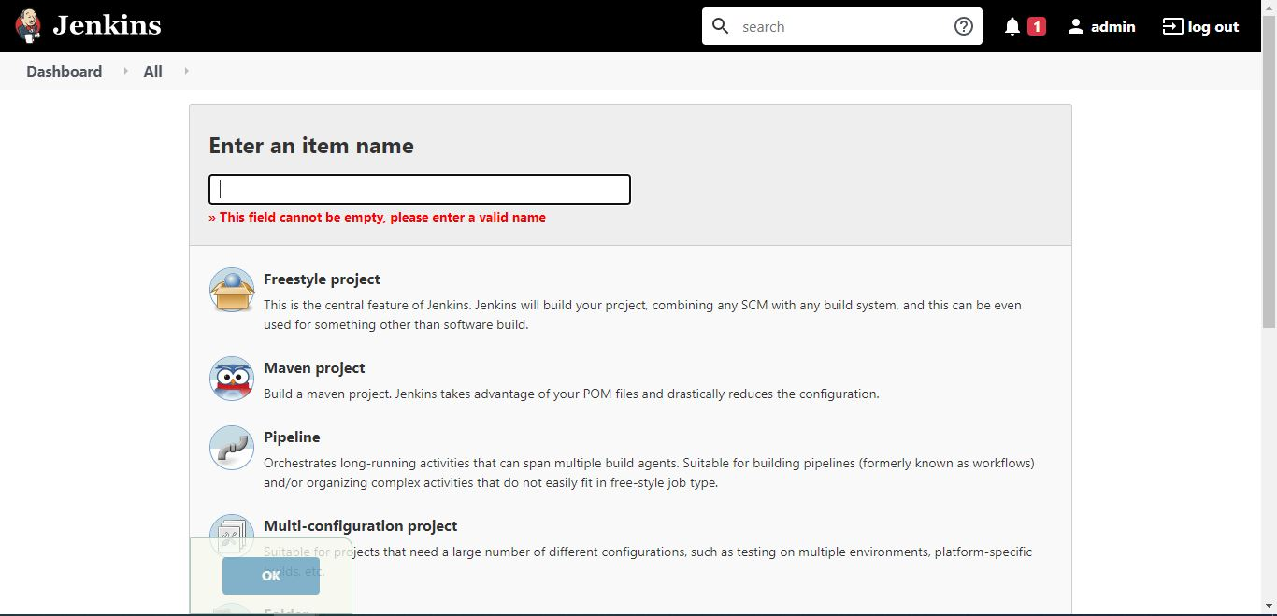

**Step-3:** Now make further settings. Go to source code management, Click on git and provide the URL of the GitHub repository.

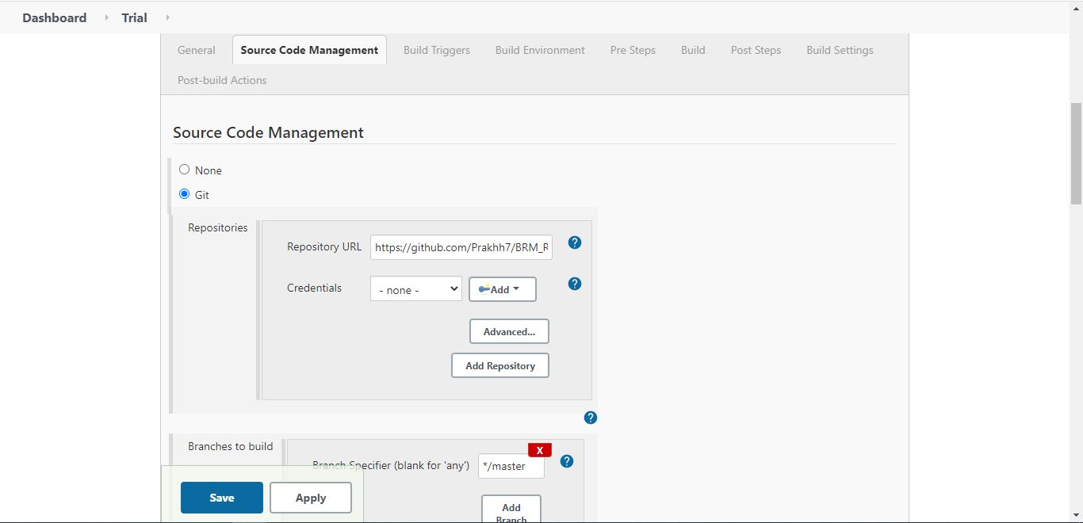

**Step-4:** Click on save button and your Jenkins is integrated with GitHub for that repository.