LAB-2

**AIM: JENKINS Integration using MAVEN AND GITHUB…**

Step: 1

Creating Github Repo.

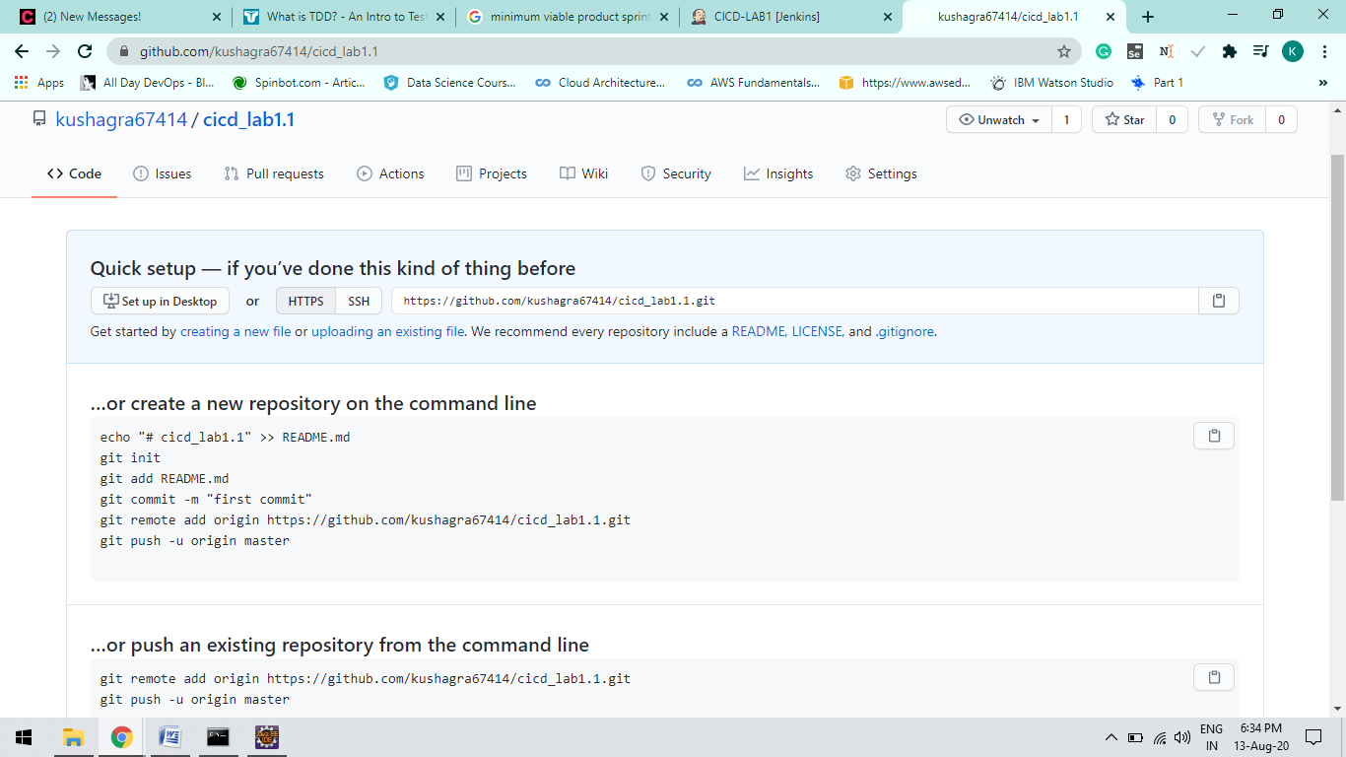

Step: 2

**Using Eclipse IDE Add Maven project to Github Repo you first created**

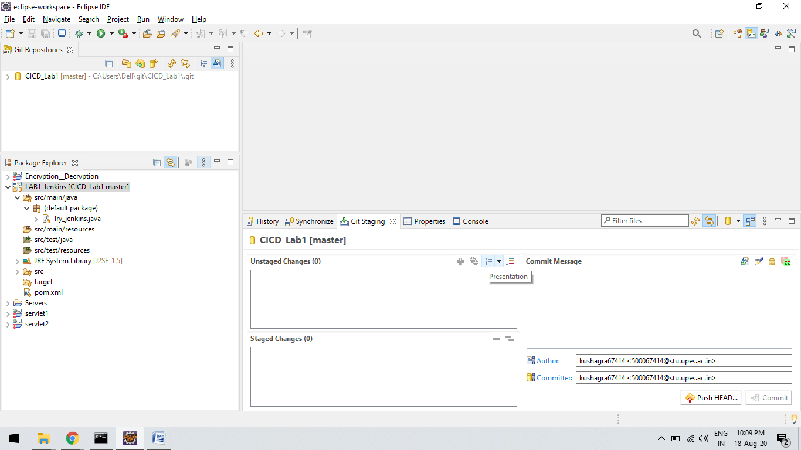

Step 3 :

Create a JOB on JENKINS AS “cicd_lab1” and Configure it..

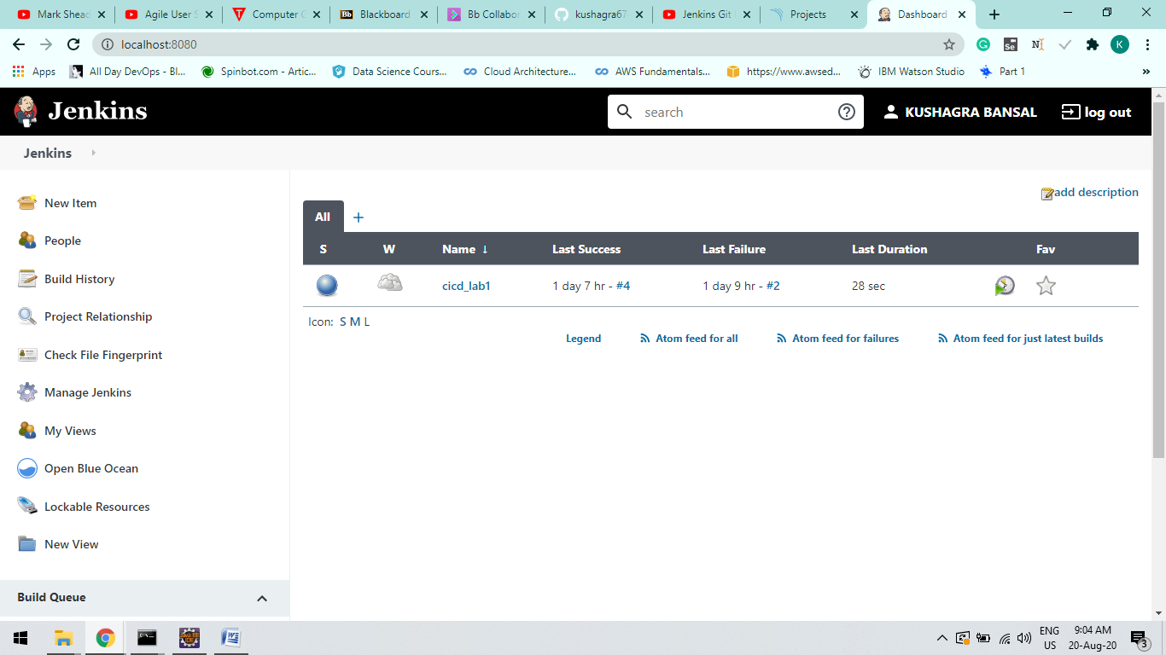

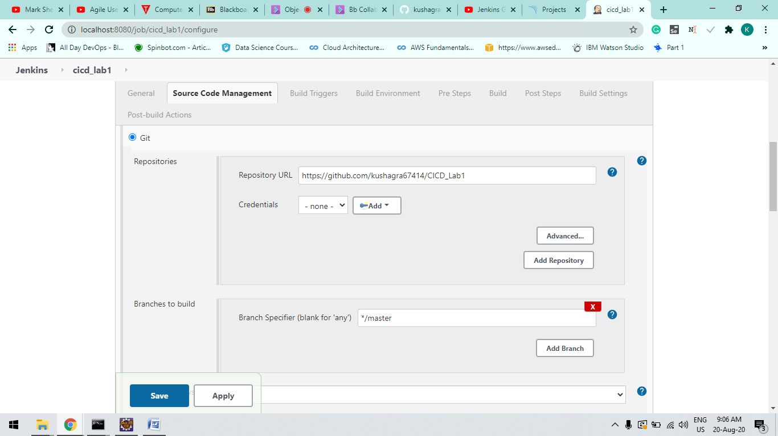

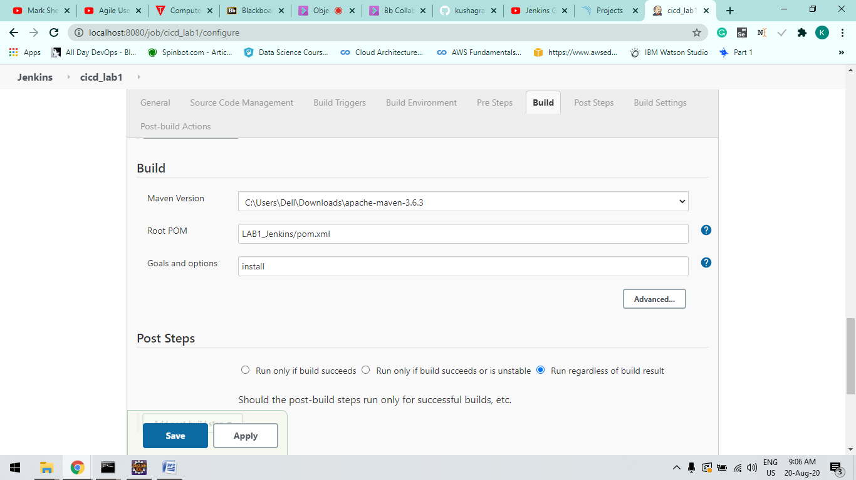

*Step-4 :*

**Now Click on Build now Option at Left Side of you window and verify the Build Success**

