***LAB -3***

AIM : Using Static Code analysis Tool “SONARQUBE”

Step-1: Setup Maven Project using Eclipse IDE and open Sonarqube at localhost.

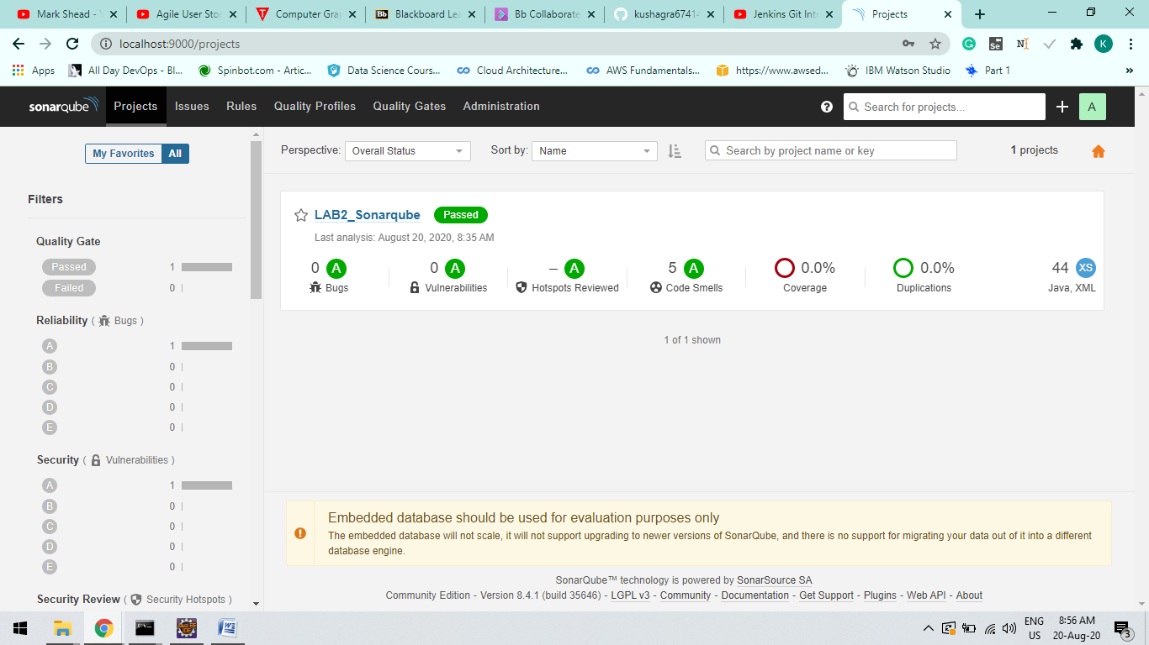

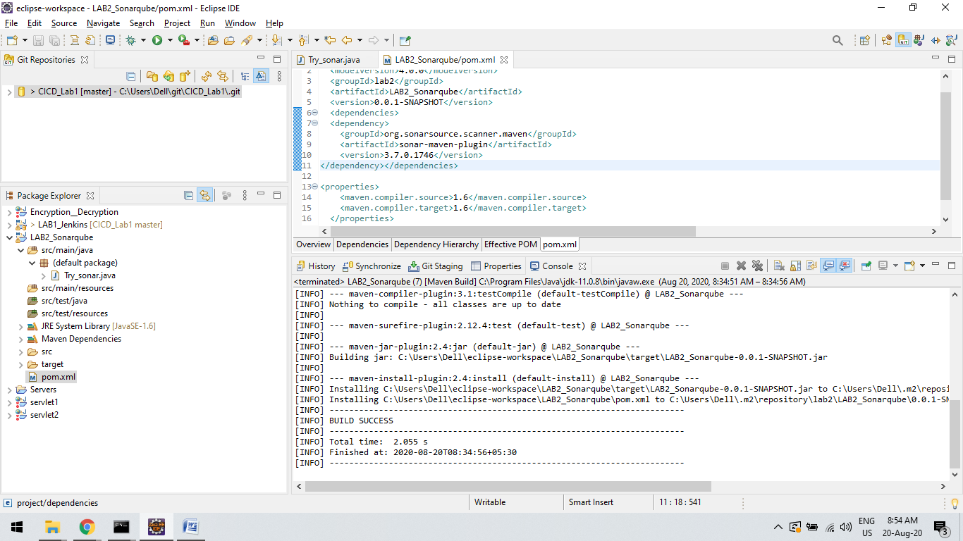

Step-2:

Open Project Path and use Command : “mvn clean install sonar:sonar

-Dsonar.host.url=http://localhost:9000 -Dsonar.analysis.mode=publish”

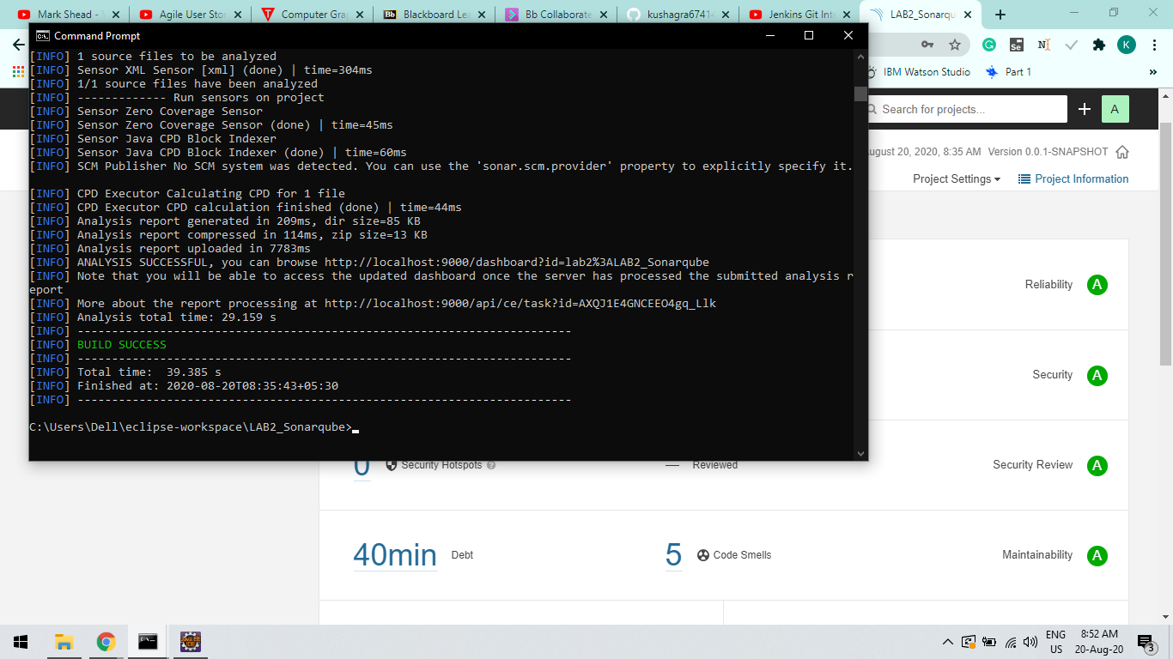

Step-3:

Now you can check Bugs , Vulnerabilities, Code Coverage, Code Smells, Duplications etc….

