***LAB – 4***

AIM : Intregrating Jenkins , Maven, Sonarqube, Github and Eclipse IDE..

OR Jenkins integration with Sonarqube

Step-1

Intregate Github and Eclipse As Previously done in above Experiment.

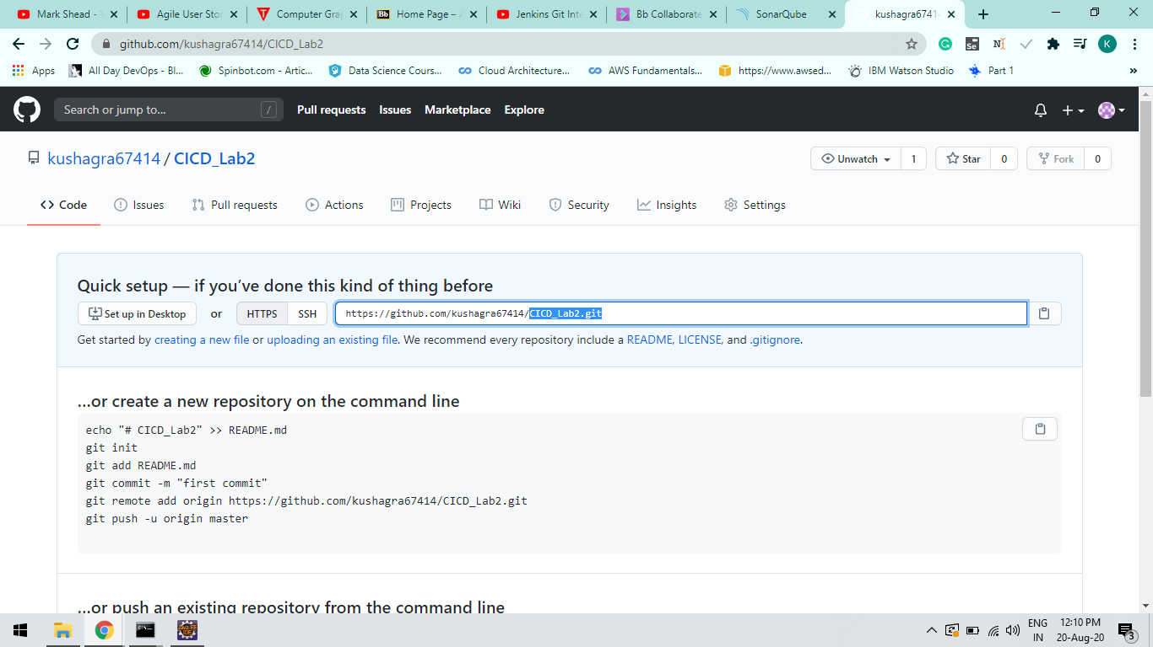

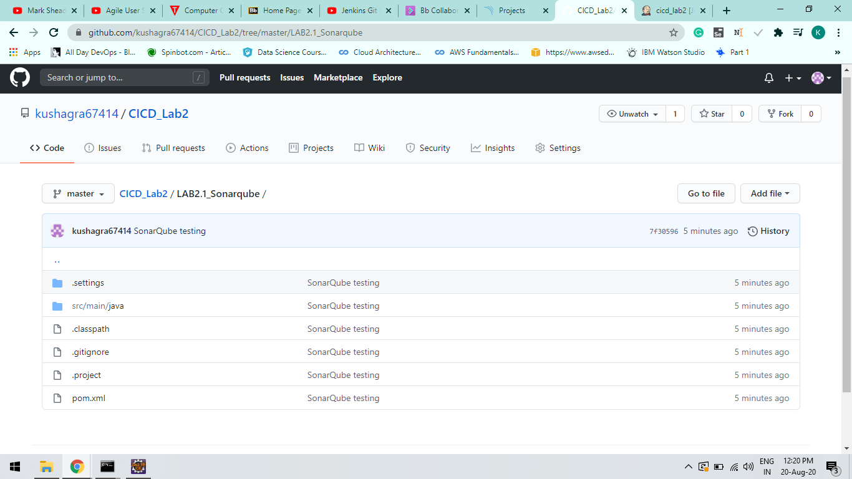

Step-2

Instead of using Maven Cli configure Jenkins and give the path of the Maven Goal and Plugin.

Command : “mvn clean install sonar:sonar

-Dsonar.host.url=http://localhost:9000 -Dsonar.analysis.mode=publish”

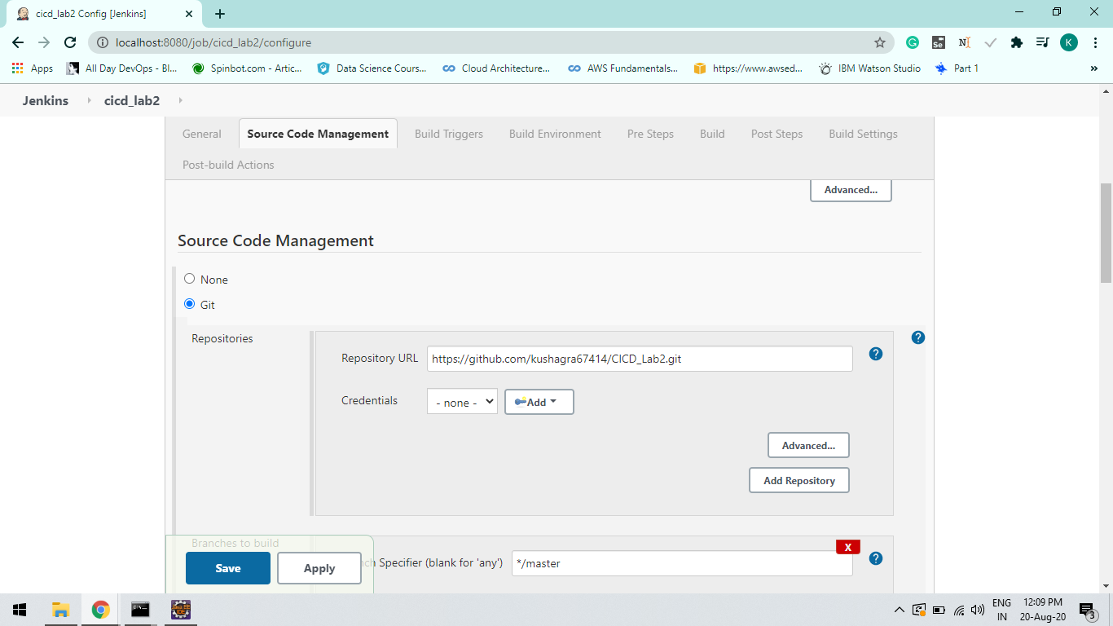

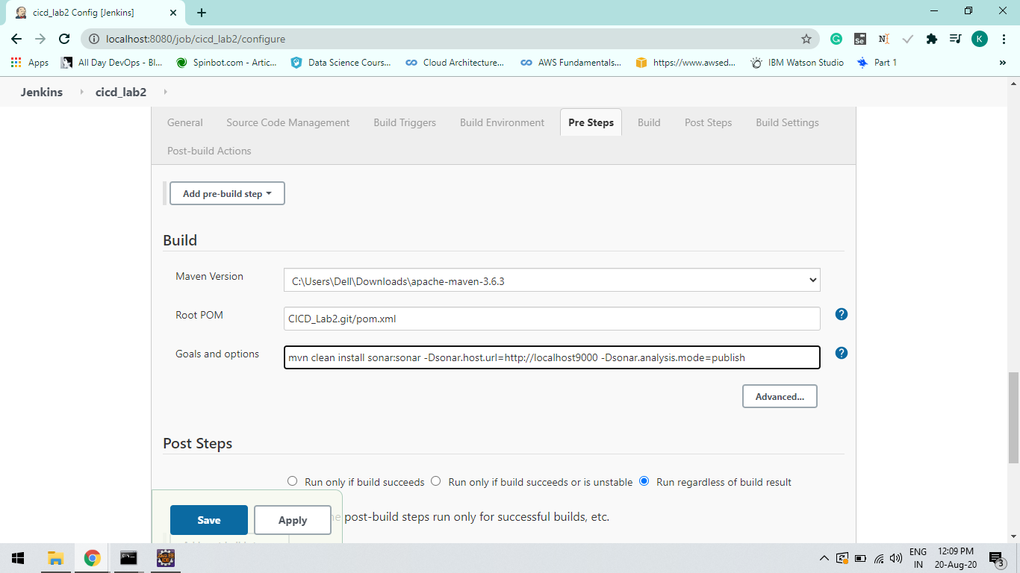

Step-3:

Build the Project and IT will automate the project at Sonarqube.

Check your Build on Console Output.

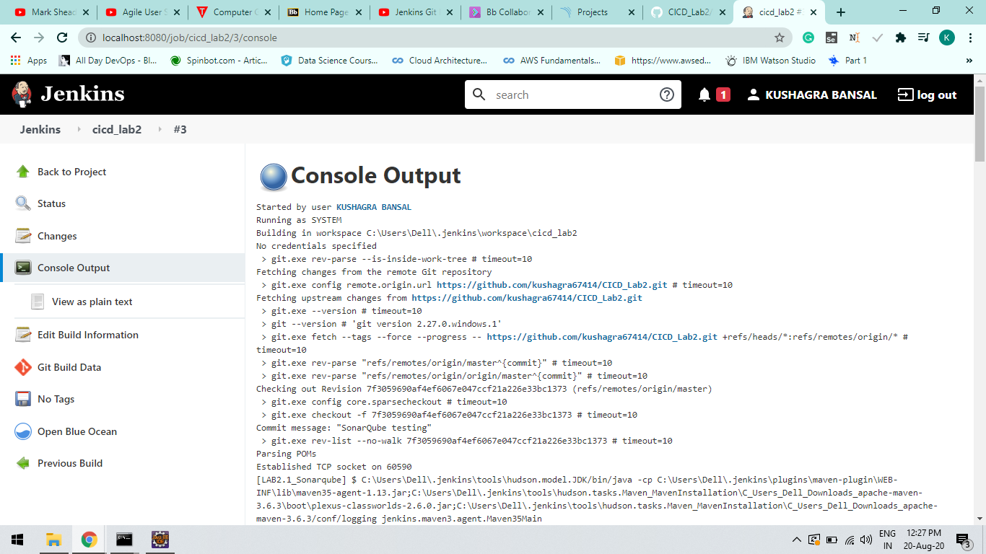

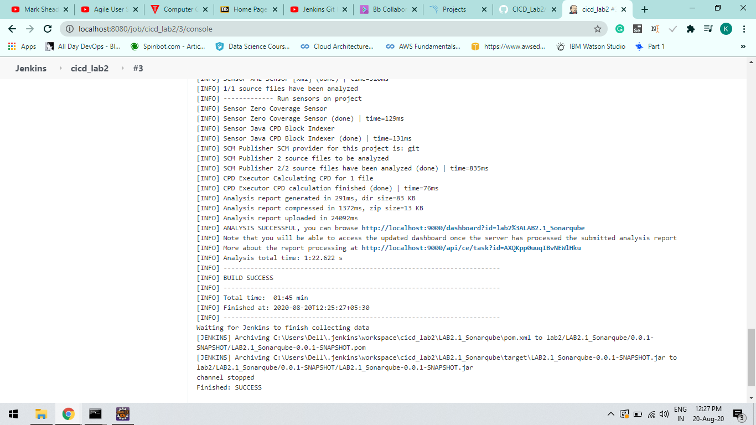

Step-4

Refresh and Check Sonarqube.

