# Exp-9

AIM : Hosting the jar file to nexus so that become available to other developers

Deploying maven created jar file at nexus repository manager platform.

Step-1:

Download nexus 3.18.1-01. Extract it you will find two file :

1. nexus-3.18.1-01 b. sonatype-work (here Configurations are stored)

run command : nexus.exe /run

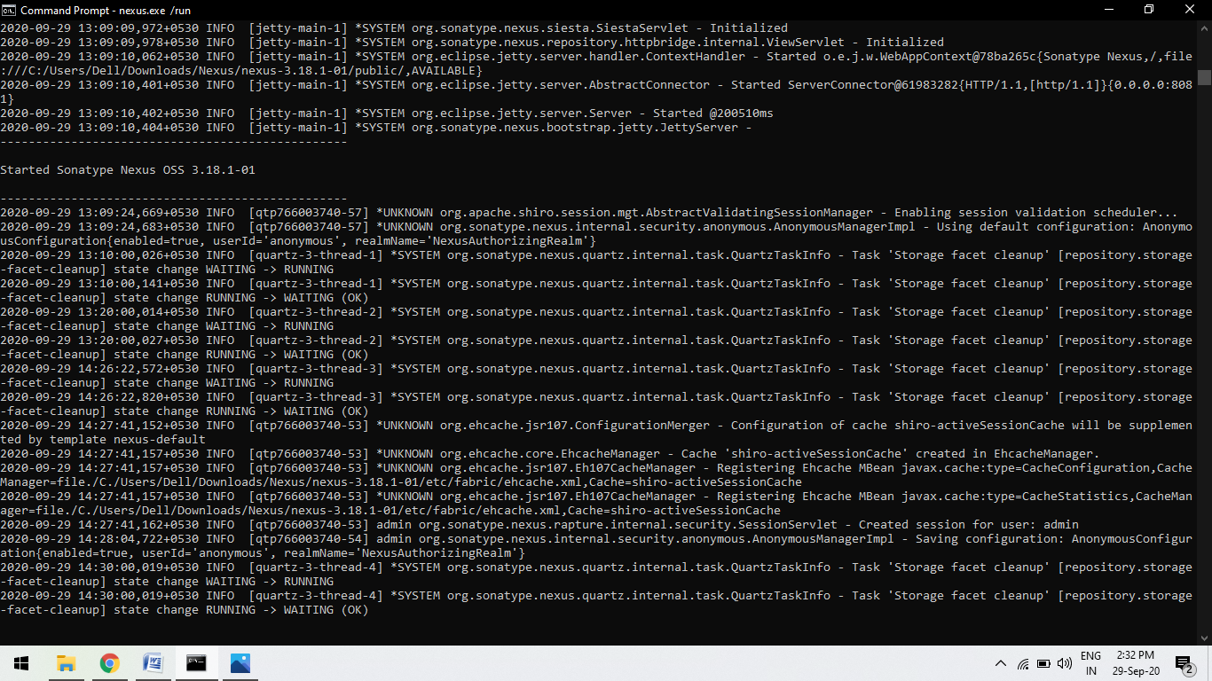

You will see such screen in your command line.

Step-2

Open browser and type localhost:8081

Nexus Repository Dashboard will be open.

Sign-in in you dashboard, It will ask for the password first

Configure Your password:

Goto “sonatype-work > nexus3>admin.password”

Open the file admin.password, Copy the unique/one time key and paste at the password option

After this it will ask for the new password and submit and you will enter in your nexus Homepage.

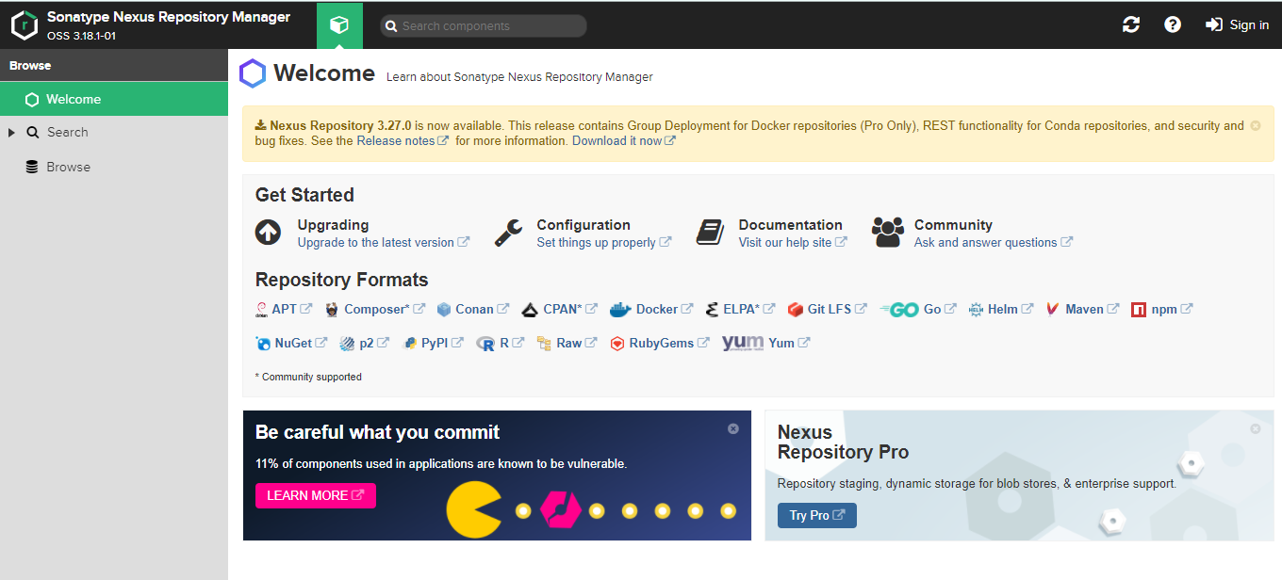

Step-3:

To Create Repository

Go to “Setting> Repository> Create Repository” and click

Now select “maven (hosted)” type repository because we are working on a maven project.

Configurations required :

1. Give name for the project
2. In Version policy: Select “Snapshot” as our maven project version in snapshot.
3. In Hosted : Select Allow redeploy so we can re-deploy it at anytime.

Now Create the repo.

Step-4:

Goto maven folder location , open Conf folder and then open settings xml document.

Write the below command too.

1. Id can be anything according to you.
2. Username and password same as nexus repo manager web application

<server><id>cicd_lab8</id><username>admin</username> <password>Kushagra@121</password> </server>

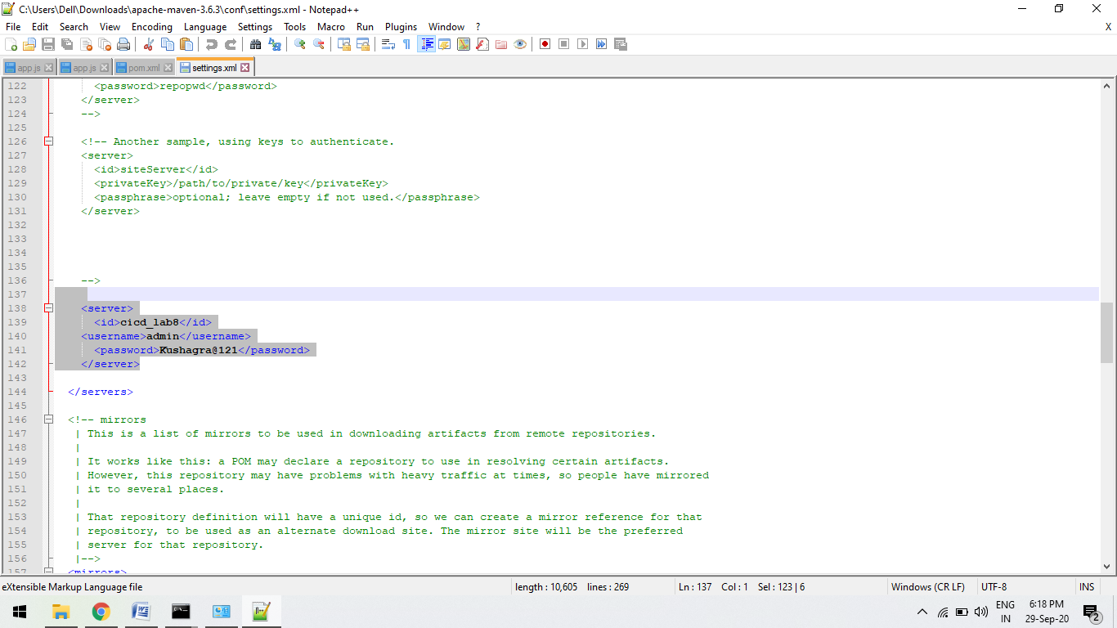

Step-5:

Since we have to deploy so we will run mvn deploy command.

For this we have to some changes in our maven project pom file to connect to the nexus repo manager.

Configurations:

<maven.compiler.source>1.6</maven.compiler.source>

<maven.compiler.target>1.6</maven.compiler.target>

<distributionManagement>

<snapshotRepository>

<id>upes</id>

<name>upes</name>

<url>http://localhost:8081/repository/cicd_lab8/</url>

</snapshotRepository>

</distributionManagement>

A.

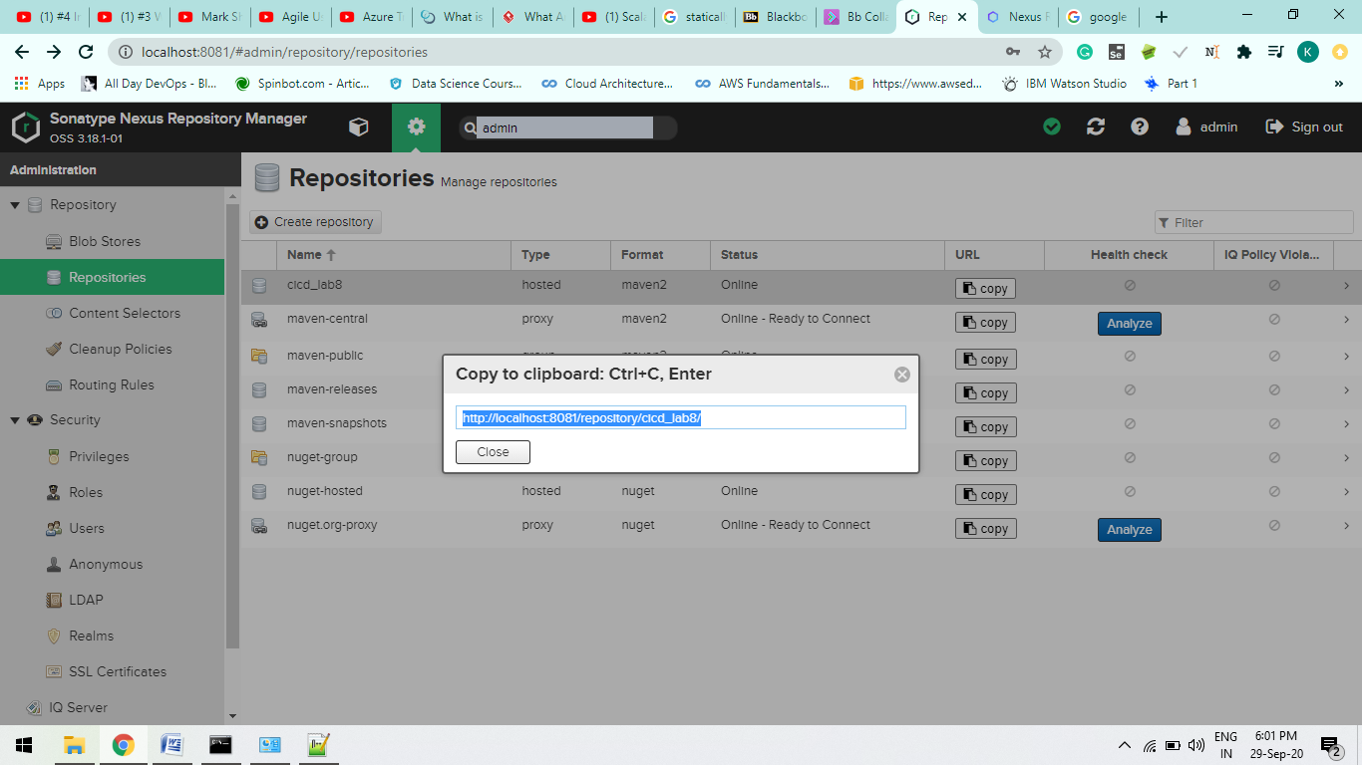

B.

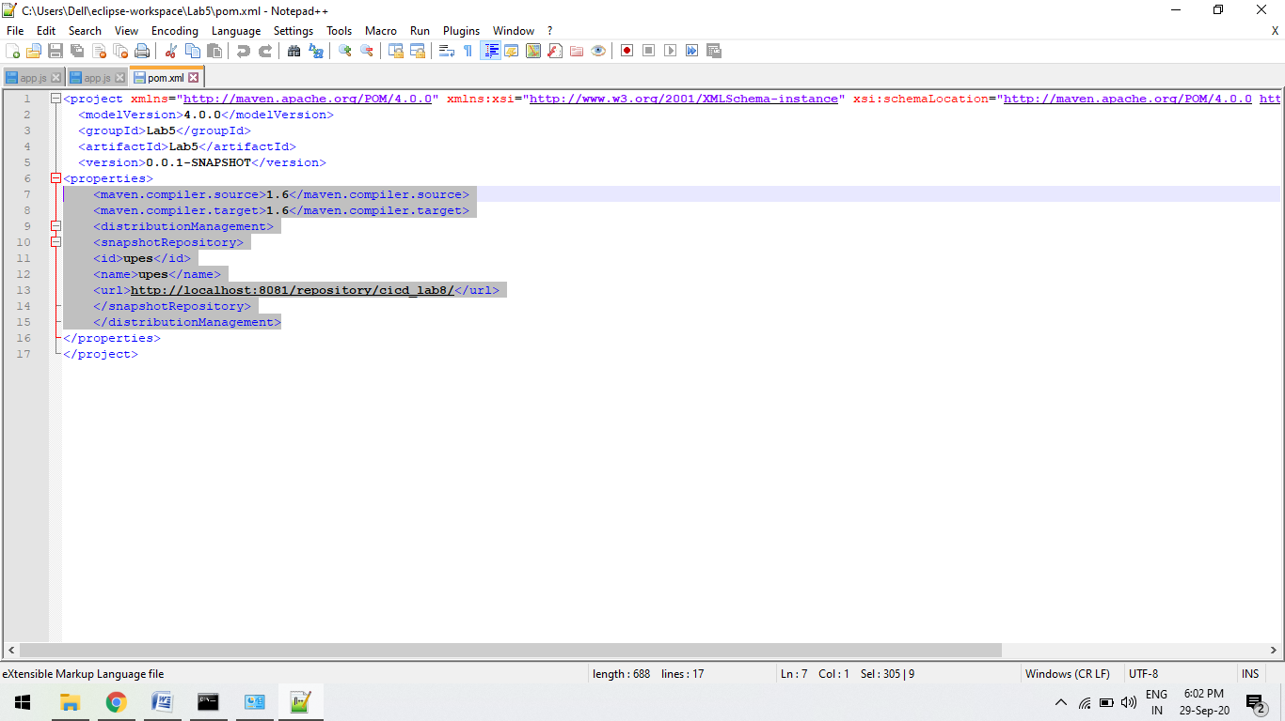

Step-6:

Goto the maven project where pom file is stored.

Run command “mvn deploy”

This command will automatically run the maven goal before the deploy goal like clean and install goal of maven.

jar file will be create and will host the jar file to the nexus repo manager.

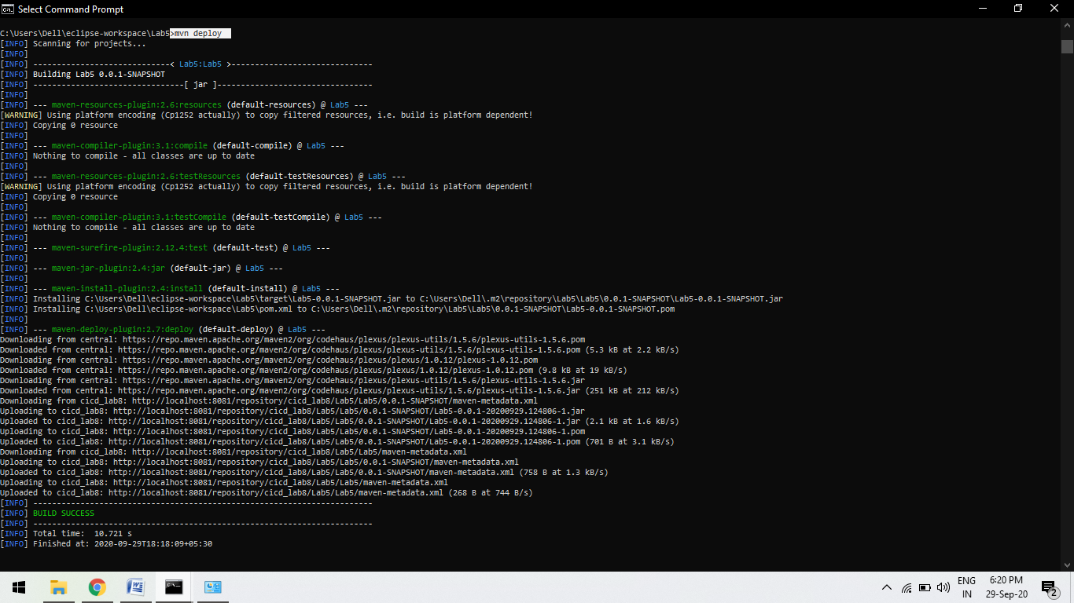

B.

