**CI / CD LAB EXPERIMENT ( TERRAFORM AND AWS )**

**SUBMITTED BY:**

**NAME:** Devashish Choudhary

**BRANCH:** CSE - DevOps

**ROLL NUMBER:** R171218122

**SAP ID:** 500070510

**SEMESTER**: V

**SUBJECT:** CI / CD



**SUBMITTED TO:**

**Mr. Hitesh Kumar**

***Terraform :-***

Terraform is a tool for building, changing, and versioning infrastructure safely and efficiently. Terraform can manage existing and popular service providers as well as custom in-house solutions.

Configuration files describe to Terraform the components needed to run a single application or your entire datacenter. Terraform generates an execution plan describing what it will do to reach the desired state, and then executes it to build the described infrastructure. As the configuration changes, Terraform is able to determine what changed and create incremental execution plans which can be applied.

***AWS ( Amazon Web Service ) :-***

Amazon Web Services provides a highly reliable, scalable, low-cost infrastructure platform in the cloud that powers hundreds of thousands of businesses around the world.

 Industries are taking advantage of the following benefits :-

1. Low Cost

### Agility and Instant Elasticity

### Open and Flexible

### Secure

***Implementation are given in the following steps :-***

**Step 1 : Terraform Initializing**

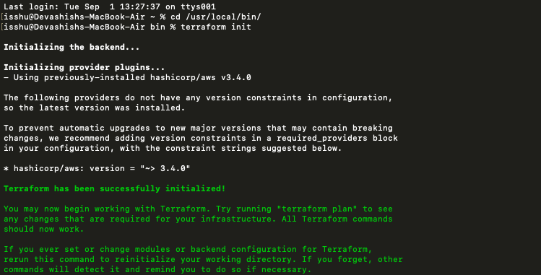

**Step 2 : Terraform Planing**

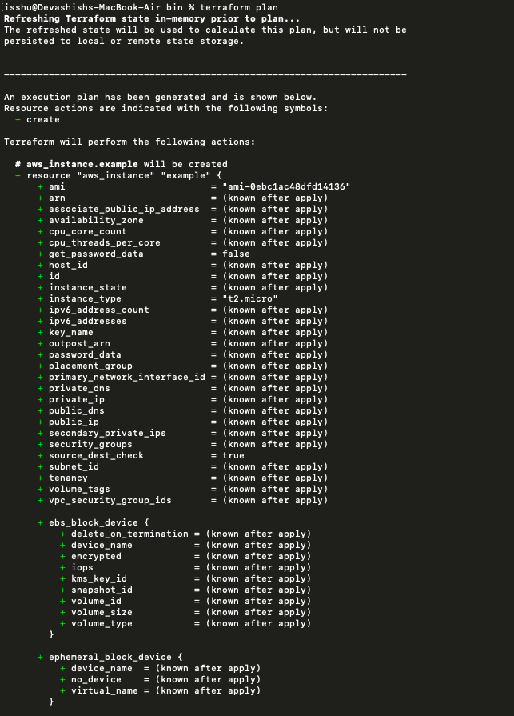

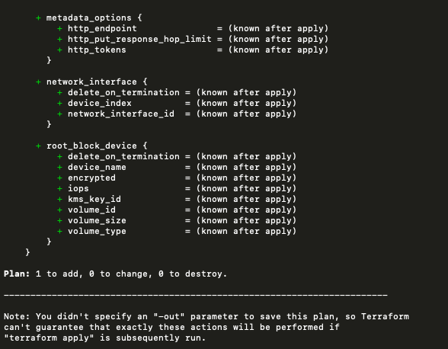

**Step 3 : Terraform Applying**

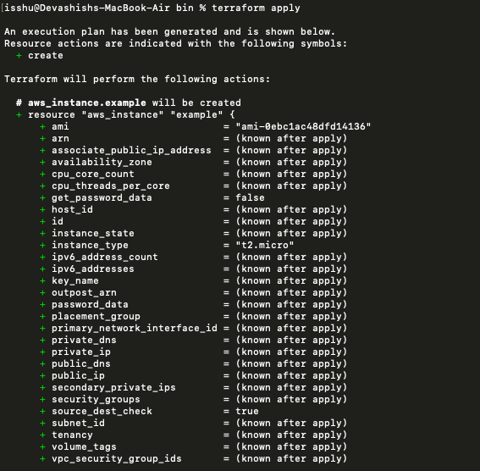

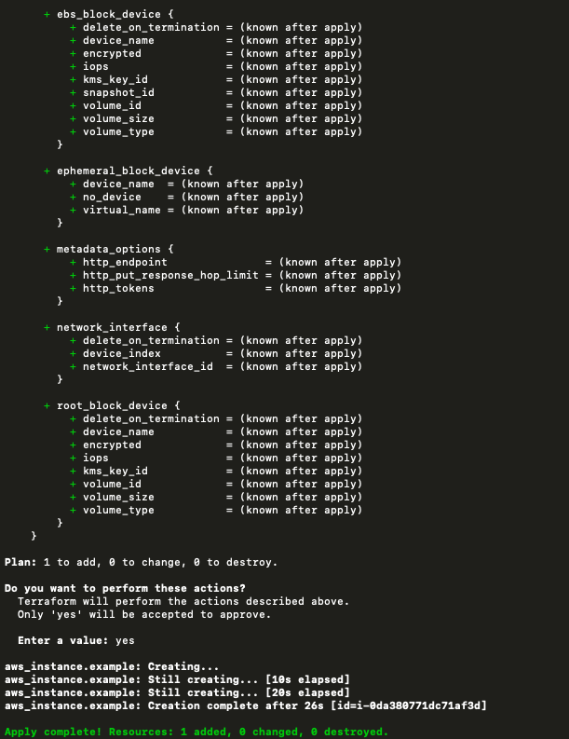

***Instance Running***

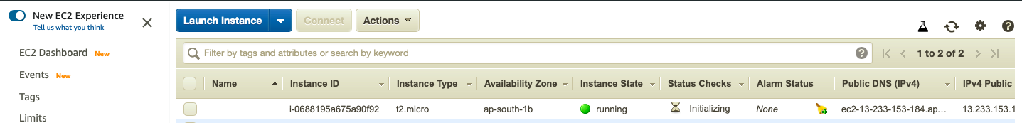

**Step 4 : Terraform Destroying**

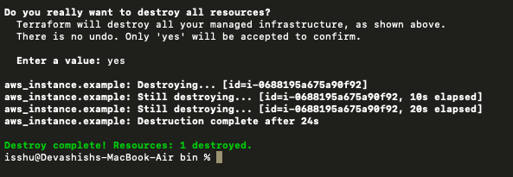

***Instance Terminated***

