

**Name - Devashish Choudhary**

**Roll.No – R171218122**

**SAP ID – 500070510**

**DevOps Batch-2 (5th Semester)**

**Submitted to- Mr. Hitesh Kumar**

**CICD LAB-6 Experiment (Ocean Blue Plugin)**

***OceanBlue Plugin Installed :-***

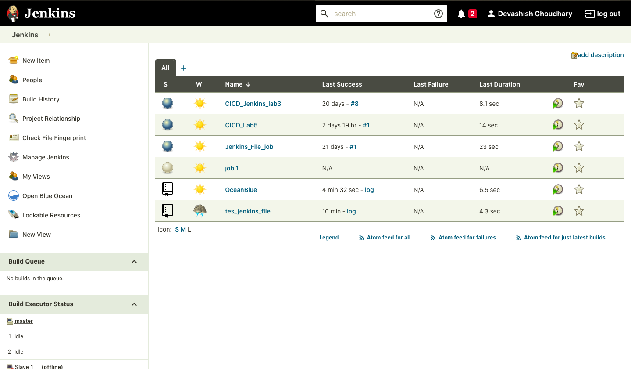

***Jenkins File at GitHub :-***

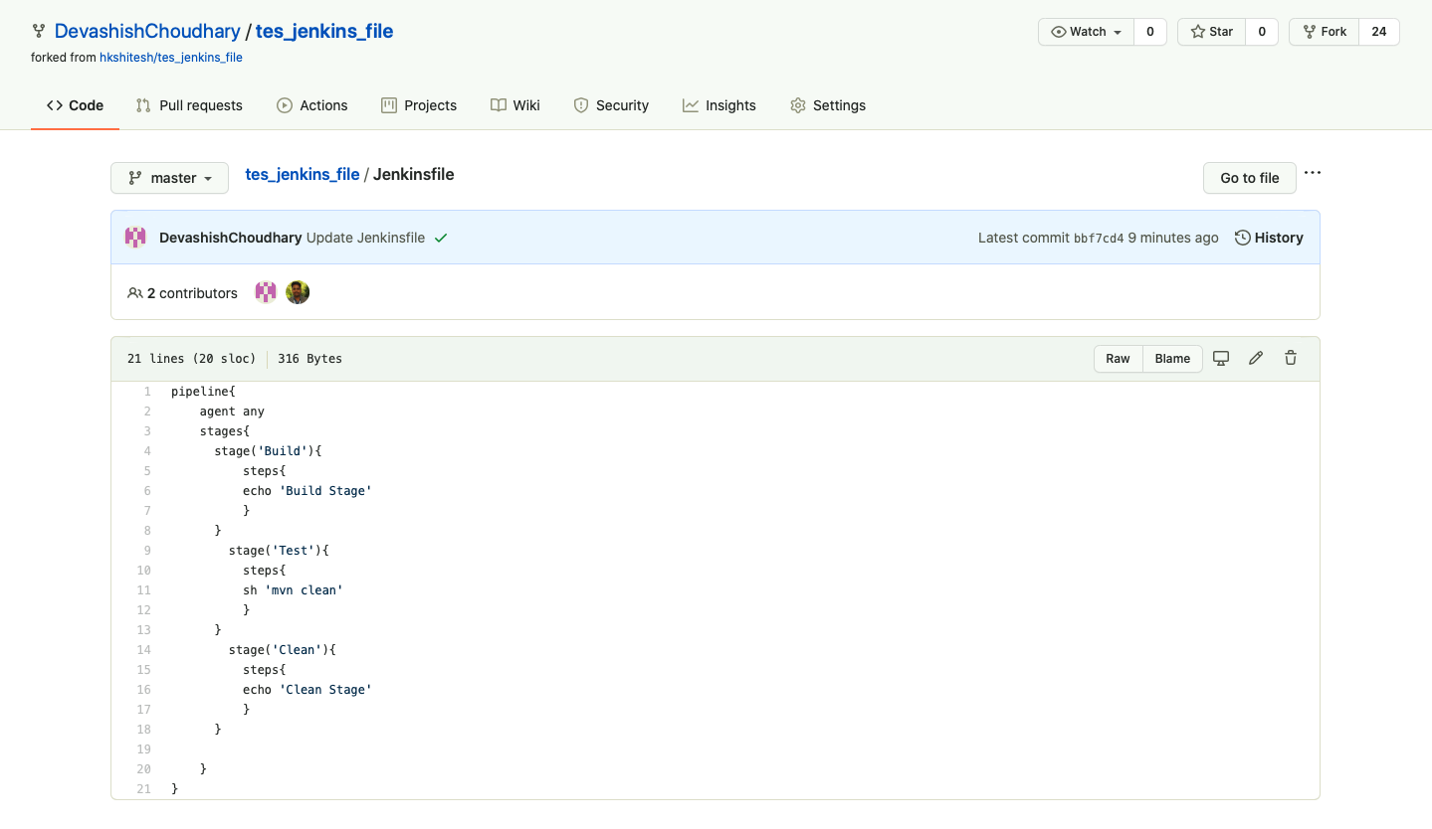

***Pipeline Created :-***

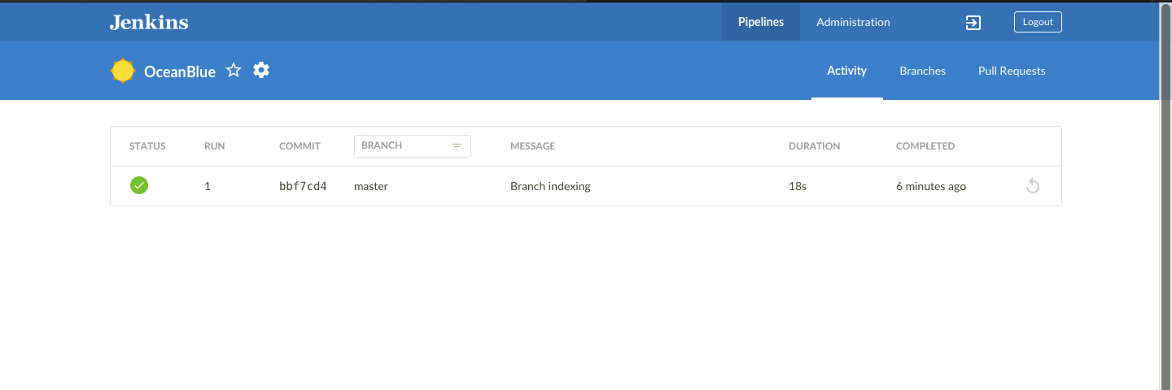

***Successful Output :-***

