

**Name - Devashish Choudhary**

**Roll.No – R171218122**

**SAP ID – 500070510**

**DevOps Batch-2 (5th Semester)**

**Submitted to- Mr. Hitesh Kumar**

**CICD LAB-8 Experiment (Master/Slave)**

***Terminal OutPut :-***

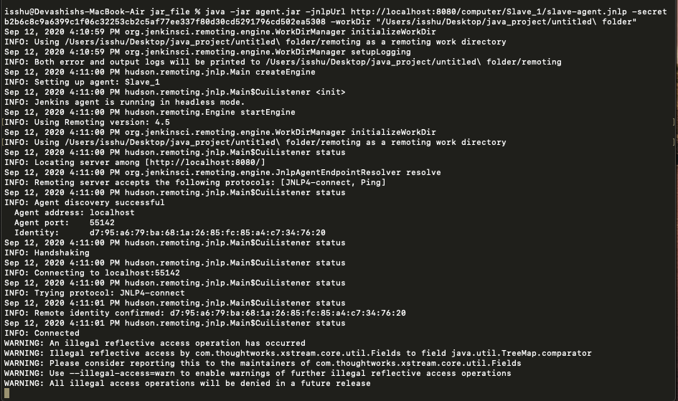

***Working of Slave_1 :-***

*Before -*

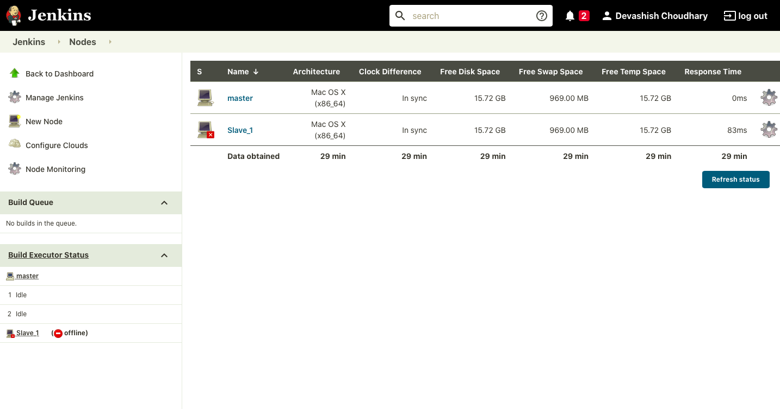

*After -*

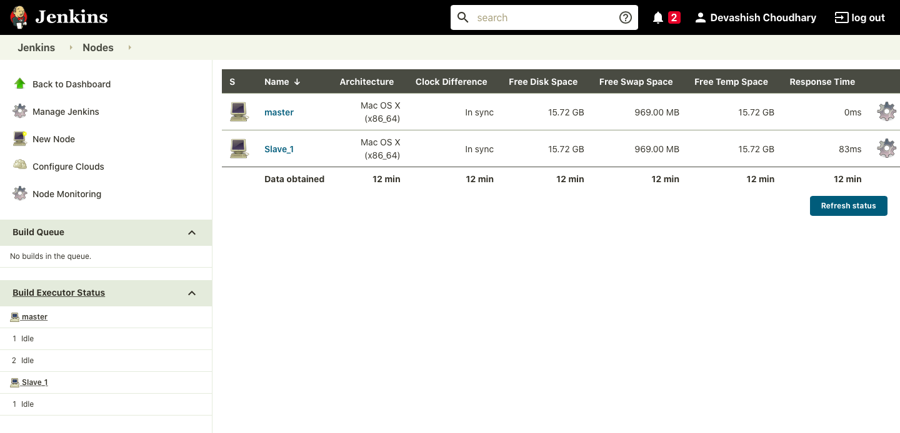

***Console OutPut :-***

