# Name:- Devashish Choudhary

Roll.No:- R171218122

SAP_ID:- 500070510

Topic:- Setup Docker Machine

## Installation of Docker

* First, in order to ensure the downloads are valid, add the GPG key for the official Docker repository to your system:  
    
  $ curl -fsSL https://download.docker.com/linux/ubuntu/gpg | sudo apt-key add -
* Add the Docker repository to APT sources:

$ sudo add-apt-repository "deb [arch=amd64] https://download.docker.com/linux/ubuntu $(lsb_release -cs) stable"  
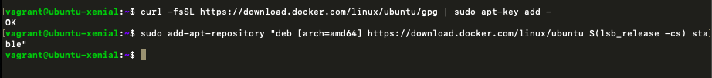

* Next, update the package database with the Docker packages from the newly added repo:

$ sudo apt-get update

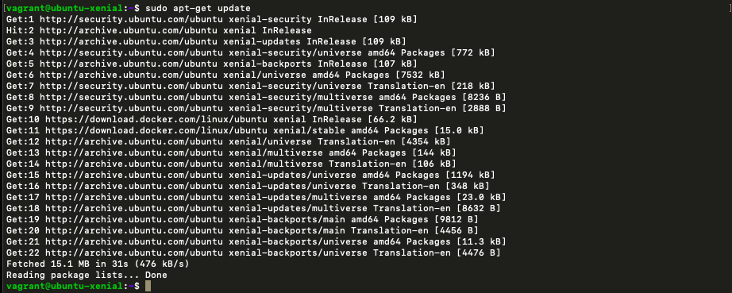

* Make sure you are about to install from the Docker repo instead of the default Ubuntu 16.04 repo:

$ apt-cache policy docker-ce

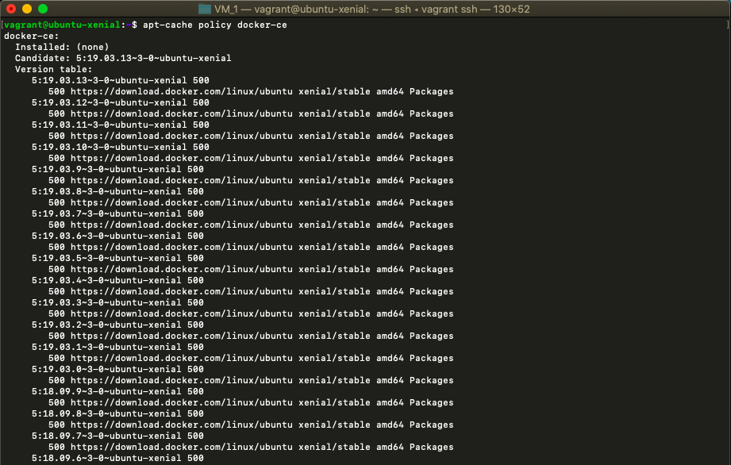

* Finally, install Docker:  
  $ sudo apt-get install -y docker-ce  
  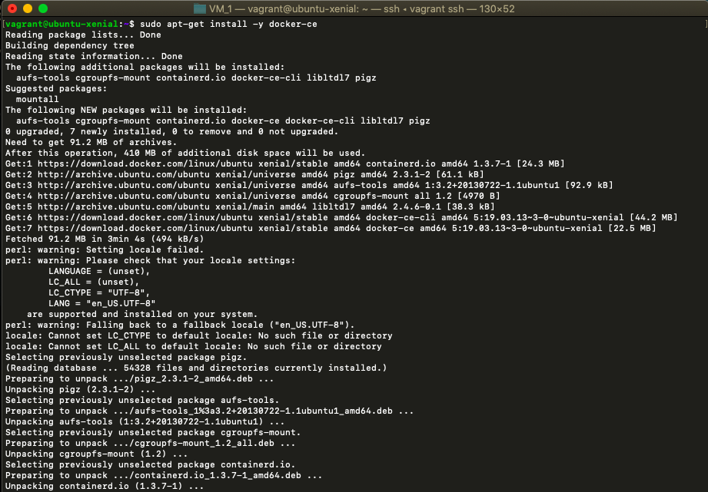
* Check that it’s running:

$ sudo systemctl status docker

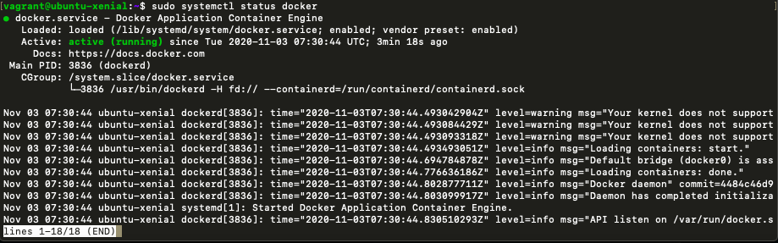

## Configuration

* Executing the Docker Command Without Sudo

If you want to avoid typing sudo whenever you run the docker command, add your username to the docker group:

$ sudo usermod -aG docker ${USER}

* To apply the new group membership, you can log out of the server and back in, or you can type the following:

$ su - ${USER}

You will be prompted to enter your user’s password to continue. Afterwards, you can confirm that your user is now added to the docker group by typing:

* If you need to add a user to the docker group that you’re not logged in as, declare that username explicitly using:

$ sudo usermod -aG docker username

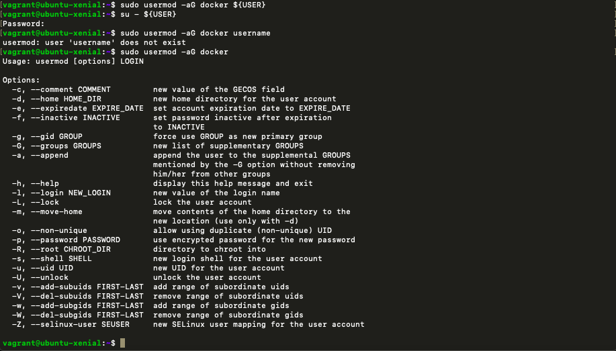

* Run Docker by using command “docker run -it ubuntu” which creates a ubuntu docker container and make directory in this ubuntu container.

