**CI/CD**

**LAB EXPERIMENTS 1**

**SUBMITTED BY:**

NITISH KUMAR SINGLA

500071913

R171218126

**SUBMITTED TO:**

HITESH KUMAR SHARMA SIR

**Installation of Jenkins and Execution of a Simple Job in Jenkins**

* Install Jenkins 2.259

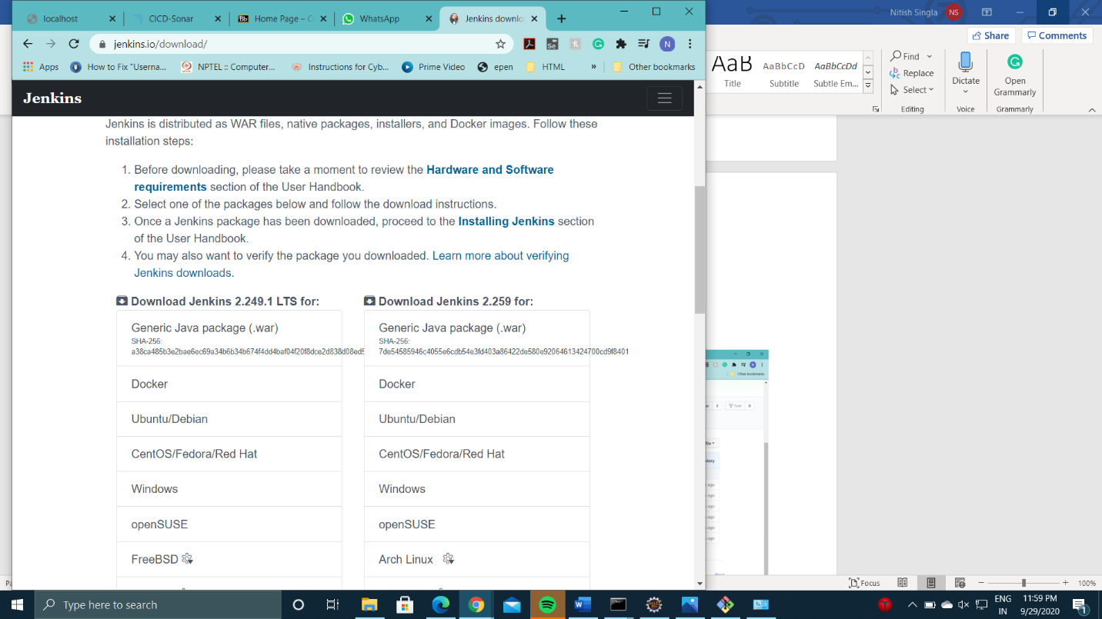

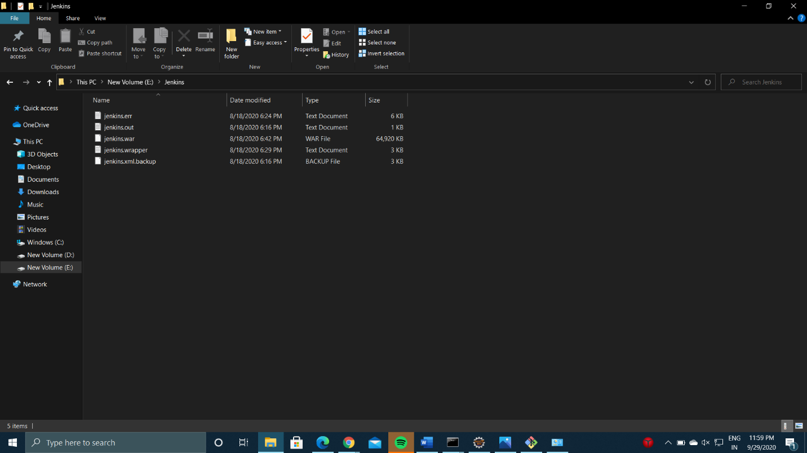

* Run command **java -jar jenkins.war** to start jenkins

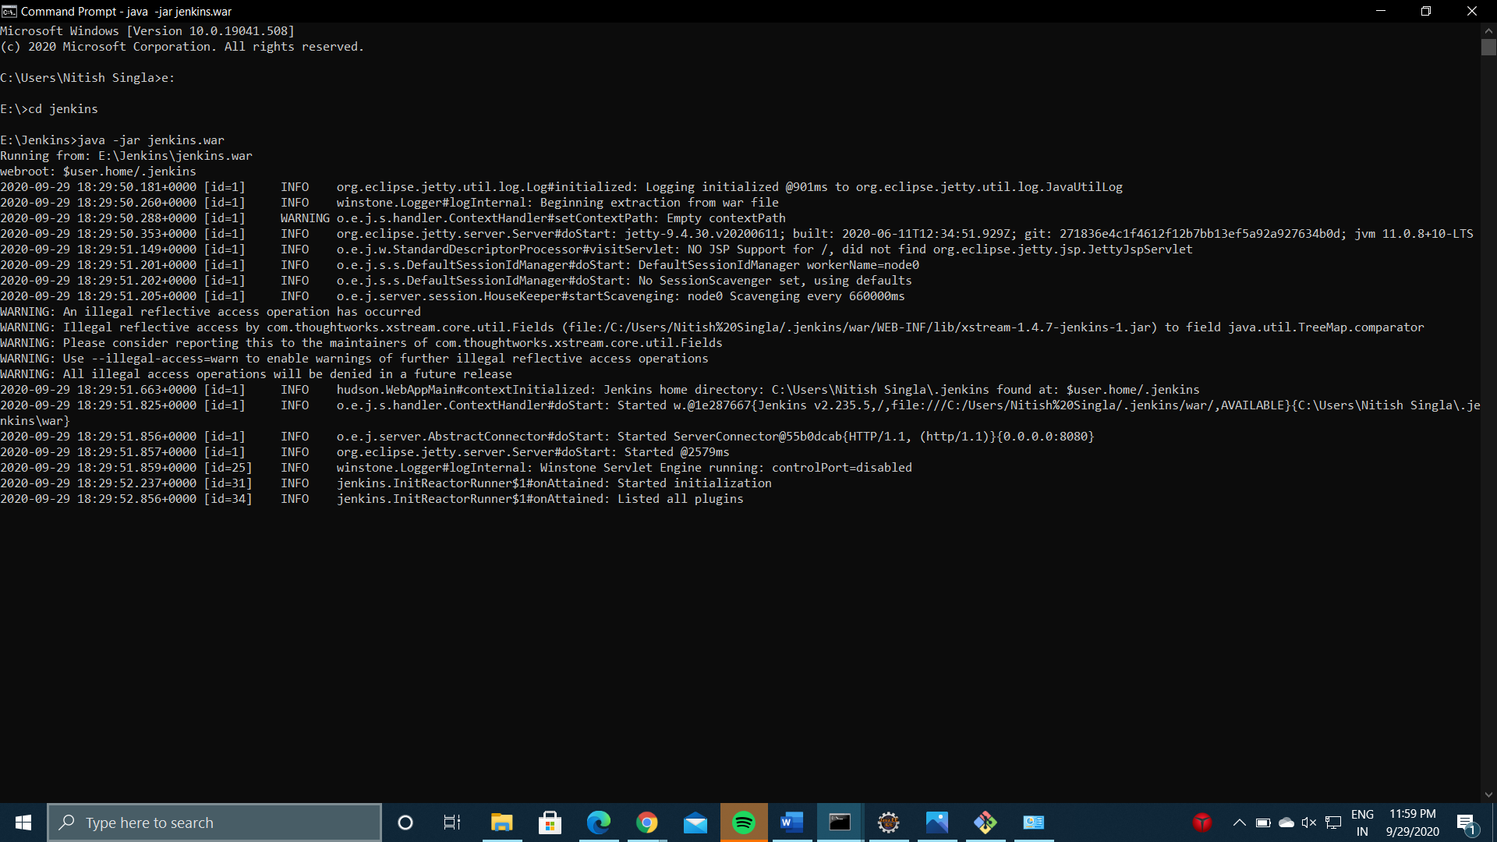

* Go to localhost:8080 and log in into Jenkins

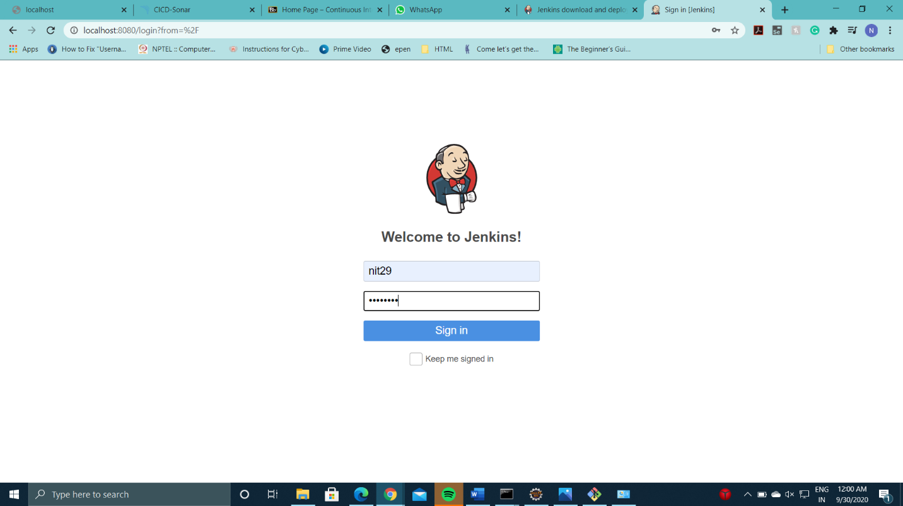

* This is Jenkins Page

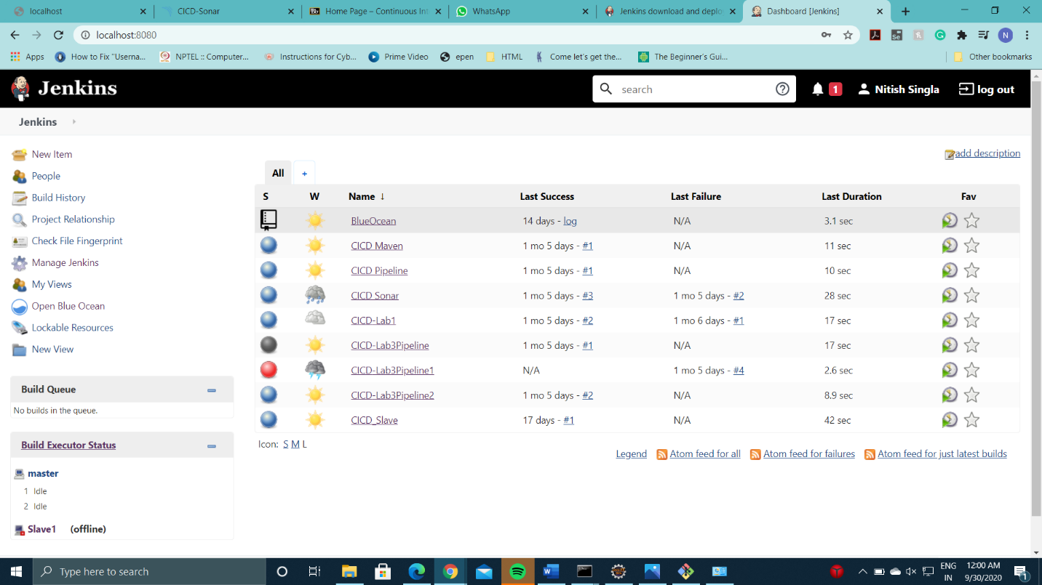

* Click on new item to create a project or pipeline using Jenkins

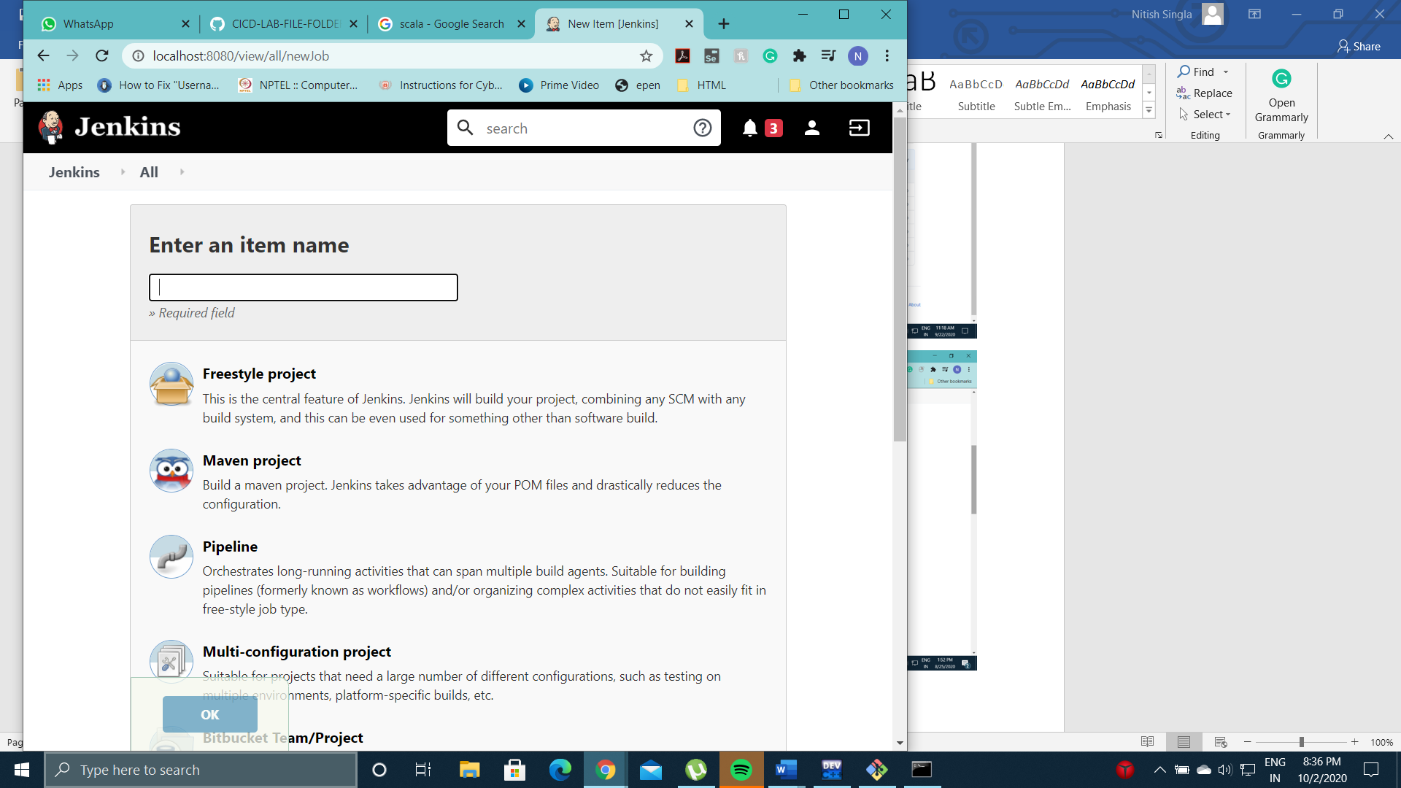

* Github Repository URL which contains the Maven Project Contents.

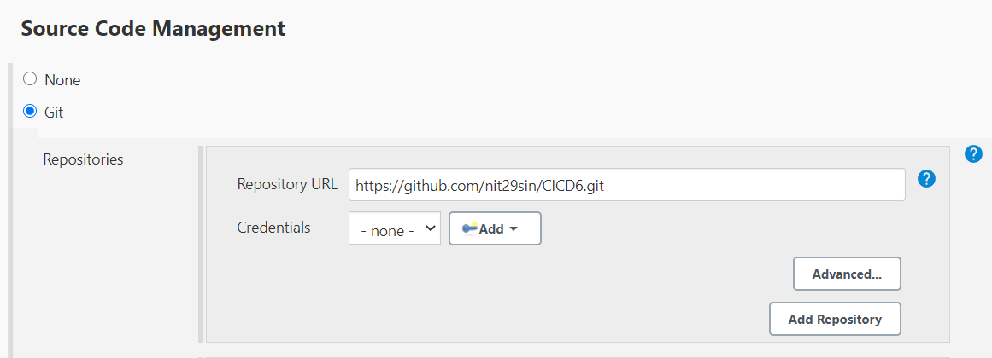

* pom.xml location and maven goal

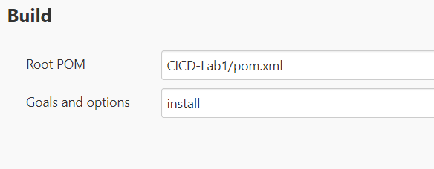

* Build Success

