**CI/CD**

**LAB EXPERIMENTS 2**

**SUBMITTED BY:**

NITISH KUMAR SINGLA

500071913

R171218126

**SUBMITTED TO:**

HITESH KUMAR SHARMA SIR

**Jenkins Integration with Github**

* Install Git Plugins to intergrate Jenkins with Git

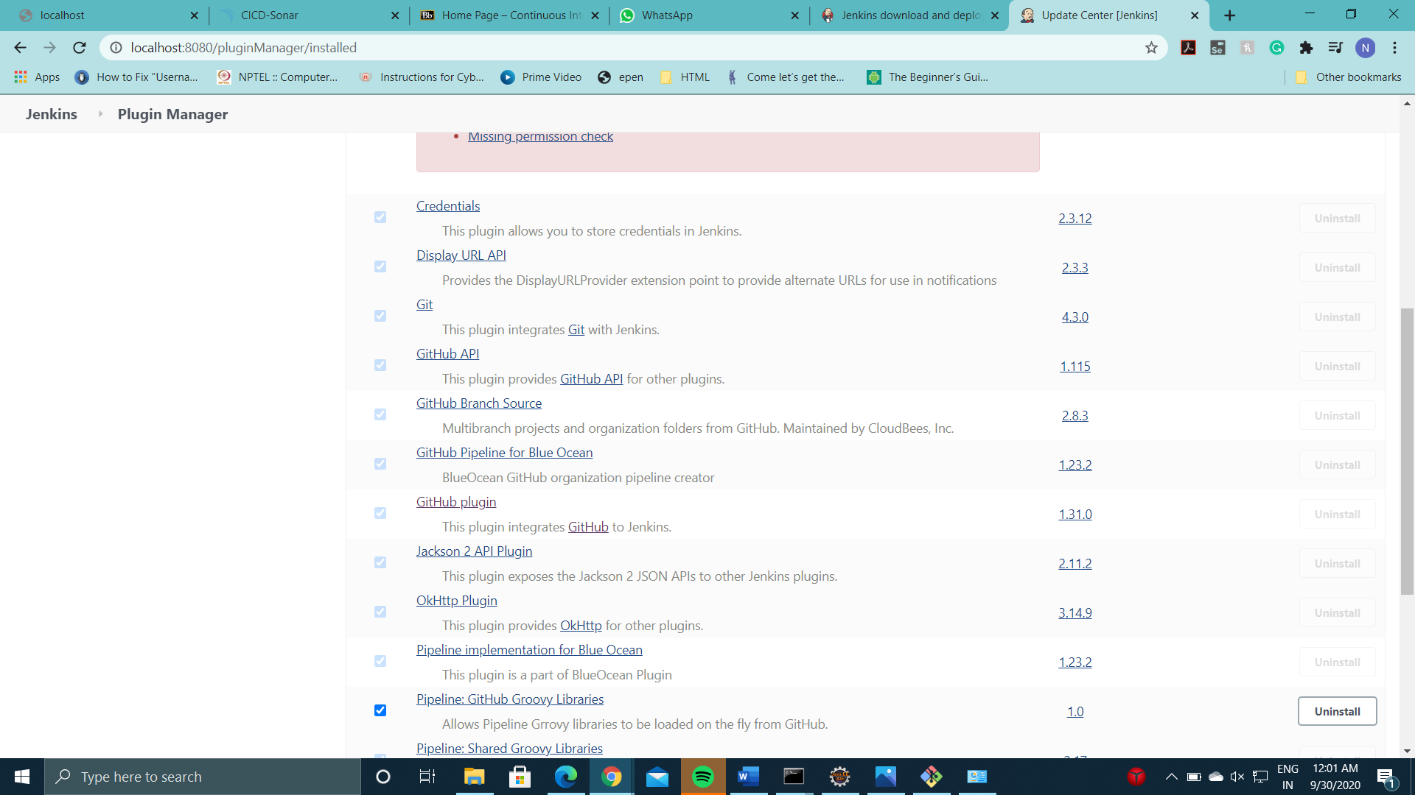

* Create a Maven Project and write the url of the github repository which contains the contents of Maven Project to integrate jenkins with a maven project.

