**CI/CD**

**LAB EXPERIMENTS 3**

**SUBMITTED BY:**

NITISH KUMAR SINGLA

500071913

R171218126

**SUBMITTED TO:**

HITESH KUMAR SHARMA SIR

**Jenkins Integration with Maven and Github**

* Create a Maven Project in Eclipse
* Integrate the Maven Project with a Github Repository in Eclipse
* Push the Project to Github using Eclipse

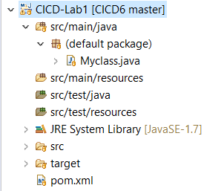

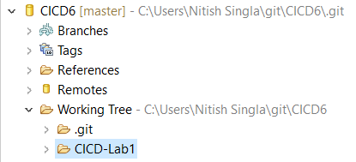

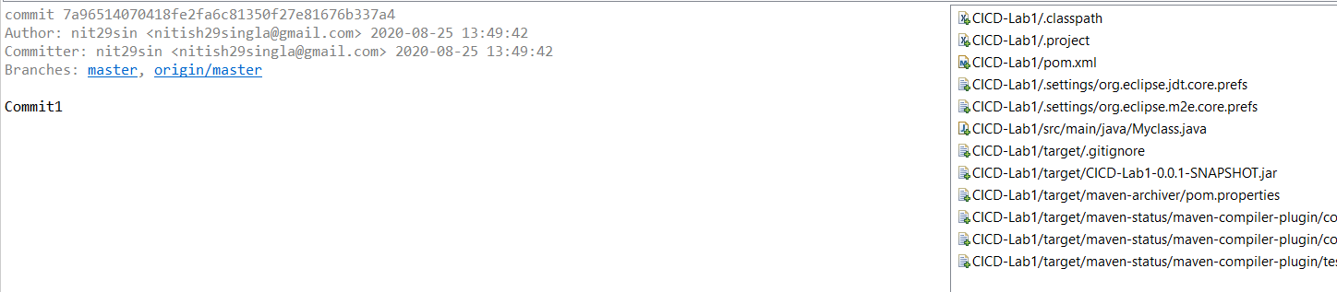

* Maven Project Contents in a Github Repository

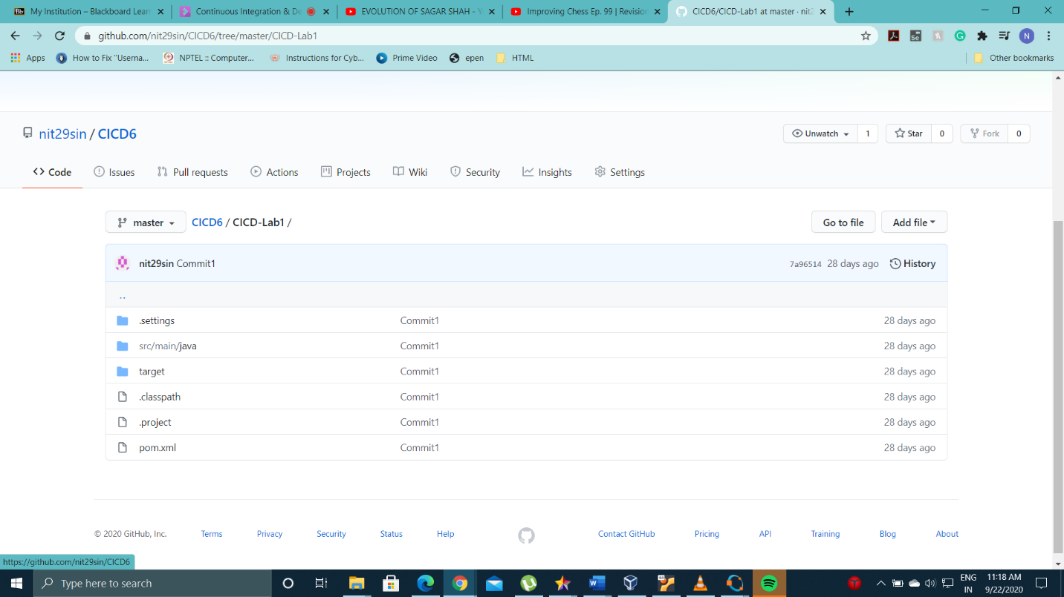

* Go to Jenkins, Click on New Item and then Click on Maven Project.

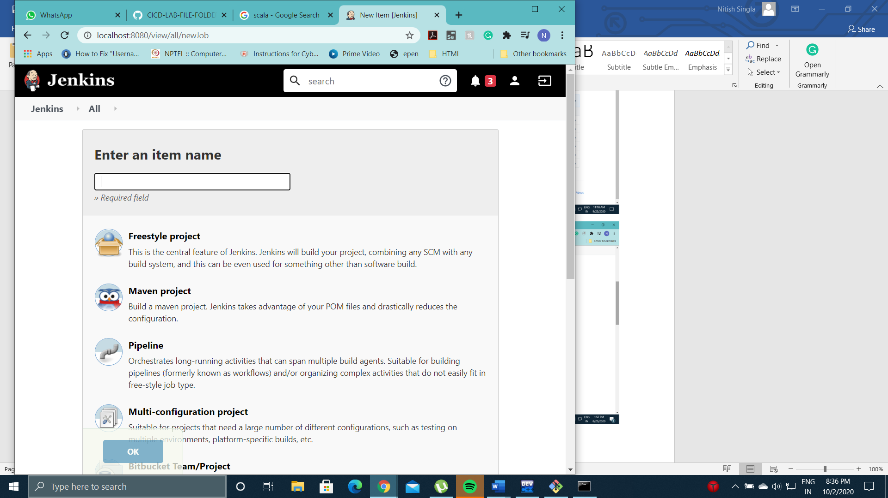

* Install Maven Plugin



* Add the url of the Github Repository which contains your Maven Project

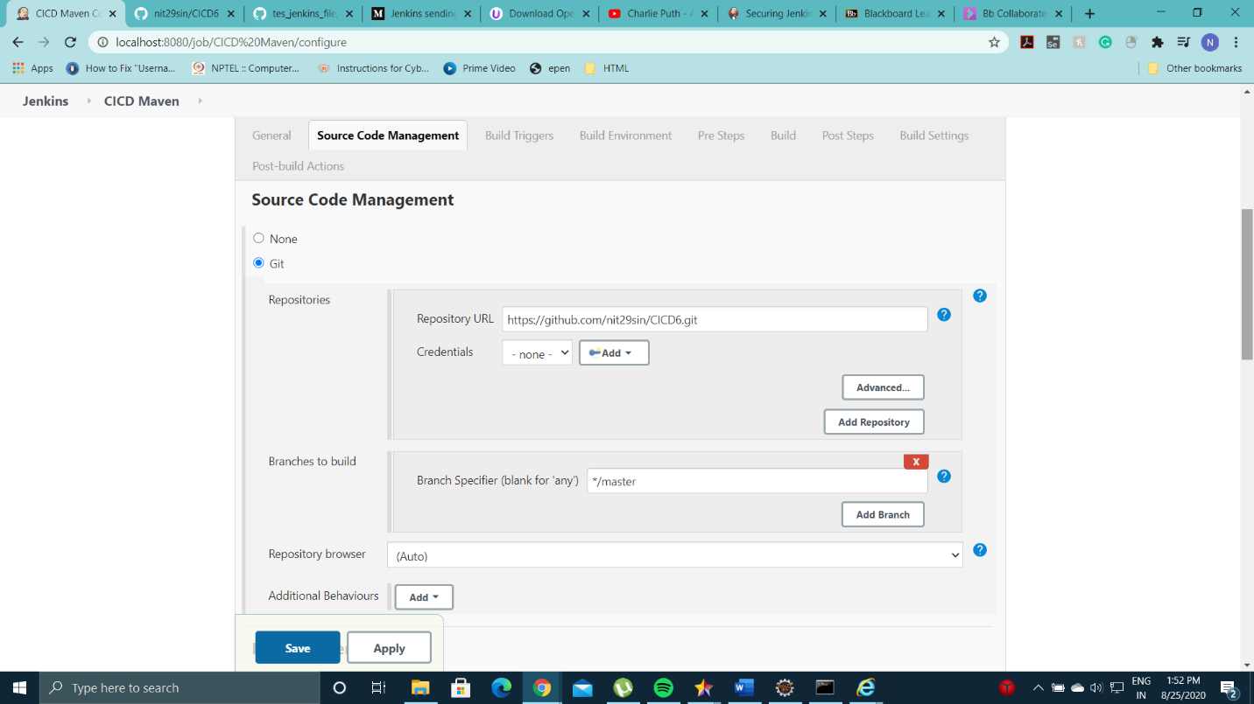

* Write install in goals and updates to create build of the project

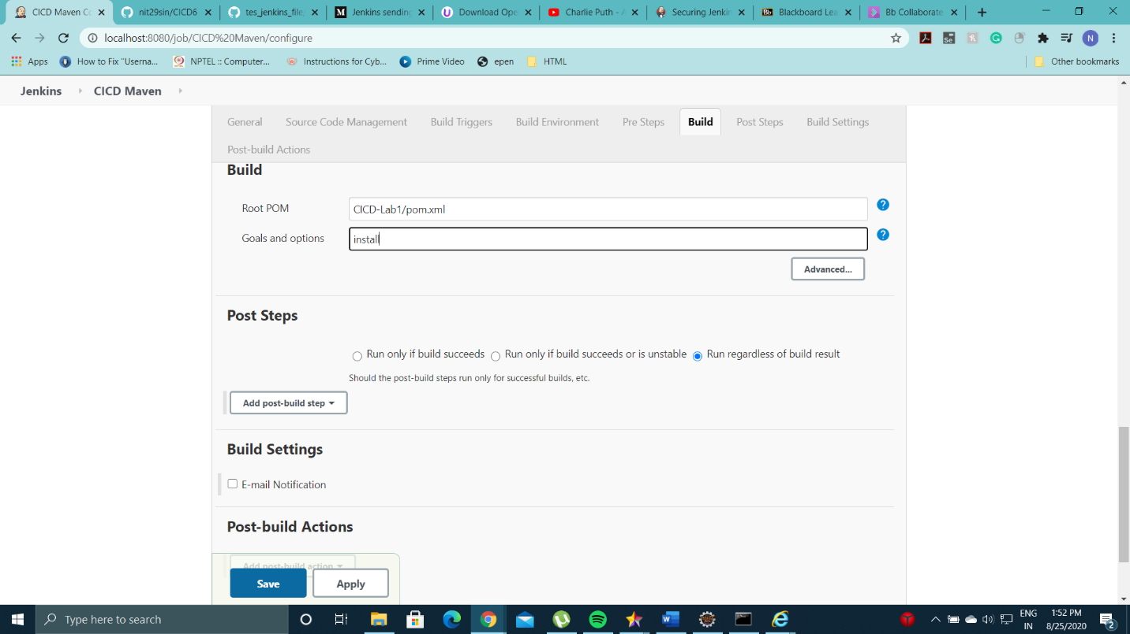

* Click on Build Now

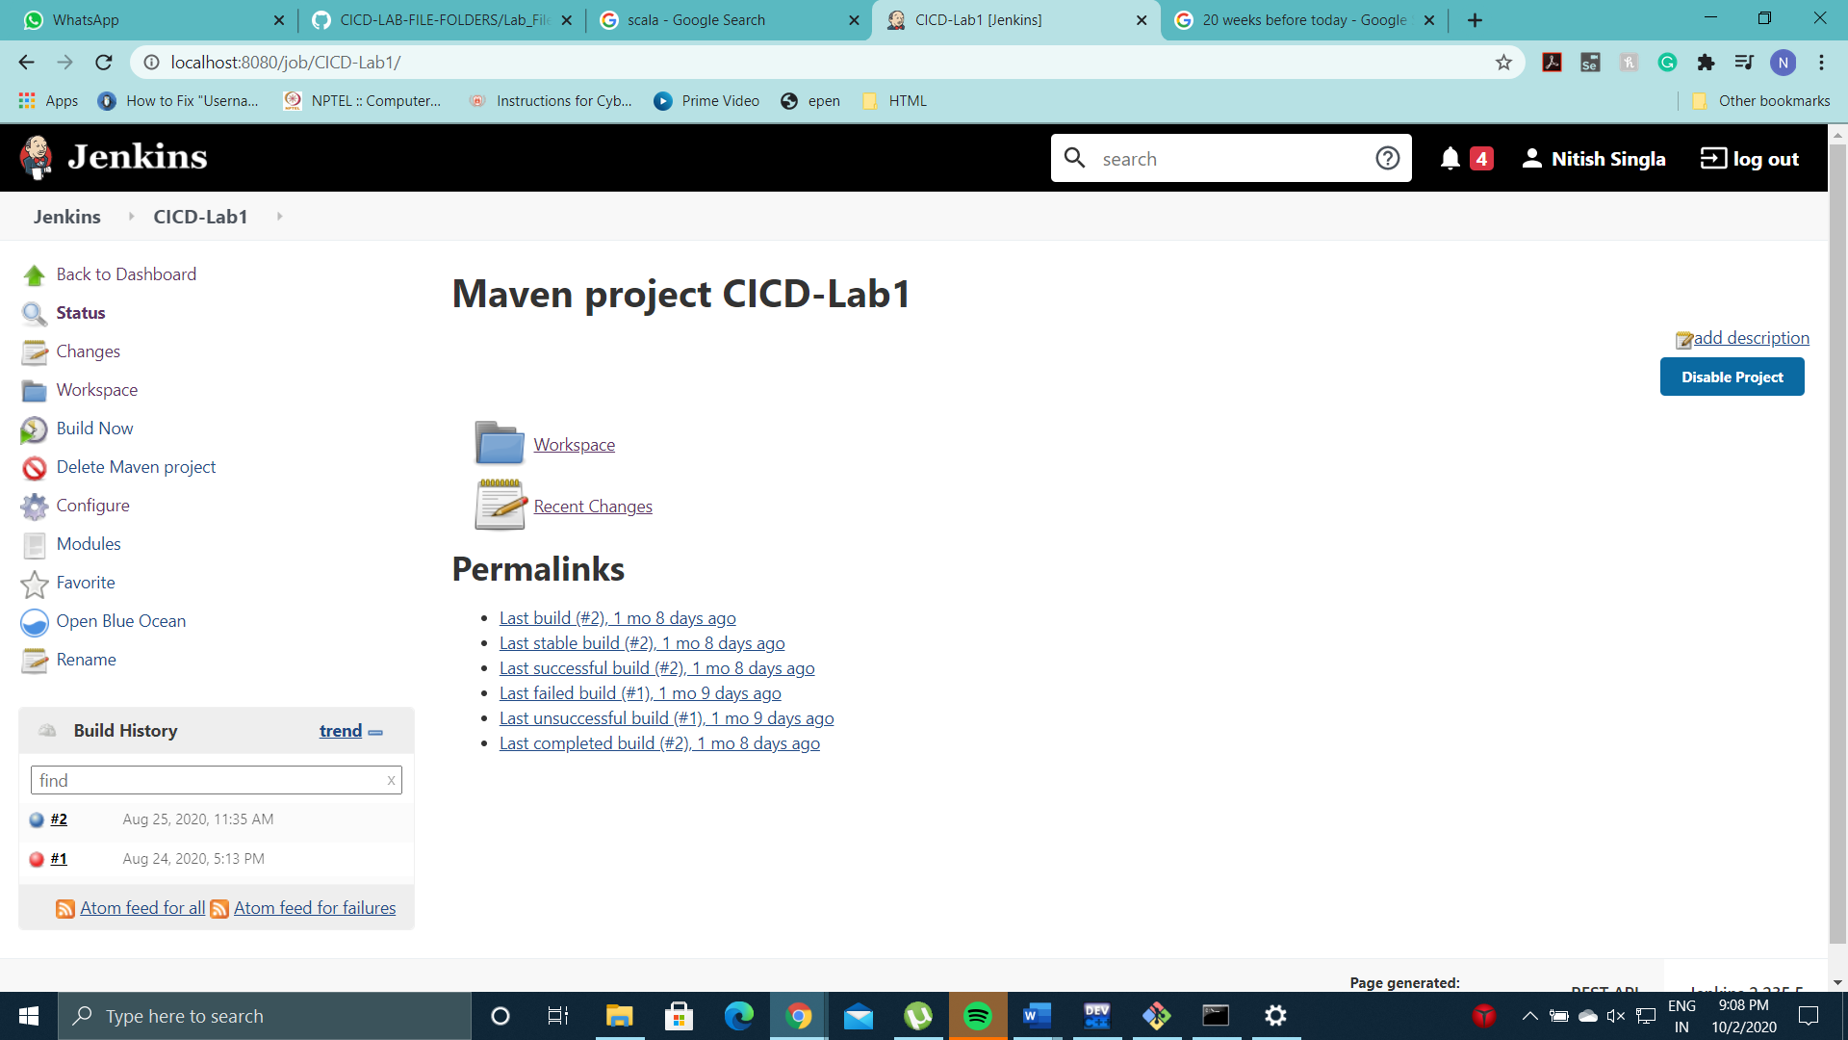

* Build is created successfully

