**CI/CD**

**LAB EXPERIMENTS 4**

**SUBMITTED BY:**

NITISH KUMAR SINGLA

500071913

R171218126

**SUBMITTED TO:**

HITESH KUMAR SHARMA SIR

**Static Code Analysis using Sonarqube**

* Create a Maven Project

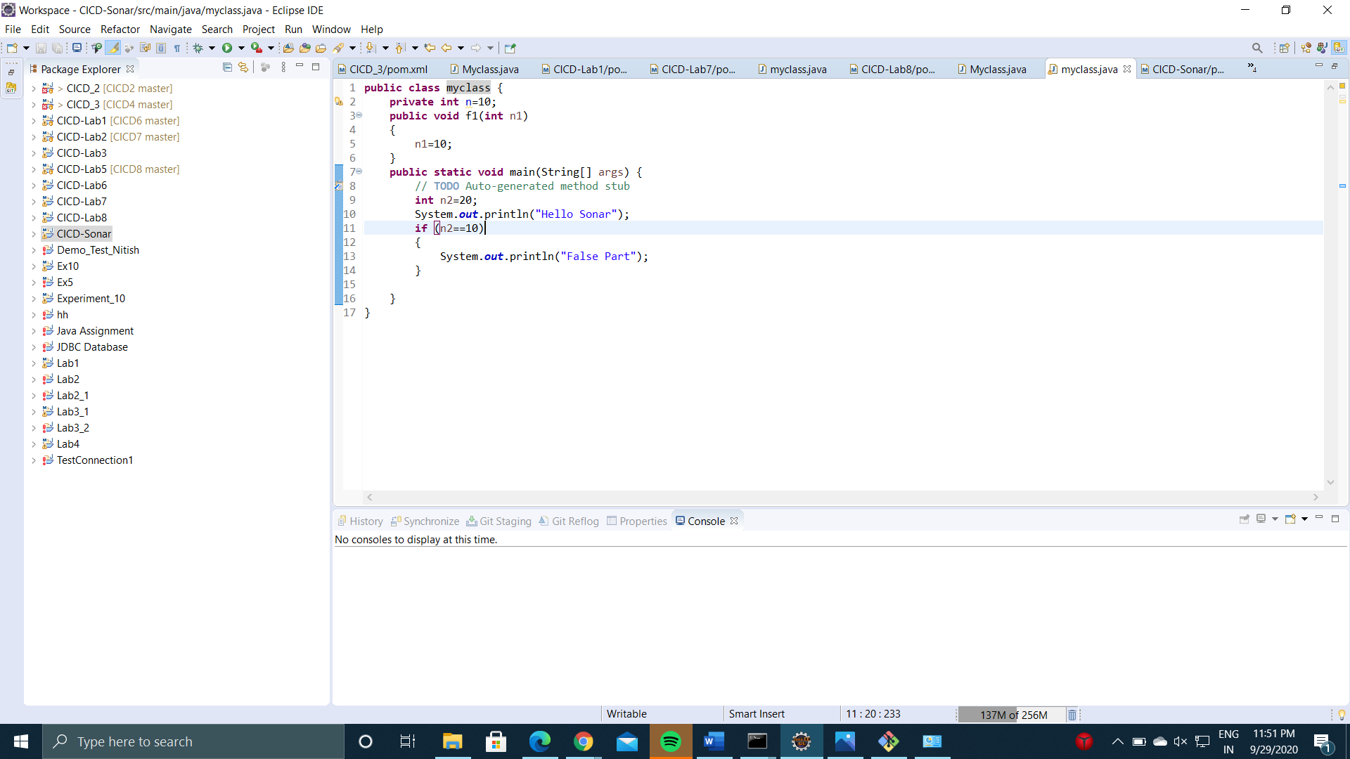

* Run command **mvn clean install sonar:sonar -Dsonar.host.url=http://localhost:9000 -Dsonar.analysis.mode=publish** to create build of the project and import it to Sonarqube for Static Code Analysis.

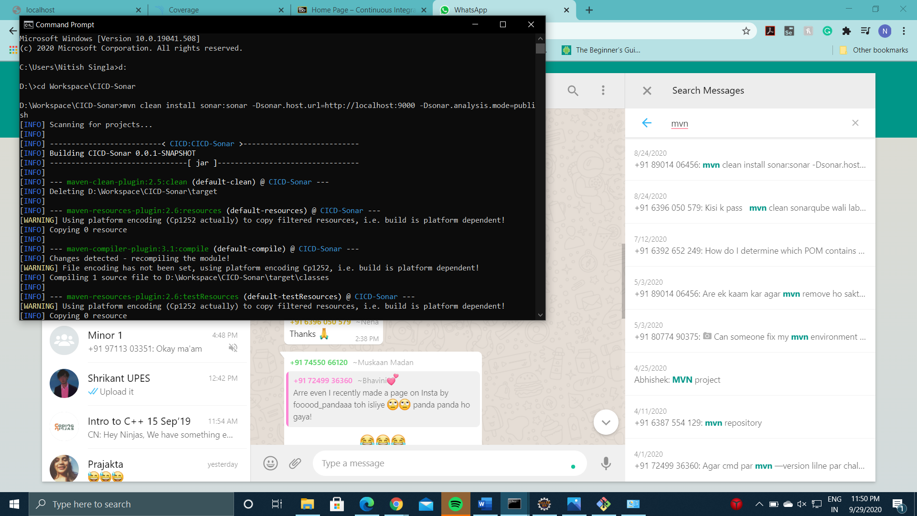

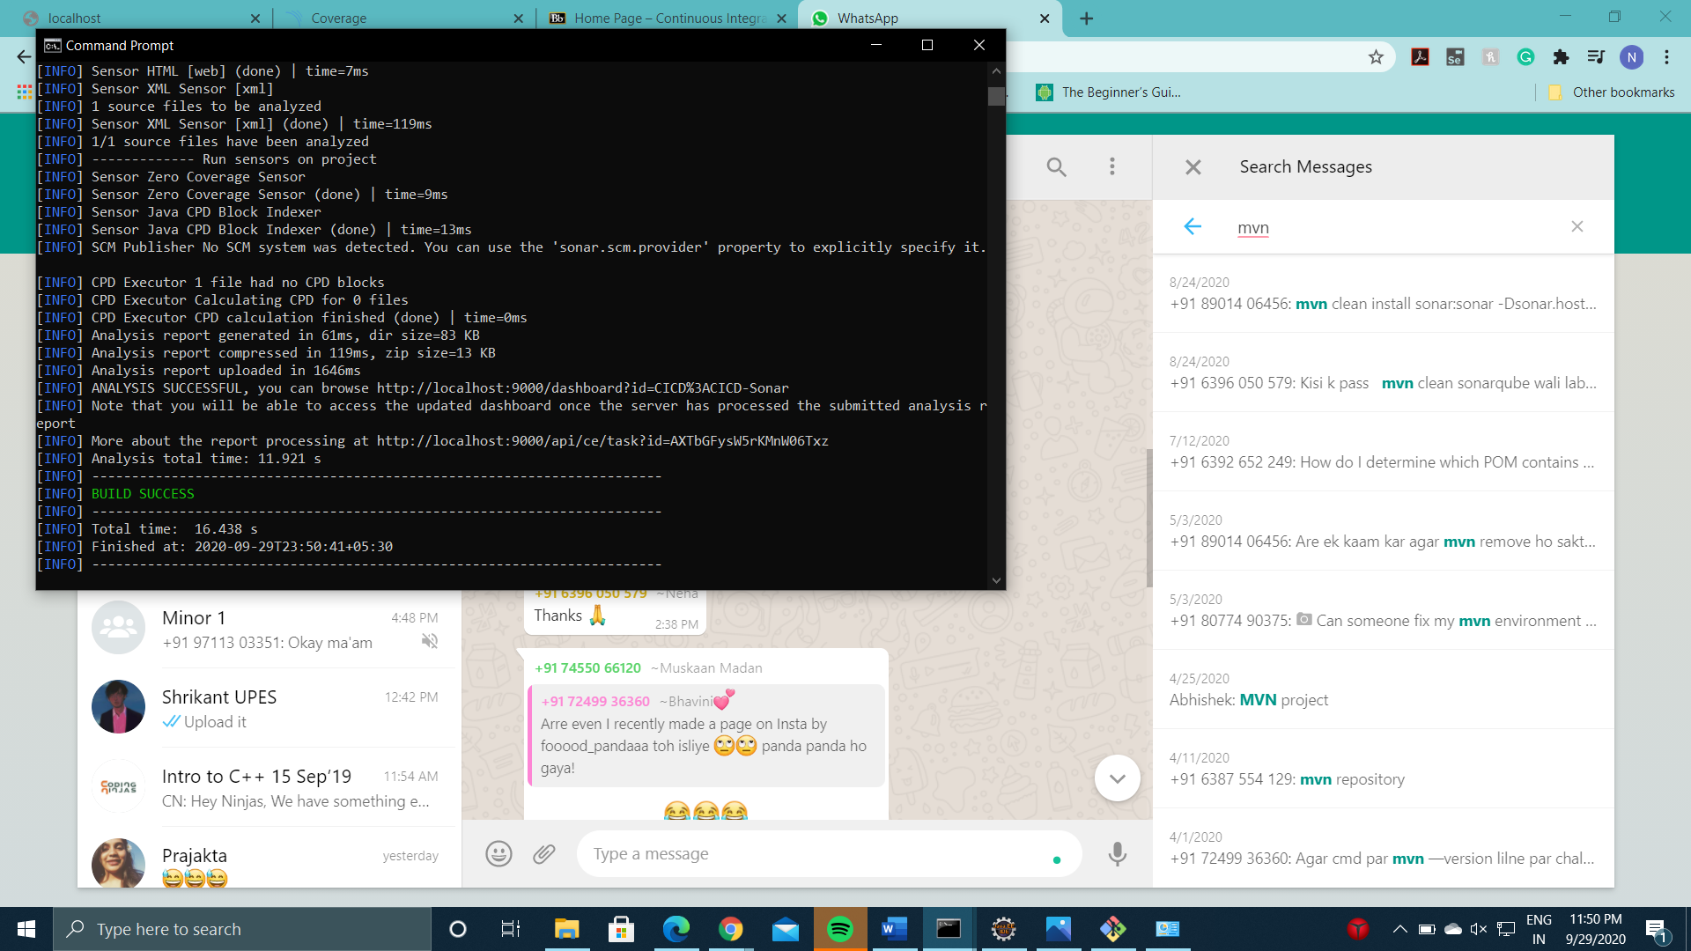

* Run command **StartSonar.bat** to start Sonarqube Server and Log on to localhost:9000 and land on Sonarqube Server.

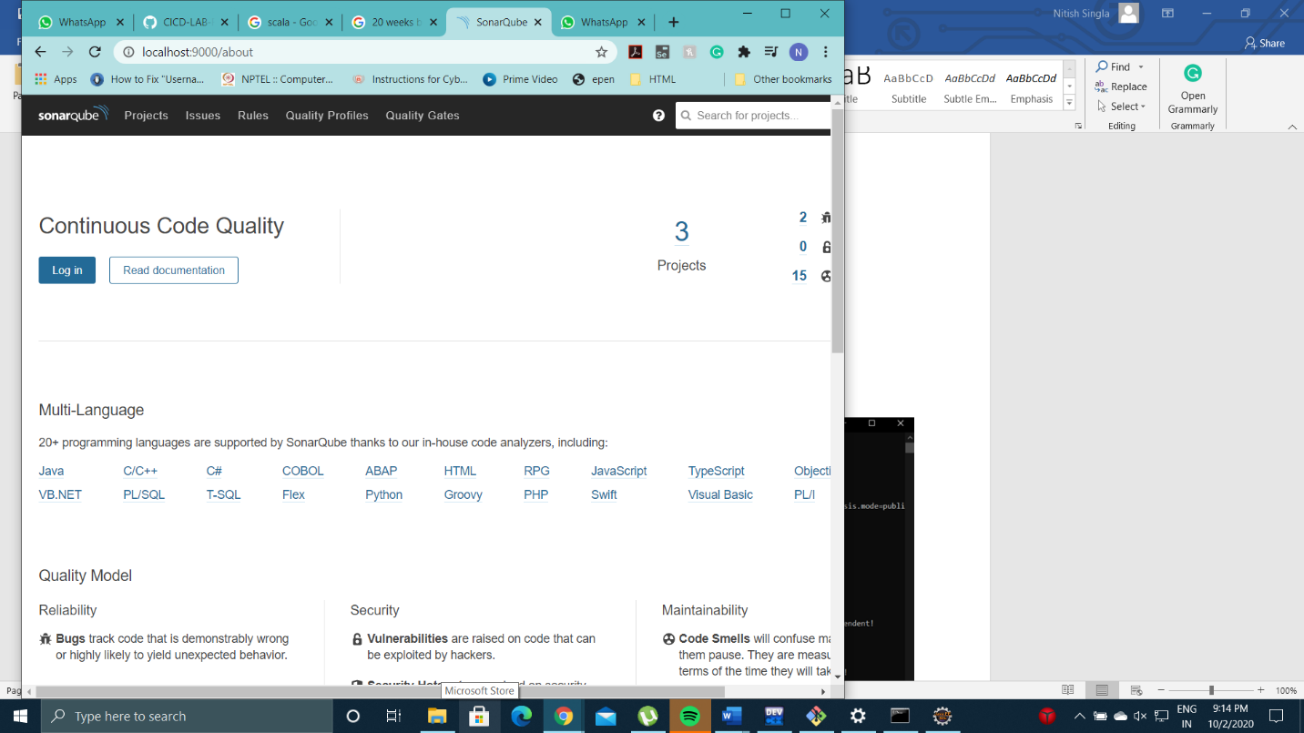

* Now, the project has been imported to Sonarqube. Here, you can check for various things such as bugs, vulnerabilities, code covergae etc.

