**CI/CD**

**LAB EXPERIMENTS 5**

**SUBMITTED BY:**

NITISH KUMAR SINGLA

500071913

R171218126

**SUBMITTED TO:**

HITESH KUMAR SHARMA SIR

**Jenkins Integration with Sonarqube**

* Create a Maven Project

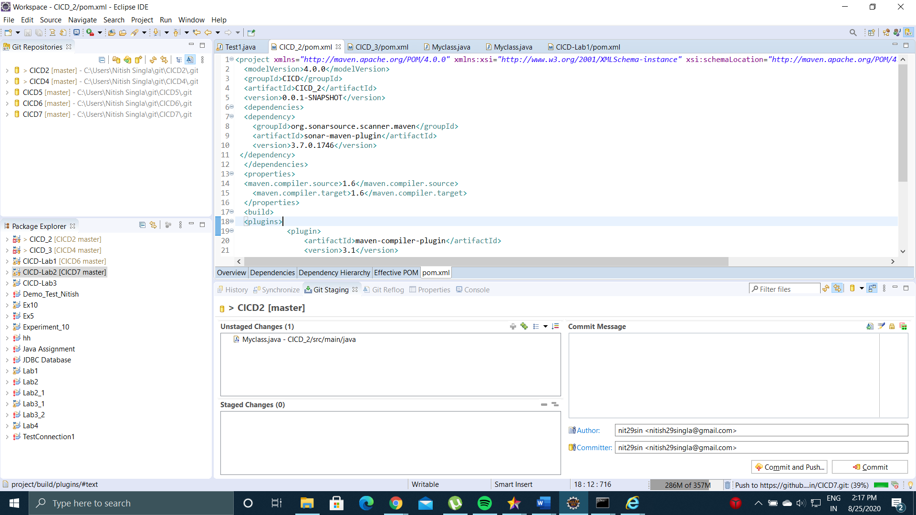

* Import the Maven Project to Github Repository

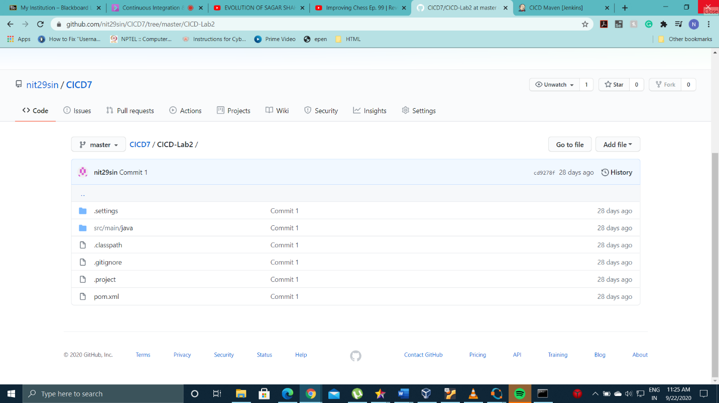

* Create a Maven Project in Jenkins and add the url of Github Repository
* Run a command **mvn clean install sonar:sonar -Dsonar.host. url=http://localhost:9000 -Dsonar.analysis.mode=publish** in Jenkins to create the build and integrate Maven Project with Sonarqube

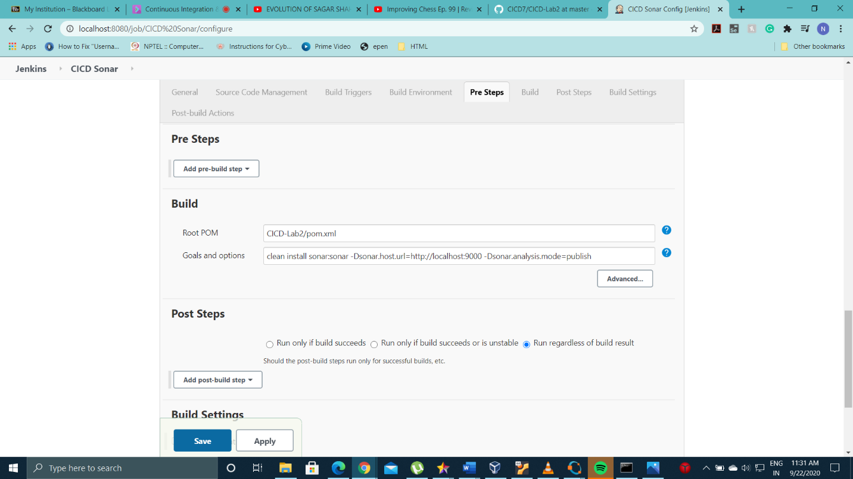

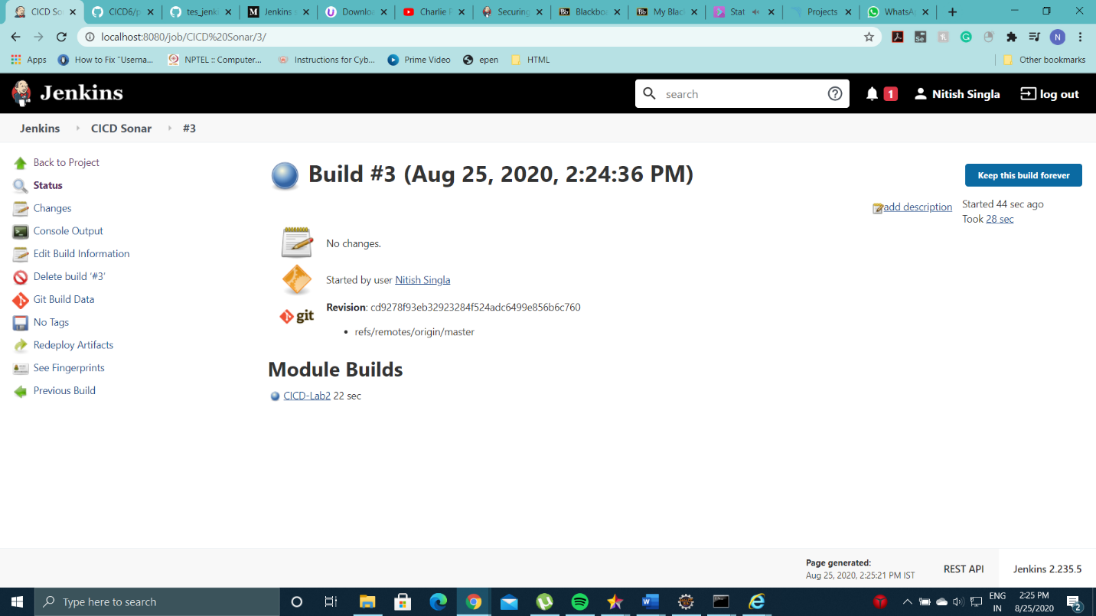

* Build Success and the project will be imported to Sonarqube

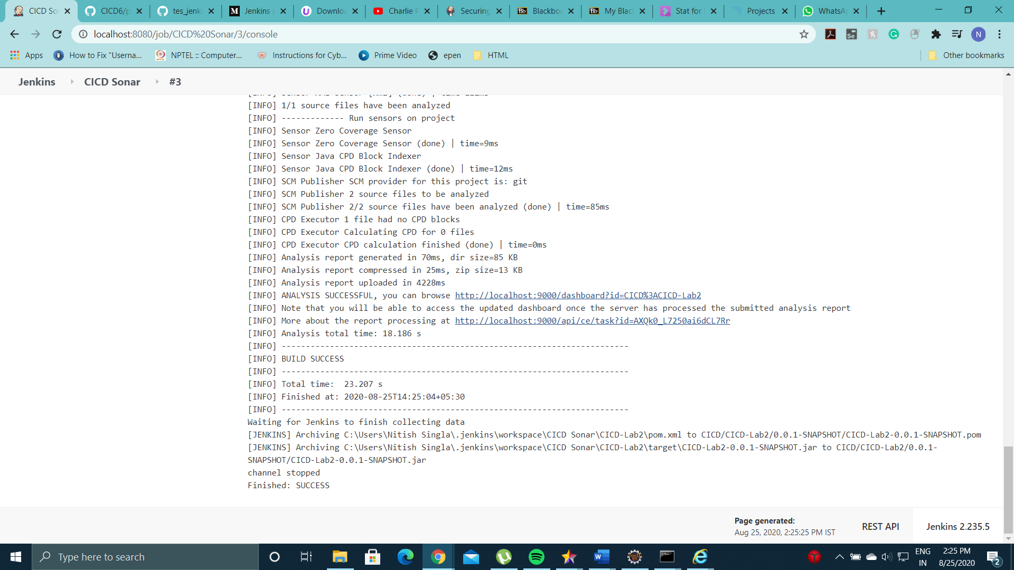

* Log on to localhost:9000 and land on Sonarqube Server. Here, you can see the Static Code Analysis for the project.

