**CI/CD**

**LAB EXPERIMENTS 6**

**SUBMITTED BY:**

NITISH KUMAR SINGLA

500071913

R171218126

**SUBMITTED TO:**

HITESH KUMAR SHARMA SIR

**Create Pipeline using Jenkinsfile**

* Create a Maven Project

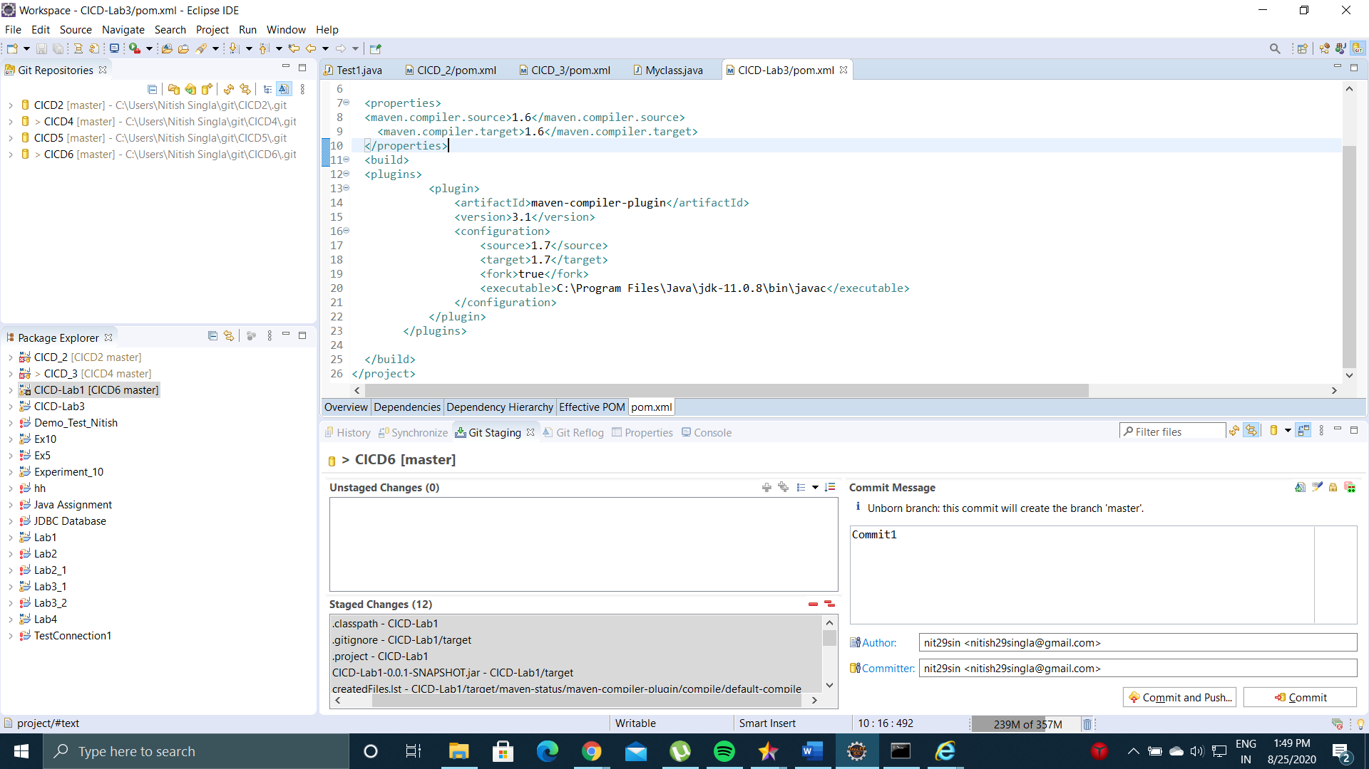

* Import the Maven Project to a Github Repository

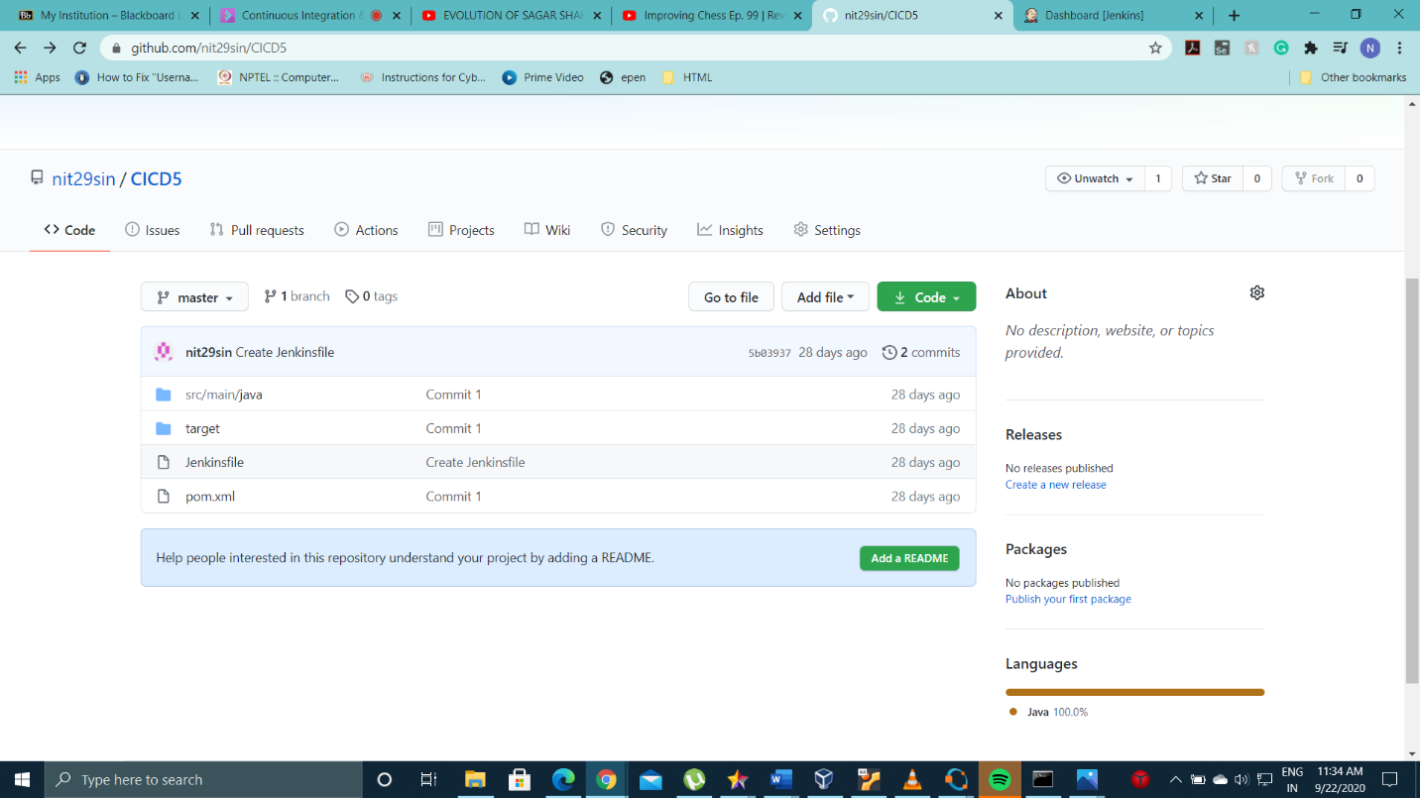

* Create a Jenkinsfile in the github repository and write a script in it (you can write maven goals in the file). Jenkinsfile is a text file that contains the definition of a Jenkins Pipeline and is checked into source control.

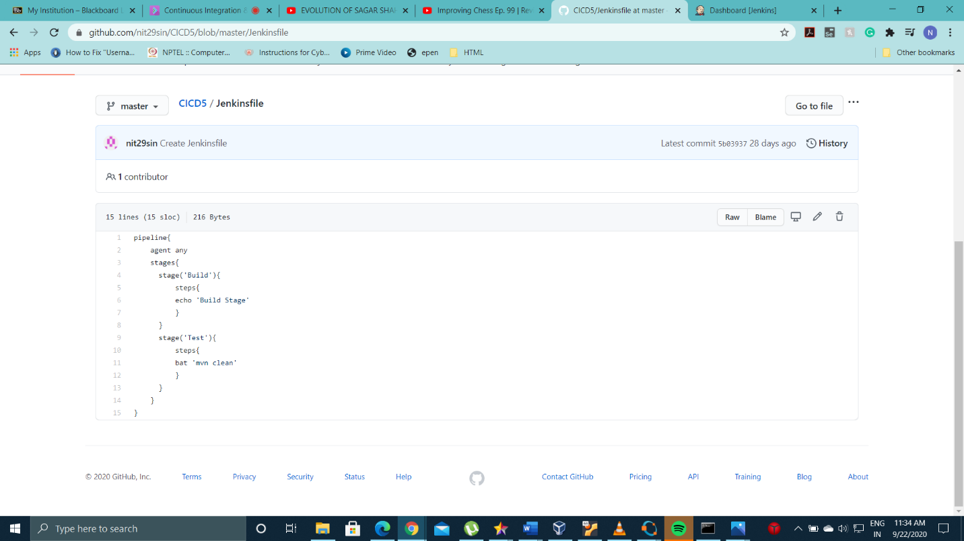

* Click on Pipeline to create a Jenkins Pipeline

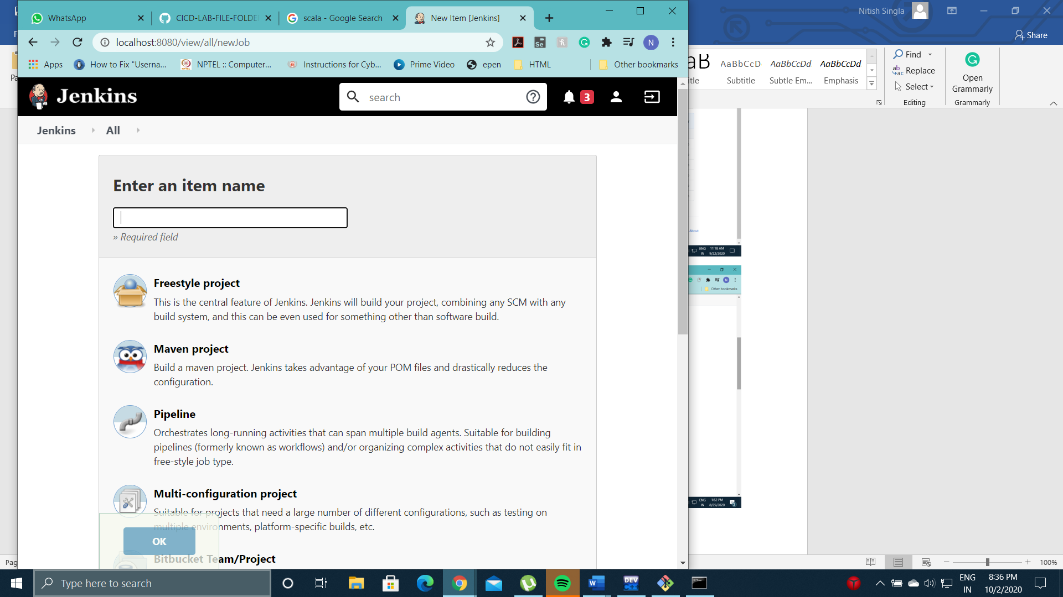

* Enter the url of github repository which contains the maven project.

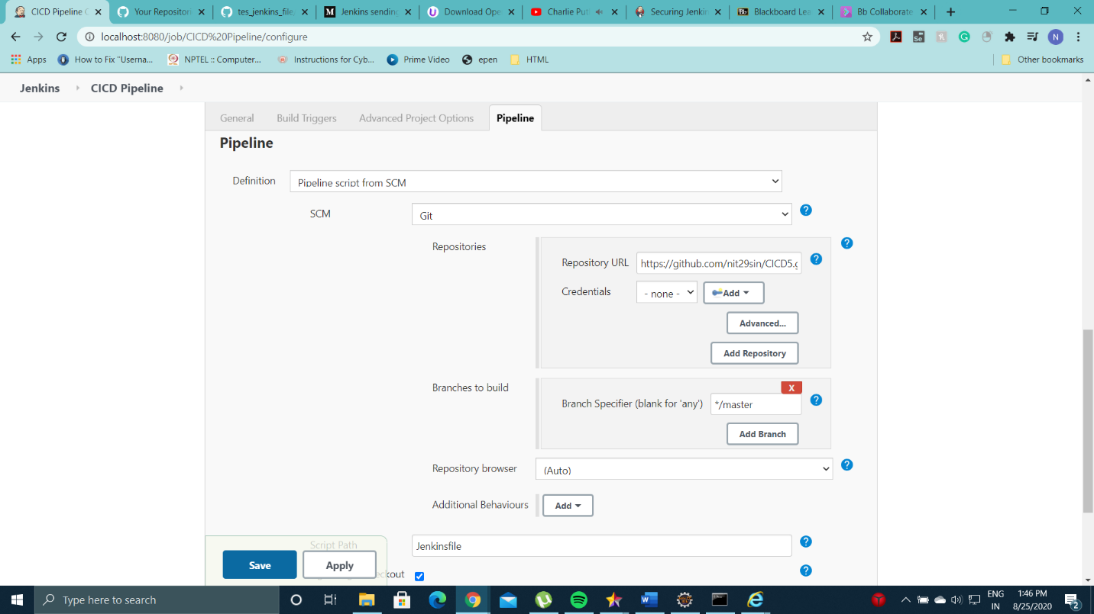

* Click on build now to execute the pipeline written in the Jenkinsfile
* Look at Stage View for stages times and successful execution of each goal

