**CI/CD**

**LAB EXPERIMENT 7**

**SUBMITTED BY:**

NITISH KUMAR SINGLA

500071913

R171218126

**SUBMITTED TO:**

HITESH KUMAR SHARMA SIR

**Create Jenkins Pipeline using BlueOcean Plugin**

**Blue Ocean** is a new user experience for **Jenkins** based on a personalizable, modern design that allows users to graphically create, visualize and diagnose CICD Pipelines.

* Install BlueOcean Plugin
* Click on Open BlueOcean

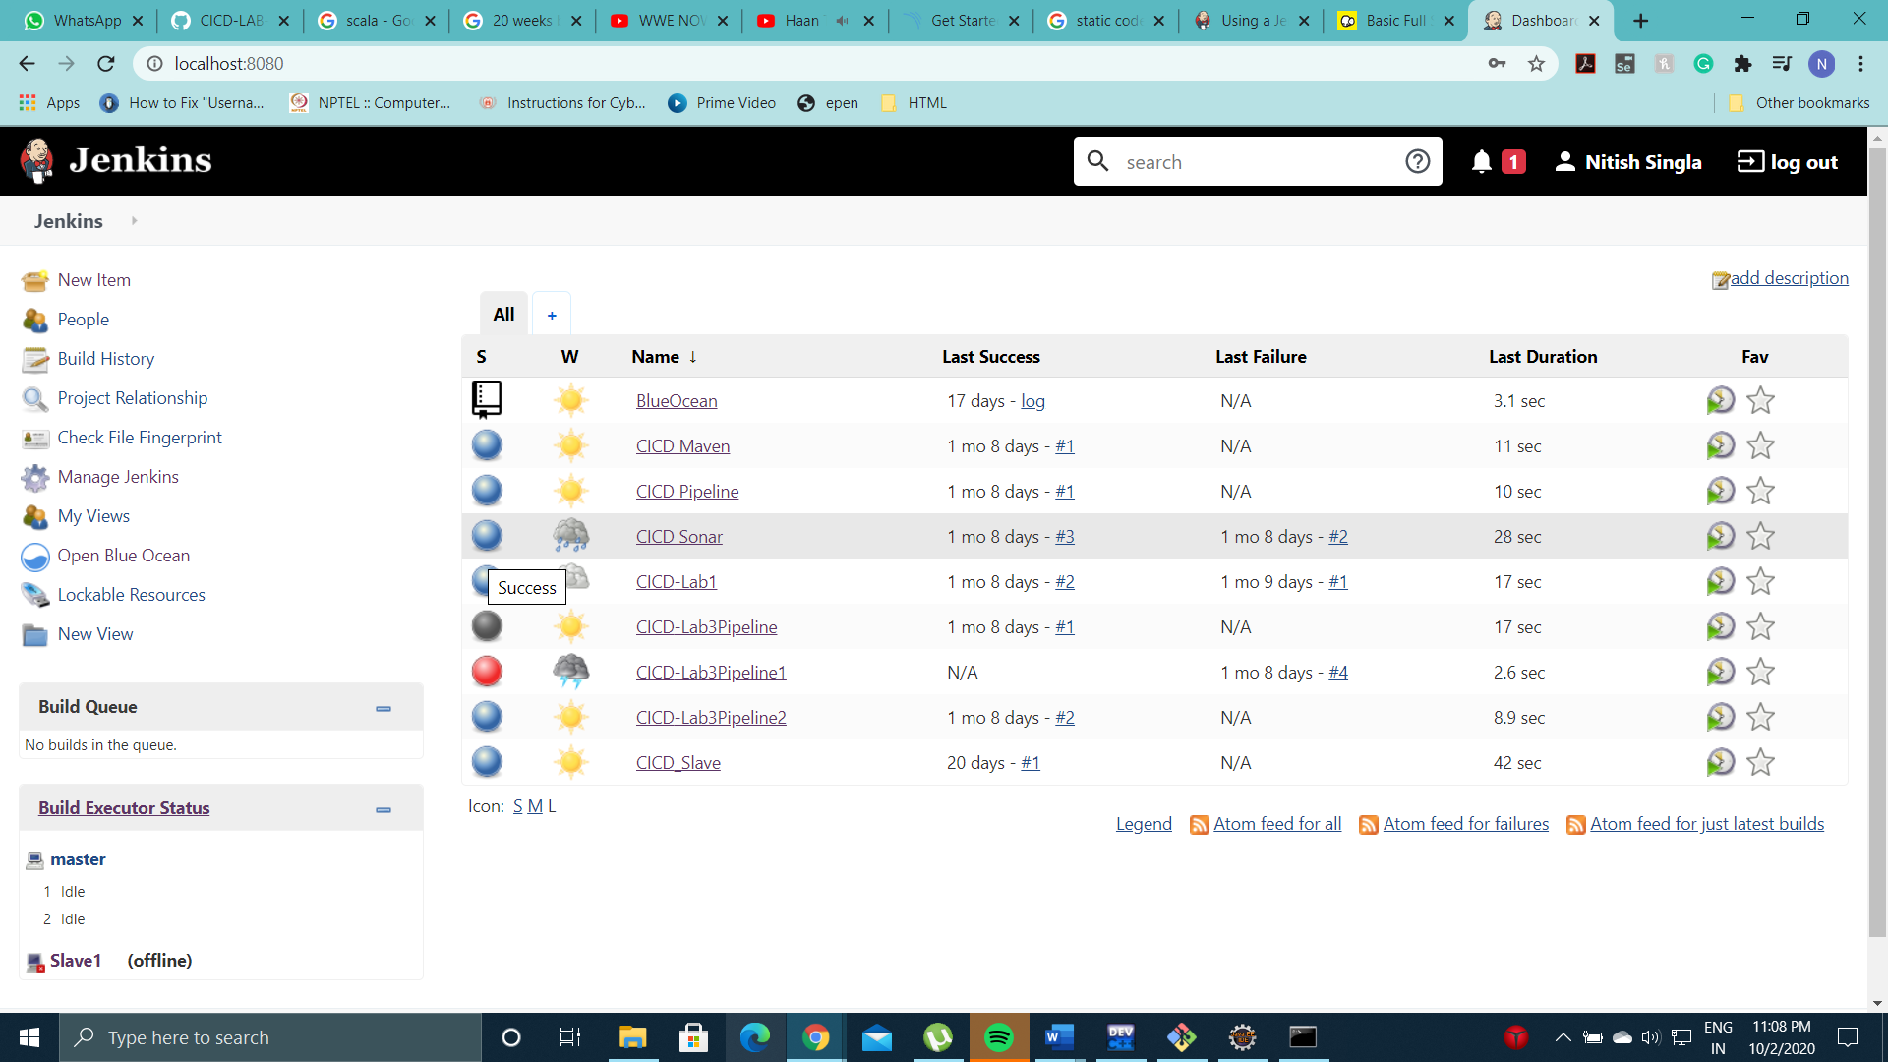

* Enter Github Credentials to integrate BlueOcean with Github

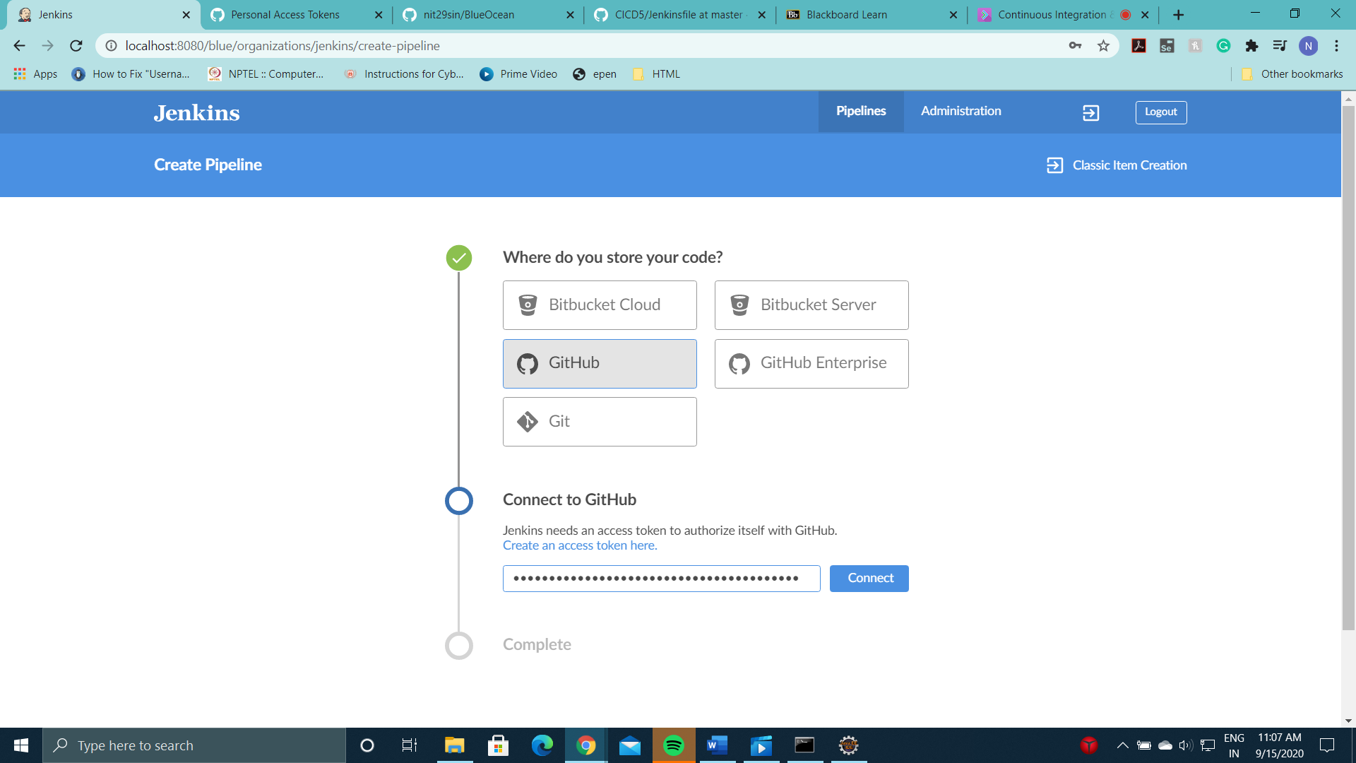

* Select a Github Repository with a Maven Project and Jenkinsfile in it.

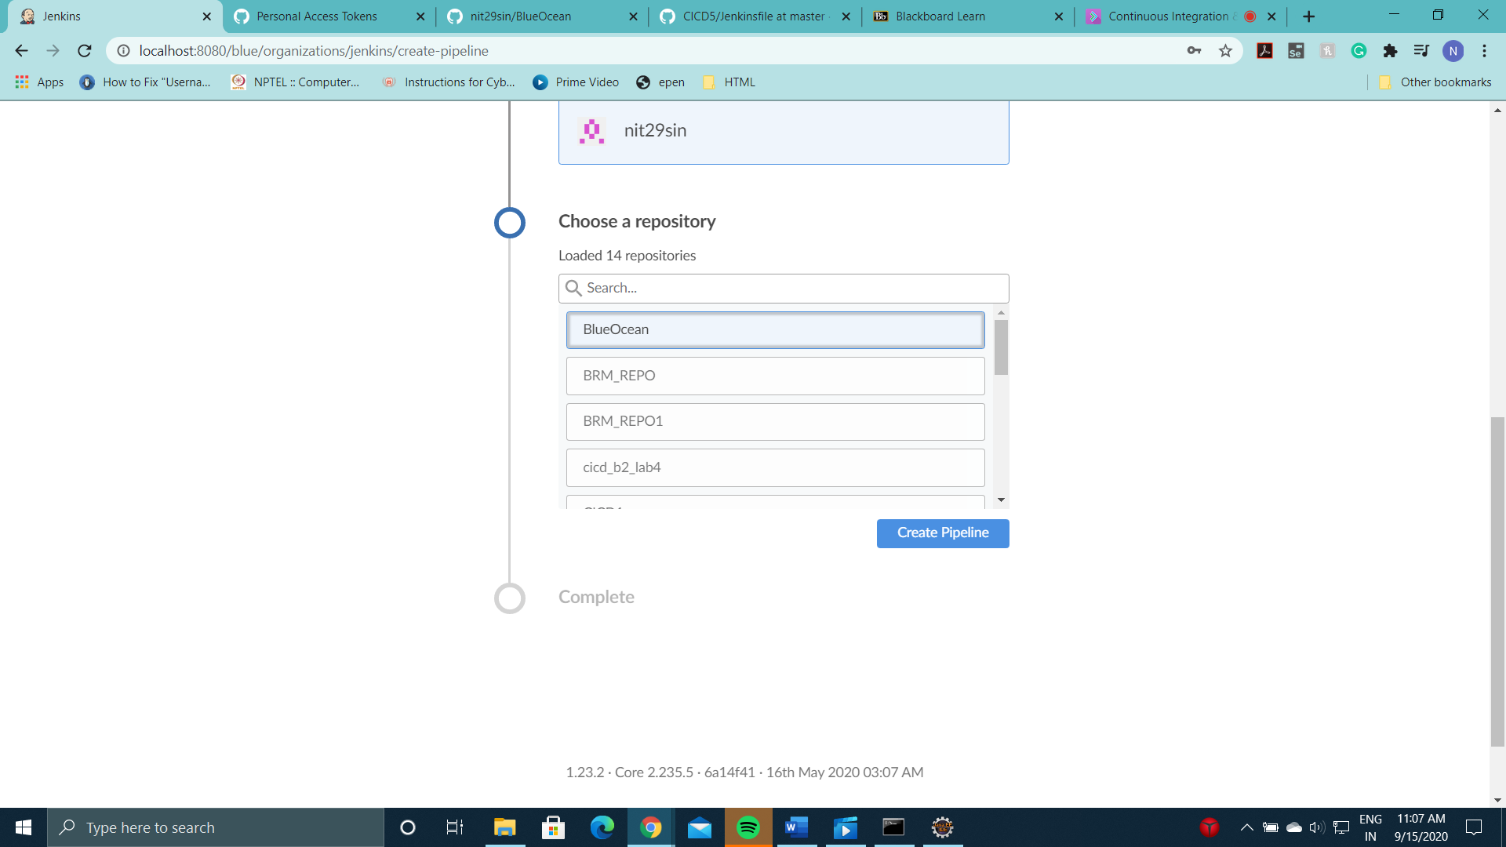

* Now your Maven Project is integrated with BlueOcean. Click on the desired project.

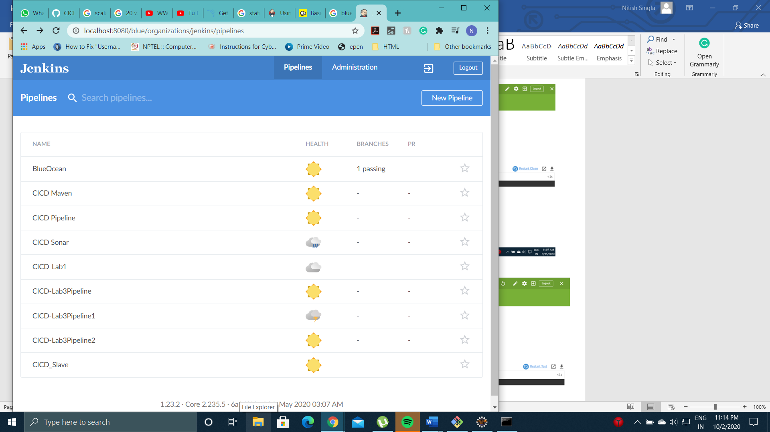

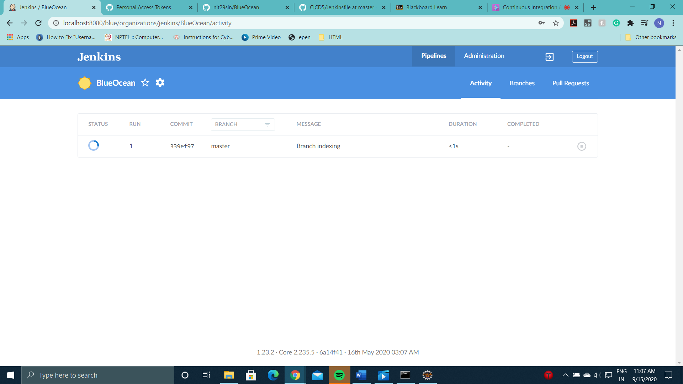

* Pipeline has been successfully executed.

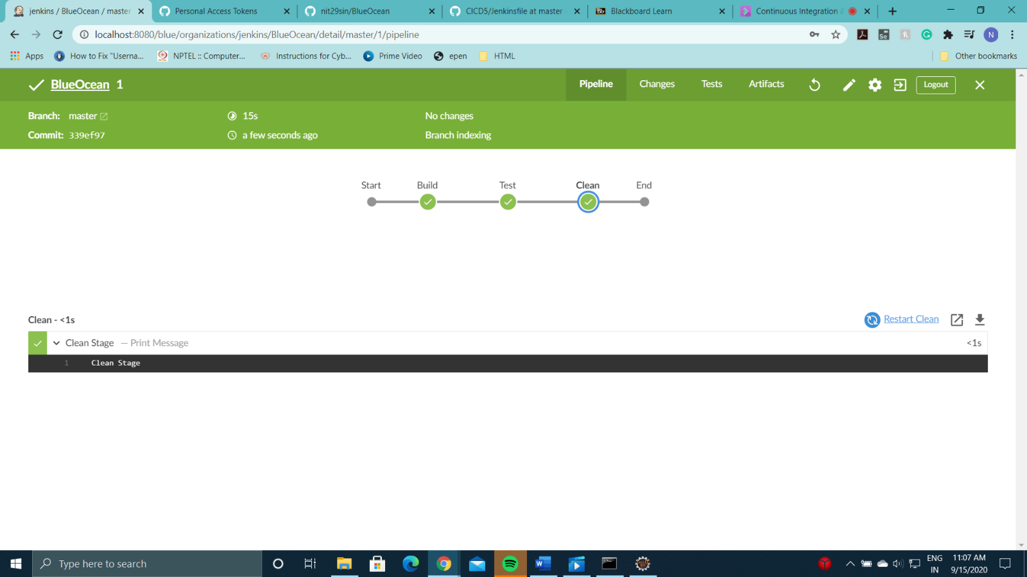

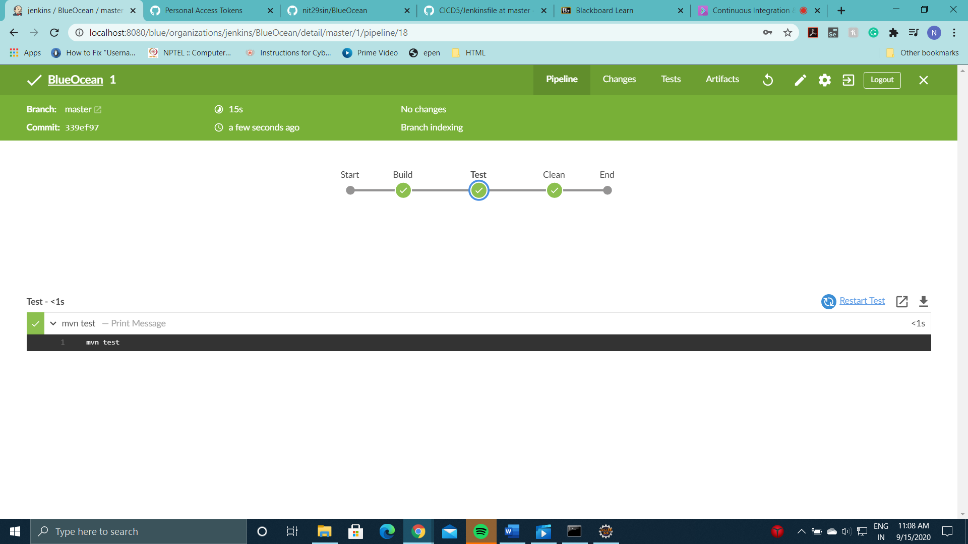

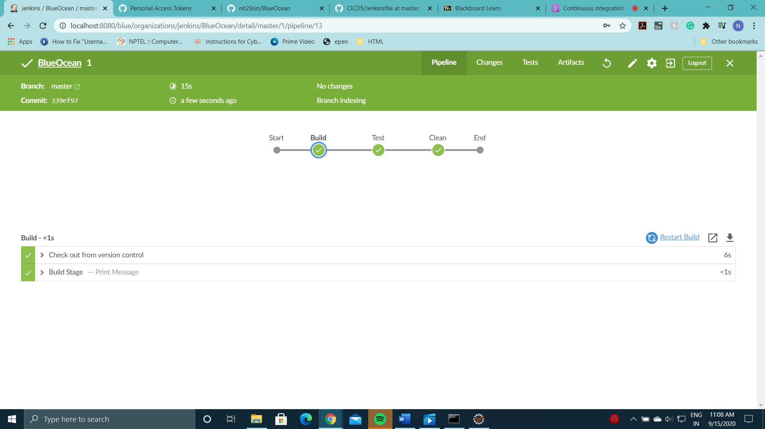

* Jenkinsfile

