**CI/CD**

**LAB EXPERIMENT 8**

**SUBMITTED BY:**

NITISH KUMAR SINGLA

500071913

R171218126

**SUBMITTED TO:**

HITESH KUMAR SHARMA SIR

**Implementing Master/Slave Architecture in Jenkins**

* Create a new node and name it as Slave1
* Download agent.jar file
* Create a folder
* Run the command java -jar agent.jar……. with working directory of the folder created earlier
* Create a Maven Project in Jenkins and mention the slave name there.
* Build the Maven Project

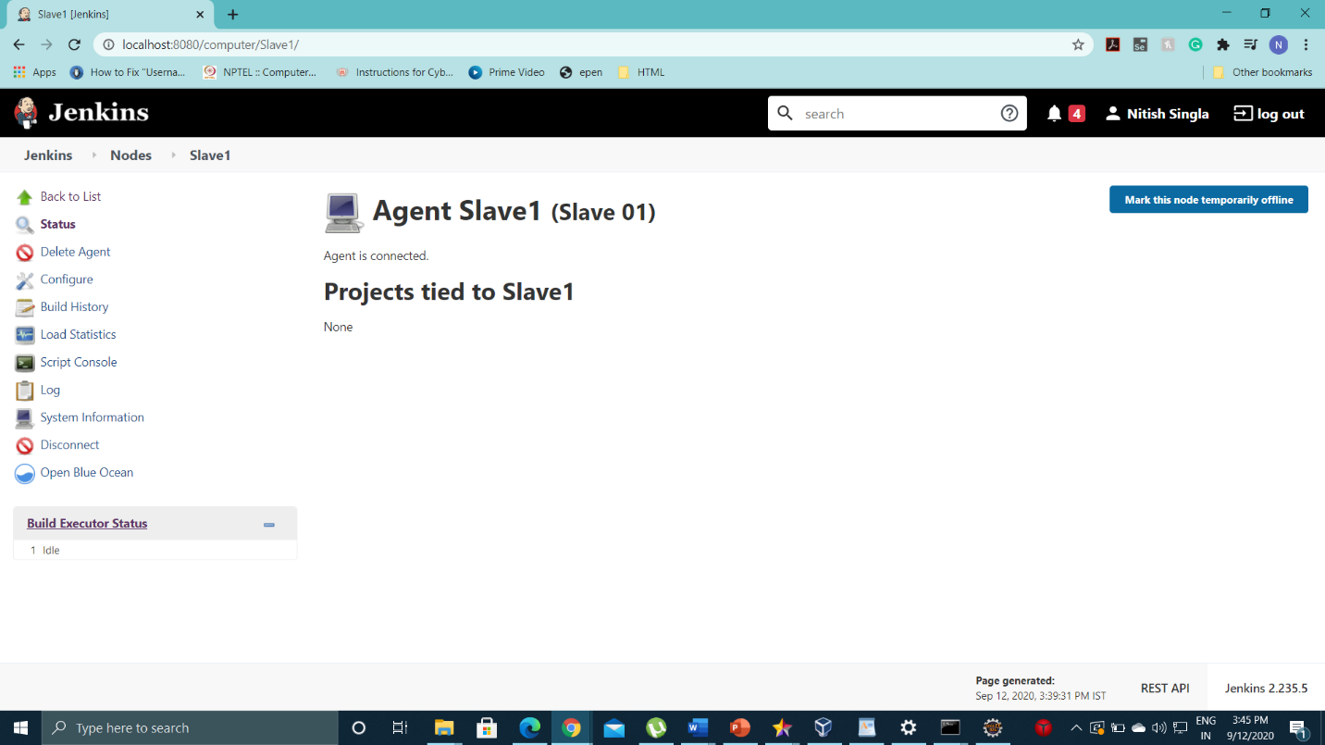

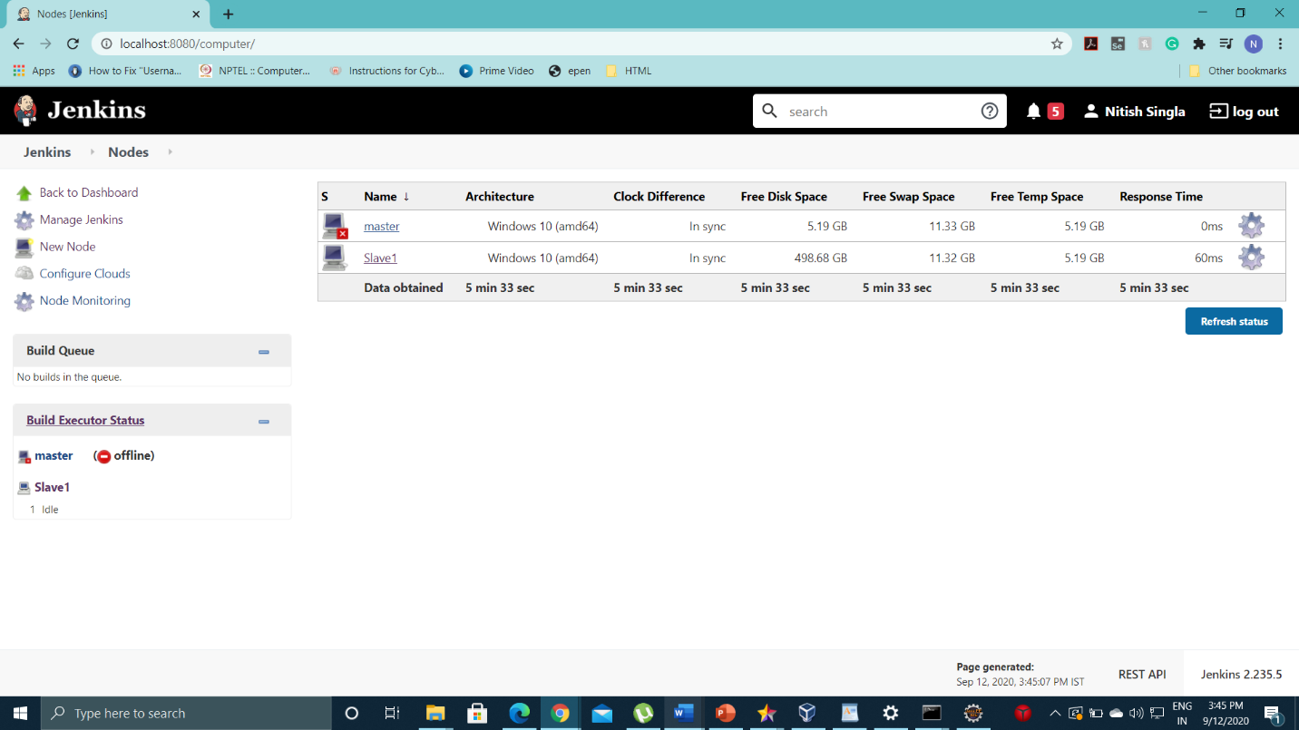

* agent.jar

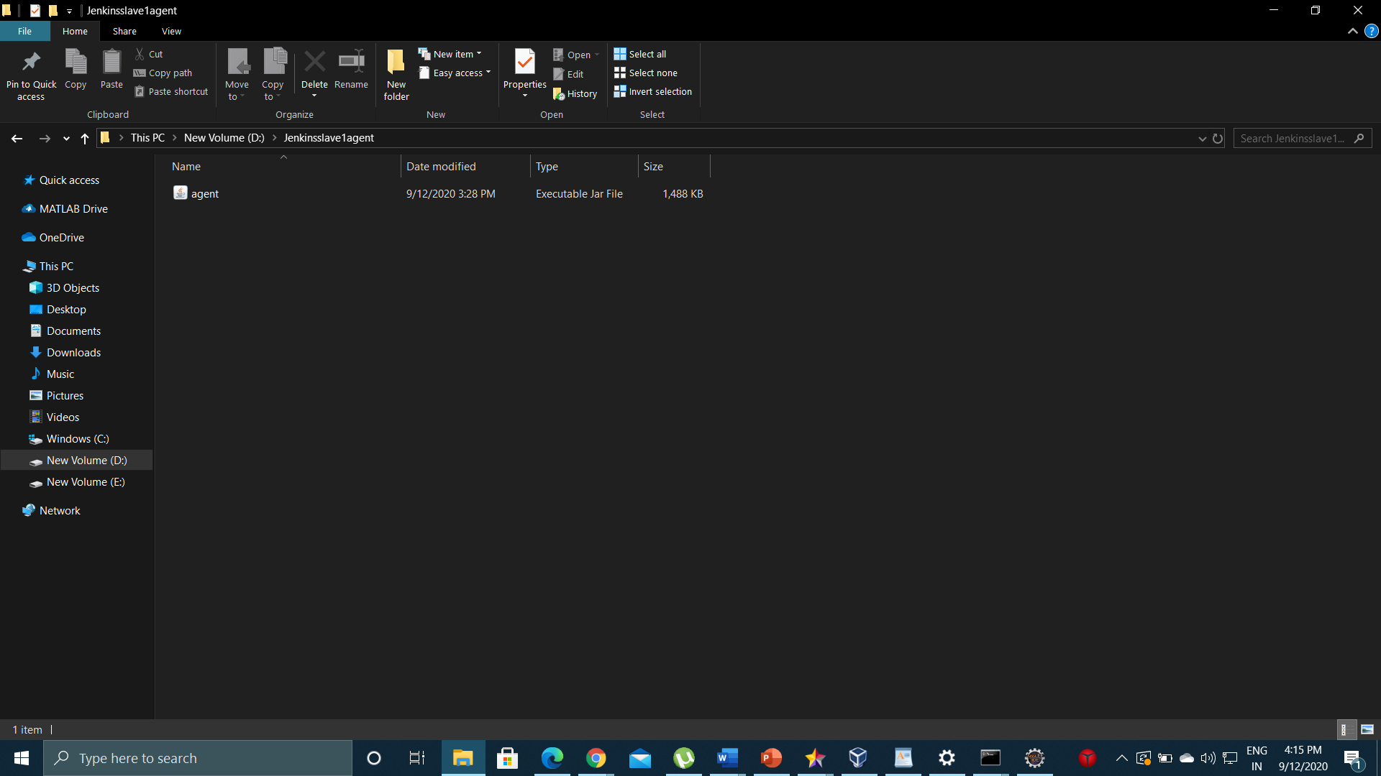

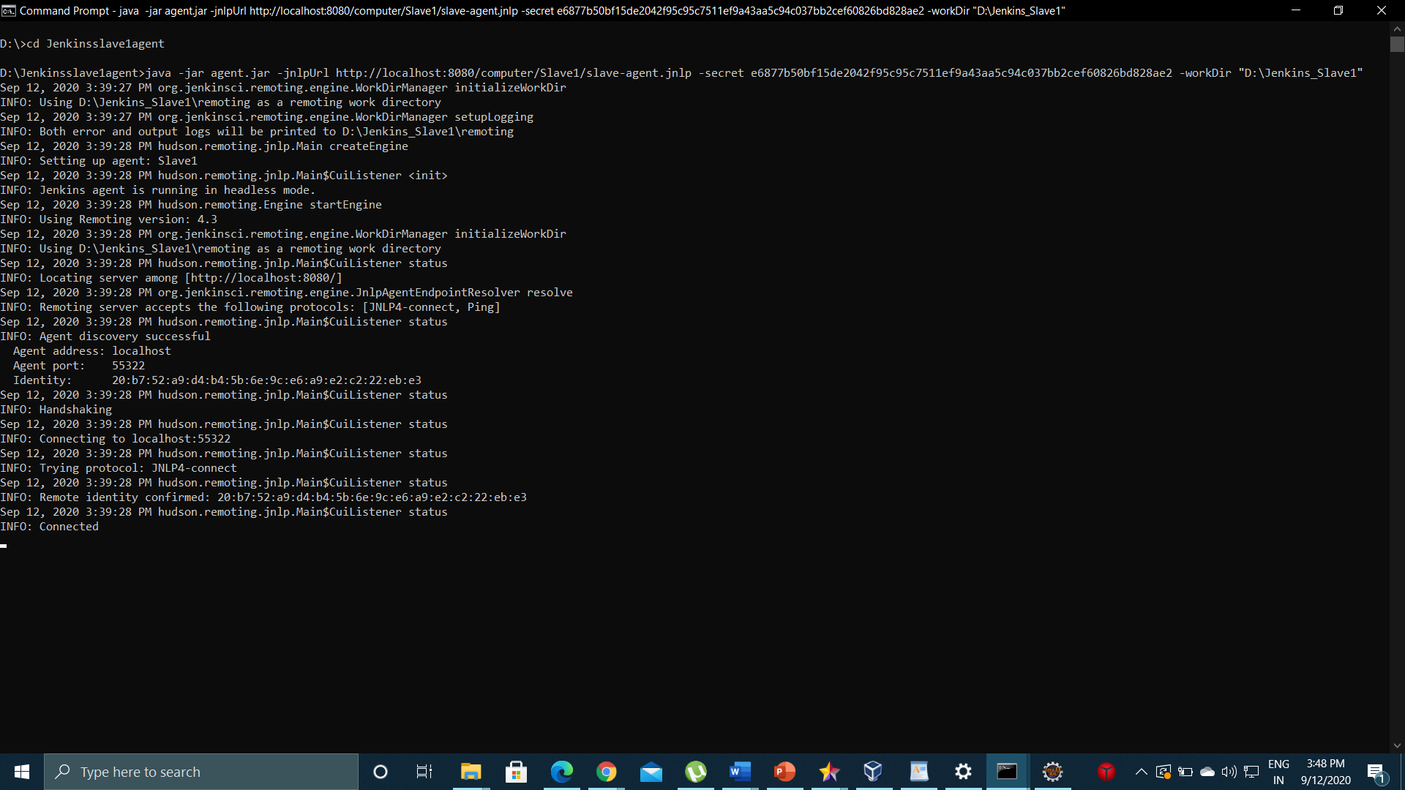

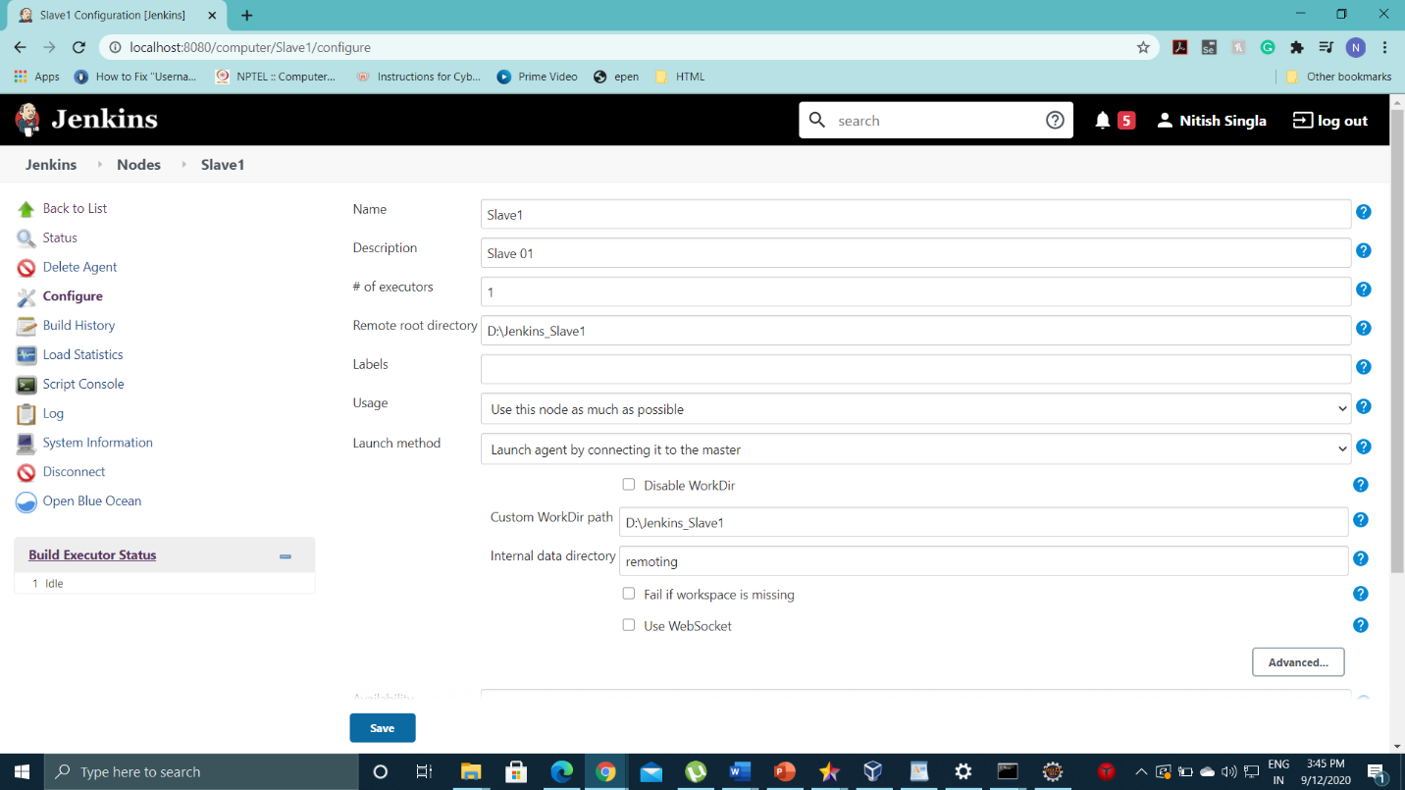

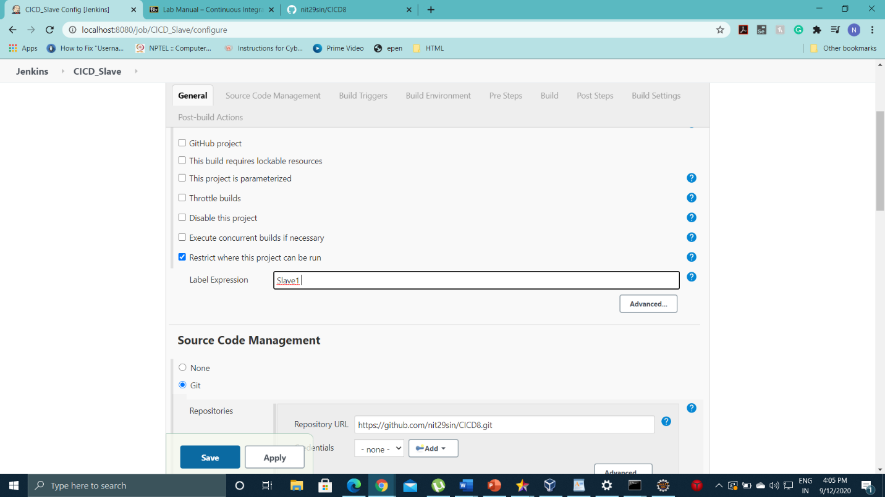

* Build Success

