**CI/CD**

**LAB EXPERIMENT 11**

**SUBMITTED BY:**

NITISH KUMAR SINGLA

500071913

R171218126

**SUBMITTED TO:**

HITESH KUMAR SHARMA SIR

Install Vagrant by Hashicorp Version 2.2.10 from <https://www.vagrantup.com/downloads.html>

Run Command **vagrant –version** to check whether Vagrant has been installed on the system or not.

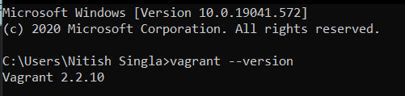

Create a Folder and Give it a Name. The Virtual Machine will be created by the same name in Oracle Virtual Box.

Run command **vagrant init** to initialize Vagrant.

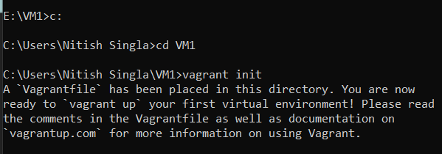

After Running vagrant init command, **Vagrantfile** will be created.

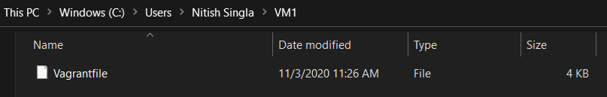

This is Vagrantfile. Enter the name of the image of Ubuntu Operating System which you want to run in the Oracle Virtual Box.

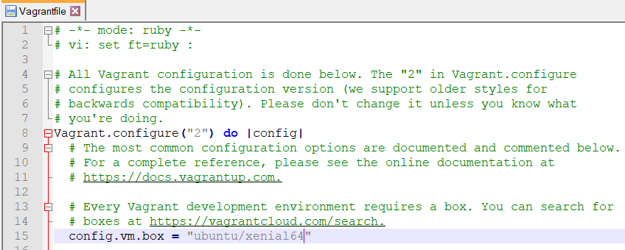

Now, Run command **vagrant up.**

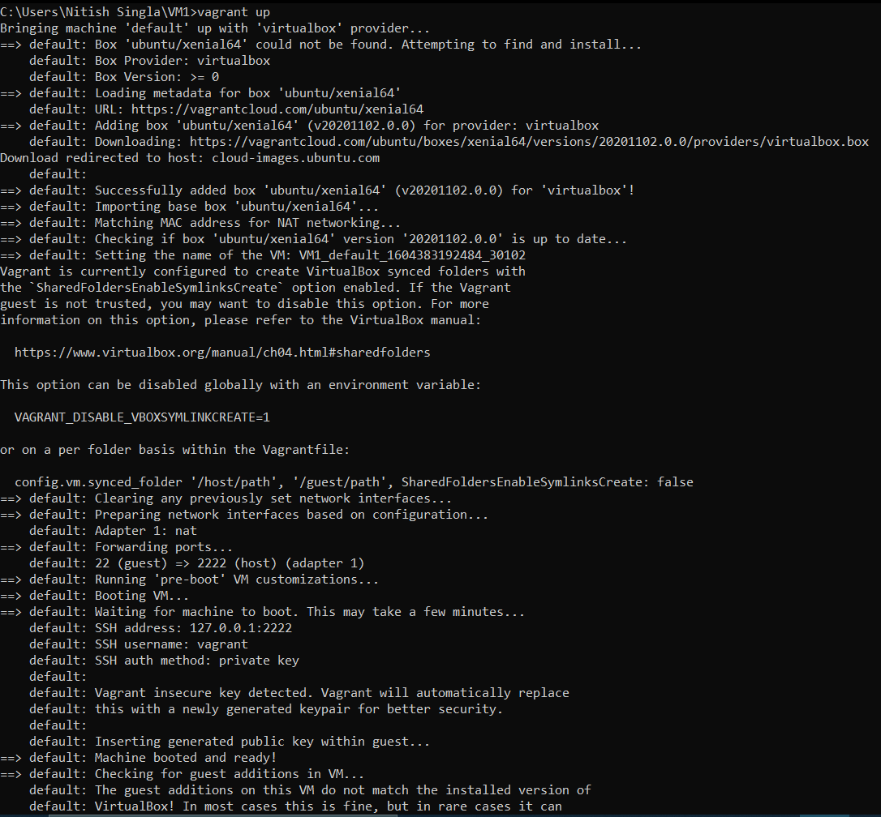

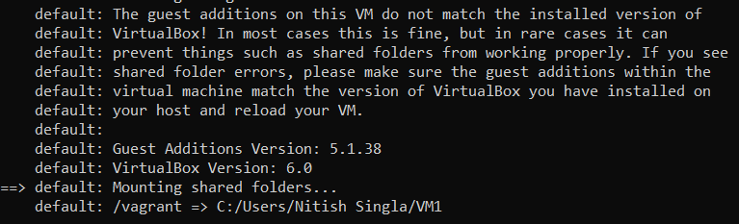

Now, Run command **vagrant ssh** to use Ubuntu in Windows.

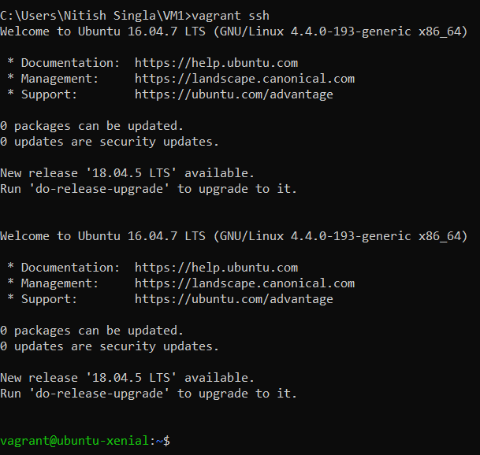

VM1_default_1604383192484_30102 Virtual Machine is created in Oracle Virtual Box.

