**CI/CD**

**LAB EXPERIMENT 12**

**SUBMITTED BY:**

NITISH KUMAR SINGLA

500071913

R171218126

**SUBMITTED TO:**

HITESH KUMAR SHARMA SIR

**Installing Docker**

$ curl -fsSL https://download.docker.com/linux/ubuntu/gpg | sudo apt-key add –

$ sudo add-apt-repository "deb [arch=amd64] https://download.docker.com/linux/ubuntu $(lsb_release -cs) stable"

$ sudo apt-get update

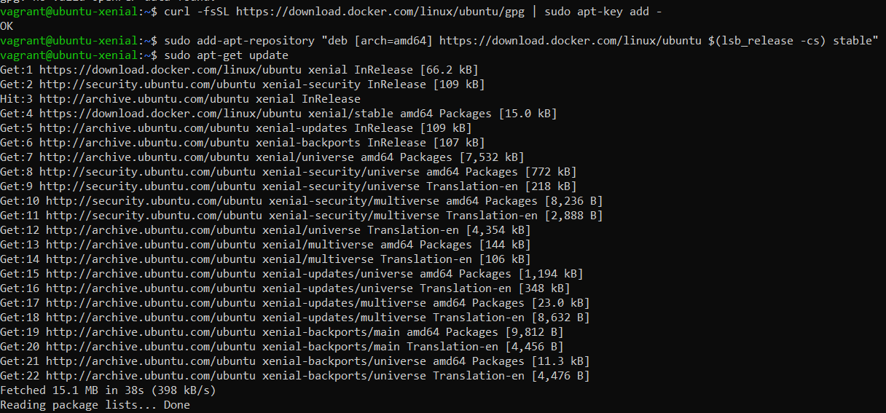

$ apt-cache policy docker-ce

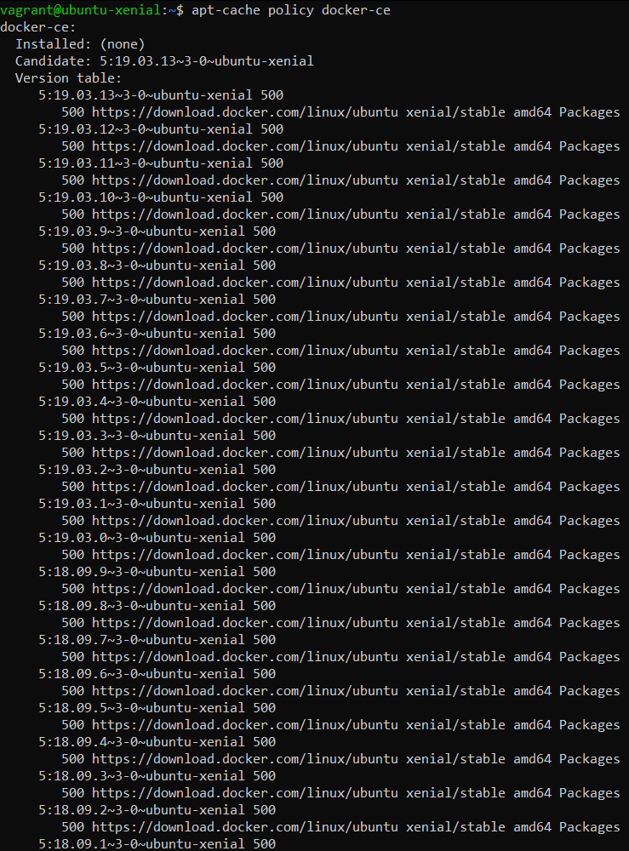

$ sudo apt-get install -y docker-ce

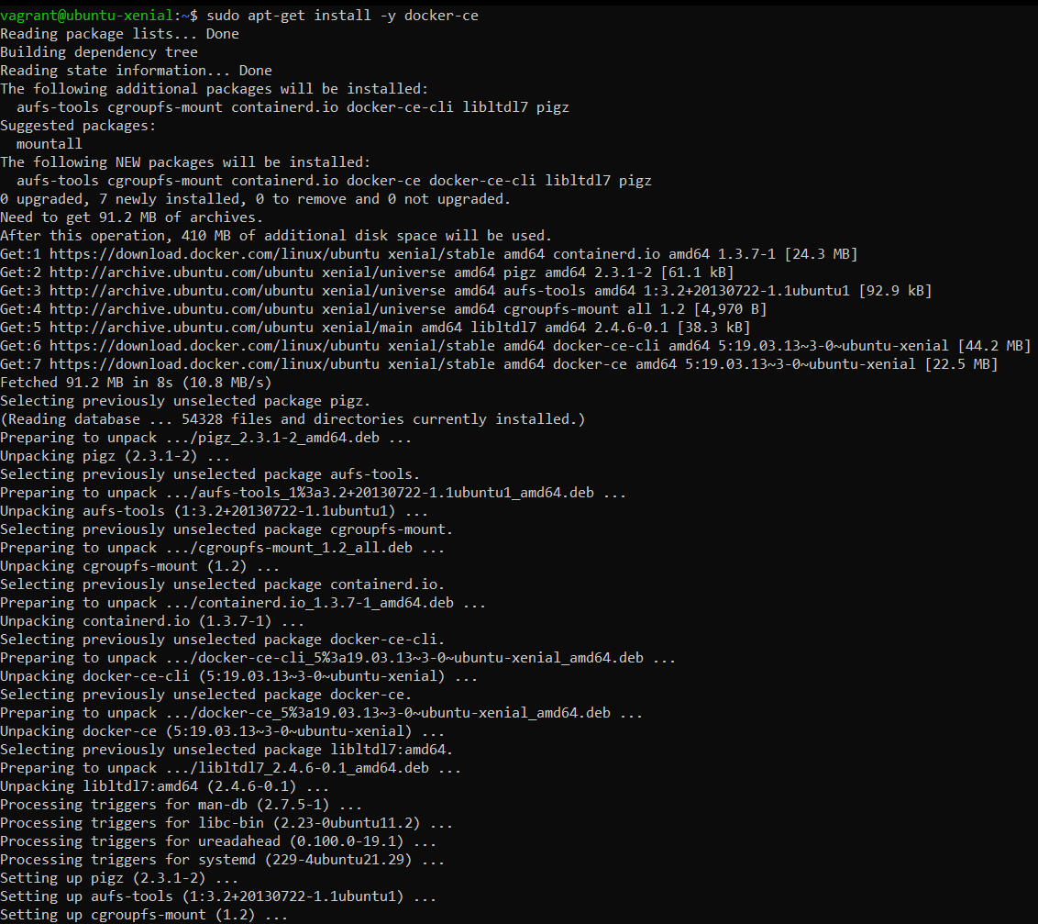

$ sudo systemctl status docker

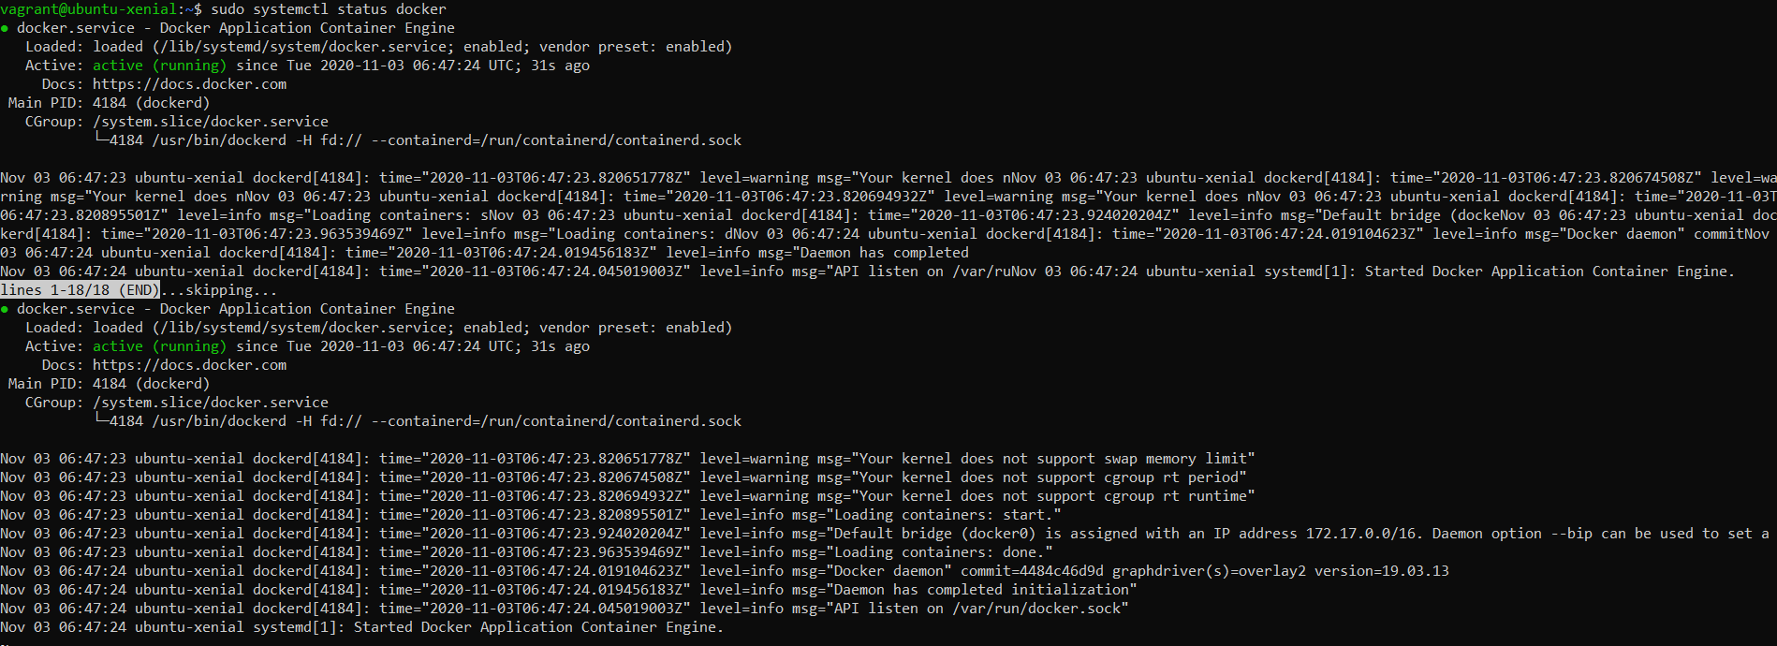

$ docker --version

$ sudo usermod -aG docker ${USER}

$ su - ${USER}

$ sudo usermod -aG docker vagrant

$ docker run -it ubuntu

$ docker ps

$ docker ps -a

