**Real-Time IoT based Forcasting Power Generation in Microgrid System**

*Narendra Babu P1,1, Ajay1,2, and Gayadhar Panda2,3

1School of EEE, VIT Bhopal University, Sehore, Bhopal-Indore Highway, Bhopal-466114, 2Department of Electrical Engneering, Natıonal Instıtute of Technology Meghalaya, Shıllong-793003

narendrababu.p@vitbhopal.ac.in1, ajaysinghpoonia805@gmail.com2, and [gayadhar.panda@nitm.ac.in](mailto:gayadhar.panda@nitm.ac.in3)[3](mailto:gayadhar.panda@nitm.ac.in3)

**Abstract.** A microgrid network is a small scale electrical grid network which is used to generate electrical power from various renewable energy resource such as wind energy and solar energy to provide reliable and consistent power to the local customer. Wind energy and Solar energy are both weather dependent renewable resource due to this intermitence power generation occur and unstable quality power generation cause voltage fluctuation between point of common coupling and load in microgrid system. Therefore in order to supply high quality sufficient, consistent, and stable power to critical loads it is mandatory to study on accurate power forcasting in microgrid system. Power outages power in microgrid vary the power consumption and affect electrical tariff and changes human behaviour in response to the changes in electrical tariff. The intermittence and uncertainty renewable energy may cause unstable quality power generation in microgrid. The paper presents the IoT based power forecating in microgrid systems. Moreover, real-time power quality characteristcks are also presented in the paper.

**Keywords:** Microgrid, distribution generation, power forcasting, PV system, IoT.

**1 Introduction**

Primary power grids consist of a complex fabric of generation plants, substations and transmission lines that help supply electricity to cities, homes, and small businesses. In a conventional grid energy may come from a variety of sources, such as coal hydroelectric plants and nuclear energy. In addition to primary power grinds there exits smaller independent grids called micro grids. These micro grids provide power to remote areas. A power grid system that incorporates micro grids would still have conventional centralized energy sources, but many more users would have local sources of energy.

In a utility grid network that incorporates micro grids, the micro grid can coordinate the use of local energy sources. This allows local power grids to maintain necessary levels of service, operating independently from the larger grid, so users may continue to receive power even after a blackout occurs. In a conventional power grid, a blackout at the utility company substation would cause all users to lose power. A microgrid can separate itself from the main grid during unscheduled periods of electricity interruption to continue feeding its own islanded portion of the grid. In addition, micro grid users can independently manage and distribute homegrown energy, since these sources are distributed locally within the micro grid. Micro grids include the integration and control of multiple local generation and storage devices, such as diesel generators, and battery systems. This provides on-site generation for local loads in both grid-tied and islanded modes of operation.

In addition to these conventional generation sources, micro grids also incorporate the use of renewable energy such as wind turbines and solar panels (PV). This helps reduce the dependency on conventional fossil fuel, while at the same time reducing carbon dioxide (C02) emissions. The drawback of incorporating these renewable energy sources is in their dependency on variable natural resources. The variability of renewable energy sources requires quick response from the micro grid and highly efficient storage devices to ensure stability. For this reason, it is necessary for micro grids to have the ability to forecast wind and solar behaviour to estimate the electricity production during the day. This paper focuses on a prediction model for solar irradiance forecasting. The proposed forecasting method model’s historical data as a time series to predict solar irradiance behaviour. The proposed solar irradiance prediction model is tested using a residential micro grid model.

Energy forecasting has come to be a common concern among research due to the cumulative impact of renewable energy in the present-day power system. The most common RESs are wind, water, solar and biofuel or biomass. The customary utilization of these energy sources includes power generation, heating, and transport fuels. Renewable energy sources are of importance because of their capacity to sustain. This outcome is a substitute for the diminution of conventional energy sources for example coal, petrol, and nuclear energy. Energy from these sources is clean and has a much lower environmental impact when compared to traditional energy sources. As a result of the impact, it is vital for grid workers and stakeholders to ascertain how much power renewable energy sources will yield in the succeeding hours and days. A distributed micro grid system is a less expensive option for the construction of large, central power plants and High-Voltage transmission lines. They afford consumers the potential for lower cost, higher service reliability, high power quality, increased energy efficiency, and energy independence. The use of renewable distributed energy such as wind, photo-voltaic, geothermal, hydroelectric power can also provide a significant environmental benefit.

This research, therefore, presents a method for short term energy forecasting in Distributed renewable energy source (D-RES) micro-grids using mobile devices at the network edge. This ensures effective and efficient management of the generated power from micro-grids. Also, these mobile devices have the required storage and network resources to avoid delay-sensitive tasks. Research in used mobile devices to formulate an IoT architecture that can execute complex computational tasks at the network edge. Mobile devices, however, could be any electronic devices capable of running complicated programming constructs using the medium to low power computational resources. Examples of such devices include micro-controllers, smartphones, and desktop/laptop computers. Generally, energy forecasting for D-RES is done for the effective coordination of power from the grid to the consumers and for scheduling the operation of the different types of Renewable Energy sources in the micro-grid. This research, however, considers the use of energy forecasting for the latt

er. This is because RESs operate on different mechanisms and with proper coordination and management; they can be made to support each other thus providing a sustainable source of power for distribution to consumers. A well-defined Electrical topology is therefore proposed in this research that allows for the easy incorporation of RESs into a micro-grid in a distributed fashion. As opposed to the other approaches, this ensures the addition of any number of RES into the DRES network which in turn eliminates the limit to the power that could be generated from the micro-grid. However, as stated in the above paragraph, the mobile devices provide control for the RESs in the D-RES network at the network edge.

A wireless sensor network (WSN) is employed to gather data (generated electrical energy) from the D-RES network and passed to the local mobile device for administering the control by using pre-defined control algorithms. With this approach, the appropriate control operation would be administered without delay since operations are carried out at the network periphery. Moreover, external updates would be easily administered with little or no stress on the network bandwidth as the data from the sensors are analyzed locally on mobile devices. However, the cloud would be used as a support for the mobile devices by providing permanent storage for the locally generated data and a platform for offloading resource-intensive computations. Nevertheless, mobile devices are constrained by limited computational resources such as memory and processing power. Therefore, the method for energy forecasting should be carefully selected to work with these constraints while still maintaining acceptable accuracy. This research, therefore, utilizes the method of Deep Neural Network (DNN) for creating lightweight machine learning models that can be easily deployed on the resource-constrained devices at the network periphery. DNNs are simply Artificial Neural Networks (ANNs) with a higher number of hidden layers in their architectures. They are well known for their ability to capture complex relationships between features of very large non-linear datasets. This approach is used instead of the very old shallow learning method which has fewer hidden layers or the LSTM-based RNN methods which require a huge amount of memory-bandwidth during its operation. The dataset for forecasting energy in the micro-grid is historical data of its generated power. Other researchers consider the use of meteorological data obtained from meteorology stations with special considerations to changes in atmospheric features such as humidity, temperature, light, etc. Even though results obtained with such a dataset are good, the data is not always available for use and as such cannot be relied on.

This research would focus on creating the electrical network topology for incorporating the RESs into the micro-grid network with a clear description of the different components and sections. Furthermore, a dataset from a solar power generation company in Belgium would be used to create a DNN model that can be deployed on any mobile device at the network edge. However, the model would be tested with a test dataset to observe for over fitting. Evaluation matrices such as the mean square error (MSE) and the r-square would be used to evaluate the model. Also, the model would be tested with different topologies (number of hidden layers and activation functions) to determine the optimal architecture for the DNN in the D-RES.

**2 System Description**

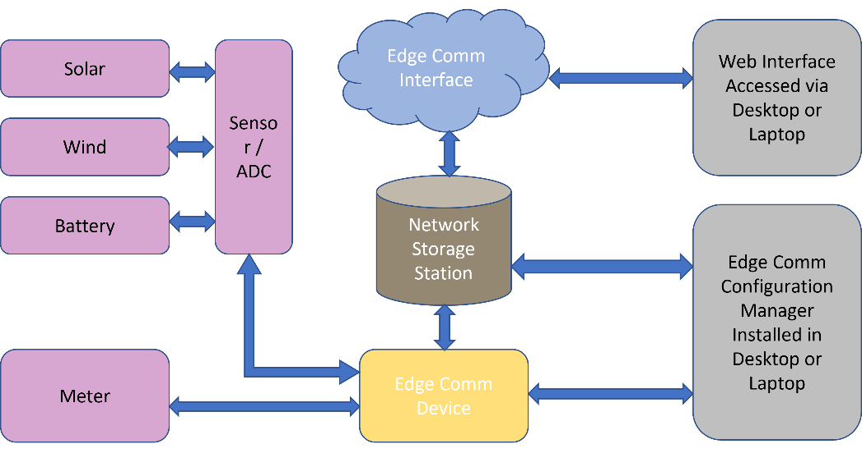Fig. 1: Generalized block diagram of the proposed system

Remote monitoring and controlling of the sub-station equipment is an important issue for the power/energy management department which is normally done manually, or using an expensive PLC and SCADA system. With the emergence of the internet and computational era, a smart monitoring and reliable controlling system over the entire sub-station equipment is highly desirable that can be achieved by introducing the Internet of Things (IoT) technology.

The IoT based system allows objects to be sensed or controlled remotely across existing network infrastructure, creating opportunities for more direct integration of the physical world into computer-based systems and resulting in improved efficiency, accuracy and economic benefit with the added merits of minimum human intervention.

**2.1. Components and sub-systems:**

Fig. 2: EDGE Comm controller



Fig. 3: Workstation



Fig. 4: Overall functional blocks

**2. Energy Forecasting**

**3. Real-time IoT based Forecating**

Fig. 5: Real-time IoT setup

IoT has been proposed to monitor the system data and information and communicate the system appliances with the central management system and control unit. The execution time, required memory, and the proposed scheme’s time response have been executed to validate the proposed scheme’s complexity. The results show the IoT ability to execute the system data and information and respond fast to any system load variations. This improves system performance and avoids the delay in the system energy supply.

Grid-connected mode is one of the decisive and crucial operational modes in microgrid, creates a balance between power generation and consumption to avoid the system outage problem. In this scenario, optimal integration of the microgrid with the traditional grid is solely based on the micro controller unit’s decision. Micro controller unit (MCU) decides whether to act as local generation plant or purchase electricity to/from the traditional grid after real-time monitoring and communication with other two control units. One of the other factors that influences the MCU’s decision is the worst’s case transactional module for the surplus power with the aim to promote business between traditional grid and microgrid. Thus, it is verified that due to transaction mechanism electrical network is always in a balanced state. Power factor (PF) is the ratio of working power, measured in kilowatts (kW), to apparent power, measured in kilovolt amperes (kVA). Apparent power, also known as demand, is the measure of the amount of power used to run machinery and equipment during a certain period. It is found by multiplying, kVA = VA. The result is expressed as kVA units. The PF of an inductive load is lagging and that of a capacitive load is leading. A pure inductor has zero-lagging power factor and absorbs positive reactive power. A pure capacitor has zero-leading power factor and absorbs negative reactive power or delivers positive reactive power. Loads are usually specified in terms of P and PF at a rated voltage Examples are motors and household appliances.

Alternatively, the apparent power and PF can be specified. The product of V and I is called the apparent power. The investment cost of a utility depends on the voltage level and the current carried by the conductors. Higher current needs larger, more expensive conductors. Higher voltage means more insulation costs. The revenue of a utility is generally based on the amount of energy in Kilowatt per hour sold. At low power factors, the revenue is low since power P and energy sold is less. For getting full benefit of investment, the utility would like to sell the highest possible energy, that is, operate at unity power factor all the time. Utilities can have a tariff structure that penalizes the customer for low power factor. Most electromagnetic equipment such as motors have low lagging PF and absorb large reactive powers. By connecting capacitors across the terminals of the motor, part or all the reactive power absorbed by the motor can be supplied by the capacitors. The reactive power from the supply will be reduced, and the supply PF improved. Cost of the capacitors is balanced against the savings accrued due to PF improvement.

Figure 6 show that the THD is under 5% which is under the permissible limit according to the IEEE 519 standard. Figure 6 shows that the maximum total power was generated on 7th March’ 2021. The simulation results demonstrate the proposed controller’s ability to regulate the SMG voltage and frequency under the load demand variation. The normalized profiles of general load demand and renewable generations in a typical spring day are shown. The proposed controller has been designed to regulate the system voltage and frequency with the variation in the system load profile (the first stage output of the proposed scheme).

**4. PV Power Forecasting**

The instability of renewable sources causes voltage fluctuation and intermittent power generation, posing the obstacle for maintaining power system operations and planning power system operations. Similarly, the electricity consumption shows its seasonality in a calendar year. Thus, developing appropriate forecasting technologies to predict power generation and load demand is highly significant to overcome the supply-demand mismatch issue. In similar days, the load curves should have similar patterns. Moreover, similar days should have also exhibited similar load patterns for certain period. However, in an actual microgrid, such an ideal situation rarely happens. It is possible that in one day the load has different pattern from time to time, or the pattern of one working day may be completely different from the other working days. For such random load changes, the basis for load forecasting can only be taken from the load trends of the similar days. When the historical data and the forecasting time have a big-time gap, even if the factors that affect the load are very similar, the prediction accuracy may not be high. Therefore, the time range between the predicted day and similar days should not be too long.

The validity of the actual data will determine the accuracy of the predicted results. The raw data are instantly read by the EMS system. After analysing the load characteristics, detailed microgrid load forecasting model can be constructed. To ensure that load forecasting gets the best results, the most important thing is the historical data. The more complete and better correlated the data are, the better the predicted results are. The time series are important factors to classify the types of loads. Usually, the load is classified into working day, weekend holiday, national holidays, and unusual days such as the day of bad weather. This is since the load data for national holidays and abnormal weather days are not large enough and is unable to establish a learning data set.

In this paper we have considered the datasheet of photo-voltaic system’s output power during four normal days 4th March’ 2021 to 7th March’ 2021. And we have aggregated the hourly data using Java, map data structure and Java Regex. And by averaging the hourly data, we have predicted the hourly power generation from the photo-voltaic system for 8th March’ 2021. And then using MATLAB we have plotted the predicted hourly generation and the actual hourly generation on 8th March’ 2021. And we have found that the predicted and the actual power generation are almost overlapping with each other.

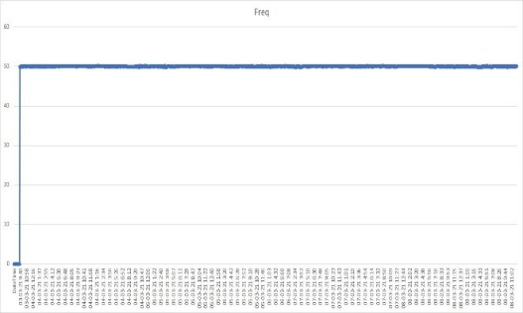

Fig. 6. Real Time frequency

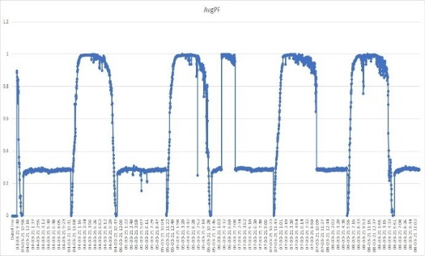

Fig. 7. Real Time average power factor

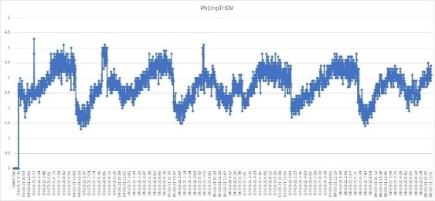

Fig. 8. Real-Time THD

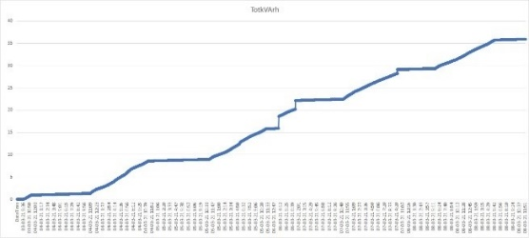

Fig. 9. Real Time kvarh generation

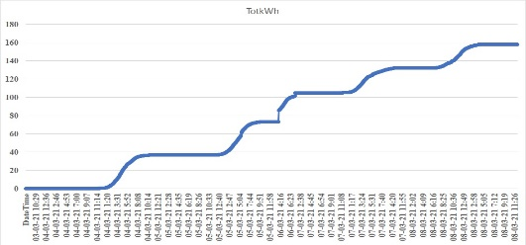

Fig. 10. Real Time kWh generation

Fig. 11: IoT based Power forecasting

**5. Conclusion**

In this paper, we have implemented an IoT based real time data forecasting for energy management in solar PV with grid-tied system. Results have been obtained from the experimental set up considering the real time loads and power from the solar PV. We have observed the total real power is increasing with the irradiation and temperature and the average power factor is almost equal to 1. The total harmonic distortion of voltages and currents of all the phases is below 5%. We can supply the power to grid during the surplus mode which even reduces the burden on the grid. Based on all the results we conclude that the system is a solution for the increasing energy which makes life of easier on this earth.

**References**

1. Bishoy E. Sedhom, Magdi M. El-Saadawi: IoT-based optimal demand side manage- ment and control scheme for smart microgrid. International Journal of Electrical Power & Energy Systems, 127, (2021).

2. H S V S Kumar Nunna, Dipti Srinivasan: A Multi-Agent System for Energy Measurement in Smart Microgrids with Distributed Energy Storage and Demand Response. 2016 IEEE International Conference on Power Electronics, Drives and Energy Systems (PEDES), pp. 1{5, (2016).

3. X. Yang, Y. Zhang, H. He.: Real-Time Demand Side Management for a Micro-

grid Considering Uncertainties. IEEE Transactions on Smart Grid, 10(3), (2019)

Location (1999)

4. S. Rahim, N. Javaid, N. Nawaz.: A convex optimization based decentralized real-

time energy management model with the optimal integration of microgrid in smart

grid. Journal of Cleaner Production, 236, (2019).

5. N. B. P, J. M. Guerrero, P. Siano, R. Peesapati, G. Panda.: A Novel Modied Control Scheme in Grid-tied Photovoltaic System for Power Quality Enhancement,

IEEE Transactions on Industrial Electronics, doi: 10.1109/TIE.2020.3031529.

6. P. N. Babu, R. Peesapati and G. Panda.: An Adaptive Differentiation Frequency Based Advanced Reference Current Generator in Grid-Tied PV Applications. IEEE Journal of Emerging and Selected Topics in Power Electronics, 8(4), pp. 3502-3515,(2020)

7. N. Babu P, J. M. Guerrero, P. Siano, R. Peesapati and G. Panda.: An Improved

Adaptive Control Strategy in Grid-Tied PV System With Active Power Filter for

Power Quality Enhancement. IEEE Systems Journal,15(2), pp. 2859{2870, (2021).

8. K. P. Panda et. al.: A Novel Adaptive Fuzzy based Controller Design using FPGA for grid connected PV systems. Advances in Smart Grid Power System: Network, Control and Security, Elsevier, pp.331{364, (2020).

Write a chapter named “A Comprehensive Study on Smart Farming for Transforming Agriculture Through Cloud and IoT” , Externship Certificate from SMARTINTERNZ in AI and ML, Project Completion Certificate from SMARTINTERNZ, Microsoft PowerPlatform App Maker,