

Contents

**Introduction** 3

**Aim** 3

**Objective** 3

**Database Design** 4

**Relationship between Models** 5

**Data Types** 5

**Schema Screenshots** 6

**Database Table** 9

**Conclusion** 11

# **Introduction**

MyFutsal is an online platform for futsal players to book any Futsal Arena within the Kathmandu valley. The site provides a platform to two kinds of users, the players who want to book the arena (Players) and the administrators who can make use of the site to link their respective Futsal (Admin). MyFutsal not only provides a system to connect to all the futsal arenas around the kathmandu valley but also contains a google-embedded map of different areas in the valley where you can plan out a futsal booking as per the efficiency and requirement of futsal booking. The connecting of futsal API will be enhanced once the system of API for individual futsal will be initiated around the Kathmandu valley. Well known Futsal arenas like Prime Futsal, Surya Futsal, Shantinagar futsal are all included , as are many others.

# **Aim**

MyFutsal aims to provide the futsal users an efficient and reliable booking management system so that without contacting the futsal management physically or through phone.

# **Objective**

# 

* Create a web API system that can help you make preferred Futsal of a specific time period.
* Access to the futsal booking system anytime anywhere via internet access.
* Provide information regarding futsal areas around the Kathmandu valley, along with their timings for booking.
* Provide management systems for both admins and futsal users so that the booking management system can be made use on both user-admin ends.
* To make a breakthrough in an online booking system for futsal and collect data on users who book futsal in kathmandu valley online.
* Push digitalization for online booking system by further improvising the API of the booking system.

# 

# 

# **Database Design**

The database that has been used to store data for users and admins in this project is MongoDB. The values that will be stored are user login information, admin login information and the list of data for the futsal booked. MongoDB is a non-tabular database, which does not restrict its usage to relational tables, and it is also open-source and available for free. These are the reasons why the database of MyFutsal has been designed with MongoDB. Not being limited to relational tables, mongo DB uses values stored in json formats, thus making it perfect to be correspondent with JSON documents. Not only that, but data can be stored in a huge amount in a no-SQL database. Absence of tabular form results in faster processing , thus MongoDB is ideal for fast database storing and fetching.

The Pros and Cons of MongoDB are as follows:

**PROS**

=> Non-tabular data give speed retrieving and storing actions

=> Simple language and coding(easy to understand)

=> No need for translation of json or map objects.

=> Data is stored in ROM, so it gives off a high processing speed due to cache storing.

=> The scalability uses “sharding” which used vertical scaling for huge database storage

=> Non- structured data storing ( stores all forms of data)

**CONS**

=> The transactions(updating/deleting) of data occurs in multi-documents, therefore there is a danger of data corruption.

=> Being a no-SQL database, MongoDB does not have linking of any tables.

=> The speed processing is only possible with proper indexing, without which delay or error in data retrieval can occur.

# **Relationship between Models**

As you can see in the diagram below, the many models of the system are linked together. The following ER diagram depicts four different sorts of models: customer, booking, invoice, and administration.

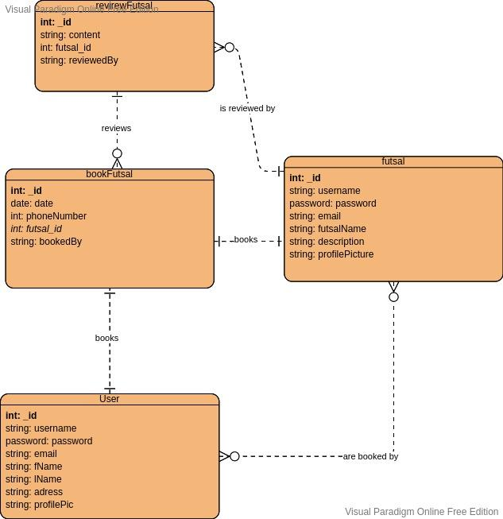

# **Data Schema Screenshots**

Screenshot of the project's backend (database models) are below:

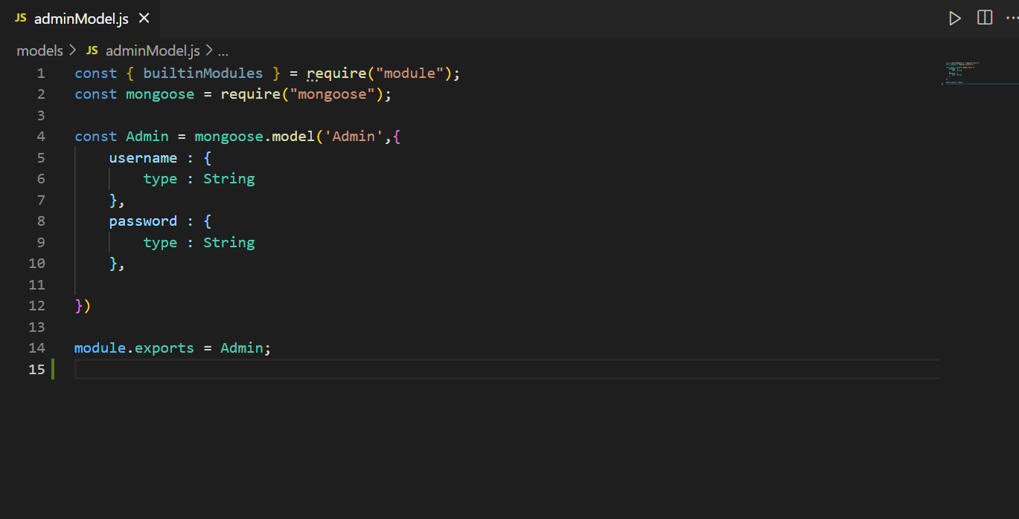

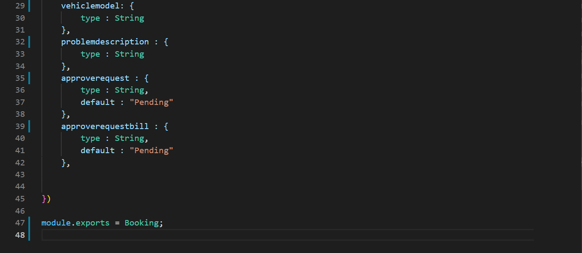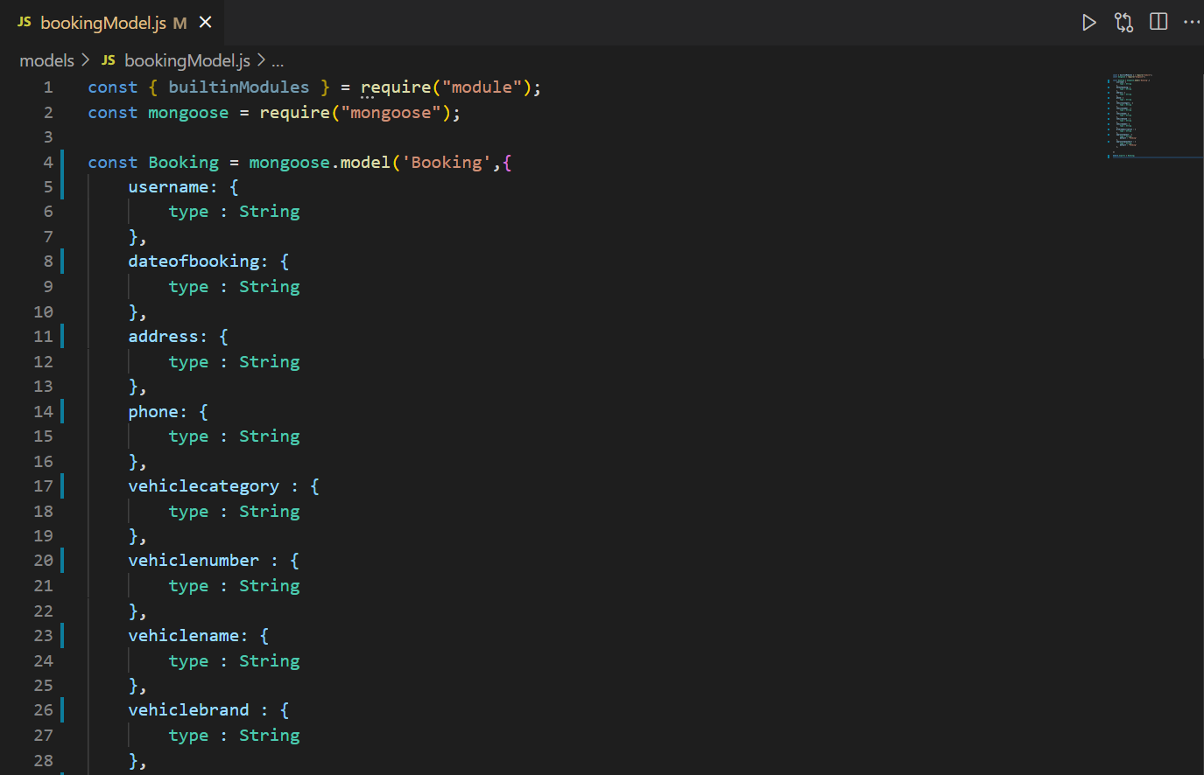

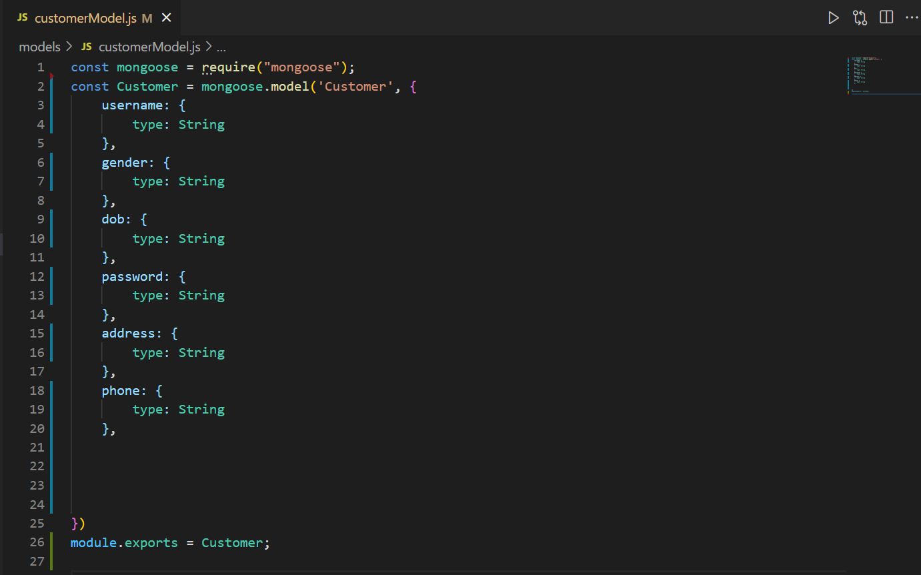

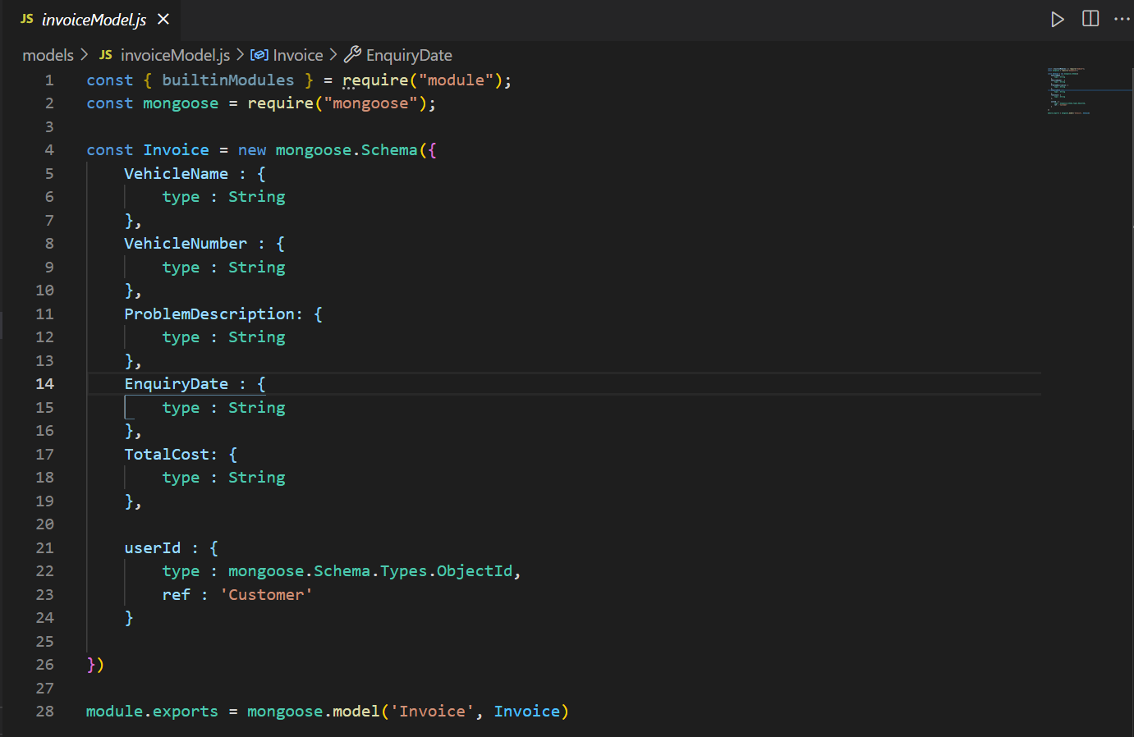

# **Database Table**

Listed below are the screenshots of the back-end database collections.

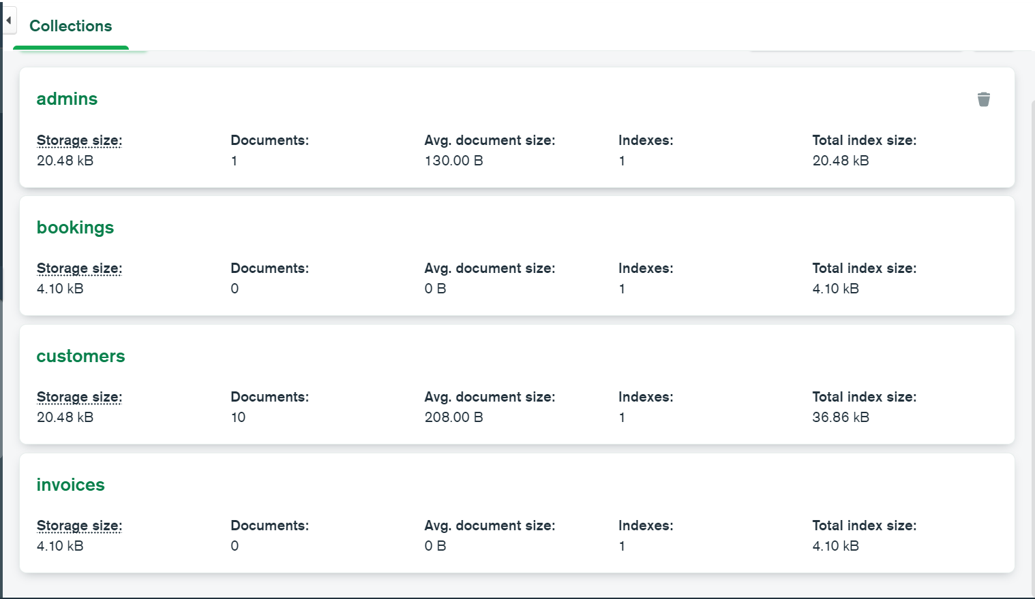

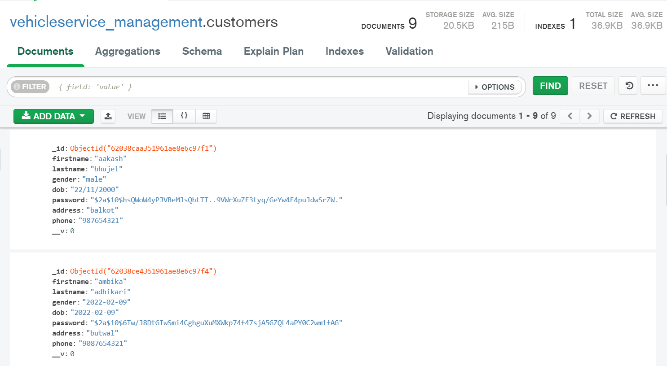

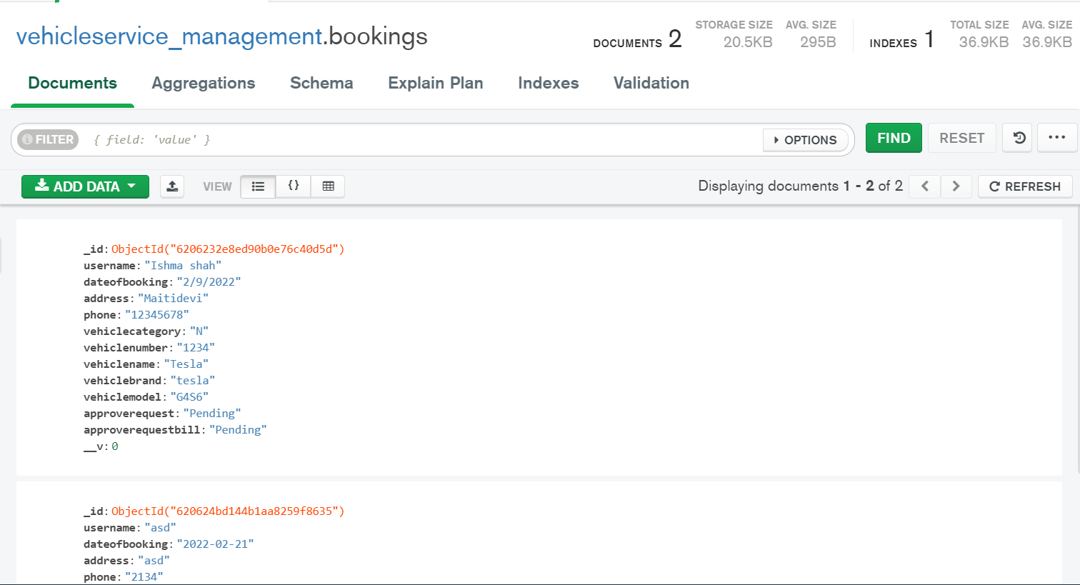

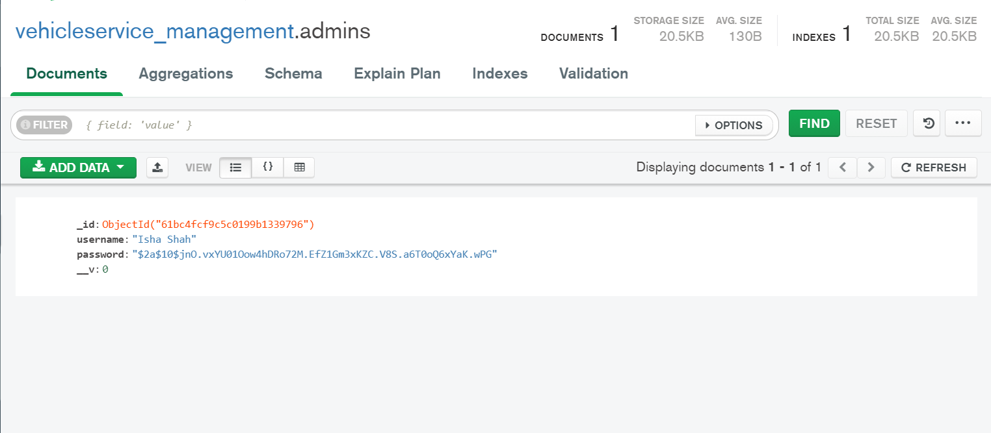

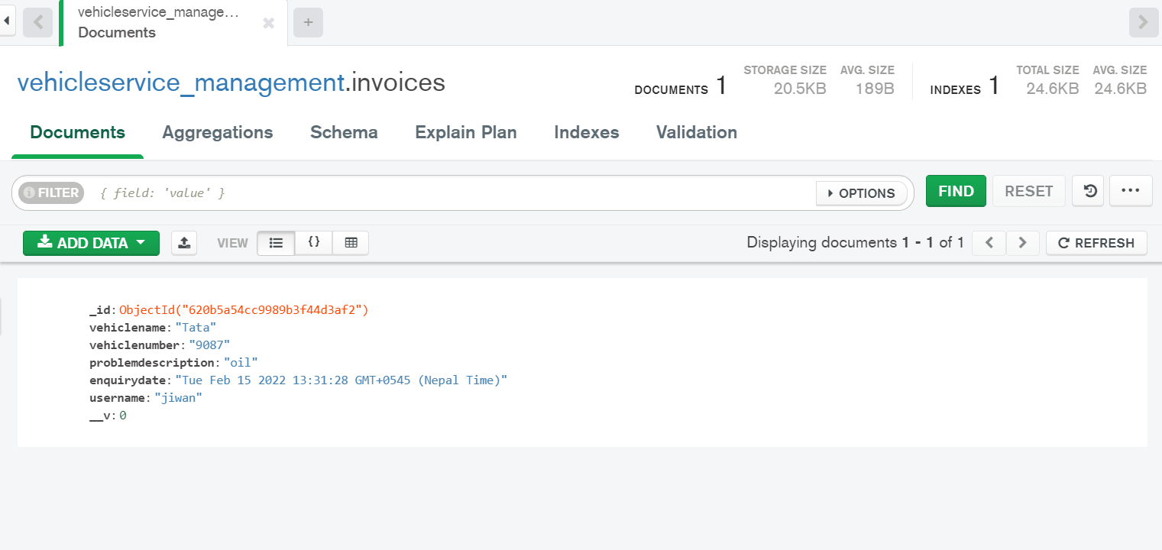

# **Conclusion**

Thus , not sonly solving the real-time problems of having to physically locate or call a futsal for booking, MyFutsal provides the network of available futsal arenas for booking and

also provides a map based futsal booking system for referencing of futsal arena location. Together, MyFutsal aims to create a fully functional and accessible WEB API system for booking of futsal arenas all over Nepal.