RAJEEV GANDHI MEMORIAL COLLEGE OF ENGINEERING & TECHNOLOGY (AUTONOMOUS)

Department of CSE (Data Science)
The Hostel Visitor Time Tracker is a Java-based application designed to efficiently manage and monitor visitor entry and exit within hostel premises. The system captures essential visitor details such as name, contact information, and purpose of visit, along with precise entry and exit timestamps using the LocalDateTime API. This ensures accurate and reliable recording of all visitor activities. The application includes a stay duration calculator that automatically computes the total time spent by each visitor, reducing manual effort and minimizing errors in time tracking. Visitor information is stored dynamically using Java lists, which allows easy management, retrieval, and iteration over records. The Visitor List Viewer module enables administrators to review visitor history quickly and efficiently. To ensure long-term preservation, the application incorporates file handling techniques that securely store visitor data for future reference. By digitizing the visitor management process, the system reduces reliance on paper logs, improves operational efficiency, and enhances accountability. It provides hostel authorities with a clear record of all visitors and their activities. The system also strengthens security by tracking and maintaining visitor movement accurately. Its modular design allows scalability and future integration with other hostel management tools. Overall, the Hostel Visitor Time Tracker offers a practical, reliable, and organized solution for monitoring hostel visitor activity. It ensures transparency, minimizes manual errors, and improves overall administrative control..
Student Name:
P Ajay (25095A3202)
M Aksah(25095A3203)
Signature by Guide:
Dr.K.Samunissa
Associate Professor Dept of CSE-(DS) RGMCET

Problem Statement:
- Hostels require proper monitoring of visitor entry and exit for security purposes.
- Visitor details are usually recorded manually in registers.
- Manual record keeping is time-consuming and prone to human errors.
- Calculating the total duration of a visitor’s stay manually is difficult and inaccurate.
- Maintaining and retrieving past visitor records is inefficient.
- There is a risk of data loss or damage to physical records.
- Hence, an automated system is required to manage visitor entry, exit, and visit history efficiently.

Proposed Solution:
- The Hostel Visitor Time Tracker is a Java-based application developed to automate visitor management in hostels.
- Visitor entry and exit times are recorded automatically using Java’s LocalDateTime class.
- The system calculates the total stay duration using Java time-difference calculations.
- Multiple visitor records are stored using Java collections (ArrayList).
- Visitor details can be viewed easily through list iteration.
- Visitor data is stored permanently in a text file using Java file handling techniques.
- The system reduces manual effort, improves accuracy, and enhances hostel security.

Hostel Visitor Time Tracker – Implementation Explanation:
The Hostel Visitor Time Tracker is a Java-based application designed to record visitor entry and exit times, calculate their stay duration, display visit history, and store records permanently in a file.
Modules

1. Visitor Entry Module (Java Class)

Concept Used:
- Classes & Objects
- Encapsulation

Implementation Explanation:
A Visitor class is created to represent each hostel visitor. This class stores visitor details such as:
- Visitor name
- Purpose of visit
- Entry time
- Exit time
Each time a visitor enters the hostel, an object as the visitor class is created and stored in a collection.
Key Points:
- Fields are kept private for data security
- Constructors initialize visitor details
- Getter and setter methods manage access
This module acts as the core data model of the system.

2. Time Logger (LocalDateTime)

Concept Used:
- java.time.LocalDateTime

Implementation Explanation:
When a visitor enters or exits the hostel, the system records the current date and time using LocalDateTime.now().
Usage:
- Entry time is logged at the time of visitor arrival
- Exit time is logged when the visitor leaves
This ensures:
- Accurate timestamp recording
- No manual time input errors
The stored timestamps are later used to calculate the stay duration.

3. Stay Duration Calculator (Math Functions)

Concept Used:
- Time difference calculation
- Basic math operations

Implementation Explanation:
The stay duration is calculated by finding the difference between entry time and exit time.
Steps:
- Convert entry and exit times into minutes or seconds
- Subtract entry time from exit time
- Convert the result into hours and minutes
This module helps in:
- Tracking how long a visitor stayed
- Enforcing hostel visiting rules.

4. Visitor List Viewer – List Iteration

Purpose:
The Visitor List Viewer module is used to display all visitor records stored in the system. It allows hostel authorities to view details of visitors who have entered and exited the hostel.

Concepts Used:
- ArrayList
- List Iteration
- for-each loop

Explanation:
Each visitor’s details are stored as an object in an ArrayList. This list holds multiple visitor records during program execution. Using list iteration, the program loops through each visitor object and displays relevant information such as:
- Visitor name
- Entry time
- Exit time
- Duration of stay
The for-each loop is commonly used because it provides a simple and readable way to traverse all elements in the list. This module helps in monitoring visitor activity and reviewing daily visitor data efficiently.

Importance:
- Easy access to all visitor records
- Helps hostel staff verify visitor movements
- Useful for daily or shift-wise reporting

5. Visit File Storage – File Handling

Purpose:
The Visit File Storage module is responsible for permanently storing visitor visit details in a file so that records are not lost after the program terminates.

Concepts Used:
- File Handling
- FileWriter
- BufferedWriter
- Text file storage

Explanation:
When a visitor exits the hostel, their visit information (name, entry time, exit time, and stay duration) is written into a text file such as visitor_history.txt. Java file handling classes are used to write data efficiently into the file.
This module ensures that visit data is saved permanently and can be accessed later for:
- Security checks
- Record verification
- Audit purposes

Importance:
- Prevents data loss
- Maintains long-term visitor history
- Supports accountability and security

6.Storing in Table – SQL Queries
Purpose:
The Storing Data in Table module is responsible for transferring visitor data from an existing .txt file into a database table without manually using the INSERT INTO command. This helps convert text-based records into a structured tabular database format for easy access and management.
Concepts Used:
• SQL (Structured Query Language)
• CREATE TABLE
• Importing Data from Text File
• Bulk Data Loading
• Comma-Separated Values (CSV Format)
• Relational Database Management System (RDBMS)
Explanation:
In this module, visitor details are already stored in a .txt file (for example: visitor_log.txt). the data is directly imported into the database table using bulk import features provided by the database system.
First, a table is created using the CREATE TABLE command with appropriate columns.
Then, the existing .txt file (which contains comma-separated values) is loaded into the table using database import functionality.

Importance:
• Saves time by avoiding manual insertion
• Efficiently handles large amounts of data
• Converts unstructured text data into structured database format
• Improves data retrieval and reporting
• Enhances data management and reliability

Source code:
import java.time.LocalDateTime;
import java.time.Duration;
import java.util.ArrayList;
import java.util.List;
import java.util.Scanner;
import java.io.BufferedWriter;
import java.io.FileWriter;
import java.io.IOException;
/* ================= Visitor Class ================= */
class Visitor {
private String visitorName;
private String hostName;
private String purpose;
private LocalDateTime entryTime;
private LocalDateTime exitTime;
private long duration; // in minutes
public Visitor(String visitorName, String hostName, String purpose,
LocalDateTime entryTime, LocalDateTime exitTime, long duration) {
this.visitorName = visitorName;
this.hostName = hostName;
this.purpose = purpose;
this.entryTime = entryTime;
this.exitTime = exitTime;
this.duration = duration;
}
public String getVisitorName() {
return visitorName;
}
public String getHostName() {
return hostName;
}
public String getPurpose() {
return purpose;
}
public LocalDateTime getEntryTime() {
return entryTime;
}
public LocalDateTime getExitTime() {
return exitTime;
}
public long getDuration() {
return duration;
}
}
/* ================= Stay Duration Calculator ================= */
class StayDurationCalculator {
public static long calculateMinutes(LocalDateTime entryTime, LocalDateTime exitTime) {
return Duration.between(entryTime, exitTime).toMinutes();
}
}
/* ================= Visitor List Viewer (Module 4) ================= */
class VisitorListViewer {
public static void displayVisitors(List<Visitor> visitors) {
if (visitors.isEmpty()) {
System.out.println("No visitor records available.");
return;
}
System.out.println("\n----- Visitor List -----");
for (Visitor v : visitors) {
System.out.println("Visitor Name : " + v.getVisitorName());
System.out.println("Host Name : " + v.getHostName());
System.out.println("Purpose : " + v.getPurpose());
System.out.println("Entry Time : " + v.getEntryTime());
System.out.println("Exit Time : " + v.getExitTime());
System.out.println("Duration : " + v.getDuration() + " minutes");
System.out.println("------------------------");
}
}
}
/* ================= Visit File Storage (Module 5) ================= */
class VisitFileStorage {
private static final String FILE_NAME = "visitor_log.txt";

public static void saveToFile(List<Visitor> visitors) {
try (BufferedWriter writer = new BufferedWriter(new FileWriter(FILE_NAME, true))) {
for (Visitor v : visitors) {
writer.write(
v.getVisitorName() + "," +
v.getHostName() + "," +
v.getPurpose() + "," +
v.getEntryTime() + "," +
v.getExitTime() + "," +
v.getDuration()
);
writer.newLine();
}
System.out.println("Visitor data saved to file successfully.");
} catch (IOException e) {
System.out.println("File error: " + e.getMessage());
}
}
}
/* ================= Main Class ================= */
public class HostelVisitorTracker {
public static void main(String[] args) {
Scanner sc = new Scanner(System.in);
List<Visitor> visitorList = new ArrayList<>();
while (true) {
System.out.println("\n--- Hostel Visitor Time Tracker ---");
System.out.println("1. Add Visitor Entry");
System.out.println("2. View Visitor List");
System.out.println("3. Save Visitor Data to File");
System.out.println("4. Exit");
System.out.print("Enter your choice: ");
int choice = sc.nextInt();
sc.nextLine();
switch (choice) {
case 1:
System.out.print("Enter Visitor Name: ");
String visitorName = sc.nextLine();
System.out.print("Enter Host Name: ");
String hostName = sc.nextLine();
System.out.print("Enter Purpose of Visit: ");
String purpose = sc.nextLine();
LocalDateTime entryTime = LocalDateTime.now();
System.out.println("Entry Time Recorded: " + entryTime);
System.out.print("Press ENTER when visitor exits...");
sc.nextLine();
LocalDateTime exitTime = LocalDateTime.now();
System.out.println("Exit Time Recorded: " + exitTime);
long duration =
StayDurationCalculator.calculateMinutes(entryTime, exitTime);
Visitor visitor = new Visitor(
visitorName, hostName, purpose,
entryTime, exitTime, duration
);
visitorList.add(visitor);
System.out.println("Visitor entry added successfully.");
break;
case 2:
VisitorListViewer.displayVisitors(visitorList);
break;
case 3:
VisitFileStorage.saveToFile(visitorList);
break;
case 4:
System.out.println("Exiting system. Thank you!");
sc.close();
System.exit(0);
default:
System.out.println("Invalid choice. Try again.");
}
}
}
}

SQL Queries:
CREATE FILE FORMAT Comma_separator
TYPE = 'CSV'
FIELD_DELIMITER = ','
SKIP_HEADER = 1
NULL_IF = ('\\N')
COMPRESSION = 'AUTO'
RECORD_DELIMITER = '\n'
FIELD_OPTIONALLY_ENCLOSED_BY = NONE;

CREATE or replace TABLE visitor_logs (
visitor_name VARCHAR(30),
host_name VARCHAR(30),
purpose VARCHAR(40),
entry_time TIMESTAMP_NTZ primary key,
exit_time TIMESTAMP_NTZ,
duration int
);

COPY INTO visitors_data.visitor_logs
from @Visitors_data
files = ('visitor_log.txt')
file_format =(format_name=Comma_separator);

select * from visitor_logs;
Output:

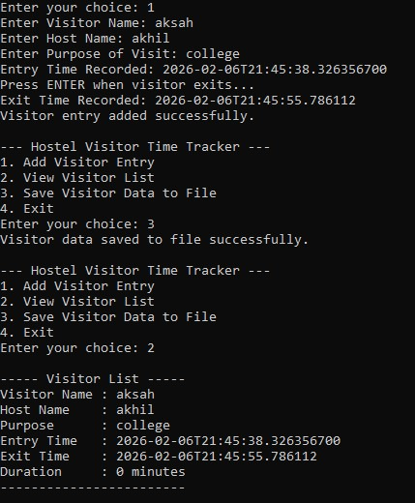
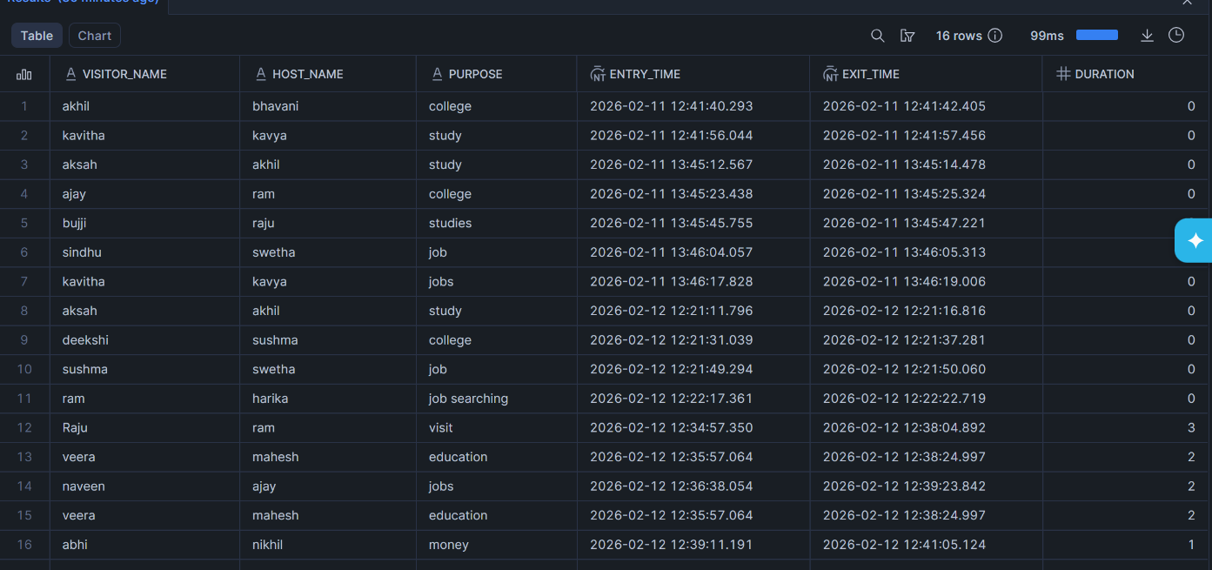
Conclusion:
The Hostel Visitor Time Tracker successfully provides an automated and efficient solution for managing visitor entry and exit records in hostels. By replacing manual register-based systems, the application reduces human errors and improves accuracy in recording visitor timings. The use of Java’s LocalDateTime ensures precise time logging, while automatic stay duration calculation simplifies monitoring of visitor presence.
The system efficiently manages multiple visitor records using Java collections and allows easy viewing of stored data. Additionally, the implementation of file handling enables permanent storage of visitor information for future reference. Overall, this project enhances hostel security, improves record management, and demonstrates the effective use of object-oriented programming concepts and Java libraries in solving real-world problems.

