Create a table called Employee that contain attributes EMPNO, ENAME, JOB, MGR,SAL & execute the following.

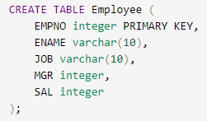

1. **Add a column commission with domain to the Employee table.**

=>alter table Employee add commision integer;

**2. Insert any five records into the table.**

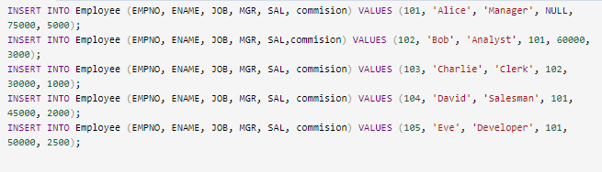

**3. Update the column details of job.**



**4. Rename the column of Employ table using alter command.**



**5. Delete the employee whose Empno is 105.**

=> delete from Employee where EMPNO=105;