Queries using aggregate functions(COUNT,AVG,MIN,MAX,SUM),Group by,Orderby.

Employee(E_id, E_name, Age, Salary)

1. **Create Employee table containing all Records E_id, E_name, Age, Salary.**

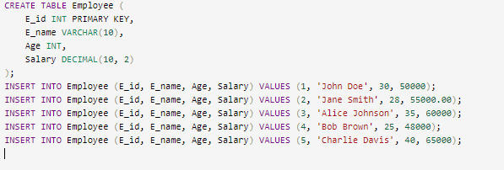

**0/p:**

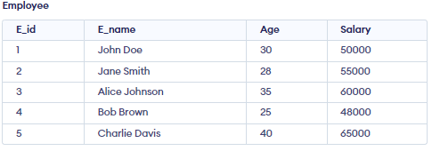

1. **Count number of employee names from employee table**

=>select count(E_name) as no_of_employees from Employee;

**0/p:**

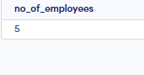

3**. Find the Maximum age from employee table.**

=>select max(Age) as Maximum_age_in_table from Employee;

**o/p:**



4**. Find the Minimum age from employee table.**

=>select min(Age) as Minimum_age_in_table from Employee;

**o/p:**



5**. Find salaries of employee in Ascending Order.**

=>SELECT Salary FROM Employee ORDER BY Salary ASC;

**o/p:**

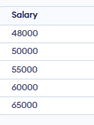

6**. Find grouped salaries of employees.**

=>select Salary,count(E_id) as no_of_earning_this from Employee group by Salary;

**o/p:**

