**Create a row level trigger for the customers table that would fire for INSERT or UPDATE or**

**DELETE operations performed on the CUSTOMERS table. This trigger will display the**

**salary difference between the old & new Salary.**

**CUSTOMERS(ID,NAME,AGE,ADDRESS,SALARY)**

**NOTE:** SET SERVEROUTPUT ON;

Step1:

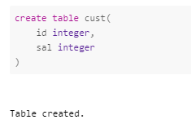

Step 2:

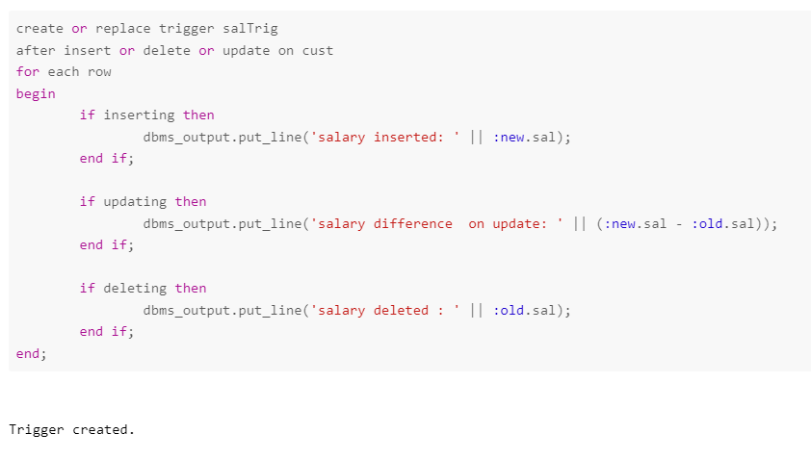

Step 3:

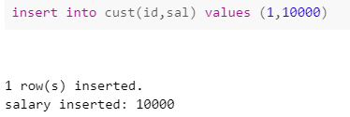

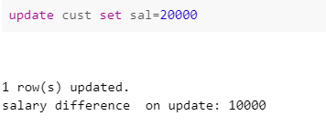

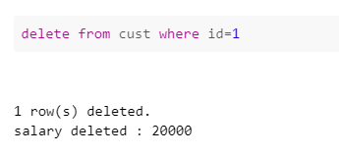

In step 3 we are checking by inserting updating ad deleting,thattrigger will fire upo itself or notl