**Create cursor for Employee table & extract the values from the table. Declare the variables**

**,Open the cursor & extract the values from the cursor. Close the cursor.**

**Employee(E_id, E_name, Age, Salary)**

**Step1:**

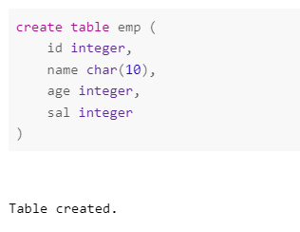

**Step2:**

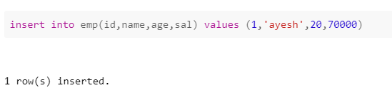

**Step 3:**

**Cursor is used to fetch the required data from a table without using select command**

