Create a table called Employee & execute the following. Employee(EMPNO,ENAME,JOB, MANAGER_NO, SAL, COMMISSION)

1. **Create a user and grant all permissions to the user.**

=>CONNECT SYS AS SYSDBA//**(sysdba is a previllage given to administrator to create delete other users and grant permisiions)**

CREATE USER USER1 IDENTIFIED BY mypassword

GRANT CONNECT,RESOURCE,DBA TO USER1;

**2.Insert the any three records in the employee table contains attributes EMPNO, ENAME JOB, MANAGER_NO, SAL, COMMISSION and use rollback. Check the result.**

=> 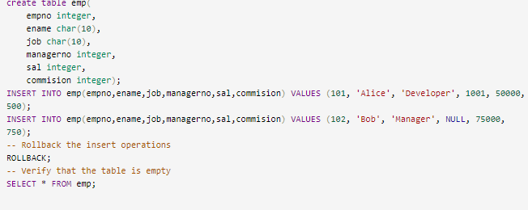

**3. Add primary key constraint and not null constraint to the employee table.**

**4. Insert null values to the employee table and verify the result.**

