

­­­

Sanofi CRM and Axtria SalesIQ Integration and Environment Strategy

Version 1.0

Last Updated:

Copyright © 2020 Axtria, Inc. All Rights Reserved.

The information contained herein is subject to change without notice.

Table of Contents

1 Document Details 4

2 Version Control 5

3 Document Approvers 6

4 Introduction 7

4.1 Purpose 7

4.2 Scope 7

4.3 Scope of Integration 7

4.4 Tools and Software Used 9

5 Axtria SalesIQTM for Sanofi– ARCHITECTURAL DESIGN 10

High - Level Architectural Diagram 10

Integration Approach 11

6 CRM to SalesIQTM Integration Business Rules (Inbound) 13

Account 13

Account Address 14

Account Affiliation Object 14

Employees Object 15

Product 15

Profiling 16

GAS Assignments 16

IR Data 17

External Sales Data 17

Internal Sales Data 18

Sell out Swing Data 19

Shapes-Bricks 19

Eligibility Info Data 19

Stock in Trade Data 20

Forecast Data 20

Team Master Data 21

Call Plan Data 21

Geography Master Data 21

Geography Territory Data 22

Customer Territory Data 22

Territory Hierarchy Data 23

User-Territory Data 23

7 SalesIQTM to Sanofi Integration Business Rules (Outbound) 25

Axtria SalesIQTM for Sanofi – Outbound Integrations 25

User Role (User) 26

Territory Hierarchy (Territory2) 26

Position Employee (UserTerritory2Association) 26

Position Account (ObjectTerritory2Association) 27

MCCP 27

Payroll 27

8 SalesIQTM Environment strategy 28

# Document Details

|  |  |
| --- | --- |
| Document Title | SalesIQTM - CRM Integration |
| Date of Release |  |
| Version No. |  |
| Document Owner |  |
| Document Author |  |
| Document Approver |  |

# Version Control

|  |  |  |  |  |
| --- | --- | --- | --- | --- |
| Version No | Release Date | Revision Notes | Date Approved | Approved By |
| **1.0** |  | First draft for stakeholders |  |  |
| **2.0** |  |  |  |  |

# Document Approvers

**From client organization:**

|  |  |  |  |
| --- | --- | --- | --- |
| Approver | Approver Name | Date Approved | Signature |
| 1 |  |  |  |
| 2 |  |  |  |

# Introduction

## Purpose

This document contains the complete design description of the Axtria SalesIQTM implementation with Sanofi Inbound and Outbound migration. This includes the architectural features of the system, detailed operations that each code module will perform, and the design layout.

## Scope

Axtria is implementing SalesIQTM for Sanofi Sales Planning and Execution. The following modules are being implemented:

* Roster Management
* Alignment Management
* Segmentation & Targeting
* Call Plan Feedback
* Incentive Compensation

## Scope of Integration

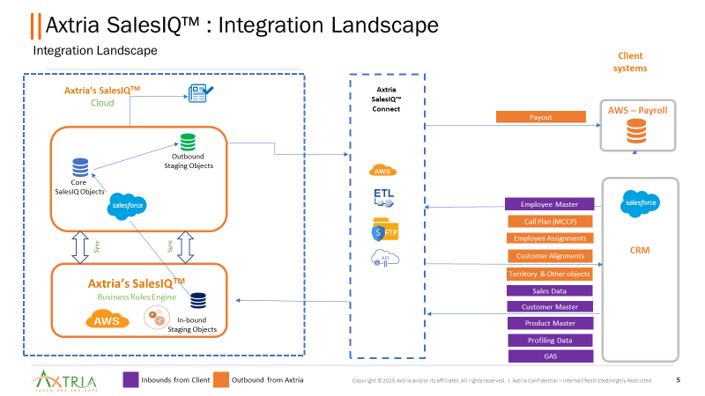

**In Scope:**

Sanofi CRM to Axtria SalesIQ:

* Account
* Account Address
* Account Affiliation
* Employee
* Product
* Profiling
* GAS Assignment
* IR Data
* External Sales
* Internal Sales
* Sellout Swing Number
* Shapes-Bricks
* Eligibility Info
* Stock in Trade
* Forecast Data
* Team Master
* Call Plan
* Geography Master
* Geography-Territory
* Customer - Territory
* Territory Hierarchy
* User-Territory

Axtria SalesIQ to Sanofi CRM:

* UserRole
* Territory Hierarchy (Territory2)
* Position Employee (User2TerritoryAssociation)
* Position Account (Object2TerritoryAssociation)
* MCCP
* Payroll

## Tools and Software Used

|  |  |
| --- | --- |
| Tools | Application |
| Data source | Axtria SalesIQTM |
| Database | PostgreSQLv9.4 |
| Code | Salesforce Apex, PostgreSQL, Python |

# 5 Axtria SalesIQTM for Sanofi– ARCHITECTURAL DESIGN

## High - Level Architectural Diagram

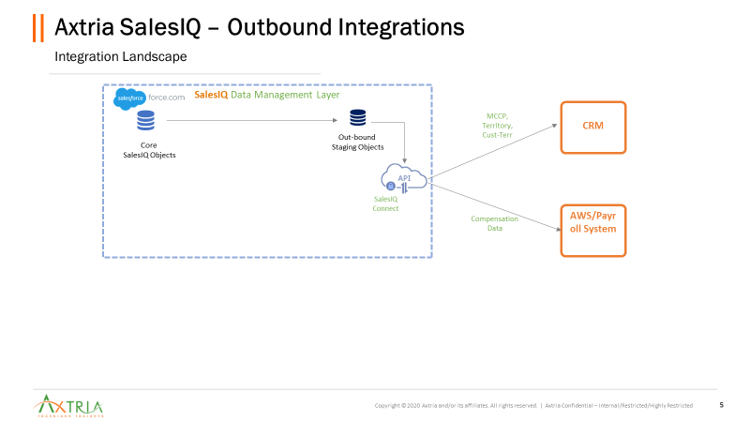

## Integration Approach

Axtria will expose an API which will be hosted on AWS EC2.

The API will be consumed by CRM team to send the data in Axtria’s staging objects in the JSON format.

The APIs would be generic and will accept as parameters the object type and data in JSON.

Once the data is pushed to staging objects, Axtria’s ETL jobs will push the data to master objects of salesforce.

**API Architecture**

Below are the steps for API connectivity:

**Step 1: Provide URL**

Axtria will provide the URL and Parameters to CRM to enable connectivity.

**Sample URL:** <https://sanofiart.axtria.com/api_integration/authorize>

Parameters: client_id and client_secret

**Step 2: Authorization**:

On hit of the URL, Axtria APIs will generate the **security token** for authentication.

As a response to the request, **security token** wouldbe sent to CRM

The security token is valid for 1 hour.

Step 3: **Insert records into Axtria Staging Environment**:

Data Admin user inserts the data with below mentioned URL and passes parameters in the body.

**Sample URL**: <https://sanofiart.axtria.com/api_integration/insert>

**Parameters** (POST Request)

* Table (Account, Address, Affiliation, Profiling, Image Recognition (IR) Data, HMR Data, ERP Data, GAS Assignment, Employee, Product)
* Schema (Always set as public)
* Records (JSON format)
* Token (Value = Generated in Step 1)

# 6 CRM to SalesIQTM Integration Business Rules (Inbound)

Integration jobs between CRM and SalesIQTM will Full Load, Delta.

Inbound:

1. Account
2. Account Address
3. Account Affiliation
4. Employee
5. Product
6. Profiling
7. GAS Assignment
8. IR Data
9. External Sales
10. Internal Sales
11. Shapes-Bricks
12. Eligibility Info
13. Stock in Trade
14. Forecast Data
15. Team Master
16. Call Plan
17. Geography Master
18. Geography-Territory
19. Customer - Territory
20. Territory Hierarchy
21. User-Territory

## Account

Account object contains data for all pharmacie/HCP’s. It will define all the attributes of the Account object.

The Data Dictionary defines the following:

1. All Attributes marked as Mandatory/Non-Mandatory
2. Data Types of Attributes

The Account object data must be published daily via API to Sales IQTM. CRM on a daily basis must send all the records and any change in Account Attribute(s) will be updated in the Sales IQTM

Any record that violates the following validations will be rejected for processing:

1. Blank values in mandatory column
2. Data Type mismatch

## Account Address

Account address contains pharmacy addresses with brick information. Addresses will be populated by the SalesIQTM process based on the respective parent pharmacy address.

The Data Dictionary defines the following:

* All Attributes marked as Mandatory/Non-Mandatory
* Data Types of Attributes

The Account Address object data must be sent daily via API. CRM will send the records with changes in Account Address daily.

Any record that violates the following validations will be rejected:

* Account Number should exist in Account object.
* Blank values in mandatory column
* Data Type mismatch

Further Validations such as Master Entry(Account) does not exist will be performed in post-processing at Axtria’s end and will be stored in Postgres Tables.

## Account Affiliation Object

Account Affiliation contains the parent pharmacy -child pharmacy account relationship.

The Data Dictionary defines the following:

* All Attributes marked as Mandatory/Non-Mandatory
* Data Types of Attributes

These objects must be sent daily via API. CRM will send the records with changes in Account Affiliation daily.

Any record that violates the following validations will be rejected:

* Account Number should exist in Account object.
* For every parent-child affiliation, Parent Number should exist in Account object.
* Blank values in mandatory column
* Data Type mismatch

Further Validations such as Master Entry (Account) does not exist and Circular Dependency will be performed in post-processing at Axtria’s end and will be stored in Postgres Tables.

## Employees Object

Employees Entity includes all Sales users, Contractors and BOS users.

The Data Dictionary defines the following:

* All Attributes marked as Mandatory/Non-Mandatory
* Data Types of Attributes

These objects must be sent daily via API. All users should be sent daily with required/Mandatory fields. In case few Users are not present in CRM, the delta needs to be shared with Axtria in same format via Excel.

In case a new Employee is hired, corresponding Hire Date needs to be populated.

In case an employee leaves the company, corresponding termination date needs to be populated.

Above two events are very important since they form base of all the Workbench events that will be populated in the system. Failure to provide the above info will result in incorrect Workbench events.

Any record that violates the following validations will be rejected:

* Blank values in mandatory column
* Data Type mismatch
* No two employees have same Employee ID.

## Product

Product Entity includes all Sanofi Products including Categories. Template has been designed in a way that of provides info such as Local Name, Global Name, all Products part of the category.

The Data Dictionary defines the following:

* All Attributes marked as Mandatory/Non-Mandatory
* Data Types of Attributes

These objects must be sent daily via API.

Any record that violates the following validations will be rejected:

* Blank values in mandatory column
* Data Type mismatch

## Profiling

Product Entity includes all attributes that are required in Segmentation Process. All Attributes that are to be used in Segmentation Process are part of Profiling Template.

The Data Dictionary defines the following:

* All Attributes marked as Mandatory/Non-Mandatory
* Data Types of Attributes

There are 2 ways in which Profiling info could be provided.

Way 1: - All attributes corresponding to Account and Product are shared in a single row. Unique key in this case would be Account + Product. Please note, there can be no duplicates in this file corresponding to a key. This format is primarily used in case data needs to be uploaded via excel.

E.g.

|  |  |  |  |  |  |  |  |  |  |
| --- | --- | --- | --- | --- | --- | --- | --- | --- | --- |
| Account | Product | Question1 | Response1 | Question2 | Response2 | Question3 | Response3 | Question4 | Response4 |

Way 2: - Corresponding to Account and Product, there are multiple rows for Question and Response. Unique key in this case would be Account, Product and Question. There can be duplicates in this file and only latest response (Based on Last Modified date) will be used for further processing. Only Submitted response (Status = ‘Submitted’) will be processed further.

|  |  |  |  |  |  |
| --- | --- | --- | --- | --- | --- |
| Account | Product | Question | Response | Status | LastModifiedDate |

Any record that violates the following validations will be rejected:

* Blank values in mandatory column
* Data Type mismatch

## GAS Assignments

This entity includes all explicit assignments added by Rep to their Territory.

This data will be added to SalesIQ Core Alignment Tables and will be further pushed to downstream system.

The Data Dictionary defines the following:

* All Attributes marked as Mandatory/Non-Mandatory
* Data Types of Attributes

These objects must be sent daily via API.

Any record that violates the following validations will be rejected:

* Blank values in mandatory column
* Data Type mismatch

## IR Data

This entity includes Image Recognition data detailing Brand presence on shelf and/or marketing material placement in store. This will be used to calculate Distribution and Perfect Store KPIs. This data needs to come from CRM, if not available in CRM, Data can be shared in Excel format as well.

The data must be pushed at Account, Product, Cycle and Visibility Type level.

No Historical data is required in this case.

The Data Dictionary defines the following:

* All Attributes marked as Mandatory/Non-Mandatory
* Data Types of Attributes

These objects must be sent on Monthly basis via API or File.

Any record that violates the following validations will be rejected:

* Blank values in mandatory column
* Data Type mismatch

## External Sales Data

This entity includes Product and Market Sales Information received from External Sources. These data sets are used in Potential Calculations in Segmentation and Sales Target Settings

The data must be pushed at Account, Product, Territory, Year-Month and Channel level.

This assumes that all Business rules are considered (such as Brick-Territory mapping, Channel Filtration etc before data is sent to SalesIQ).

Please note Territory is required only for IC purposes. Data consumed in Segmentation Process will be irrespective of territory.

Past 12 months data is required in this case.

The Data Dictionary defines the following:

* All Attributes marked as Mandatory/Non-Mandatory
* Data Types of Attributes

These objects must be sent on Monthly Basis via API or File.

Any record that violates the following validations will be rejected:

* Blank values in mandatory column
* Data Type mismatch
* Duplicate records in external key.

## Internal Sales Data

This entity includes Sales captured in ERP System for all Sanofi Products inclusive of Transfer Orders.

The data must be pushed at Account, Product, Territory, Year-Month and Sales Type level.

Please note Territory is required only for IC purposes. Data consumed in Segmentation Process will be irrespective of territory.

Past 12 months data is required in this case.

The Data Dictionary defines the following:

* All Attributes marked as Mandatory/Non-Mandatory
* Data Types of Attributes

These objects must be sent on Monthly Basis via API or File.

Any record that violates the following validations will be rejected:

* Blank values in mandatory column
* Data Type mismatch
* Duplicate records in external key.

## Sell out Swing Data

This entity includes Represents the Sales Growth of Sanofi Products against the Self Medication Market Sales.

The data must be pushed at Territory, Year-Month.

Full Cycle Data is required in this case.

Currently applicable only for Italy.

The Data Dictionary defines the following:

* All Attributes marked as Mandatory/Non-Mandatory
* Data Types of Attributes

These objects must be sent on Monthly Basis via API or File.

Any record that violates the following validations will be rejected:

* Blank values in mandatory column
* Data Type mismatch

## Shapes-Bricks

This entity has Brick to Territory Shape Files required to display Territory Boundaries on Map

Supported File Formats – KML, SHP.

This is required on demand whenever these is change in shapes. This will be required at start of cycle and on demand.

## Eligibility Info Data

This entity includes Leave information captured in HR System required for Bonus Calculation.

This is applicable for all markets and data needs to be shared In fixed template via Files.

The Data Dictionary defines the following:

* All Attributes marked as Mandatory/Non-Mandatory
* Data Types of Attributes

## Stock in Trade Data

This entity includes Actual/Target No of days, SKU is present on shelf. This KPI is required for Compensation Calculations. This is calculated based on Stock info received from wholesalers by Sanofi.

The data must be pushed at Year-Month, Territory and Employee Level.

Full Cycle Data is required in this case.

Currently applicable only for Italy and Portugal.

The Data Dictionary defines the following:

* All Attributes marked as Mandatory/Non-Mandatory
* Data Types of Attributes

These objects must be sent on Monthly Basis or on Demand via API or File.

Any record that violates the following validations will be rejected:

* Blank values in mandatory column
* Data Type mismatch

## Forecast Data

This entity includes Nation-Brand-Channel Level objectives for Sell in and Sell Out Sales Components set by Finance/Marketing Team

The data must be pushed at Year-Month, Product, Type and Channel Level.

Full 12 months Data is required in this case

The Data Dictionary defines the following:

* All Attributes marked as Mandatory/Non-Mandatory
* Data Types of Attributes

These objects must be sent On Demand (Expected thrice for a year but may vary) via File.

Any record that violates the following validations will be rejected:

* Blank values in mandatory column
* Data Type mismatch

## Team Master Data

This entity includes all Teams onboarding SalesIQ. Certain Metadata such as Name, Cycle, Alignment Type attributes are required for the team

This is one-time load.

The Data Dictionary defines the following:

* All Attributes marked as Mandatory/Non-Mandatory
* Data Types of Attributes

Format: - File Format.

Any record that violates the following validations will be rejected:

* Blank values in mandatory column
* Data Type mismatch

## Call Plan Data

This entity includes direct Load of Call Plan data. If Segmentation Process is not performed in SalesIQ. The data can be explicitly loaded to SalesIQ and Refinement process can happen.

The Data Dictionary defines the following:

* All Attributes marked as Mandatory/Non-Mandatory
* Data Types of Attributes

Format: - File Format. Direct Load (OOTB) utility can be used to Load the data.

Any record that violates the following validations will be rejected:

* Blank values in mandatory column
* Data Type mismatch

## Geography Master Data

This entity includes master data of Geographies or Bricks and their Hierarchy (if Applicable). This entity includes all the Bricks that will be part of SalesIQ.

The Data Dictionary defines the following:

* All Attributes marked as Mandatory/Non-Mandatory
* Data Types of Attributes

Format: - File Format.

Any record that violates the following validations will be rejected:

* Blank values in mandatory column
* Data Type mismatch

## Geography Territory Data

This entity includes alignment of Geographies or Bricks to the territories.

It will be one-time load, Post that all processing will happen in SalesIQ.

The Data Dictionary defines the following:

* All Attributes marked as Mandatory/Non-Mandatory
* Data Types of Attributes

Format: - File Format.

Any record that violates the following validations will be rejected:

* Blank values in mandatory column
* Data Type mismatch

## Customer Territory Data

This entity includes alignment of all Customers to respective Territories. In case Alignment Assignment Rules are not created in SalesIQ, the data can be explicitly loaded into SalesIQ. All the assignment will be marked as Explicit in this case.

The Data Dictionary defines the following:

* All Attributes marked as Mandatory/Non-Mandatory
* Data Types of Attributes

Format: - File Format.

Any record that violates the following validations will be rejected:

* Blank values in mandatory column
* Data Type mismatch

## Territory Hierarchy Data

This entity includes all Positions (Territories, District, Region, Area, Nation etc) and their Hierarchy, this will be one-time load and will be loaded into SalesIQ. Post this any Hierarchy Change, Creating. Expiring Positions will happen in SalesIQ.

The Data Dictionary defines the following:

* All Attributes marked as Mandatory/Non-Mandatory
* Data Types of Attributes

Format: - File Format.

Any record that violates the following validations will be rejected:

* Blank values in mandatory column
* Data Type mismatch

## User-Territory Data

This entity includes Position to Sales User assignment, this will be one-time load and will be loaded into SalesIQ. Post this any assignment change will happen in SalesIQ.

The Data Dictionary defines the following:

* All Attributes marked as Mandatory/Non-Mandatory
* Data Types of Attributes

Format: - File Format.

Any record that violates the following validations will be rejected:

* Blank values in mandatory column
* Data Type mismatch

**Data Dictionary**

[Axtria SalesIQ -Data Mapping_v1.2.xlsx](https://sanofi.sharepoint.com/:x:/r/sites/CHLOEBOSSanofiAxtria/Shared%20Documents/General/Technical%20Design%20Documents/Axtria%20SalesIQ%20-Data%20Mapping_v1.2.xlsx?d=w8d2e98d710dd4f969db70490521ee503&csf=1&web=1&e=m7n89A)

**Data Model**

[data model](https://sanofi.sharepoint.com/:p:/r/sites/CHLOEBOSSanofiAxtria/_layouts/15/Doc.aspx?sourcedoc=%7B53364BE5-573A-46E9-AE73-FCB6E9FC3D82%7D&file=Axtria%20Data%20-%20model.pptx&action=edit&mobileredirect=true)

# SalesIQTM to Sanofi Integration Business Rules (Outbound)

## Axtria SalesIQTM for Sanofi – Outbound Integrations



Integration jobs between Sanofi CRM and SalesIQTM will run daily (To and From ).

Outbound:

1. User Role (User)
2. Territory Hierarchy (Territory2)
3. Position Employee (UserTerritory2Association)
4. Position Account (ObjectTerritory2Association)
5. MCCP
6. Payroll

## User Role (User)

This needs to be confirmed with CRM. Each CRM implements different hierarchy of User Role. In case User Role is same as Territory Hierarchy, SalesIQ can update the UserRole in case of any User-Territory Assignment Change.

Frequency – Daily

Load – Delta

SalesIQ will call informatica API which will subsequently push data to Sanofi CRM.

## Territory Hierarchy (Territory2)

SalesIQ will push Territory Hierarchy to CRM in Territory2 Object with mandatory information that are Position Name, Territory Type ID, Territory Model ID and Parent Position Name.

SalesIQ will call informatica API which will subsequently push data to Sanofi CRM.

The Data Dictionary defines the following:

* All Attributes marked as Mandatory/Non-Mandatory
* Data Types of Attributes

## Position Employee (UserTerritory2Association)

SalesIQ will send Employee Assignment information to UserTerritory2Association.

It contains the mandatory information in following fields Employee User ID, Territory ID, Inactive and Role in Territory which must be populated in CRM UserTerritory2Association Object.

SalesIQ will call informatica API which will subsequently push data to Sanofi CRM.

The Data Dictionary defines the following:

* All Attributes marked as Mandatory/Non-Mandatory
* Data Types of Attributes

## Position Account (ObjectTerritory2Association)

SalesIQ will send Account to Territory association information to ObjectTerritory2Association.

There are active assignments that will be pushed to CRM with IsDeleted flag as false and inactive assignment will be pushed to CRM with IsDeleted flag as true.

SalesIQ will call informatica API which will subsequently push data to Sanofi CRM.

The Data Dictionary defines the following:

* All Attributes marked as Mandatory/Non-Mandatory
* Data Types of Attributes

## MCCP

SalesIQ will push MCCP Data in the required format. This data will be output of Segmentation Rule and will be pushed to CRM system in case of any changes made in SalesIQ.

All updates/lookups will be performed on Basis of External ID of respective Objects. The data will be pushed only for Live Cycles.

SalesIQ will call informatica API which will subsequently push data to Sanofi CRM.

## Payroll

SalesIQ will push payroll data to required SFTP location in fixed Global format.

This will run at end of cycle or on Demand.

An email will be sent to user Post processing.

Notification to Informatica system is still under discussion.

# SalesIQTM Environment strategy

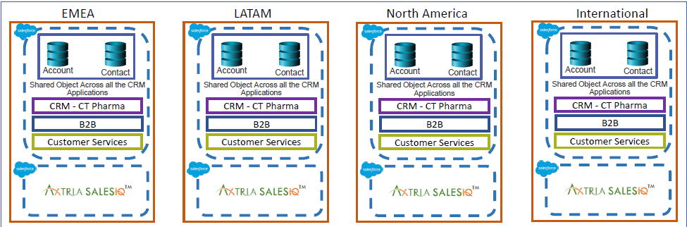

SalesIQ will maintain 1:1 mapping between Sanofi CRM and SalesIQ org. SalesIQ will procure AWS servers based on all Security compliances.

It was agreed by all stakeholders that there would be one to one mapping between CRM org and Axtria Org. In Case Axtria team foresees that onboarding multiple countries on same org would breach Axtria proposed limits and there is no other way to solve the problem, A new org will be created (in special cases) after discussion and approval from all Stakeholders. Below is the case where discussion needs to happen in case below limits are breached for a specific org.

|  |  |
| --- | --- |
|  | **Data Volume Limits** |
| **Limits** |
| **Total No of Scenarios** | 200 |
| **Total No of records** | 50 MM |
| **Total No of Bulk Batches** | **7K** |
| **Total No of Cycle Plans** | **2000** |