COMPUTER VISION ASSIGNMENT 2
AJAY SHRIHARI, 20171097

Question 1

DLT
This method maps any object point X that we do not know anything about the intrinsic nor extrinsic parameters. Here, the object points should be non-planar in the 3 dimensional world. In this method, we will be needing at least 6 pairs of points to extract the parameters.

This can be done by first finding the correspondences and finding least squared solution to find our homography, which is a 3*4 projection matrix. The least squared solution was found by taking SVD, and finding the component with the least eigenvalue.

Output
Projection matrix:
[[-3.05125352e-02 -7.31516249e-03 -7.74423073e-02 -6.89821827e-01]
[ 1.60745140e-02 -8.36504249e-02 -1.60366367e-02 -7.13898348e-01]
[ 1.45950579e-05 -4.62905071e-06 -1.41473815e-05 -4.48443414e-04]]

Next,we find K, R, T by decomposition. This can be done using RQ decomposition, but due to the presence of non square singular matrices, we take the QR decomposition and take the inverse.
Camera matrix:
[[-3.68603521e+03 -1.71262474e+01 1.57420188e+03]
[-0.00000000e+00 -3.67064394e+03 1.95288107e+03]
[-0.00000000e+00 -0.00000000e+00 1.00000000e+00]]
Rotation:
[[-0.69532152 0.00416451 -0.71868675]
[-0.16241063 -0.97502637 0.15148061]
[-0.70010768 0.22205009 0.67863318]]
Translation
[ 15.54277708 -2.7150417 -14.77500386]
REPROJECTION ERROR
Next, we find the reprojection by doing L2 norm on each set of points in the matrices.
Reprojection error: 2.29116721760245

RANSAC
Next, we do RANSAC on DLT by using the reprojection error as a metric. Based on the value of the error, we find the set of parameters/points for which the error is minimum, and select the projection matrix based on that.

Projection for minimum error: [[ 3.06224149e-02 7.33654529e-03 7.78385037e-02 6.88841896e-01]
[-1.60285259e-02 8.32965828e-02 1.75064944e-02 7.14803846e-01]
[-1.45715540e-05 4.56686888e-06 1.47999436e-05 4.48457933e-04]]
Radial Distortion
The radial distortion can be cured using the cv2.undistort function. For this, we need the distortion parameters, which can be found using cv2.calibrateCamera and the ROI can be found using cv2.getOptimalNewCameraMatrix.
Using this, the output is undistorted.

ZHANG’S ALGORITHM
In Zhang’s method, in order to calculate the camera’s intrinsic (K) and extrinsic parameters (R and t) we would perform our experiment on planar world coordinates. In particular, checkerboard is used as planar world and world’s origin is fixed at one of its corner. Due to the known dimensions of checkerboard’s boxes and known location of world’s origin at one of the corners, we could find out the location of all other points on the checkerboard by exploiting Cartesian coordinate arrangement of the boxes.
We use cv2.calibrateCamera for this as well. We generated a wireframe from this.
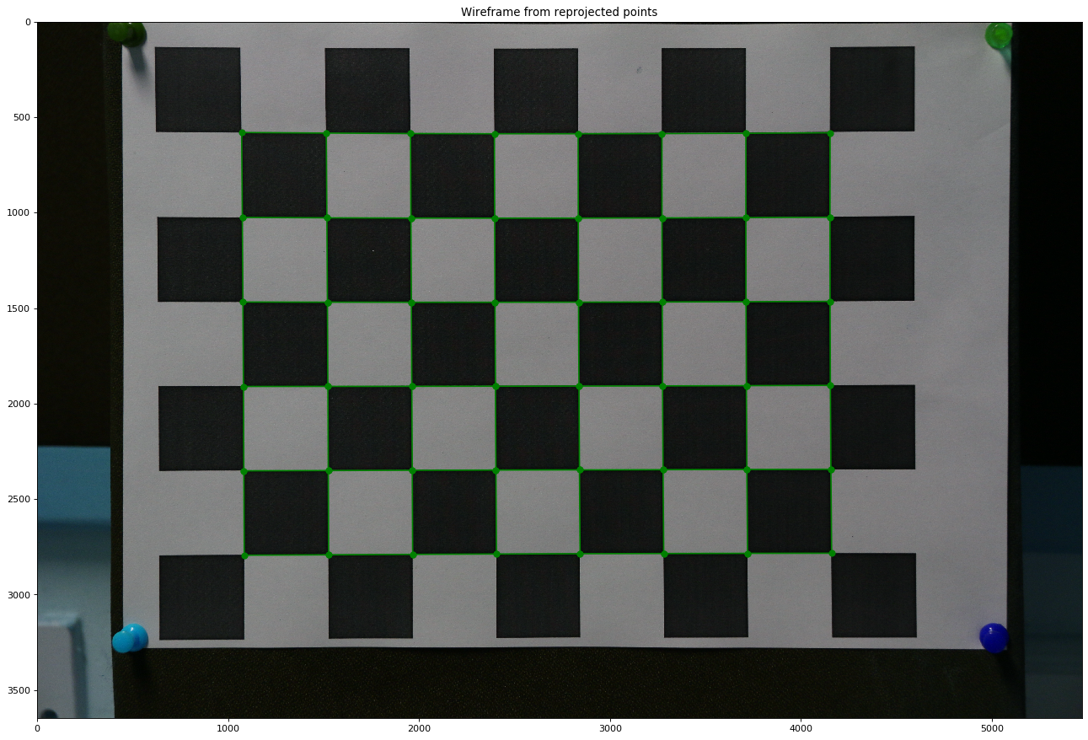

Reprojection Error: 2.4810849836605735
Camera Calibration Matrix:
[[1.36634762e+04 0.00000000e+00 3.33653229e+03]
[0.00000000e+00 1.36813824e+04 1.49659839e+03]
[0.00000000e+00 0.00000000e+00 1.00000000e+00]]
Distortion Parameters:
[[ 9.52117076e-02 1.01093672e+01 -1.52799117e-02 2.87211432e-02
-1.60591737e+02]]
Zhang’s algorithms was applied on images taken by camera.
Reprojection Error: 0.9814698747743387
Camera Calibration Matrix:
[[3.71013199e+03 0.00000000e+00 5.88238742e+02]
[0.00000000e+00 3.81360976e+03 4.90492693e+02]
[0.00000000e+00 0.00000000e+00 1.00000000e+00]]
Distortion Parameters:
[[ 6.05060296e+00 -3.88405337e+02 1.15882395e-02 -6.15665408e-02
-2.92505410e+03]]
DLT was applied on different images
Projection matrix:
[[ 2.25682647e-02 2.91589842e-03 -3.52130305e-03 4.69785434e-01]
[-1.69412184e-03 9.86979233e-03 -2.43346616e-02 8.82087775e-01]
[ 1.75323929e-06 9.84943746e-06 -2.79771375e-06 3.41674820e-04]]
Camera matrix:
[[ 2.08660660e+03 1.87783097e+02 7.24097285e+02]
[-0.00000000e+00 -2.03818640e+03 1.50421097e+03]
[-0.00000000e+00 -0.00000000e+00 1.00000000e+00]]
Rotation:
[[-0.96419184 0.21552659 0.15453928]
[-0.20457141 -0.23359326 -0.95057074]
[-0.16877394 -0.94814686 0.26931929]]
Translation
[-13.39489596 -24.57557139 27.21322311]
Varying focus: The camera matrix should not change because only the aperture of the images is changing, i.e, because of the pinhole model consideration and the pricipal focus and projection plane distances remaining constant. But there is a little change due to some rotation and translation error in our image.
Projection matrix:
[[-2.34386216e-02 -1.05923630e-03 3.42023135e-03 -4.69532048e-01]
[ 1.04424718e-03 -6.14725843e-03 2.43118990e-02 -8.82239992e-01]
[-2.17371749e-06 -8.34909610e-06 2.60700459e-06 -3.40255856e-04]]
Camera matrix:
[[ 2.48642612e+03 1.52419255e+02 8.45870668e+02]
[ 0.00000000e+00 -2.41645643e+03 1.38417914e+03]
[ 0.00000000e+00 0.00000000e+00 1.00000000e+00]]
Rotation:
[[-0.95246883 0.28310481 0.11249353]
[-0.18610107 -0.24837831 -0.95061801]
[-0.24118358 -0.92636919 0.28925871]]
Translation
[-14.41729278 -27.65938114 29.91398757]

Drive link for files: https://drive.google.com/drive/folders/1OFK5OFcJs2_fK2yF-YIda8qVHrPHgWeB?usp=sharing

