Session 4: Problem Solving & Prototyping

1. Session objectives
By the end of this session, participants should be able to:
- Translate a loosely defined business problem into clear, testable requirements.
- Use Copilot Chat to explore solution approaches and identify constraints.
- Convert business rules into an explicit solution design.
- Use GitHub Copilot to generate a small Python prototype.
- Generate meaningful tests for normal cases, edge cases, and invalid inputs.
- Review generated code for correctness, maintainability, and unsafe behavior.
- Separate deterministic business rules from AI-generated explanations.
- Improve a prototype through an iterative Generate, Explain, Review, Test, Challenge, Approve workflow.
- Identify where human review and approval are required before a solution is used.
Central message: A prototype is not a finished solution. GenAI helps accelerate implementation, but requirements, business rules, tests, and human review determine whether the solution is fit for purpose.

Facilitator preparation checklist
Before the session, prepare:
- Code/ticket_triage_starter.py
- Code/test_ticket_triage.py
- Code/data_quality_validator_starter.py
- Code/test_data_quality_validator.py, to be created for the Data track exercise
- Python and pytest in the demonstration environment
- GitHub Copilot access in VS Code
- Microsoft Copilot Chat access
- The agreed training rules for both tracks
- A known-good reference implementation and test results for checking participant work
For the Data track, explicitly settle the allowed transaction status values before the hands-on exercise. Do not allow Copilot to invent them.
For the Enterprise Operations track, emphasize that customer criticality, affected transaction count, and symptom must not influence escalation unless an explicit rule is supplied.

Slide 1. Title slide
Problem Solving & Prototyping
From business problem to tested solution using GenAI

Slide 2. Why this session matters
Slide content
AI can generate code quickly. That does not mean it has solved the right problem.
Common problems with AI-generated solutions include:
- Requirements are incomplete or ambiguous.
- Business rules are assumed rather than confirmed.
- The code handles only the happy path.
- Edge cases are ignored.
- Tests are missing or too superficial.
- The implementation works for sample data but fails on real inputs.
- The solution performs actions that should require approval.
Facilitator explanation
Start by asking participants:
"If Copilot generates a Python script that runs successfully, what evidence do you need before trusting it?"
Expected responses include testing, code review, requirements, sample outputs, error handling, and validation against expected results.
Explain that successful execution proves only that the code ran. It does not prove that the business logic is correct.
Today's objective is to demonstrate a controlled process for moving from a business need to a small, testable prototype.

Slide 3. The problem-to-prototype lifecycle
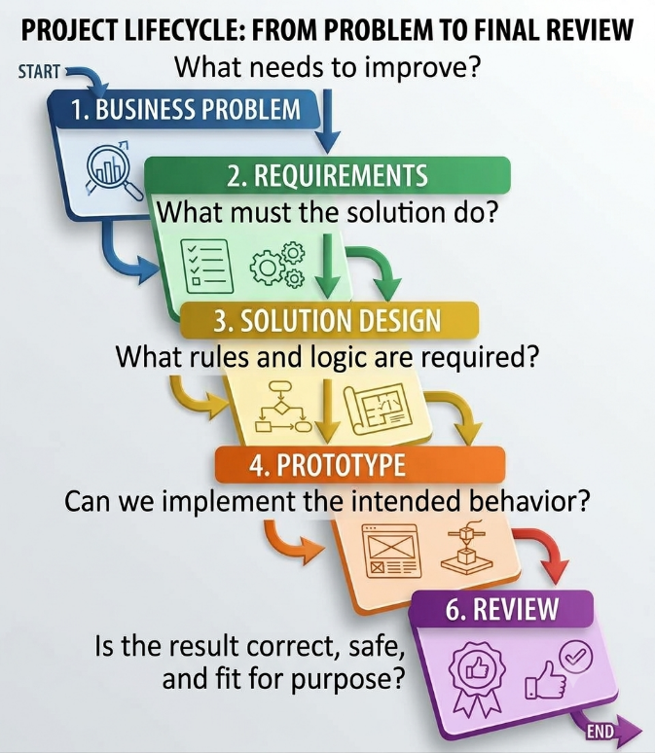
Facilitator explanation
Walk through each stage.
- Business problem: Describe the need in business terms.
- Requirements: Specify what the solution must and must not do.
- Solution design: Define inputs, rules, outputs, and exception handling.
- Prototype: Implement a limited version of the solution.
- Testing: Verify expected behavior and boundary conditions.
- Review: Decide whether the prototype meets the acceptance criteria.
Emphasize that GenAI can assist at every stage, but participants must retain responsibility for the requirements and approval decisions.

Slide 4. A vague request versus a well-defined problem
Weak request:
"Build a script to prioritize operational tickets."
What is missing?
- What constitutes a high-priority ticket?
- Which fields are available?
- What does an SLA breach mean?
- How should critical customers be treated?
- What should happen when information is missing?
- What output format is required?
- Which decisions require human approval?
Improved problem statement:
Create a deterministic Python function that evaluates a ticket using documented severity and SLA rules, returns an explainable classification, identifies whether escalation is required, and handles invalid or missing inputs explicitly.
Facilitator explanation
Ask participants why the weak request is insufficient.
Explain that different developers could produce very different implementations while all claiming to have completed the task. A clear problem statement reduces ambiguity and makes the solution testable.
The improved request still requires specific business rules. Those rules must be confirmed rather than invented by Copilot.

Slide 5. The problem-definition framework
Use the following structure before asking AI to generate a solution.
- Business problem: What needs to improve?
- User or stakeholder: Who will use the solution?
- Inputs: What data or parameters are available?
- Business rules: What decisions or calculations must be performed?
- Outputs: What must the solution return?
- Constraints: What must not happen?
- Exceptions: What happens when information is missing, invalid, or contradictory?
- Acceptance criteria: How will we determine whether the solution is correct?
Facilitator explanation
Explain that this structure works for code, spreadsheet automation, data validation, operational scripts, and other small prototypes.
For example, "calculate SLA breaches" is not a complete requirement. We must also know which timestamp or elapsed-time field is used, how the SLA limit is defined, and whether equality with the limit counts as a breach.
A prototype cannot reliably implement a business rule that has not been defined.

Slide 6. Demo 1: Use Copilot Chat to clarify the problem
Objective
Demonstrate that Copilot Chat can help turn an ambiguous request into a structured problem definition before any code is written.
Scenario
WinTrust Operations wants to improve the consistency of incident triage. Different analysts may interpret the same ticket differently.
The proposed prototype should evaluate a ticket using explicit business rules and produce an explainable result.
Exact prompt for Microsoft Copilot Chat
Act as a senior business analyst and solution designer.

WinTrust wants to create a small Python prototype for
deterministic operational ticket triage.

The prototype should evaluate ticket information and
produce an explainable triage result.

Do not write code yet.

First, turn the request into a problem definition containing:

1. Business problem
2. Intended users
3. Required inputs
4. Proposed outputs
5. Business rules that must be confirmed
6. Error and exception scenarios
7. Security and operational constraints
8. Acceptance criteria
9. Decisions that require human approval

Clearly distinguish:
- Requirements established by the request
- Assumptions that need confirmation
- Questions that cannot be answered from the information provided

Do not invent WinTrust policies or SLA thresholds.

Finish with the five most important questions that must
be resolved before implementation.
Facilitator demonstration steps
- Run the prompt in Copilot Chat.
- Review the proposed inputs and outputs.
- Identify which business rules remain undefined.
- Ask participants which assumptions would be dangerous to make.
- Explain why implementation should wait until the required rules are explicit.
Expected learning
Copilot is useful for structuring a problem and identifying missing requirements. It should not silently convert unanswered questions into business rules.

Slide 7. Demo 1: Define the acceptance criteria (no prompt)
A requirement describes what the solution must do. An acceptance criterion describes how we will verify it.
For the ticket-triage prototype, examples of acceptance criteria include:
- A ticket that exceeds its defined SLA limit is identified as breached.
- A ticket that is exactly at the SLA limit follows the documented boundary rule.
- A critical-severity ticket follows the documented escalation rule.
- A ticket with an invalid severity is not silently classified as valid.
- The result includes an explanation of the rules applied.
- The function returns a consistent output structure.
- Tests verify both expected and unexpected inputs.
Facilitator explanation
Point out that acceptance criteria should be testable. "The script should be robust" is too vague. "The function must reject an unsupported severity and provide a clear validation error" is testable.
Also emphasize that examples of rules are not substitutes for an approved policy. The exact boundary and escalation behavior must match the business rules supplied for the exercise.

Slide 8. The solution-design template
Before generating code, define the following:
PROBLEM
What are we solving?

INPUTS
What fields and data types are required?

RULES
What decisions or calculations must be performed?

OUTPUTS
What information must be returned?

VALIDATION
What inputs must be rejected or flagged?

EXCEPTIONS
How should missing or contradictory information be handled?

TESTS
Which scenarios prove the intended behavior?

CONTROLS
Which actions require human review or approval?
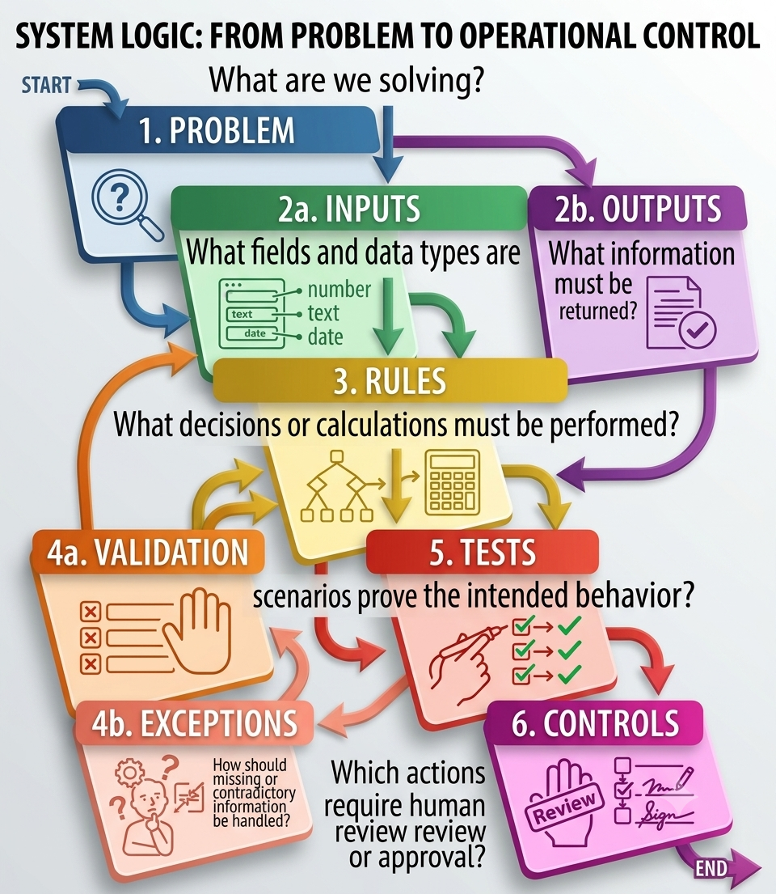
Facilitator explanation
This template is a bridge between business analysis and implementation.
Ask participants to identify which sections are often skipped when they use Copilot to generate code directly from a short request.
The usual omissions are explicit business rules, error handling, acceptance criteria, and tests.

Slide 9. Demo 2: Introduce the ticket-triage starter
Starter file: Code/ticket_triage_starter.py
The training pack includes a starter model for a ticket:
from dataclasses import dataclass

@dataclass
class Ticket:
ticket_id: str
customer_criticality: str
severity: str
elapsed_minutes: int
sla_minutes: int
affected_transactions: int
symptom: str

def classify_ticket(ticket: Ticket) -> dict:
"""Implement deterministic WinTrust triage rules using GitHub Copilot."""
raise NotImplementedError
The starter deliberately leaves the classification function incomplete.
Facilitator explanation
Explain the purpose of the starter file:
- It defines the input structure.
- It gives participants a bounded implementation task.
- It allows the group to focus on business logic, validation, and tests rather than writing boilerplate.
- It makes it possible to compare different implementations against the same input model.
The affected_transactions and symptom fields are available, but they should not influence escalation unless a documented rule specifies how they are used.

Slide 10. Demo 2: Establish the business rules before coding
For the demonstration, use the following explicit training rules:
- A ticket with severity P1 must be escalated.
- A ticket whose elapsed time exceeds its SLA limit must be escalated.
- An SLA breach occurs when elapsed time is strictly greater than the SLA limit.
- A ticket exactly at the SLA limit is not considered breached.
- An unsupported severity or invalid time value must be rejected rather than silently accepted.
- The output must explain the reason for escalation.
- The function must not perform any external action, modify a ticketing system, or send notifications.
Important: These are rules for this training exercise, not a claim about WinTrust's actual production policy.
Facilitator explanation
This slide is critical because the same words can imply different implementations.
For example, "SLA breach" could mean elapsed_minutes > sla_minutes or elapsed_minutes >= sla_minutes. Neither should be chosen arbitrarily.
For the demonstration, the boundary rule is explicit. In a real implementation, the approved policy would determine it.

Slide 11. Demo 2A: Ask Copilot Chat to review the design
Exact prompt
Act as a senior Python solution architect.

Review the proposed deterministic ticket-triage design.

Input model:
Ticket(
ticket_id,
customer_criticality,
severity,
elapsed_minutes,
sla_minutes,
affected_transactions,
symptom
)

Training rules:
- P1 tickets must be escalated.
- Tickets are SLA-breached when elapsed_minutes is
strictly greater than sla_minutes.
- A ticket exactly at the SLA limit is not breached.
- Unsupported severity and invalid time values must
be rejected.
- The output must explain the classification.
- No external action or system modification is allowed.

Do not write the implementation yet.

Provide:
1. A decision table
2. Input-validation requirements
3. Boundary cases
4. Expected output fields
5. At least eight test scenarios
6. Potential ambiguity or design risks

Use only the rules supplied above.
Do not introduce additional escalation rules based on
customer criticality, affected transaction count, or symptom.

Clearly identify any remaining design decisions.
Facilitator demonstration steps
- Ask Copilot to generate the decision table.
- Check that the P1 rule and SLA rule are separate.
- Verify that the exact SLA boundary is handled correctly.
- Look for invented rules based on customer criticality or affected transactions.
- Confirm that the proposed outputs include the reason for the classification.
Expected learning
A design review before coding can expose incorrect assumptions that would otherwise become embedded in the implementation.

Slide 12. Demo 2B: Generate the implementation with GitHub Copilot
Tool: GitHub Copilot in VS Code.
File: Code/ticket_triage_starter.py
Exact prompt
Implement the classify_ticket function in the open file
Code/ticket_triage_starter.py.

Use the existing Ticket dataclass.

Implement only these training rules:

1. Severity P1 requires escalation.
2. An SLA breach occurs when elapsed_minutes is strictly
greater than sla_minutes.
3. An SLA-breached ticket requires escalation.
4. A ticket exactly at the SLA limit is not breached.
5. Reject an unsupported severity.
6. Reject invalid time values, including negative elapsed
time and non-positive SLA limits.
7. Reject negative affected_transactions.
8. Validate that ticket_id is not blank.

Return a dictionary containing:
- ticket_id
- severity
- sla_breached
- escalate
- reasons

The reasons field must explain the rule or rules that
caused escalation. If escalation is not required,
provide an appropriate explanation.

Requirements:
- Keep the function deterministic.
- Do not use an LLM or external service.
- Do not modify external systems or send notifications.
- Do not invent additional escalation rules.
- Use clear variable names and type hints.
- Raise a clear ValueError for invalid input.
- Preserve the existing Ticket dataclass.

After implementation, explain each rule and identify
the test cases needed to verify it.
Facilitator demonstration steps
- Review the code generated by Copilot.
- Check whether the implementation matches every rule.
- Verify that the function returns a consistent dictionary.
- Check that invalid inputs are rejected.
- Confirm that the code does not introduce external side effects.
Note: Remember to save the file as it is to be used for a later demo.
Expected learning
GitHub Copilot can accelerate implementation, but the developer must verify that every requirement has been implemented correctly.

Slide 13: Starter test | readable and reviewable
Testing must cover more than one successful example.
The supplied test file is Code/test_ticket_triage.py. It already contains two starter tests:
from ticket_triage_starter import Ticket, classify_ticket

def test_critical_customer_sla_breach():
t = Ticket(
"INC-TEST-1", "Critical", "P2",
300, 240, 12000, "elevated response time"
)
assert classify_ticket(t)["escalate"] is True

def test_low_impact_ticket():
t = Ticket(
"INC-TEST-2", "Medium", "P4",
30, 2880, 2, "documentation issue"
)
assert classify_ticket(t)["escalate"] is False
These tests provide a starting point, but more coverage is needed.
Facilitator explanation
The first test should escalate because the elapsed time exceeds the SLA limit, even though the severity is P2. The second should not escalate under the supplied rules.
The label critical_customer in the first test name does not mean customer criticality is an escalation rule. The actual expected behavior is driven by the SLA breach.
This distinction is useful for demonstrating why test names, business rules, and implementation logic must agree.

Slide 14: Start with tests, not trust | Generate meaningful tests
- Existing tests are a starting point, not proof of correctness.
- Add P1 within SLA, P2 with breach, P4 within SLA, and P1 plus breach.
- Test the exact boundary and one minute beyond it.
- Test unsupported severity, negative elapsed time, zero SLA, negative impact count and blank ID.
- Check both the decision and explanation returned.
- Never weaken a valid test just to make generated code pass.

Slide 14: Demo 2C: Ask GitHub Copilot to expand the tests
Exact prompt
Expand Code/test_ticket_triage.py using pytest.

Keep the existing tests unless they conflict with the
explicit training rules.

Add tests for:

1. A P1 ticket that is within its SLA.
2. A P2 ticket that has breached its SLA.
3. A P4 ticket that is within its SLA.
4. A ticket exactly at the SLA boundary.
5. A ticket one minute beyond the SLA boundary.
6. An unsupported severity.
7. Negative elapsed time.
8. A zero or negative SLA limit.
9. A negative affected_transactions value.
10. A blank ticket_id.
11. A ticket that breaches its SLA and is P1.
12. A ticket that does not require escalation.

For valid inputs, verify the relevant output fields,
including sla_breached, escalate, and reasons.

For invalid inputs, verify that a clear ValueError is raised.

Use the exact training rules. Do not add escalation
behavior based on customer_criticality, symptom, or
affected_transactions.

Do not change the business rules to make a test pass.

Explain what each test verifies.
Facilitator demonstration steps
- Ask Copilot to add the tests.
- Review whether the tests actually check the expected behavior.
- Run the test suite.
- Examine failures rather than immediately changing the assertions.
- Correct the implementation if it violates the defined requirements.
Note: Remember to save the file as it is to be used for a later demo.
Expected learning
Tests are executable acceptance criteria. A test suite is useful only if its expected results reflect the agreed business rules.

Slide 15. Demo 2: Run the tests and investigate failures
The development cycle:
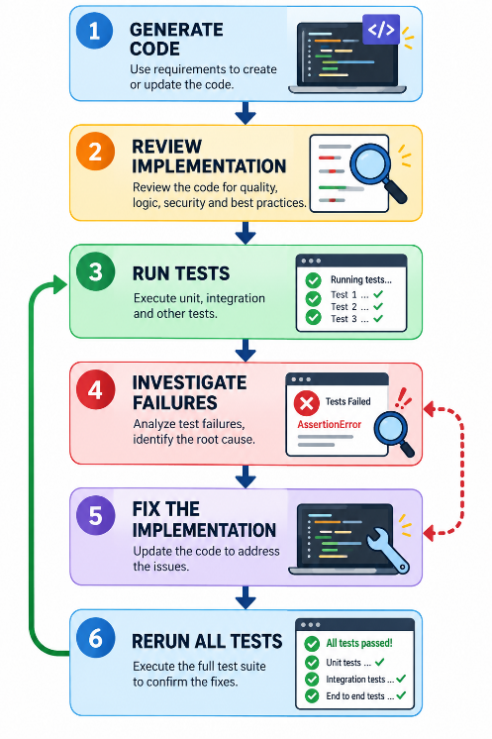
Facilitator explanation
Ask participants what they would do if a test fails.
The correct response is to investigate the failure and compare the implementation with the requirements. Do not automatically change a test assertion simply because the code disagrees with it.
For this exercise, the expected results come from the explicit training rules. In real work, expected results should come from an approved specification or policy.
If a test fails because the implementation escalates a P2 ticket solely because the customer is marked Critical, the implementation has introduced an unsupported rule and should be corrected.

Slide 16. Demo 3: Challenge the prototype
A prototype can pass basic tests and still contain defects.
Do not show/run the prompt for Demo 3 yet. That is on next slide.
Review it for:
- Incorrect boundary handling.
- Missing input validation.
- Inconsistent return values.
- Unsupported business rules.
- Confusing variable names or hidden assumptions.
- Unhandled exceptions.
- External side effects.
- Tests that duplicate the implementation's assumptions instead of checking the requirements.
Facilitator explanation
Explain that testing and review serve different purposes.
- Tests check defined behaviors.
- Code review checks implementation quality and consistency with requirements.
- Security review considers misuse, permissions, and unintended effects.
- Business review confirms that the implemented rules are appropriate.
Passing tests is necessary, but not sufficient, for approving a solution.

Slide 17. Demo 3: Conduct a code review with Copilot Chat
Exact prompt
Act as an independent senior Python code reviewer.

Review:
- Code/ticket_triage_starter.py
- Code/test_ticket_triage.py

Use the explicit training rules as the source of truth.

Check:

1. Whether every rule is implemented.
2. Whether SLA boundary conditions are correct.
3. Whether invalid inputs are rejected consistently.
4. Whether the output structure is consistent.
5. Whether reasons accurately explain the decision.
6. Whether unsupported escalation rules have been introduced.
7. Whether tests cover normal cases, edge cases, and invalid inputs.
8. Whether any code has unintended external side effects.
9. Whether the implementation is unnecessarily complex.
10. Whether the tests could pass despite incorrect business logic.

For every issue, provide:
- File and function
- Evidence from the code or tests
- Why it matters
- Severity
- Recommended correction
- Test that would verify the correction

Do not claim to have executed the tests unless they
were actually run.

Do not change the business rules.
Prioritize correctness over stylistic preferences.
Facilitator demonstration steps
- Ask Copilot to review the files.
- Select one substantive finding.
- Inspect the referenced code.
- Decide whether the finding is valid.
- Apply a correction only when it is justified.
- Run the tests again.
Expected learning
AI can act as a useful reviewer, but review findings must themselves be checked. A confident explanation is not proof of a defect.

Slide 18. Demo 3: Test contradictory and unexpected inputs
A good prototype must behave predictably when inputs are unusual or incomplete.
Examples:
- A P1 ticket that has not breached its SLA.
- A P2 ticket that has breached its SLA.
- A ticket exactly at the SLA boundary.
- A ticket with a negative elapsed time.
- A ticket with a zero SLA limit.
- A ticket with an unsupported severity.
- A ticket with a blank identifier.
Facilitator explanation
Ask participants to predict the expected result for each case before running the code.
This encourages them to reason from the requirements rather than infer behavior from the implementation.
The combination of P1 severity and an SLA breach should trigger escalation for two reasons, but the output should remain consistent and explain both reasons if the design requires it.

Slide 19. A critical distinction: Deterministic rules versus AI judgment
Use deterministic code when a decision depends on explicit, testable rules.
Examples:
- Determine whether elapsed time exceeds an SLA limit.
- Reject invalid field values.
- Calculate a percentage using a defined denominator.
- Validate that a required identifier is present.
Use GenAI to assist with tasks such as:
- Explaining an error message.
- Suggesting possible causes of an incident.
- Summarizing a set of findings.
- Drafting documentation.
- Proposing test cases for human review.
Facilitator explanation
Explain that a prototype does not need an LLM merely because it is part of a GenAI training program.
For the ticket-triage example, the classification is deterministic. Using an LLM to make the same decision could introduce variability without providing a benefit.
The more consequential the decision, the more important it is to make the rule explicit, testable, and reviewable.

Slide 20. Data track application: SQL-based data-quality investigation
Objective: Use GitHub Copilot to translate data-quality requirements into SQL queries that identify invalid or suspicious records.
Scenario: The WinTrust data team receives transaction data from upstream systems. Before using it for reporting, the team needs to identify records that violate agreed data-quality rules.
Tools: GitHub Copilot and a SQL environment such as DuckDB.
Input file: transactions_500.csv from the existing demo pack. First confirm the actual CSV headers before writing queries.
Proposed checks, subject to confirming the source schema:
- Missing transaction or customer identifiers.
- Invalid transaction dates.
- Unsupported currency codes.
- Unsupported product codes.
- Negative transaction amounts.
- Duplicate transaction identifiers.
- Missing or unexpected status values, where an approved status vocabulary exists.
The last two checks should be treated carefully: duplicates require an agreed definition, and status values must not be invented.

Slide 21. Define the rules before generating SQL
Present this as the data-quality contract for the exercise.
Check | Rule | Expected result
Transaction ID | Must not be null or blank | Flag invalid rows
Customer ID | Must not be null or blank | Flag invalid rows
Transaction date | Must be a valid date in YYYY-MM-DD format | Flag invalid rows
Currency code | Must belong to the approved set | Flag unsupported values
Product code | Must belong to the approved set | Flag unsupported values
Amount | Must be numeric and non-negative | Flag invalid amounts
Duplicate ID | Check repeated transaction IDs | Report duplicates for investigation
Status | Compare against an approved list, if available | Do not invent allowed values
For the demonstration, the existing starter material identifies these candidate currency values: INR, USD, EUR, and product codes: PAY, DAT, OPS, SEC, ANL. Confirm these against the approved exercise specification before treating them as authoritative.

Slide 22. GitHub Copilot demo: Generate SQL data-quality checks
Use the following prompt with GitHub Copilot Chat. The prompt deliberately requires schema inspection before query generation.
Act as a senior data engineer and SQL developer.

The WinTrust data team needs to investigate data-quality issues
in transactions_500.csv before using the data for reporting.

We want a SQL-based solution, not a Python validation function.

First:
- Inspect the actual CSV headers and data types if the file is available.
- List the confirmed columns and identify any schema assumptions.
- Ask for clarification if the required fields are absent.

Then help implement SQL checks for:
- Missing or blank transaction identifiers
- Missing or blank customer identifiers
- Invalid transaction dates in YYYY-MM-DD format
- Unsupported currency codes
- Unsupported product codes
- Negative transaction amounts
- Duplicate transaction identifiers

Use these candidate allowed values only if confirmed for the exercise:
Currency codes: INR, USD, EUR
Product codes: PAY, DAT, OPS, SEC, ANL

Requirements:
- State the SQL dialect you are using.
- Do not invent columns or silently rename source fields.
- Do not invent allowed status values or other business rules.
- Make each check independently executable.
- Return the records that fail each check, along with a reason.
- Include a summary of the number of failing records per check.
- Explain how NULLs and blank strings are handled.
- Include test cases for valid records, invalid records and boundary cases.

Do not claim the SQL has been executed or validated unless it has.
Do not modify the source data. The exercise is read-only.
Start by confirming the schema and proposed approach before
generating the complete SQL solution.
Demonstration steps
- Ask Copilot to inspect the schema or work from the confirmed column list.
- Review its proposed rules before accepting the SQL.
- Generate one query at a time, starting with missing identifiers.
- Ask Copilot to explain each query.
- Run the SQL in the selected SQL environment.
- Compare the results against a few manually checked records.
- Ask Copilot to challenge its own query for missed cases.

Slide 23. Challenge the generated SQL
After generating the initial checks, use this review prompt.
Review the SQL data-quality checks you generated.

Check for:
- Incorrect or invented column names
- Incorrect handling of NULL and blank values
- Invalid date handling, including impossible calendar dates
- Duplicate detection that produces misleading counts
- Incorrect treatment of negative, NULL or non-numeric amounts
- Hard-coded allowed values that lack approval
- Queries that flag records incorrectly or miss invalid records
- SQL dialect incompatibilities
- Unnecessary modification of source data

For every issue:
- Show the relevant SQL
- Explain the problem
- Provide a corrected query or expression
- Give a test record that would expose the problem

Distinguish issues you can establish from the SQL itself from
issues that require execution against the dataset.

Do not claim that the queries passed tests unless they were run
and their results were inspected.
Key teaching point: Syntactically valid SQL is not necessarily logically correct SQL. Data-quality rules need both business validation and technical testing.

(skip) Slide 20. Data track application: Data-quality validation
Data teams can apply the same problem-solving workflow to transaction validation.
Example problem:
"Create a Python function that validates a transaction against a documented set of data-quality rules and returns explainable findings."
Next slide shows the code to be used.
Potential validation checks include:
- Required identifiers are present.
- Amounts satisfy documented constraints.
- Currency codes belong to an approved set.
- Product codes belong to an approved set.
- Dates follow the required format and business rules.
- Findings identify the affected field and the reason for the failure.
Facilitator explanation
Explain that data validation is a good prototyping exercise because rules can be expressed as explicit inputs, conditions, and expected results.
The challenge is to distinguish a true data-quality defect from a value that merely looks unusual.
For example, a negative transaction amount might be invalid for one transaction type but valid for a reversal. The rule must be defined before the validator rejects it.

(skip) Slide 21. Data track: Define the validation requirements
Starter file for the exercise: Code/data_quality_validator_starter.py
Do not show/run the prompt yet. That is on net slide.
The following starter can be added to the training pack for the Data track:
from dataclasses import dataclass

@dataclass
class Transaction:
transaction_id: str
customer_id: str
transaction_date: str
product_code: str
currency_code: str
amount: float
status: str

VALID_CURRENCIES = {"INR", "USD", "EUR"}
VALID_PRODUCTS = {"PAY", "DAT", "OPS", "SEC", "ANL"}

def validate_transaction(tx: Transaction) -> list[dict]:
"""Return deterministic validation findings."""
raise NotImplementedError
Training rules
- Transaction and customer identifiers must not be blank.
- Transaction date must use the documented YYYY-MM-DD format.
- Currency must be one of the listed valid currencies.
- Product code must be one of the listed valid products.
- Amount must be numeric and non-negative for this training exercise.
- Status must belong to an explicitly agreed set of permitted values.
- Findings must identify the field, rule, and reason.
Important: The permitted status values must be agreed before implementation. Do not ask Copilot to invent them.
Facilitator explanation
The starter provides the data structure and two controlled reference sets. Participants must turn the remaining requirements into a deterministic validator.
For this exercise, a negative amount is considered invalid. That is a training rule, not a universal rule for every financial transaction system.

(skip) Slide 22. Data Track Demo: Generate the validator with GitHub Copilot
Exact prompt
Implement validate_transaction in the open file
Code/data_quality_validator_starter.py.

Use the existing Transaction dataclass,
VALID_CURRENCIES, and VALID_PRODUCTS.

Requirements:

1. Reject blank transaction_id and customer_id values.
2. Validate transaction_date using YYYY-MM-DD.
3. Reject dates that do not represent a valid calendar date.
4. Reject unsupported currency codes.
5. Reject unsupported product codes.
6. Reject non-numeric or negative amounts.
7. Validate status against an explicitly supplied set
of allowed values. If that set has not been provided,
identify the missing requirement rather than inventing
business values.
8. Return a list of findings.
9. Each finding must identify the field, rule, and reason.
10. Return an empty list when all supplied rules pass.

Do not modify the input transaction.
Do not access external services.
Do not invent additional business rules.
Use clear type hints and readable code.

Explain the implementation and list the tests required.
Facilitator demonstration steps
- Review the generated validation logic.
- Check whether the date is validated as a real calendar date, not merely as a string with the right shape.
- Check the handling of blank identifiers.
- Confirm that the validator does not modify the input.
- Resolve the allowed status values before treating that rule as implemented.
Note: Remember to save the file as it will be used in the next demo.
Expected learning
Participants should see how a business requirement becomes a deterministic validation rule, and how missing requirements should be surfaced instead of guessed.

(skip) Slide 23. Data Track: Test the validator
Exact prompt
Create pytest tests for Code/data_quality_validator_starter.py.

Cover:

1. A valid transaction.
2. A blank transaction_id.
3. A blank customer_id.
4. An invalid date format.
5. An impossible calendar date.
6. An unsupported currency.
7. An unsupported product code.
8. A negative amount.
9. A non-numeric amount, if supported by the input model.
10. Multiple validation failures in one transaction.
11. An input with no validation findings.

Use only the rules explicitly defined in the exercise.

Do not invent allowed status values. If status values
are still unresolved, mark that test as blocked by
a missing requirement rather than assuming a value.

Assert the actual finding fields and reasons, not only
the total number of findings.

Explain what each test verifies.
Facilitator explanation
A good test should verify the content of the validation result, not simply that the function returns a list.
If a record has three defects, the test should verify that the correct fields and reasons are reported.
This helps detect validators that technically return findings but identify the wrong field or apply the wrong rule.

Slide 24. Enterprise Operations application: Safe prototyping
Enterprise Operations teams can use the same method to prototype:
- Ticket classification.
- SLA calculations.
- Log-file summaries.
- Operational report generation.
- Runbook pre-checks.
- Detection of conditions requiring human review.
A prototype should begin with read-only analysis or a dry-run mode when it concerns operational changes.
Facilitator explanation
Explain that generating a script to identify old logs is different from generating a script that deletes them.
For this program, participants are not building agents or connecting to production systems. The objective is to prototype controlled logic and understand the safeguards required before automation can be trusted.
Any consequential action should be governed by explicit approval requirements and an appropriate operational process.

Slide 25. The prototype quality checklist
Before considering a prototype complete, verify the following:
- Requirements are explicit and testable.
- Business rules are documented.
- Inputs are validated.
- Outputs are consistent and explainable.
- Normal and boundary cases are tested.
- Invalid inputs are handled safely.
- Tests reflect the requirements, not the implementation's assumptions.
- The code has been reviewed for unintended side effects.
- Limitations are documented.
- Human approval is obtained where required.
Facilitator explanation
Reinforce that a prototype may be suitable for demonstrating feasibility without being ready for operational use.
A successful prototype proves that an approach can work under defined conditions. It does not automatically prove production readiness, security, scalability, or compliance.

Final 30 minutes: Participant hands-on
The remaining five slides support the participant exercise. The facilitator should not introduce another demonstration during this time.

Slide 26. Hands-on challenge: Solve a defined business problem

Enterprise Operations track
Scenario
You are supporting a WinTrust team that wants to improve the consistency and reliability of a small business process.
Choose the track-specific challenge assigned to your group.
Implement the ticket-triage function using:
- Code/ticket_triage_starter.py
- Code/test_ticket_triage.py
Apply the documented training rules:
- P1 tickets require escalation.
- Tickets exceeding their SLA limit require escalation.
- An SLA breach occurs only when elapsed time is strictly greater than the SLA limit.
- Invalid input must be rejected.
- The output must explain the decision.
Your objective
Produce a small, testable prototype that implements explicit requirements, handles expected edge cases, and includes automated tests.

Data track
Scenario: The WinTrust data team must assess whether a transaction dataset is suitable for downstream reporting.
Participants should:
- Inspect the CSV headers and confirm the schema.
- Ask GitHub Copilot to translate the agreed rules into SQL.
- Execute the checks in the selected SQL environment.
- Investigate flagged records.
- Review false positives, missed cases, and assumptions.
- Produce a concise data-quality summary.
Files and tools
- transactions_500.csv
- GitHub Copilot

Slide 27. Hands-on task and workflow
Enterprise Operations participants
- Review the starter code and test cases.
- Ask Copilot Chat to review the requirements and identify ambiguities.
- Use GitHub Copilot to implement classify_ticket.
- Expand the test suite.
- Run the tests and investigate failures.
- Review the code for unsupported rules and unintended side effects.
Data participants
Use this sequence:
INSPECT SCHEMA → DEFINE RULES → GENERATE SQL → REVIEW → EXECUTE → VALIDATE RESULTS
- Inspect schema: confirm the actual columns and types.
- Define rules: agree what constitutes a defect.
- Generate SQL: use Copilot to produce individual checks.
- Review: challenge the generated queries before execution.
- Execute: run them against the dataset.
- Validate results: manually inspect sample records and reconcile counts.
Participants should not alter source data to make the checks pass. They should report the defects and their implications.
By the end of the exercise, each participant should produce:
- A confirmed source schema.
- SQL queries for the agreed data-quality checks.
- Results from actually executing the queries, where the SQL environment is available.
- A summary of defect counts by rule.
- A small set of manually verified records.
- One limitation or unresolved business rule.
- One recommendation for improving upstream data quality.

Hands-on prompt: Enterprise Operations (not shared)
Share this only if required.
Participants on the Enterprise Operations track can use this exact prompt in GitHub Copilot.
Implement the function classify_ticket in Code/ticket_triage_starter.py.

Use the existing Ticket dataclass and follow these explicit training rules:
- Severity P1 requires escalation.
- An SLA breach occurs when elapsed_minutes is strictly greater than sla_minutes.
- An SLA-breached ticket requires escalation.
- A ticket exactly at the SLA limit is not breached.
- Reject unsupported severity values.
- Reject negative elapsed time and non-positive SLA limits.
- Reject negative affected_transactions.
- Reject a blank ticket_id.

Return a dictionary containing:
- ticket_id
- severity
- sla_breached
- escalate
- reasons

The reasons field must explain the rule or rules that caused escalation. If escalation is not required, provide an appropriate explanation.

Requirements:
- Keep the function deterministic.
- Do not use an LLM or external service.
- Do not modify external systems or send notifications.
- Do not invent additional escalation rules.
- Use clear variable names and type hints.
- Raise a clear ValueError for invalid input.
- Preserve the existing Ticket dataclass.

Then expand Code/test_ticket_triage.py to cover normal cases, P1 escalation, SLA breaches, the exact SLA boundary, invalid severity, invalid time values, and blank identifiers.

Explain the implementation and tests. Do not change business rules to make a test pass.

Hands-on prompt: Data (not shared)
Share this only if required.
Participants on the Data track can use this exact prompt in GitHub Copilot.
You are helping the WinTrust data team investigate transaction
data quality using SQL.

Use transactions_500.csv.

First confirm the actual schema. Do not assume columns exist
until they have been verified.

Build SQL checks for:
- Missing or blank transaction and customer identifiers
- Invalid dates
- Unsupported currency and product codes, using only approved
values supplied for the exercise
- Negative transaction amounts
- Duplicate transaction identifiers

For each check:
- Return the affected records.
- Include a clear reason for each finding.
- Provide a summary count.
- Explain NULL and blank-value handling.
- Suggest test records for validating the query.

Requirements:
- State the SQL dialect.
- Do not invent columns, allowed status values or business rules.
- Do not update or delete source records.
- Identify any rule that cannot be implemented because its
specification is incomplete.
- Do not claim execution or correctness without evidence.

After generating the SQL, review it for boundary cases,
false positives, false negatives and dialect compatibility.
Provide a short checklist for manually validating the results.

Hands-on deliverables and review
Each participant or group must submit:
Deliverable 1: Problem definition
A concise statement of the problem, inputs, business rules, expected outputs, and acceptance criteria.
Deliverable 2: Working prototype
The implemented Python function in the assigned starter file.
Deliverable 3: Automated tests
A test file that covers normal cases, edge cases, and invalid inputs.
Deliverable 4: Test results
Evidence that the tests were executed, including any failures investigated and resolved.
Deliverable 5: Review notes
A short explanation of:
- What the prototype does.
- Which business rules it implements.
- What assumptions or limitations remain.
- Which additional tests would be useful.
- What human review would be required before operational use.
Evaluation criteria
- Correctness against the documented requirements.
- Appropriate input validation.
- Test coverage and meaningful assertions.
- Clear and maintainable implementation.
- No unsupported business rules.
- Recognition of limitations and human-control requirements.

Closing message
The core lesson from Session 4 is that generating code is only one step in solving a problem.
A reliable prototype starts with clear requirements, implements explicit rules, passes meaningful tests, and undergoes review before anyone relies on its output.
The recurring workflow:
GENERATE
|
v
EXPLAIN
|
v
REVIEW
|
v
TEST
|
v
CHALLENGE
|
v
APPROVE
Use Copilot to accelerate the work, GitHub Copilot to help implement and test the solution, and human judgment to determine whether the result is correct and appropriate for its intended use.

