Session 6: MC-II, Under the Hood
WinTrust AI Capability Program | Masterclass for Data and Enterprise Ops
Primary tool: Microsoft Copilot Chat Supporting tool: GitHub Copilot in VS Code, for the optional code-review demonstration.
Masterclass design principle: Focus on how models behave, how to diagnose failures, and how to make better technical decisions. Avoid spending too much time on introductory AI definitions.

Facilitator reference: Files and datasets required
These are the files to prepare before delivering the session. They are references to the existing WinTrust demo pack, not newly generated files.
- WinTrust_Runbook_Disk_Utilization.docx
  - Required for Slide 19, grounding demonstration.
  - Used to check whether Copilot distinguishes documented procedures from unsupported recommendations.
- ops_tickets_200.csv
  - Required for Slide 17, prompt-quality demonstration.
  - Use the actual CSV schema and independently verify counts or other computed findings.
- transactions_500.csv
  - Optional extension for the Data lab.
  - Use if you want participants to investigate a larger dataset after completing the five-row exercise.
- WinTrust_Operations_SLA_Policy.docx
  - Optional supporting source for Slide 19.
  - Useful when comparing runbook recommendations with documented escalation and service-level requirements.
- WinTrust_GenAI_Security_Guidelines.docx
  - Optional supporting source for Slide 19.
  - Adds security context when evaluating operational recommendations.
- Code/ticket_triage_starter.py and Code/test_ticket_triage.py
  - Optional GitHub Copilot demonstration, Slide 29.
  - Used to contrast code explanation with actual test evidence.

Slide 1: Title slide
MC-II: Under the Hood
How LLMs work, why they fail, and how to troubleshoot them with confidence.
Audience: Data and Enterprise Ops.
Visual prompt:
Create a professional enterprise technology visual for a masterclass titled “Under the Hood: How LLMs Work”. Show a large language model at the centre, receiving prompts and contextual documents, processing tokens and producing a response. Include subtle visual references to data analytics, code and IT operations. Clean corporate aesthetic, dark navy and teal palette, minimal labels, 16:9 landscape composition. Avoid decorative futuristic robots.

Slide 2: Why this masterclass matters
On-slide content
- AI can produce fluent answers that are incorrect.
- Better prompts cannot compensate for missing evidence.
- More context is not always better context.
- Some problems require retrieval, computation or testing, not more prompting.
- High-impact actions still require appropriate controls and human judgment.
Key message: Understand the failure mechanism before choosing the fix.
Facilitator notes: Explain that this session builds on earlier prompting practice. Participants should leave with a troubleshooting method, not merely a vocabulary of AI terms.

Slide 3: Learning outcomes
By the end of this masterclass, participants can:
- Explain tokenization, context windows, attention and next-token prediction.
- Distinguish model knowledge from supplied evidence and retrieved information.
- Diagnose common response failures.
- Select an appropriate corrective action.
- Verify AI-assisted outputs before relying on them.

Module 1: How LLMs Work

Module 1: How Models Work

Slide 4: How LLMs Work
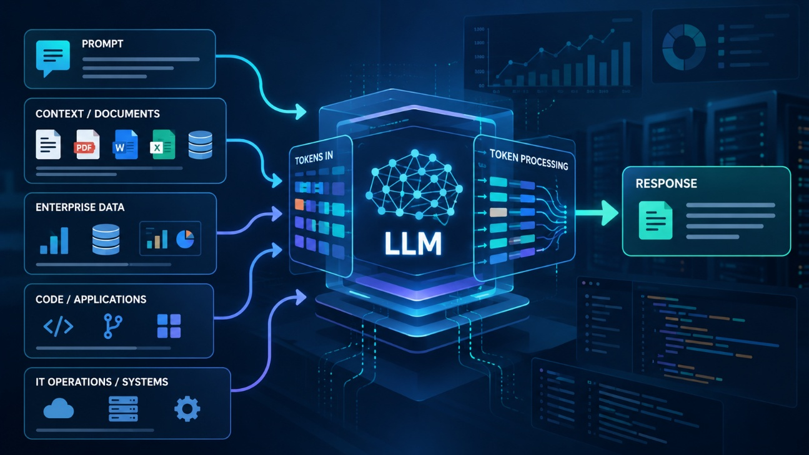

Slide 5: An LLM predicts the next token
A simplified generation process:
- Receive the prompt and available context.
- Convert text into tokens.
- Process contextual relationships through the model.
- Estimate probabilities for the next token.
- Select a token and repeat until generation stops.
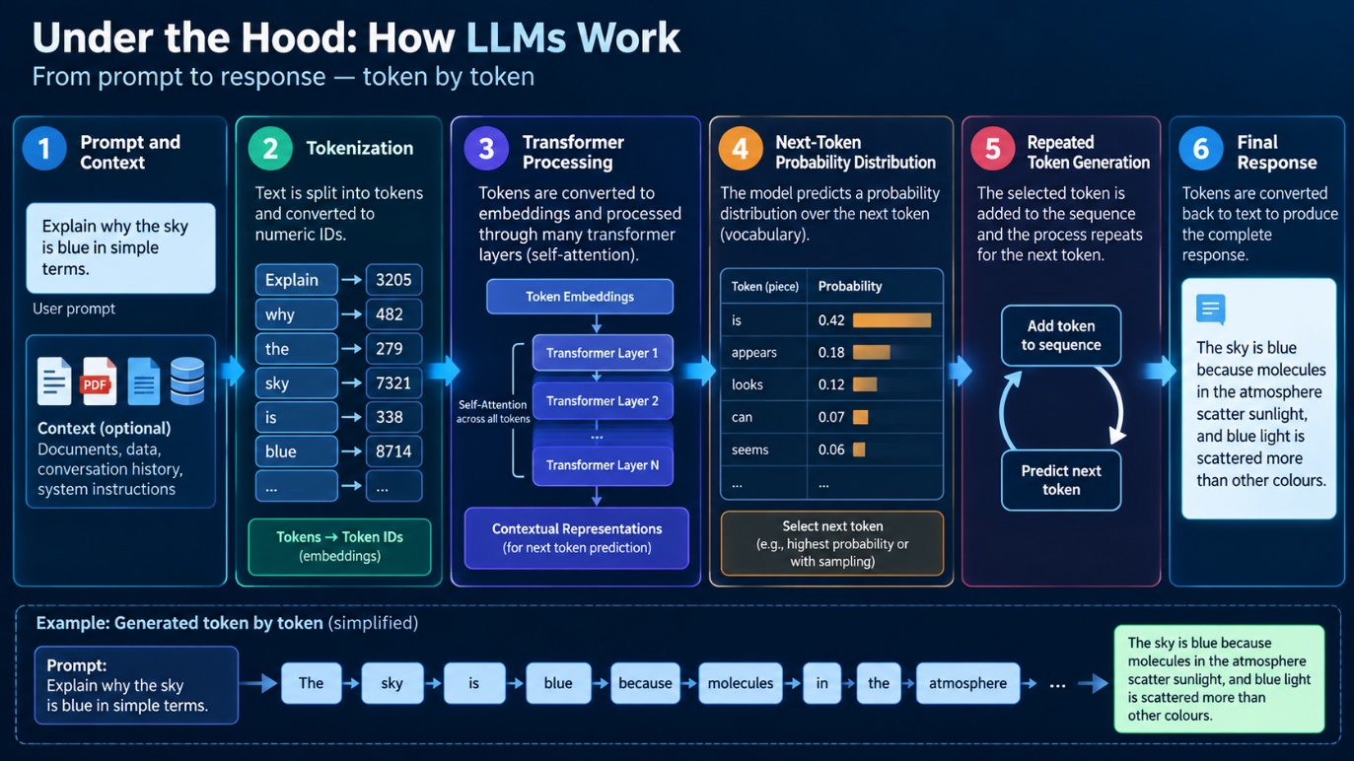
Key takeaway: An LLM generates a sequence of tokens conditioned on the available context. It does not guarantee that the resulting answer is factually correct.
Facilitator notes: Avoid saying that the model simply selects the single most probable word each time. Actual generation depends on the model, decoding strategy and configuration.

Slide 6: What is a token?
Tokens are the units used to represent text for model processing.
- A token may be a whole word, part of a word, punctuation or another text unit.
- One word does not necessarily equal one token.
- Longer prompts and documents generally consume more tokens.
- Tokenization varies by model and tokenizer.
Example:
Troubleshooting production incidents
A tokenizer might represent this as whole words or multiple subword tokens, depending on its vocabulary. Do not assume a fixed token count.
Facilitator question: Why can a long document consume more of the model's available context than a short question?

Slide 7: What is a transformer?
The transformer architecture enables the model to process token sequences and learn contextual relationships.
- Attention: Helps the model relate different tokens and parts of the context.
- Model parameters: Encode learned patterns from training.
- Layers: Repeated transformations build contextual representations.
- Generation: The model uses its processed representations to predict subsequent tokens.
Do not confuse: Attention is not the same as verified factual reasoning, and model parameters are not a searchable database of guaranteed facts.
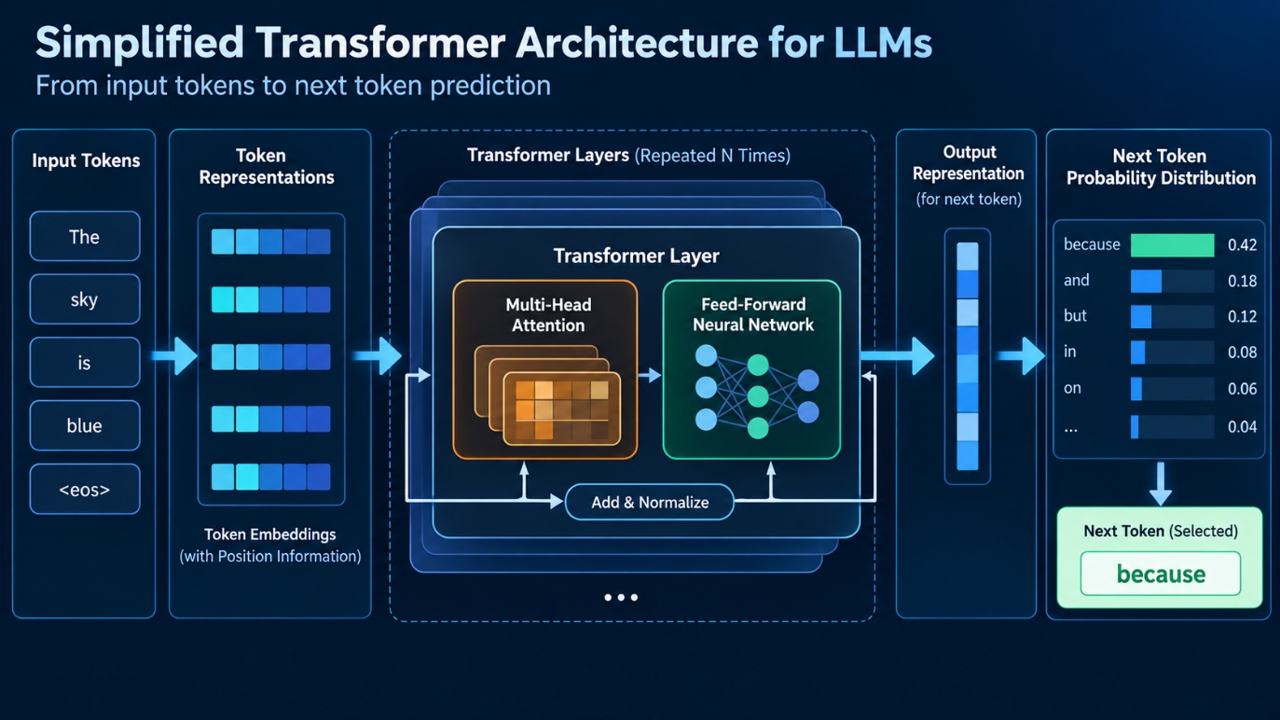

Slide 8: Training versus inference
Training | Inference
Model parameters are learned from training data. | The trained model processes a new request.
Large-scale optimization shapes learned patterns. | Prompt, context and configuration influence the response.
Takes place during model development or subsequent training. | Happens when a user submits a prompt.
Practical implication: A prompt normally changes the current task and context, not the model's underlying trained parameters.
Facilitator note: Product-specific memory, customization or learning features are separate considerations. Do not suggest that every conversation retrains the model.

Slide 9: Why fluent answers can be wrong
An LLM is optimized to generate plausible continuations under its training and inference setup. Plausibility is not proof.
Potential failure modes:
- Fabricated details or references
- Incorrect calculations
- Misinterpreted instructions
- Unsupported causal conclusions
- Outdated or missing knowledge
- Inconsistent answers across different prompts
Key takeaway: Confidence of tone is not evidence of correctness.

Module 2: Tokens, context and attention

Slide 10: Understanding the context window
The context window is the model's bounded working context for a request.
It may include:
- System and developer instructions
- The current user prompt
- Conversation history
- Supplied or retrieved material
- Generated tokens, subject to the model's limits
Implications
- Long conversations may consume substantial context.
- Relevant details can be buried in irrelevant material.
- Product implementations may summarize, truncate or otherwise manage context.
- The advertised context limit is not a guarantee of perfect recall.

Slide 11: More context is not always better
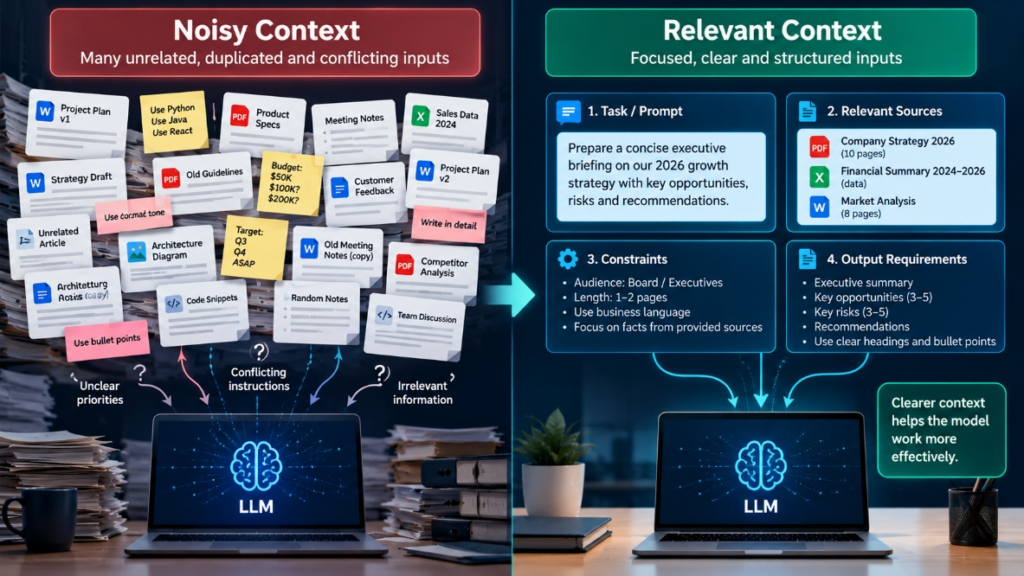
Poor context:
- Many unrelated documents
- Repeated or conflicting instructions
- Unclear source authority
- Large amounts of irrelevant material
Better context:
- The specific task
- Relevant source documents
- Clear constraints
- Required output format
- Explicit handling of missing evidence
Rule of thumb: Supply the smallest sufficient set of relevant, trustworthy evidence.

Slide 12: Attention and long-context limitations
Attention helps the model relate information across the available token sequence.
However:
- Relevant information may be difficult to use when buried in lengthy context.
- Contradictions can create ambiguity.
- Long context does not guarantee complete recall.
- The model may overlook a crucial qualification.
Practical response: Put critical constraints up front, ask targeted questions, and verify important claims against source material.
Facilitator note: Avoid oversimplifying attention as a human-like spotlight or claiming that the model always attends correctly to the most important information.

Slide 13: Checkpoint: diagnose the problem
A user asks Copilot to summarize an 80-page policy but receives an answer that omits an important exception.
What should you investigate first?
- Was the exception present in the supplied material?
- Could Copilot access the document?
- Was the relevant section retrieved or included in context?
- Did the prompt ask for exceptions and limitations?
- Does the answer accurately represent the source?
Discussion: Do not assume the prompt alone caused the failure.

Module 3: Why models fail

Slide 14: Five common failure patterns
- Hallucination: Plausible content unsupported by adequate evidence.
- Ambiguity: The request permits multiple interpretations.
- Missing context: Necessary facts were not provided or retrieved.
- Instruction conflict: Requirements contradict one another.
- Reasoning or calculation error: The response contains faulty inference or computation.
Facilitator note: These categories can overlap. For example, missing context can lead to an unsupported answer.

Slide 15: Match the failure to the fix
Failure | First corrective action
Ambiguous request | Clarify the task and constraints.
Missing evidence | Supply or retrieve relevant evidence.
Unsupported claims | Require evidence and explicit uncertainty.
Exact calculations | Use deterministic computation and verify results.
Code defects | Review, test and execute only in an appropriate environment.
High-impact actions | Apply authorization, safeguards and human approval.
Key takeaway: Do not use prompt rewriting as the universal solution.

Slide 16: Demo 1A: Same question, different context
Tool: Copilot Chat
Demo objective: Show how the availability of evidence changes what the model can responsibly conclude.
Ask Copilot Chat a policy question without supplying the policy.
First prompt
What caused the incident, and what should we do next?
Separate confirmed facts from assumptions. If the evidence is insufficient to determine the cause, say so.
Then provide this fictional incident record on next slide.

Slide 17: Demo 1B: Fictional Incident and Better Prompt
Incident INC-2048

10:02: Monitoring detected a sharp increase in API response time.
10:04: API error rate increased from 0.5% to 8%.
10:06: Database CPU reached 94%.
10:08: A scheduled reporting job began.
10:12: API latency remained elevated.

No database execution plan, query log or dependency trace is available.
Second prompt
Using only this incident record, identify:
- Confirmed facts.
- Plausible hypotheses.
- Missing evidence needed to determine the root cause.
- Safe, non-destructive diagnostic next steps.
Do not claim that the reporting job caused the incident. Do not recommend a production change without sufficient evidence.
Debrief
- The reporting job is a plausible hypothesis, not a confirmed cause.
- The second prompt supplies evidence and constrains unsupported conclusions.
- More context improves the basis for analysis, but does not guarantee a correct diagnosis.
Files required: None. The incident record is embedded in the slide and prompt.

Slide 18: Demo 2A: Improve the task definition
Tool: Copilot Chat
Analyze these operational tickets and tell me what matters.

Slide 19: Demo 2B: Improved Prompt
Upload: ops_tickets_200.csv from the existing WinTrust demo pack.
Analyze the supplied operational tickets.
Return:
- Three recurring incident patterns, if supported by the data.
- Evidence for each pattern, including ticket references and counts where available.
- Any severity or SLA concerns supported by the supplied records.
- Missing information and limitations.
Do not invent ticket fields, infer causation from correlation, or claim that you executed queries or independently verified the data.
Demonstration instructions:
- Upload or attach the CSV using the available Copilot Chat file feature.
- Run the initial prompt.
- Run the improved prompt against the same data.
- Compare specificity, evidence, assumptions and limitations.
Facilitator note: Check the CSV's actual headers before presenting it. Do not claim that Copilot computed accurate counts unless the results have been independently verified.

Slide 20: Grounding, supplied context and RAG
Three distinct sources of information:
- Model knowledge: Patterns learned during training.
- Supplied context: Documents or data provided with the request.
- Retrieval-augmented generation (RAG): A system retrieves relevant source material and provides it to the model as context.
RAG can improve access to relevant evidence, but it cannot guarantee that the right evidence was retrieved or correctly interpreted.
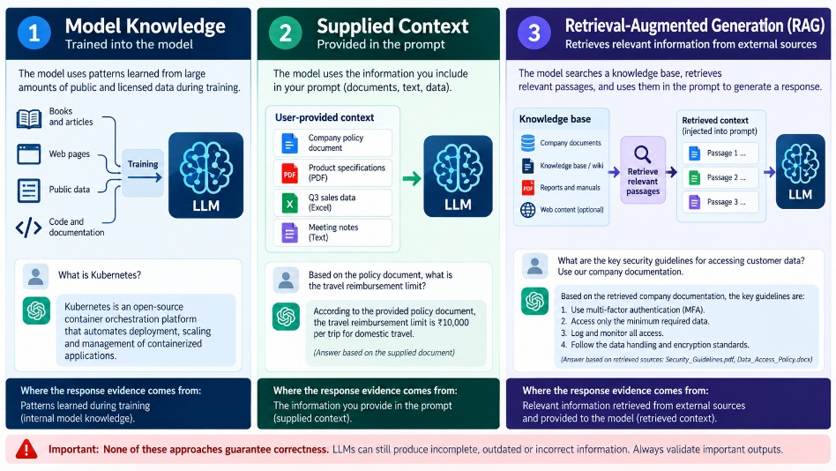

Slide 21: Demo 3: ground the answer in a runbook
Tool: Copilot Chat
Required document
- WinTrust_Runbook_Disk_Utilization.docx
Optional supporting documents
- WinTrust_Operations_SLA_Policy.docx
- WinTrust_GenAI_Security_Guidelines.docx
Use the runbook as the primary source. Add the optional documents only if you want participants to cross-check operational or security constraints.
Prompt
Using the supplied disk-utilization runbook, summarize the documented diagnostic and remediation steps.
For each step:
- State what the runbook explicitly says.
- Identify any prerequisites or approval requirements it documents.
- Flag risks to production availability or data integrity.
- Identify details that the runbook does not specify.
Do not invent missing procedures or approval rules. Distinguish documented instructions from your own recommendations, and reference the relevant section or wording where possible.
Demo procedure:
- Upload the runbook to Copilot Chat.
- Ask the prompt.
- Check each claim against the actual document.
- Identify any unsupported step or invented approval rule.
- If Copilot cannot access the document, supply the relevant text through an available file-grounding feature.
Key takeaway: A source-grounded answer is only as reliable as the evidence available and the model's interpretation of it.

Module 4: Troubleshooting method

Slide 22: The AI response troubleshooting framework
When a response is poor, diagnose in this order:
- Task: Is the request clear and specific?
- Context: Did the model receive the required evidence?
- Grounding: Can claims be traced to trustworthy sources?
- Method: Does the task require SQL, Python, calculation or another deterministic method?
- Verification: Have the result and edge cases been checked?
- Control: Does the proposed action require authorization or human approval?
Facilitator notes: Ask participants to apply this sequence to a weak answer from Demo 1 or Demo 3.
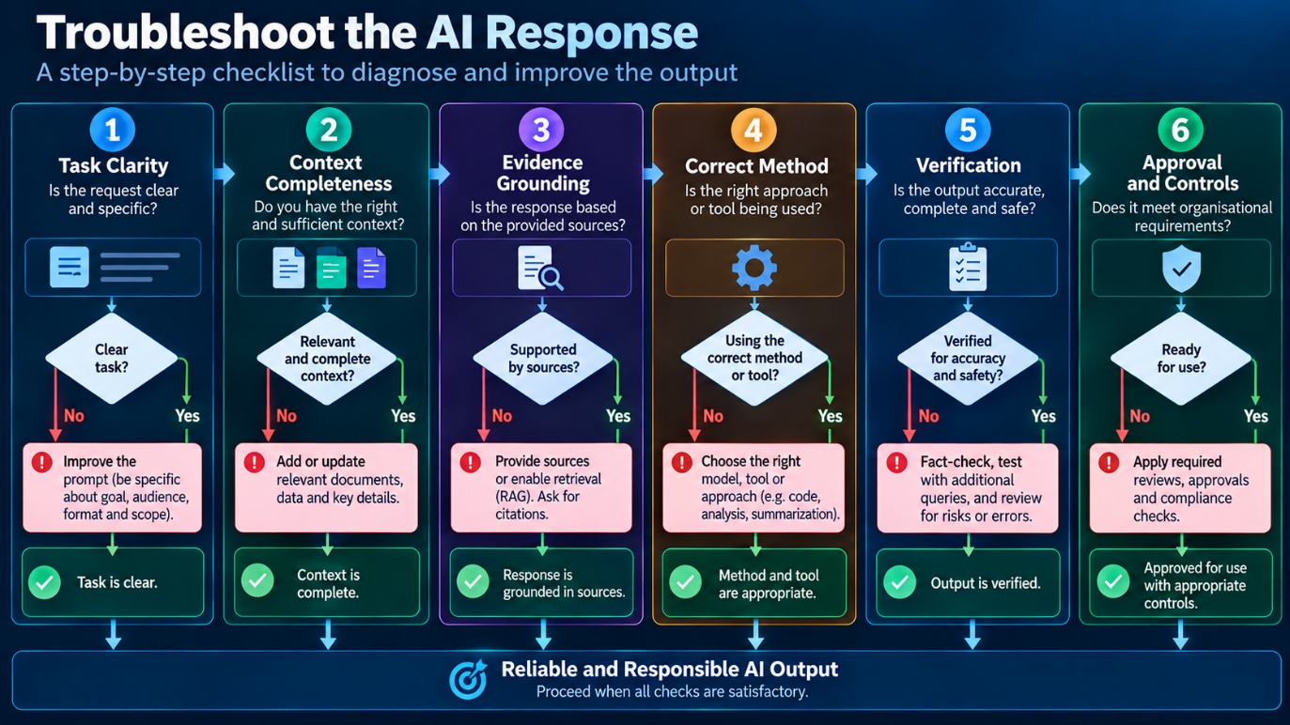

Slide 23: A practical diagnostic decision guide
- Wrong interpretation? Clarify the instruction and output format.
- Missing facts? Supply relevant evidence or use an available retrieval feature.
- Unsupported claims? Require source references and uncertainty labels.
- Incorrect calculation? Recalculate with a suitable tool.
- Incorrect code? Inspect implementation, run tests in a safe environment, and verify the result.
- Unsafe recommendation? Require risk assessment, appropriate authorization and approval.
Key message: Select the correction that addresses the actual failure mechanism.

Slide 24: Why verification matters
A good-looking response is not a verified response.
Verification techniques:
- Compare claims against source documents.
- Recalculate totals independently.
- Test SQL against known cases.
- Use unit tests for generated code.
- Challenge assumptions and boundary conditions.
- Record unresolved uncertainties.
Data example: Verify totals by currency independently rather than trusting a model's arithmetic.
Ops example: Confirm an incident recommendation against the runbook and applicable approval requirements.

Module 5: Joint hands-on lab

Slide 25: Lab instructions
Title: Diagnose the model, improve the result
Time: 25 minutes
Tool: Copilot Chat
Deliverable from each participant
- Original prompt and its weakness.
- Improved prompt and response.
- Two unsupported claims or assumptions they checked.
- One limitation that prompting alone could not resolve.
Ground rules
- Use only the supplied exercise data.
- Do not modify source data.
- Do not execute operational actions.
- Do not treat hypotheses as confirmed facts.
- Verify important calculations and claims.

Slide 26: Data Track Lab

Task #1: investigate transaction quality
Dataset: transactions_500.csv from the WinTrust demo pack is available for a richer extension. For the core exercise, use the small dataset below so the activity fits into 25 minutes.
transaction_id,amount,currency
T101,1200,INR
T102,850,INR
T103,,INR
T104,-250,INR
T105,700,USD
Initial prompt
Analyze this transaction data and tell me whether it is correct.
Participant task: Identify why this request is underspecified, then replace it with a more precise prompt.

Task #2: Improved prompt and expected result
Data lab: datasets/data_quality_incidents_24.csv | 24 records
Synthetic data-quality incidents covering missing values, duplicate candidates, invalid dates, unrecognized codes, currency issues, numeric anomalies and potential remediation risks.
Lab activities:
- Prioritize exceptions
- Develop read-only SQL validation checks
- Identify secondary risks
- Decide when data-owner approval is required.
Improved prompt
Review data_quality_incidents_24.csv. Prioritize the issues by risk and potential business impact.

For each issue:
- Distinguish observed evidence from hypotheses.
- Propose a read-only SQL check or verification query.
- Identify any additional schema, reference data or business rules required.
- Explain how a proposed remediation could introduce secondary data-quality problems.
- Identify cases requiring data-owner approval.

Do not invent missing values, reference mappings or business rules. Do not treat a duplicate candidate or outlier as a confirmed error. Do not claim that queries were executed.

Slide 27: Enterprise Ops Lab

Task #1: investigate an incident
Sample incident record
Incident: INC-3091
Service: Customer API
Alert: Disk utilization at 92%
Trend: Increased from 78% over 30 minutes
Customer impact: Intermittent API timeouts reported
Recent change: Unknown
Available evidence: Disk utilization alert only
Initial prompt
Tell me how to fix this incident.
Participant task: Identify why this prompt could lead to unsupported or risky remediation recommendations.
Files required: None. The incident record is embedded in the slide.

Task #2: investigate an incident
Data lab: datasets/ enterprise_ops_incidents_20.csv | 20 records
Operational incidents covering API availability, payment performance, identity security, database capacity, backups, batch jobs, data pipelines and file transfers.
Lab activities: Prioritize incidents, assess SLA indicators, separate evidence from hypotheses, identify safe diagnostics and flag actions requiring human approval.
Improved prompt
Review enterprise_ops_incidents_20.csv.

Summarize the incidents by severity, service, status and SLA breach indicator.

For high-priority incidents:
- Separate confirmed facts from hypotheses.
- Identify missing evidence needed for diagnosis.
- Recommend safe, non-destructive diagnostic steps.
- Flag actions that could affect production availability, customer data, security or recovery, and mark them as requiring human approval.
- Explain the rationale for the proposed priority and next steps.

Do not invent root causes, runbook procedures or approval policies. Do not claim that diagnostics or remediation have been executed. Do not recommend destructive action without documented justification and human approval.

Slide 28: Lab debrief, compare the two tracks
Diagnostic question | Data track | Enterprise Ops track
What is known? | Values in the supplied CSV | Alert and incident observations
What is uncertain? | Validity rules and business meaning | Root cause and safe remediation
What improves the response? | Explicit checks and output requirements | Evidence boundaries and diagnostic steps
What needs verification? | Counts, totals and business rules | Runbook alignment and operational risk
What cannot be solved by prompting alone? | Missing business definitions | Missing telemetry and authorization
Facilitator discussion
Ask each group: “Which part of your task improved because of the prompt, and which part still required external evidence or independent verification?”

Module 6: Optional GitHub Copilot demonstration

Slide 29: Demo 4: Code explanation is not code verification
Time: 5 to 7 minutes, if time permits
Tool: GitHub Copilot Chat in VS Code
Files from the existing demo pack
- Code/ticket_triage_starter.py
- Code/test_ticket_triage.py
Prompt
Explain how the ticket-triage implementation works.
Refer to these code files:
- Code/ticket_triage_starter.py
- Code/test_ticket_triage.py

Identify:
- The business rules implemented in code.
- Assumptions or edge cases that may be missing.
- Which behaviours can be verified through unit tests.
- Which business rules require clarification rather than inference.

Do not change the files yet. Do not claim that the tests have run.
Demonstration steps
- Open the starter implementation in VS Code.
- Ask GitHub Copilot Chat to explain it.
- Compare the explanation with the actual code.
- Inspect the existing test cases.
- Ask which additional tests would improve confidence.
Key takeaway: A plausible explanation is not proof that code behaves correctly. Tests provide evidence about specific behaviours, not a guarantee of correctness in every situation.
Facilitator note: This is an optional extension, not a required lab. If the main activities run long, skip it.

Module 7: Synthesis and close

Slide 30: Five-question knowledge check
Question 1: Does an LLM retrieve a guaranteed correct answer every time?
- Yes
- No
Answer: B. No.
Question 2: Does supplying more context always improve the answer?
- A. Yes
- B. No
Answer: B. No. Relevance and quality matter.
Question 3: Does RAG eliminate hallucinations?
- A. Yes
- B. No
Answer: B. No.
Question 4: If an answer lacks evidence, what should you do first?
- A. Ask for a longer answer.
- B. Supply or retrieve relevant evidence and require uncertainty to be stated.
- C. Ask the same question repeatedly.
Answer: B.
Question 5: Is prompting alone sufficient for high-impact operational changes or exact calculations?
- A. Yes
- B. No
Answer: B. Use appropriate computation, verification and controls.

Slide 31: The troubleshooting checklist
Before relying on an AI response, ask:
- Is the task clearly defined?
- Does the model have the relevant context?
- Are the claims supported by evidence?
- Does the task need deterministic computation?
- Have I verified the output?
- Are the required controls and approvals in place?
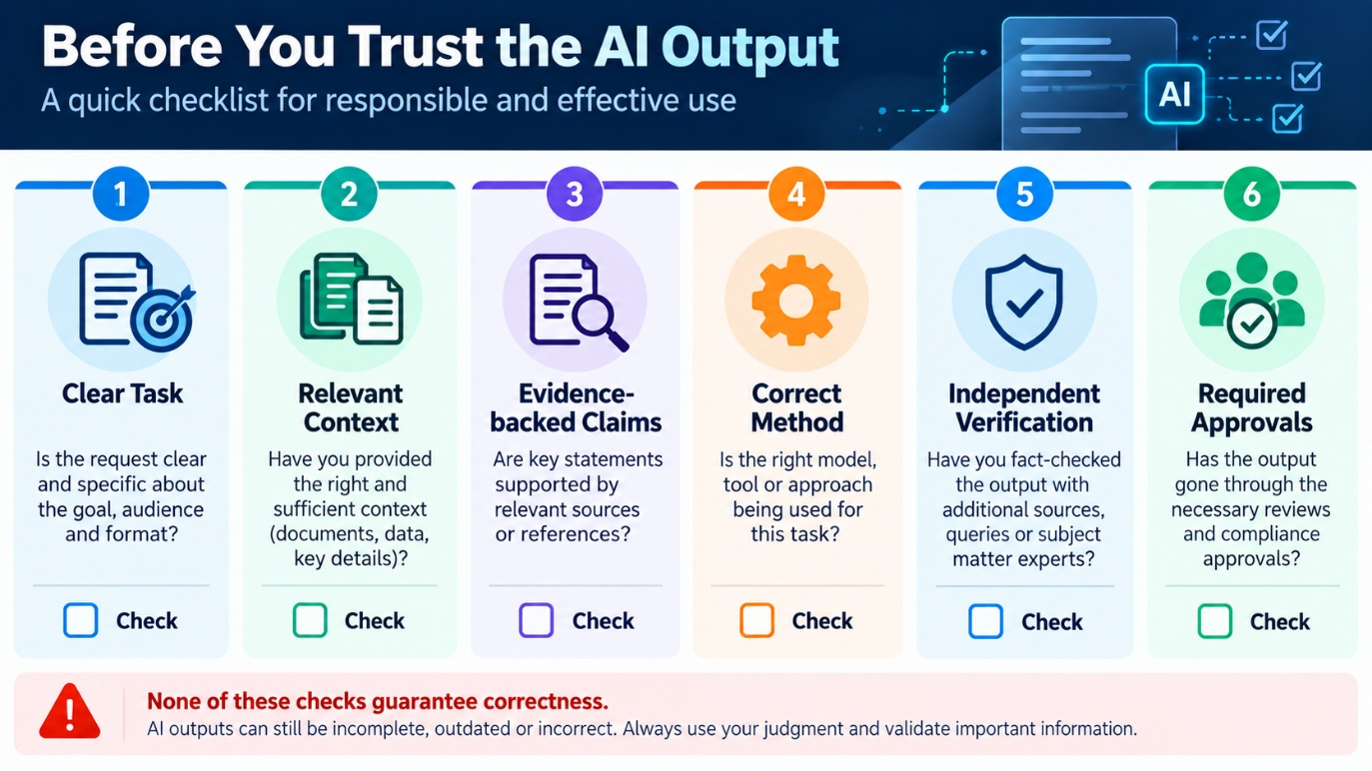

Slide 32: Key takeaways
- LLMs generate responses; they do not guarantee truth.
- Context quality matters more than context volume.
- Grounding improves evidence availability, not certainty.
- Prompting is one troubleshooting tool, not the solution to every problem.
- Verification and appropriate controls remain essential.
Closing statement
Prompting shapes the request. Context supplies evidence. Verification establishes whether the result is reliable enough to use.

Slide 33: Bridge to Session 7
MC-III: Risks, Security and Governance
The next masterclass moves from understanding model behaviour to managing the risks that follow from it.
- What can go wrong when models process sensitive data?
- How can prompt injection and malicious content affect AI-assisted workflows?
- Which controls should apply to inputs, outputs and tool access?
- When should human approval be mandatory?
Facilitator closing note: Session 6 explains why AI outputs need scrutiny. Session 7 turns that understanding into practical security and governance controls.

