Aim - To learn and understand link state routing protocol and implement Dijkstra’s SPF algorithm.

Objectives -

- To create routing table to show the cost of reaching each node from the source node and the obtain shortest path between the source and destination.

Theory -

Dijkstra’s is a single-source shortest path algorithm and aims to find solution to the given problem statement. This algorithm works for both directed and undirected graphs. It works only for connected graphs. The graph should not contain negative edge weights.
The algorithm predominantly follows Greedy approach for finding locally optimal solution. But it also uses Dynamic Programming approach for building globally optimal solution, since the previous solutions are stored and further added to get final distances from the source vertex.

Methodology -

- The main logic of this algorithm is based on the following formula-
dist[r]=min(dist[r], dist[q]+cost[q][r])
- This formula states that distance vertex r, which is adjacent to vertex q, will be updated if and only if the value of dist[q]+cost[q][r] is less than dist[r].
- Here- dist is a 1-D array which, at every step, keeps track of the shortest distance from source vertex to all other vertices, and
- Cost is a 2-D array, representing the cost adjacency matrix for the graph
- This formula uses both Greedy and Dynamic approaches. The Greedy approach is used for finding the minimum distance value, whereas the Dynamic approach is used for combining the previous solutions (dist[q] is already calculated and is used to calculate dist[r].

Working-

Following are the steps used for finding the solution-

Step 1; Set dist[s]=0, S=ϕ // s is the source vertex and S is a 1-D array having all the visited vertices
Step 2: For all nodes v except s, set dist[v]= ∞
Step 3: find q not in S such that dist[q] is minimum // vertex q should not be visited
Step 4: add q to S // add vertex q to S since it has now been visited
Step 5: update dist[r] for all r adjacent to q such that r is not in S //vertex r should not be
visited dist[r]=min(dist[r], dist[q]+cost[q][r]) //Greedy and Dynamic approach

Step 6: Repeat Steps 3 to 5 until all the nodes are in S // repeat till all the vertices have been visited
Step 7: Print array dist having shortest path from the source vertex u to all other vertices
Step 8: Exit

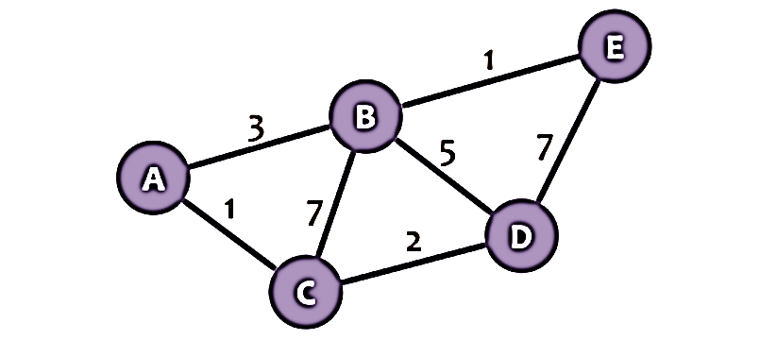

Output -

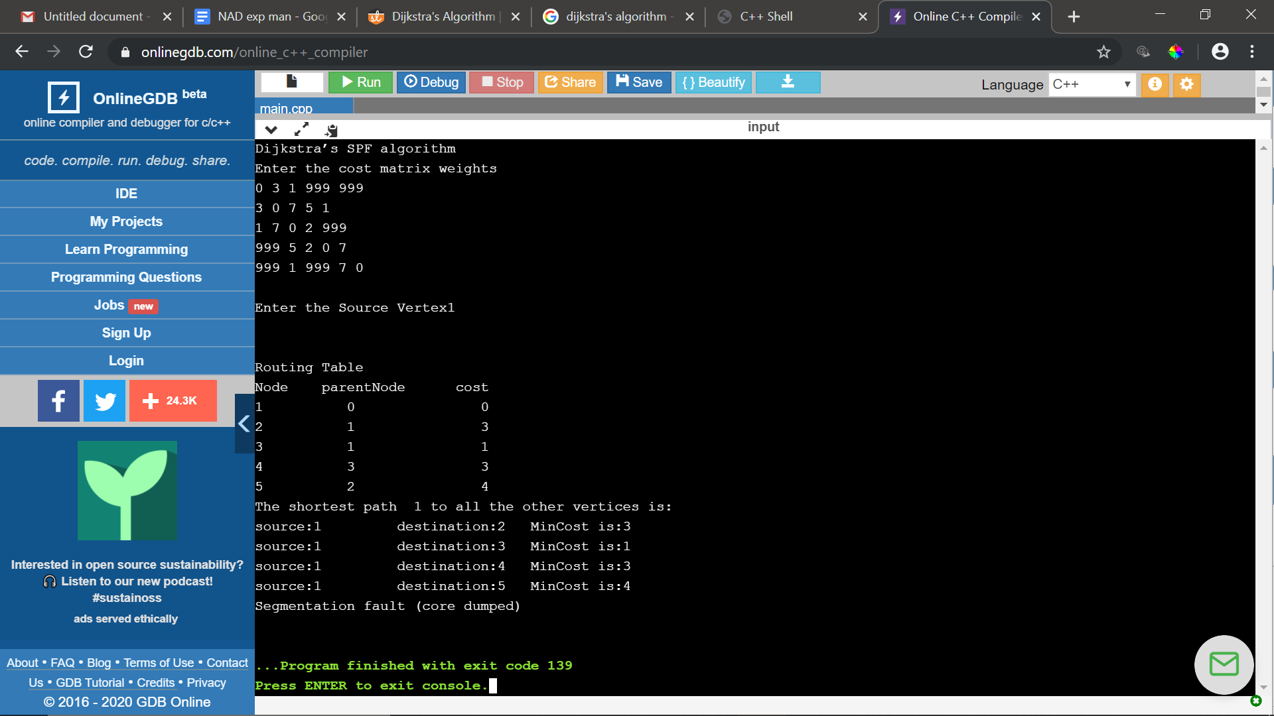

Conclusion

`

